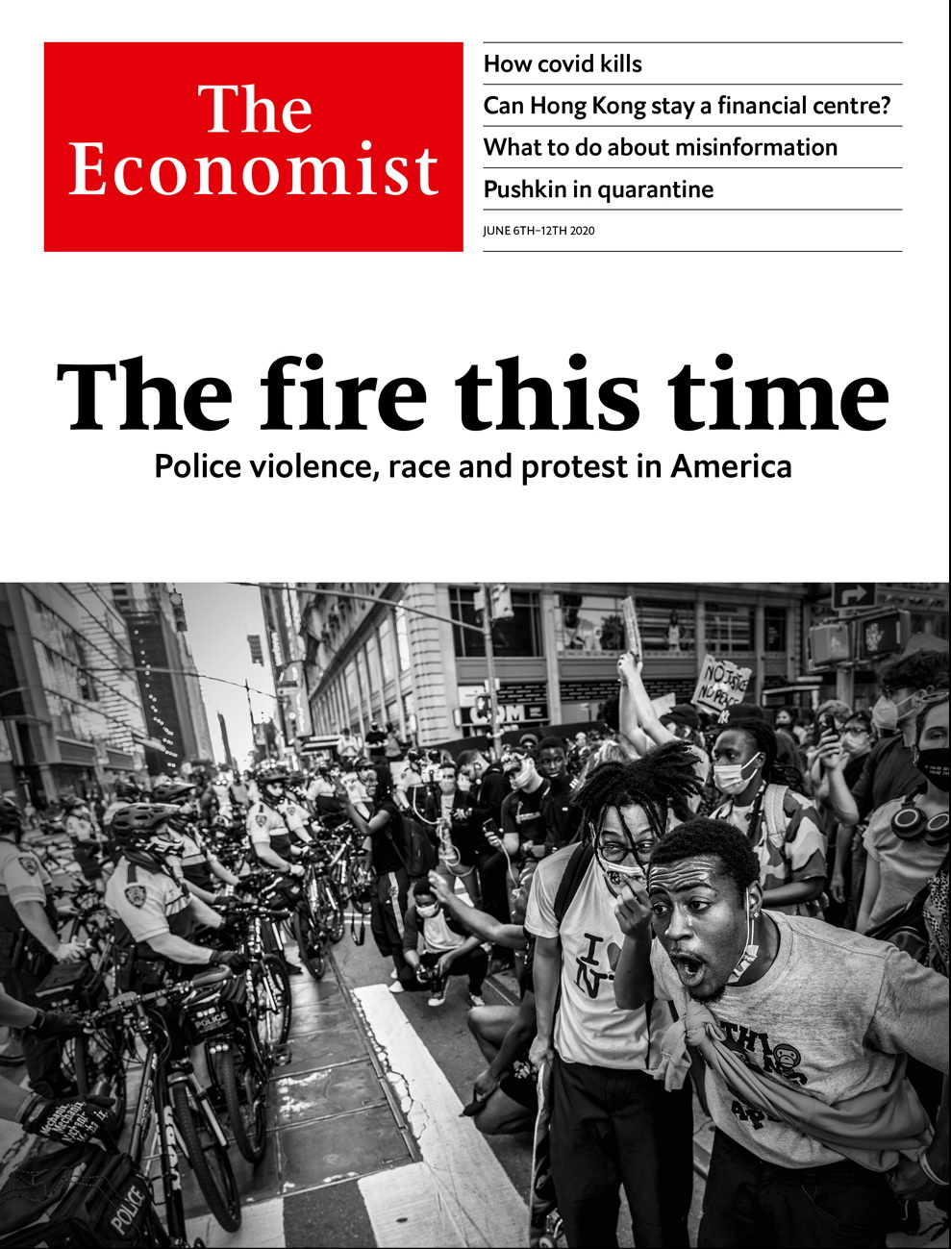

# Table of Contents

The world this week

Politics this week

KAL’s cartoon

Leaders

Policing and race in America: The fire this time

Hong Kong: Conduit’s end?

Covid-19: The other three-quarters

Inflation: Tomorrow’s problem

Letters

Letters to the editor: On public debt, Vitamin D, the BBC, clock dials, lists of three, globalisation

Briefing

How covid-19 kills: Assault and battery

United States

Criminal justice: Order above the law

African-Americans: Slow progress

Global leadership: Groping for the right grouping

Fishing: Alaska welcomes hooligans

Lexington: Far worse than Nixon

The Americas

Canada: Contenders for a cracked crown

Colombia: Medellín’s medical marvel

Bello: The empty skies

Asia

Covid-19 in South Asia: Deadly tide

Marriage in Japan: Knot happy

Repressing dissent in Thailand: Voice of treason

South Korea: Haunted by Gwangju

Indonesian politics: Viral marketing

Banyan: The beast from the east

China

The Belt and Road Initiative: Break time

Chaguan: Crossing blood lines

Middle East & Africa

Yemen and covid-19: The invisible outbreak

Israel: Empty empires

The Hirak: Streets with no rage (for now)

Boko Haram: No rain, slow gains

Women and politics in Uganda: Hell yeah, I’m a feminist

Debt relief: Thanks, but no

Europe

Inequality and the pandemic: Widening spread

Spain: A more equal country

Poverty in Italy: Hitting the poorest hardest

France: Time for a reboot

Germany: Social distancing and sex work

Slovenia: Barbarians at the gates

Turkey and covid-19: Strength in numbers

Britain

The United Kingdom: One nation, under covid

Hong Kong: A warm(ish) welcome

Ethnicity and covid-19: Doubly unlucky

Lifting lockdown: A risky reopening

Religion: Your own personal Jesus

Parliament: The mother of all queues

Documenting the pandemic: How history is made

Bagehot: The new victims

International

Fake news: Return of the paranoid style

Speech online: The moderator’s dilemma

Business

The sharing economy: What’s mine is yours

Floating not drowning: IPOs stay afloat

Video gaming: Command & reconquer

IKEA: Part of the furniture

Bartleby: Cultural challenge

Schumpeter: Boffins v the bug

Finance & economics

America’s public pensions: Counting the cost

Prudence in the pandemic: Americans saved a record chunk of their incomes in April

Sustainable finance: Social climbing

Buttonwood: The options gambit

Women in the workforce: This time is different

Free exchange: Land of the rising sum

Science & technology

Human space flight: The shape of things to come

Archaeology: Taking soundings in Teotihuacan

Climate feedbacks: Fire down below

Books & arts

Russian literature: Rapture on the battleground

Morality: Hearts of gold

Socially distanced art: The floor lines of beauty

Home Entertainment: Hayao Miyazaki’s flights

Home Entertainment: Rereading “Jane Eyre”

Perspectives: Of covid and kin

Economic & financial indicators

Economic data, markets and data

Graphic detail

Covid-19 and democracy: Out in the open

Obituary

George Floyd: The life pressed out



### Friday, June 5, 2020

|  |  |
| --- | --- |
| The world this week | 3 |
| Leaders | 5 |
| Letters | 1 |
| Briefing | 1 |
| United States | 5 |
| The Americas | 3 |
| Asia | 6 |
| China | 2 |
| Middle East & Africa | 6 |
| Europe | 7 |
| Britain | 8 |
| International | 2 |
| Business | 7 |
| Finance & economics | 7 |
| Science & technology | 3 |
| Books & arts | 6 |
| Economic & financial indicators | 1 |
| Graphic detail | 1 |
| Obituary | 1 |

|  |  |  |
| --- | --- | --- |
|  | Sections | Leaders |

The world this week

Politics this week

.

KAL’s cartoon

.

|  |  |  |
| --- | --- | --- |
|  | Sections | Leaders |

|  |  |  |  |
| --- | --- | --- | --- |
|  | Articles | Sections | Next |

# Politics this week

Jun 6th 2020 |

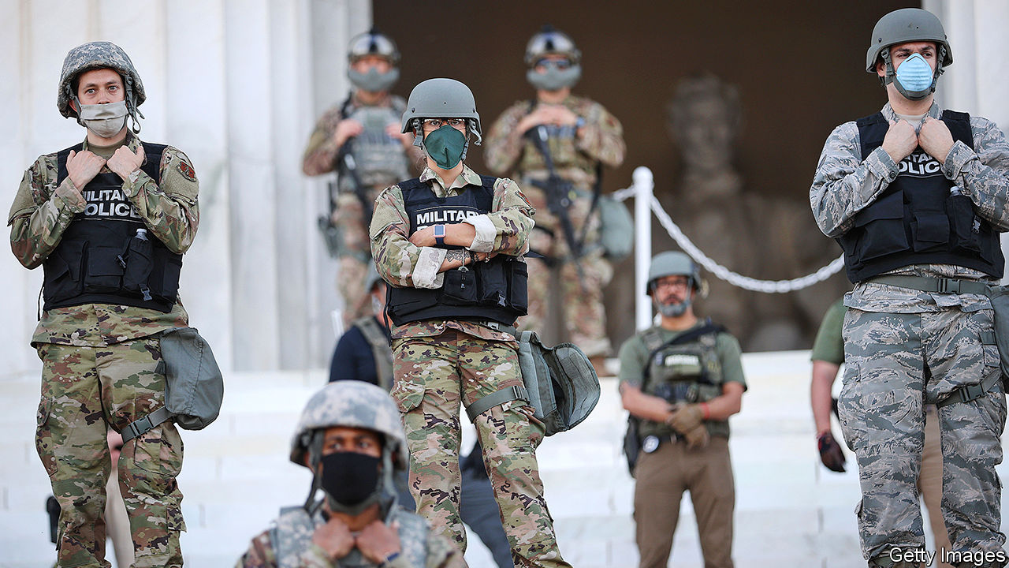

Both riots and peaceful protests spread across America in response to the death of George Floyd. It was the country’s worst unrest for decades, prompting many states to call out the National Guard and cities to impose curfews. Looting accompanied the chaos; shops in midtown Manhattan were ransacked. The policeman who knelt on Mr Floyd’s neck for nine minutes was indicted for second-degree murder; the three officers who failed to stop him were charged with lesser offences. Donald Trump suggested sending in the army to restore order. Mark Esper, the defence secretary, said soldiers should only be deployed as a last resort. See article.

NASA launched astronauts into space from American soil for the first time since the end of the shuttle programme in 2011. A capsule carrying two astronauts to the International Space Station was propelled by a SpaceX rocket, marking the first time a private company has sent humans into orbit. See [article](https://www.economist.com/leaders/2020/06/06/spacex-is-making-human-space-travel-a-routine-form-of-commerce).

Steve King, a Republican congressman from Iowa, who once questioned whether white supremacy was offensive, was booted out by voters in a primary election.

In response to China’s move to impose a new national-security bill on Hong Kong, Donald Trump said his administration would “begin the process” of scrapping the “full range” of policies that treat the territory differently from the rest of China. He also said he was “terminating” America’s relationship with the WHO, citing China’s “total control” over the body, and banned Chinese airlines from flying to the United States from June 16th, a tit-for-tat measure. China’s aviation regulator indicated that it would allow limited flights to resume. See article.

Britain’s prime minister, Boris Johnson, suggested that if China enacts the national-security law in Hong Kong, Britain could make it easier for up to 3m Hong Kongers to go to Britain to live and work and eventually become citizens. Beijing told Mr Johnson to stop interfering in its affairs. See [article](https://www.economist.com/britain/2020/06/06/britain-opens-its-doors-to-hong-kongers).

Bangladesh,India and Pakistan ended lockdowns intended to slow the spread of covid-19, even as all three countries continued to register record numbers of new cases. See article.

Taiwan’s constitutional court struck down a law that criminalised adultery, as an unwarranted invasion of personal privacy. Most of the people convicted under the law were women.

The Philippines retracted its decision in February to end a treaty under which American troops visited the country to conduct joint exercises and train Filipino troops.

As schools started to reopen the British government faced a backlash from teachers’ unions and local authorities, who claim it is still unsafe. Social distancing has meant that class sizes have been halved.

The German government unveiled a €130bn ($145bn) stimulus package that includes a cut to value-added tax, aid for local authorities and incentives to buy electric cars. It will also issue a one-off €300 boost to child benefit in order to raise household spending.

After years of fixing the petrol price close to zero, Venezuela’s government raised it to near market levels. For cars the first couple of tankfuls a month will continue to be nearly free, but refills after that will cost 50 cents a litre. The government hopes to alleviate chronic fuel shortages and reduce a massive budget deficit. Venezuela’s economy has shrunk by two-thirds since 2013.

Bolivia’s electoral tribunal agreed with political parties to hold a national election by September 6th. The vote will be a re-run of the one held in October, in which the president, Evo Morales, claimed victory but left office, and the country, after protesters accused him of electoral fraud.

Israel told thousands of students and teachers to go into quarantine for covid-19. Almost 250 people tested positive for the virus in schools, which reopened last month. Dozens have closed again.

Iran, which has had one of the worst outbreaks of covid-19, reported its highest daily number of cases in the past two months. The government warned of a second wave, even as it attempts to reopen businesses, schools and mosques. “People seem to think the coronavirus is over,” said the health minister; it “may come back stronger than before”.

Governments in the Middle East began opening some of the most important sites in Islam, such as the al-Aqsa mosque in Jerusalem. Worshippers had their temperatures checked and were asked to observe social distancing and wear masks. Islam’s holiest site, the Grand Mosque in Mecca, remained closed.

The UN said Libya’s warring parties have agreed to restart talks over a possible ceasefire.

A court in South Africa ruled that a ban on the sale of cigarettes and alcohol was unconstitutional. The ban was part of the government’s lockdown regulations to fight covid-19.

A militia leader in the Democratic Republic of Congo was arrested for the murder three years ago of two UN experts, one of whom was beheaded, and their interpreter. They had been investigating abuses of human rights.

## Coronavirus briefs

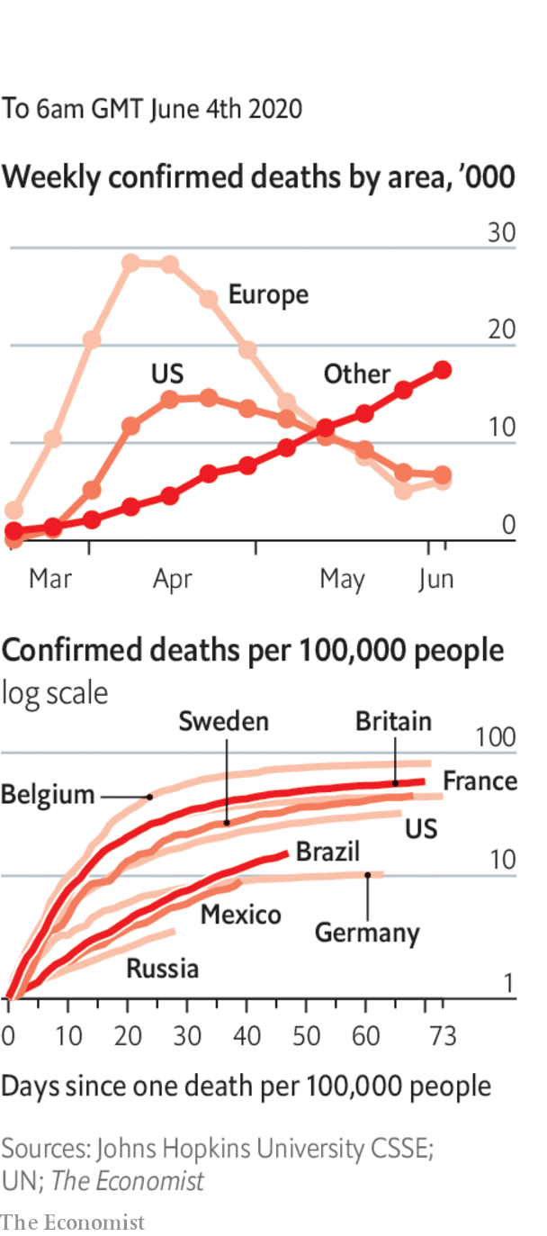

South Korea temporarily closed some schools that had only just reopened after recording the highest spike in new cases in two months.

The Chinese city of Wuhan tested all of its 10m residents for covid-19 over ten days. The campaign identified just 300 infections, all of which were asymptomatic.

The head of Britain’s statistics agency criticised Matt Hancock, the health secretary, for data published on testing, saying the distinction between actual testing and posting test-kits was “too often elided” during official presentations.

Mexico, which has the second-largest number of deaths from covid-19 in Latin America, loosened lockdown measures.

French cafés and restaurants reopened after 11 weeks of lockdown. The joie de vivre is still subject to social-distancing restrictions.

This article was downloaded by calibre from <https://www.economist.com/the-world-this-week/2020/06/06/politics-this-week>

|  |  |  |  |
| --- | --- | --- | --- |
|  | Articles | Sections | Next |

|  |  |  |  |
| --- | --- | --- | --- |
| Previous | Articles | Sections | Next |

# KAL’s cartoon

Jun 4th 2020 |

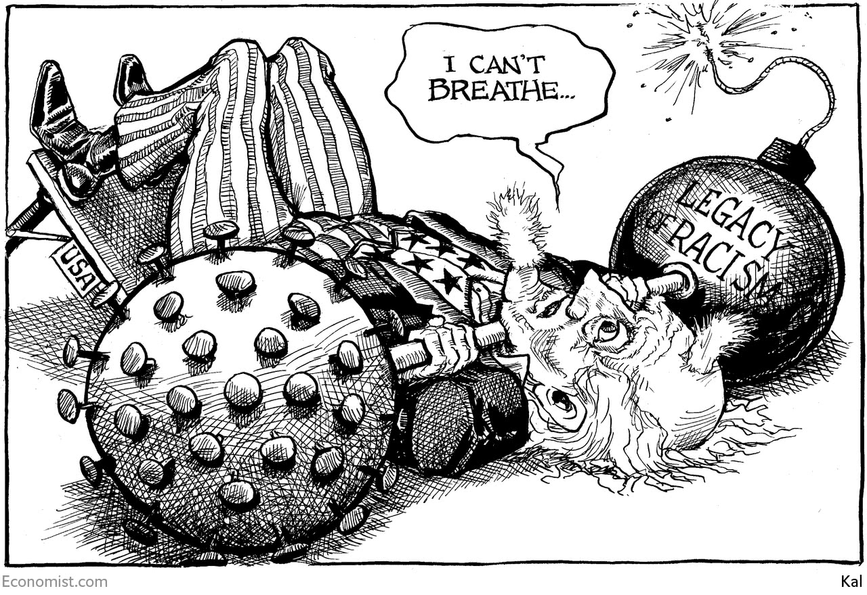

This article was downloaded by calibre from <https://www.economist.com/the-world-this-week/2020/06/04/kals-cartoon>

|  |  |  |  |
| --- | --- | --- | --- |
| Previous | Articles | Sections | Next |

|  |  |  |
| --- | --- | --- |
| The world this week | Sections | Letters |

Leaders

Policing and race in America: The fire this time

.

Hong Kong: Conduit’s end?

.

Covid-19: The other three-quarters

.

Inflation: Tomorrow’s problem

.

|  |  |  |
| --- | --- | --- |
| The world this week | Sections | Letters |

|  |  |  |  |
| --- | --- | --- | --- |
|  | Articles | Sections | Next |

#### The fire this time

# Police violence, race and protest in America

Will protesters in American cities bring progress, or set back the cause they champion?

Jun 4th 2020 |

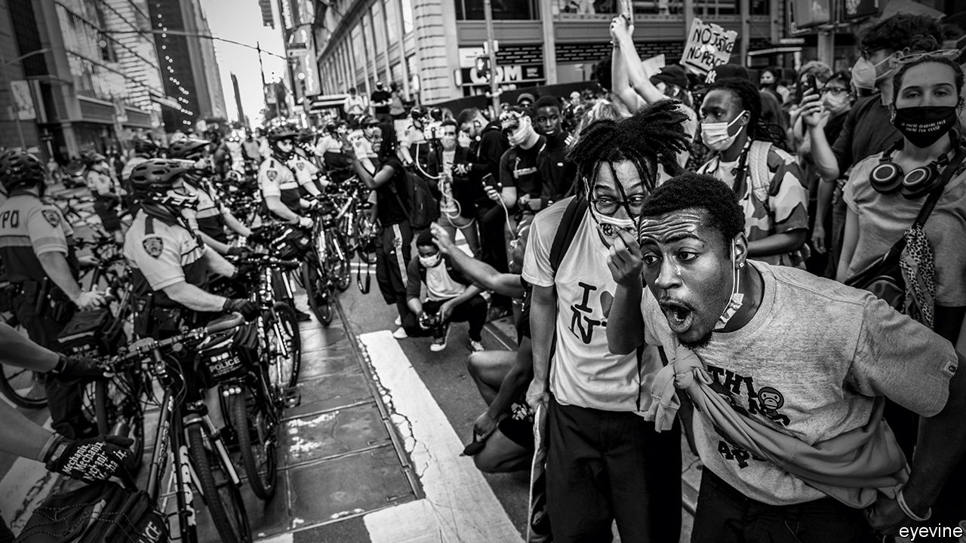

ONE HUNDRED THOUSAND Americans are dead from a virus. A feat of space flight demonstrates American ingenuity. In cities across the country, protests sparked by racial injustice are showing an ugly side of America to the world. In November voters must choose between a Republican running on a law-and-order platform, and an uninspiring vice-president running for the Democrats. The year is 1968. It is also 2020.

In 1968 the virus was flu and the space mission Apollo 8. But the injustice had the same corrosive effect. As James Baldwin wrote in the early 1960s, racism “compromises, where it does not corrupt, all the American efforts to build a better world—here, there or anywhere.” Today more than 350 cities nationwide erupted after George Floyd, an unarmed African-American man, was killed by a white police officer (see article). For nearly nine agonising minutes, deaf to Mr Floyd’s pleas and the growing alarm of the crowd, the officer choked the life out of him.

No wonder the spark ignited a bundle of kindling lying nearby. The fire this time is burning for the same reasons it has so often in the past: that many African-Americans still live in places with the worst schools, the worst health care and the worst jobs; that the rules apply differently to black people; the fact, rammed home by covid-19, that whenever America suffers misfortune, black America suffers most; a sense that the police are there to keep a lid on a city’s poor, even as they protect wealthy suburbs. And, yes, the sheer intoxication that comes from belonging to a crowd that has suddenly found its voice, and which demands to be heard.

The cycle of injustice, protest, riot and conservative reaction has come round many times since 1968. So many, that it would be easy to conclude that police violence and racial inequality in America are just too hard a problem to fix. Yet such pessimism is unwarranted. It is also counter-productive.

Activists sometimes charge that the entire criminal-justice system is racist. Police unions protect their members, including the rotten ones. In recent days a police car has rammed protesters and officers have assaulted people on the street. But the system is made up of thousands of jurisdictions and police departments. They are not all the same. For every Minneapolis, where some thuggish officers went on “warrior” courses and saw themselves as an occupying force, there is a Camden, New Jersey. Camden’s police force was so broken that in 2013 it was disbanded and the city started afresh. Its police chief was this week able to march with peaceful protesters through their city.

Policing America is hard because America is more violent than any other rich country and its citizens more heavily armed. About 50 police officers are murdered while doing their job each year. But the sustained falls in crime over the past three decades have made room for less warlike law enforcement—by training officers to diffuse confrontation, not seek it, and by making them accountable whenever they use force. Many police departments, including Camden, have already taken this chance to turn themselves round (see article). Others have not, partly because the federal government under President Donald Trump has eased the pressure for change. But the police and prosecutors are under local democratic control. They can be made to embrace reform if enough people vote for it.

Pessimism is self-defeating, too. It is a short step from thinking that America’s original racial sin is so deep that it cannot be overcome, to thinking that smashing and burning things is justified, because it is the only way to get attention. Yet if today’s protests slide into persistent rioting, as in 1968 after Martin Luther King’s assassination, the harm they cause could be felt most keenly in African-American districts. Those people who can leave will. The left-behind will be worse off, as home values plunge and jobs and shops disappear. The police may withdraw, leading to an increase in crime, which in turn may eventually bring more violent policing. The scars will be visible for decades.

Across the country, black leaders, who have seen this happen before, are telling protesters not to undermine their cause. “A protest has purpose,” said Atlanta’s mayor, Keisha Lance Bottoms, condemning the vandalism in her city. In recent days protesters have heeded that and have been trying to restrain those who just want to start a fire—some of them white troublemakers.

Black leaders also understand how riots can wreck a political cause. When neighbourhoods are ablaze, the rest of the country focuses on putting out the fires. Harm to police officers in riots may cause voters to forget where their sympathies lay when it all began. When rioting takes hold, those who support the protests may find that their demands for change are drowned out by the clamour for order to be re-established.

In a presidential election, fear often beats idealism. Mr Trump seems to want this to be the choice in November. He has encouraged his supporters to clash with protesters outside the White House and been looking to deploy active troops alongside the national guard so as to “dominate” what his people call the battlespace (see article). Law and order helped Richard Nixon beat Hubert Humphrey in 1968. It could work again.

Yet fear betrays Mr Floyd’s memory. The more America is united, the better it can strive to ensure that all its citizens are able to live by its founding ideals. Unity will not come from Mr Trump, who has spent four years trying to divide the country. Instead, the leaders of protest movements, along with America’s mayors and police chiefs, must inspire it themselves. If the protests are overwhelmingly non-violent, they also carry a promise. Not that the protesters will get everything they want, nor that the injustices holding back African-Americans can all be put right at once, but that tomorrow can be better than today.

By the end of the decade in which Baldwin wrote of the need to heal America, the country had set about dismantling the legal edifice of racial segregation. It was also in the grip of a reaction from those who thought civil rights had gone too far. America is like that. Progress tussles with its opposite. But Americans have been tugging away at racism for half a century. This week, when the cruel death of a black man drew protesters of all races onto America’s streets, it was not just a sign of how much work lies ahead, but also that progress is possible. ■

This article was downloaded by calibre from <https://www.economist.com/leaders/2020/06/04/police-violence-race-and-protest-in-america>

|  |  |  |  |
| --- | --- | --- | --- |
|  | Articles | Sections | Next |

|  |  |  |  |
| --- | --- | --- | --- |
| Previous | Articles | Sections | Next |

#### Conduit’s end

# Can Hong Kong remain a conduit between China and the world?

Its future as a financial centre depends on nothing less

Jun 6th 2020 |

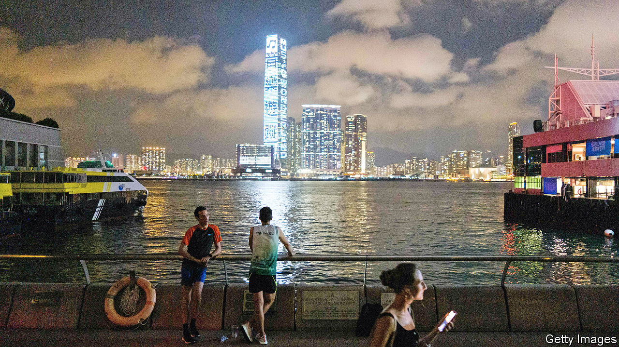

CHINA AND America have begun the fraught business of disentangling their financial systems. Chinese firms with shares listed in New York have rushed to float in Hong Kong, too, after the White House signalled they are not welcome on Wall Street. The latest is NetEase, a Chinese gaming firm that began a $3bn listing this week. But now Hong Kong itself, the world’s third-biggest international financial centre, has become a geopolitical flashpoint. Its unique role as the conduit between global capital markets and China’s inward-looking financial system means that both sides must tread carefully.

On May 28th China said it would enact a new national-security law for Hong Kong, undermining the formulation of “one country, two systems” in place since 1997, under which the territory is supposed to be governed until 2047. In response, America has said it may downgrade the legal privileges it grants Hong Kong, which treat it as autonomous from China. Britain, the former colonial power, has said that freedoms are being curtailed and that it could make it easier for up 3m Hong Kongers to go there to live and work and eventually win citizenship—a welcome, if still sketchy, gesture (see [article](https://www.economist.com/britain/2020/06/06/britain-opens-its-doors-to-hong-kongers)).

Hong Kong’s place in the world depends on having the rule of law, a trusted reputation and seamless access to Western financial markets. Other Chinese cities have big stock exchanges: shares listed in Shanghai and Shenzhen are together worth a lot more than those in Hong Kong. But neither has fair courts, an independent central bank, free movement of capital or a mix of Western and Chinese firms. These foundations are the basis for $9.7trn of cross-border financial claims, such as loans, that are booked in the territory. Hong Kong is also where mainland Chinese firms and banks go to deal in the dollar, the world’s dominant currency. Some $10trn of dollar transactions flowed through Hong Kong’s bank-to-bank payments system last year.

Until recently, conventional wisdom held that Hong Kong’s position would be assured for 20-30 years, because it would take that long for China either to upgrade its markets to Western standards or to become so powerful that it could impose mainland practices, and the yuan, on the rest of the world. But the trade war, a year of street protests and China’s iron-fisted response to them raise new questions about Hong Kong’s durability (see [article](https://www.economist.com/finance-and-economics/2020/06/06/can-hong-kong-remain-a-global-financial-centre)). Bullying from Beijing erodes the sense that it is autonomous. And there is an outside chance that America could impose sanctions or other restrictions that would stop some Hong Kong officials, firms or banks from using dollars. China’s actions raise doubts about the sanctity of contracts. America’s might bring into question whether money parked in Hong Kong is still fully fungible with money in the global financial system. If these worries spread, they could destabilise Hong Kong and cause a financial shock in China and well beyond it.

The good news is that so far there is no sign of capital flight. Hong Kong’s vast deposit base has been stable in recent weeks, say its bankers. Investors are reassured by its $440bn or so mountain of foreign reserves and a long record of capable financial management. The rush of Chinese listings will bring in new cash and drum up business in the city.

Nonetheless, for China the prudent policy is to try to speed up the development of the mainland’s financial capabilities so that it is less exposed to potential American punishment. That means attracting more global banks and investment managers into mainland China. Last year it eased rules on licences for Wall Street firms, although many remain sceptical that anything will really change after years of glacial negotiations and backtracking by Chinese officials. It also means another big push to boost the global role of the yuan and reduce China’s dependence on the dollar. China tried, prematurely, to promote the yuan after the global financial crisis with a mix of propaganda and diplomatic strong-arming. It flopped. The next effort will be more sophisticated. It may try to exploit China’s global lead in cutting-edge payments by, for example, expanding cross-border digital-payments systems that bypass much of the existing global plumbing. Or it could promote China’s plan for a digital central-bank currency.

Nonetheless all of this will be hard for China to accomplish and take a long time. Which means that Hong Kong will still matter in global finance. If you have a mutual fund with an allocation to Asian shares, or run a multinational company or bank, you should gauge Hong Kong’s financial health by three measures. One is how China implements the new security law—for example, whether it will be applied by independent judges or by judges congenial to Beijing. The second is whether America targets the dollar-payments system in Hong Kong, which has the potential to cause an immediate scare. And the last is whether the Communist Party attempts not just to suppress protests and to intimidate its critics inside Hong Kong and beyond, but also compromises the territory’s independent institutions—including its courts, the central bank, regulators and the regime for clean accounting.

People have wrongly predicted the demise of Hong Kong for the best part of two centuries. If it fails these tests, its time as a global financial centre really will be up.■

This article was downloaded by calibre from <https://www.economist.com/leaders/2020/06/06/can-hong-kong-remain-a-conduit-between-china-and-the-world>

|  |  |  |  |
| --- | --- | --- | --- |
| Previous | Articles | Sections | Next |

|  |  |  |  |
| --- | --- | --- | --- |
| Previous | Articles | Sections | Next |

#### The other three-quarters

# The pandemic is still gathering pace in most of the world

But there is lots that countries can do to curb it

Jun 4th 2020 |

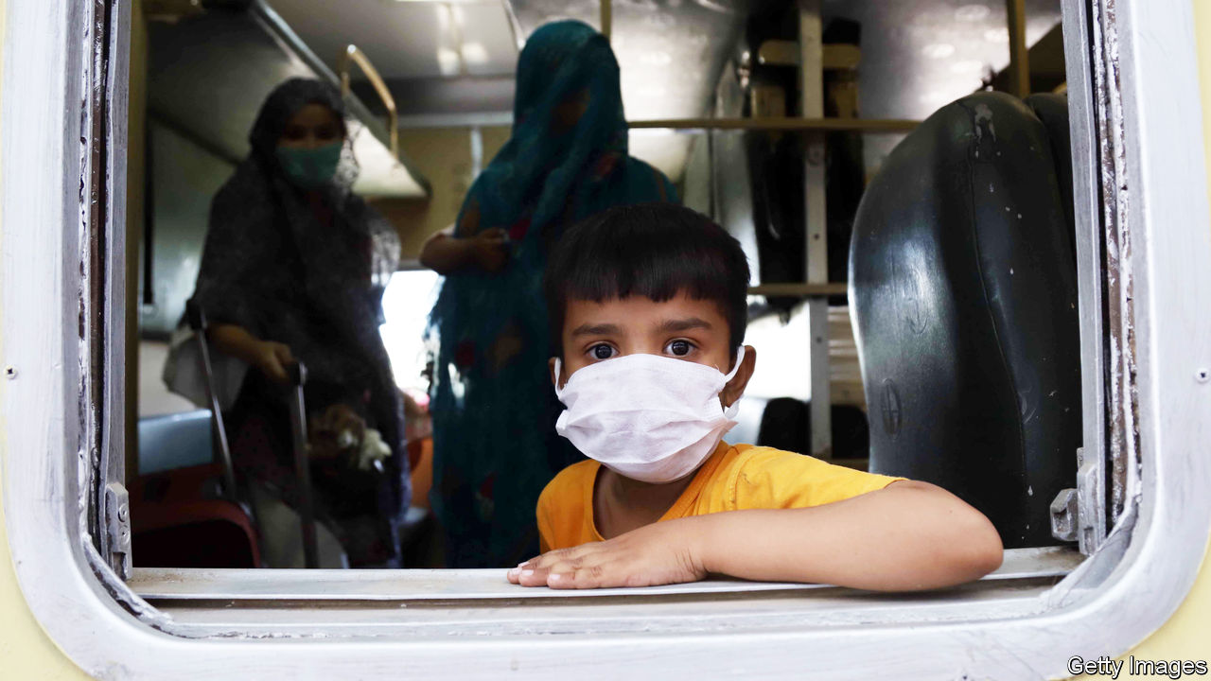

Editor’s note: Some of our covid-19 coverage is free for readers of The Economist Today, our daily [newsletter](https://my.economist.com/user#newsletter). For more stories and our pandemic tracker, see our [coronavirus hub](https://www.economist.com/news/2020/03/11/the-economists-coverage-of-the-coronavirus)

HOW TO PREVENT new surges in cases? How to reopen businesses in an era of social distancing? How to revive prone economies? These are the questions preoccupying most of the rich world, where covid-19’s first wave, at least, is mercifully ebbing. But elsewhere the pandemic remains far from any crest. Brazil is adding around 25,000 new confirmed cases a day, more than the United States. Russia and India are not far behind, with 8,000 or so apiece. All told, poorer countries account for some three-quarters of the 100,000 or so new cases detected around the world each day.

These numbers are alarming, especially because they are grave underestimates. Poorer countries tend to conduct fewer tests than richer ones, so even more infections and deaths are going uncounted in them. Random testing in the Pakistani city of Lahore suggests that the official count is catching only one case in 25. Many governments are reluctant to advertise how rapidly the virus is advancing on their watch (see article). Russia initially claimed that barely 600 Muscovites died of the disease in April, but the number of deaths in the city in excess of the average for the month was three times that. And some countries are too chaotic and violent to have much of a government. This week the UN sounded the alarm about Yemen, where the coronavirus seems to be rampaging across territory contested by the country’s two warring governments (see [article](https://www.economist.com/middle-east-and-africa/2020/06/06/covid-19-quietly-sweeps-across-yemen)).

In the most worrying countries, many live hand-to-mouth. Their governments tend not to have much money, either. That has prompted the authorities to relax the restrictions they put in place to slow the spread of the disease, to save their citizens from ruin. India, for instance, ended its lockdown on June 1st, just as the number of daily infections hit a new record (see article). Mexico has declared that it will open for tourism on June 8th. And non-essential businesses have been allowed to reopen in Rio de Janeiro, Brazil’s second-largest city.

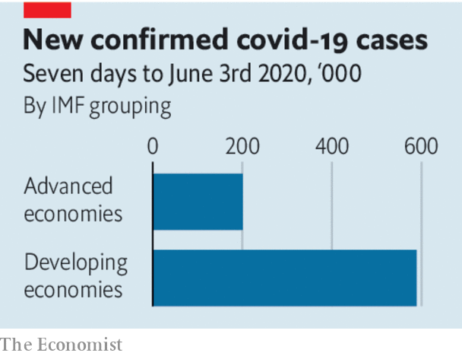

When outbreaks are big enough to overwhelm health-care systems, deaths soar, since even cases that might respond to treatment become deadly. Poor countries have fewer hospitals and doctors and less of the necessary kit, from ventilators to disposable gloves and gowns. This can lead to horrifying scenes like those witnessed in Guayaquil, Ecuador, in April, when coffins ran out and bodies were abandoned in the streets.

Even poor countries can still do much to avoid such an outcome. As many have discovered, long-lasting lockdowns, ordered from on high, tend to be both hard to enforce and to come at a calamitous cost to the economy and to people’s overall health. But basic public-health campaigns, ideally in the hands of village councils, primary health-care clinics and so on, can promote practices like washing hands, wearing face-masks and social distancing. They can organise isolation for those with symptoms and press for amenities like clean water. Even in places where it is hard to empty the streets altogether, governments can ban big gatherings in confined spaces, be it sports stadiums or churches. And—cold comfort—once it becomes clear in any given country how deadly an uncontrolled outbreak is, the instinct for self-preservation will prompt people to isolate themselves, slowing covid-19’s progress.

Richer countries can do much to help. Some stricken places will need donations of simple supplies like testing kits and protective gear. Others will need debt relief, to free money to fight the disease. Humanitarian aid for war-torn countries and the refugees they create is even more urgent than usual. Better yet, the governments backing opposing sides in civil wars in places like Afghanistan and Yemen could urge their proxies to declare temporary truces, to bring a modicum of help to afflicted regions. Coronavirus outbreaks are deadly enough without the added misery of guns and bombs. ■

This article was downloaded by calibre from <https://www.economist.com/leaders/2020/06/04/the-pandemic-is-still-gathering-pace-in-most-of-the-world>

|  |  |  |  |
| --- | --- | --- | --- |
| Previous | Articles | Sections | Next |

|  |  |  |  |
| --- | --- | --- | --- |
| Previous | Articles | Sections | Next |

#### Tomorrow’s problem

# Don’t worry about inflation—yet

Monetary stimulus is unlikely to spark sustained price rises while labour markets remain depressed

Jun 4th 2020 |

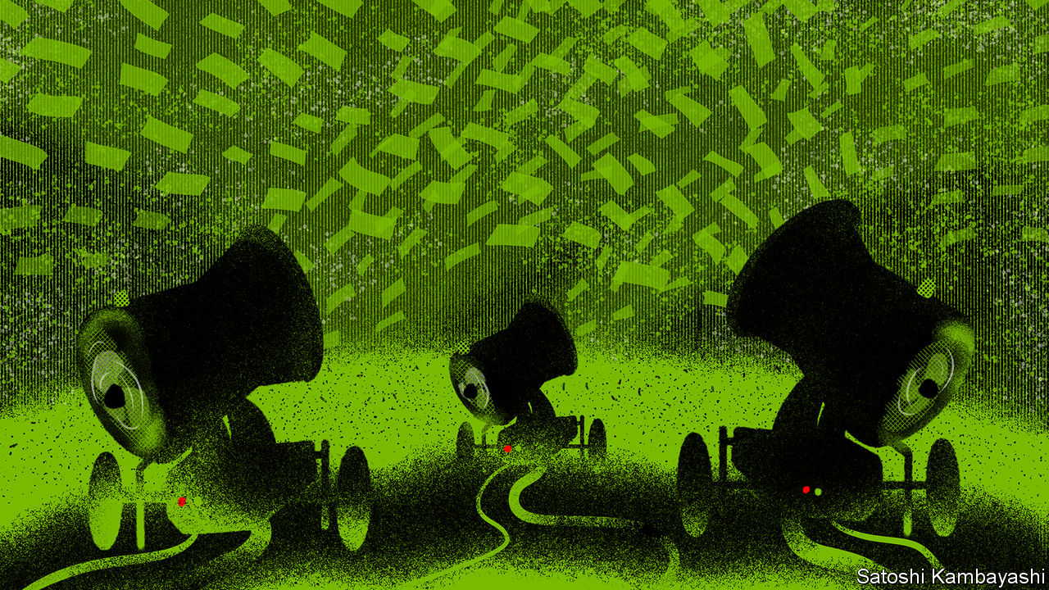

NEVER BEFORE have central banks created so much money in so little time. In the past three months America’s monetary base has grown by $1.7trn as the Federal Reserve has hoovered up assets using new money. As The Economist went to press, the European Central Bank (ECB) was expected to expand its emergency bond-buying programme beyond its initial size of €750bn ($830bn). Money-creation has tacitly financed much of the emergency spending unleashed to help economies through the pandemic. It has also propped up asset markets. The Fed is buying junk bonds; the Bank of Japan has stepped up its purchases of equities and could soon own over a fifth of many large Japanese companies (see article). All the while economies are contracting. As a result, America’s base-money-to-GDP ratio may grow by nine percentage points in the second quarter of 2020. That would be by far the biggest such rise in decades.

It is only natural for money-creation on this scale to spark fears about inflation, which is the consequence of too much money chasing too few goods and services. All the more so because the pandemic has constrained production, at least temporarily, by forcing factories and shops to close and limiting global trade. It is no surprise, therefore, that a vocal minority of investors and economists predict an inflation surge, including researchers at Morgan Stanley; Ray Dalio, a hedge-fund manager; and a clutch of monetarist academics. Similar forecasts after the financial crisis in 2007-09, when central banks’ balance-sheets also ballooned, proved to be wholly wrong. But, in contrast to then, much of today’s stimulus is ending up in households’ bank accounts. In April, for instance, Americans’ total incomes rose by 11% thanks to emergency support from the government (and, indirectly, from the Fed), even as overall wages and salaries fell by 8% as 20.5m workers lost their jobs. More money in consumers’ pockets, according to hawkish logic, means this time will be different—and that inflation is more likely.

It is not. Several reasons suggest the hawks will probably be proved wrong again. Even accounting for the fall in oil prices, inflation is sharply lower in most places because households are slashing their consumption and saving more (see [article](https://www.economist.com/finance-and-economics/2020/06/06/americans-saved-a-record-chunk-of-their-incomes-in-april)). Some of that is by necessity—it is hard to spend when shops are shut. But even as economies reopen, spending is likely to remain tepid, not least because unemployment is soaring. America’s latest monthly unemployment figures, due on June 5th, are likely to show a jobless rate of 20%. It would be similarly high in many other countries, like Britain, were they not generously subsidising employers’ payrolls. Job insecurity in a depressed labour market is reason enough to save. And governments cannot replace lost incomes indefinitely. Many are already thinking about how to wind down their support in order to get people back to work.

The immediate risk, therefore, is not too much inflation, but too little, amid a slow recovery and a painful economic restructuring. Many firms will emerge from lockdown with huge debts. Many workers may need to move from one industry to another. In such an environment the chief danger will be that policymakers withdraw stimulus too soon. That is what happened in 2011, after the global financial crisis, when the ECB raised interest rates. Financial markets seem to expect such stimulus to be insufficient. Their inflation expectations suggest the Fed, the ECB and the Bank of Japan will all undershoot their targets on average for the next decade. Even America’s buoyant stockmarket is favouring firms that can thrive in a low-inflation environment.

Only after economies and job markets have healed will a sustained rise in inflation become a risk. Governments will emerge from the pandemic with much higher public debts, and they may be tempted to press monetary policymakers to keep interest rates low rather than to apply the brakes. Even then, inflation will become a threat only if central bankers buckle under the pressure and thus start to lose the faith of the markets. In other words, there will be a time to worry. But it is not now. ■

This article was downloaded by calibre from <https://www.economist.com/leaders/2020/06/04/dont-worry-about-inflation-yet>

|  |  |  |  |
| --- | --- | --- | --- |
| Previous | Articles | Sections | Next |

|  |  |  |
| --- | --- | --- |
| Leaders | Sections | Briefing |

Letters

Letters to the editor: On public debt, Vitamin D, the BBC, clock dials, lists of three, globalisation

.

|  |  |  |
| --- | --- | --- |
| Leaders | Sections | Briefing |

|  |  |  |  |
| --- | --- | --- | --- |
|  | Articles | Sections | Next |

#### On public debt, Vitamin D, the BBC, clock dials, lists of three, globalisation

# Letters to the editor

A selection of correspondence

Jun 4th 2020 |

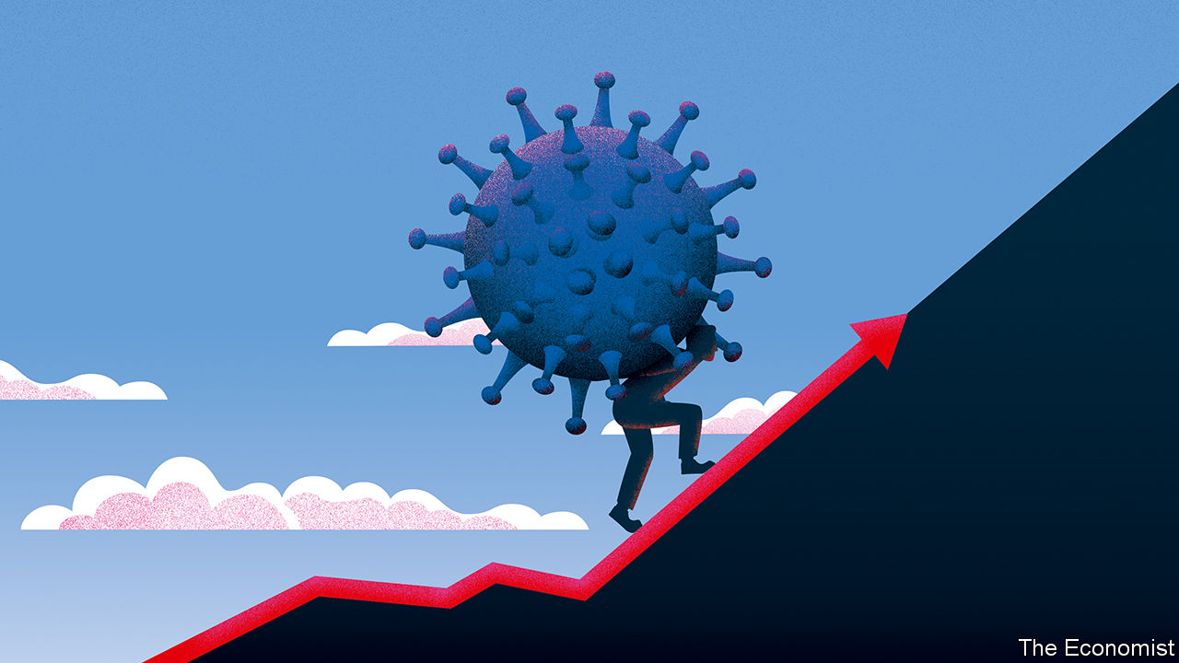

## Taxing options

You rightly say that governments’ pandemic debts will need to be paid for, and mention taxes on land, inheritance and carbon emissions as options (“[After the disease, the debt](https://www.economist.com/leaders/2020/04/23/after-the-disease-the-debt)”, April 25th). Why not add a tax on leverage to your list? After all, one reason governments will need to borrow so much is because they are bailing out over-indebted companies. Astonishingly, the credit crunch did nothing to curtail firms’ borrowings. Non- financial corporations around the world increased their debt by 70%, to $74trn, in the 12 years to 2019, according to the Institute of International Finance. What’s more, countries actually encourage their companies to splurge on debt by making interest payments tax deductible, whereas it would be far better for society if they had more equity.

Governments should phase out the tax-deductibility of interest payments once the pandemic is over. This would kill two birds with one stone. Governments would claw back some of the bail-out costs; and firms would have an incentive to build fatter equity buffers, and be in better shape when the next crisis hits.

HUGO DIXON  
London

Accelerating budget deficits and government debt caused havoc in the past. However, in modern times, quantitative easing, low inflation and negative interest rates have shown that we can create and live with much more debt than we envisaged. This is not possible in countries like Argentina and Zimbabwe with stress on their currencies, but it is possible in the big currency blocs. America, China, Europe and Japan control most of the world’s money supply. When they simultaneously decide to accelerate their spending with trillions to fight the corona crisis, and together expand their budget deficits and public debt through QE with the same speed, then the relative position of their currencies does not change much.

Over time the trade- and public-debt positions of these four blocs will be in balance with each other, but on a much higher level. They will thereby retain the value of their currencies in relation to each other. If we agree that public debt can be rolled over indefinitely, then the only limitation to higher public-debt levels should be the ability to pay the interest. And at interest-rate levels of 1% or lower, there is ample room for public-debt growth without disrupting the value of the four currencies, in relation to each other.

ADRIAAN HEBLY  
Hilversum, Netherlands

Now is the time for innovation. For example, rather than raise wages for health workers the government could borrow at less than 1% to buy residential housing and rent it to those staff at a subsided rate. We need a new psychology of taxation. In Britain, for example, people have voluntarily donated millions of pounds to support the National Health Service. Yet tax is still seen by many as something to avoid more vehemently than covid-19 itself.

RICHARD MILBURN  
Marjan Centre  
King’s College London

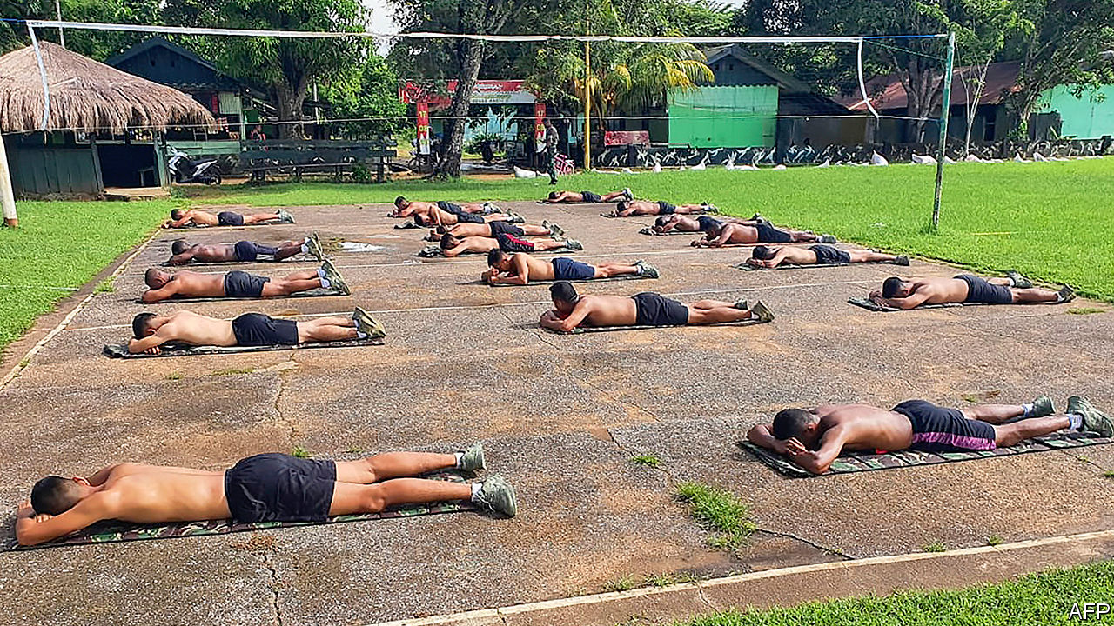

## Into the sunlight

Regarding your article about government advice in Indonesia on sunbathing (“[Hot spot](https://www.economist.com/asia/2020/05/09/sun-shy-indonesians-are-suddenly-soaking-up-the-rays)”, May 9th), it is now well established that acute respiratory-tract infections are often related to Vitamin D deficiency. There is some evidence to suggest that those dying from covid-19 are more often deficient in Vitamin D than might be expected. Vitamin D is different from most other vitamins, in that it is hard to obtain in sufficient amounts just through a good diet. The only effective normal way to obtain it is through regular exposure to the sun, something that is not popular in Indonesia and in many other hot countries.

Such is the growing deficiency of Vitamin D that supplementing Vitamin D3 intake is now highly recommended, especially for those not getting sufficient sunlight on their skin. A meta-analysis using many studies and a review published in the British Medical Journal in 2017 by doctors from around the world showed with convincing evidence that regular supplementation offered protection against respiratory-tract infections. Despite all of this medical corroboration demonstrating an important relationship between vitamin D deficiency and lack of sun exposure with increased respiratory deaths, the issue is often overlooked.

PETER WOODROOF  
Kuala Lumpur



## Thinking outside the box

The solution to the BBC’s funding problems (“[The next episode](https://www.economist.com/britain/2020/04/25/the-bbc-is-having-a-good-pandemic)”, April 25th) is to package its incredible catalogue of programmes under the BBC brand, rather than bundle them through BritBox, and offer subscriptions free to those who already pay their licence fee. That would appeal to younger audiences who want to watch, for example, old episodes of “Doctor Who”. The BBC doesn’t fail to attract younger audiences because of its content. Rather, younger viewers are put off by its archaic format. Why be stuck in front of a TV set for hours when you can binge watch your favourite series whenever you want online?

THOMAS TSOULIAS  
London

The BBC is good at two things: news coverage and documentaries. I would challenge anyone who thinks it is still the world leader in period dramas to note the global popularity of Netflix’s “The Crown”. Regarding the BBC’s wider product, I have yet to meet someone who believes that their licence fee was well spent on creating no fewer than nine seasons of “Two Pints of Lager and a Packet of Crisps”.

OLLIE ORMISTON  
Litchfield, Hampshire

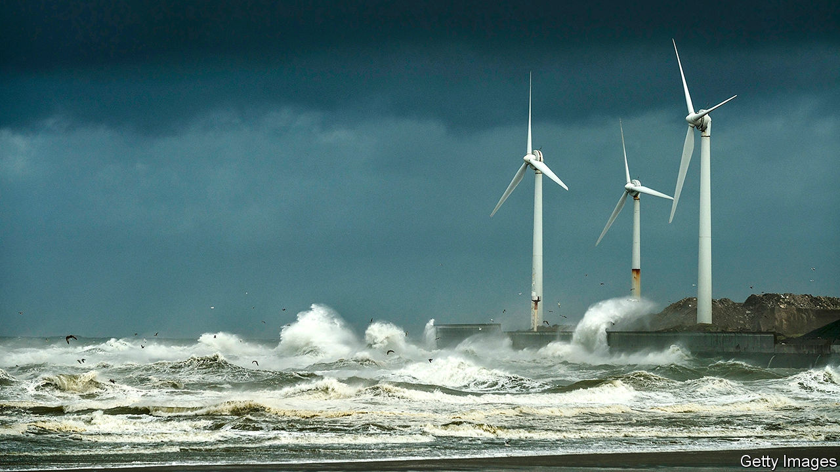

## Time on their hands

It probably is not “an accident of history” that clock hands rotate in the direction they do (“[Shear, veer, cheer](https://www.economist.com/science-and-technology/2020/05/14/which-way-a-wind-turbine-turns-might-not-seem-to-matter)”, May 16th). Clockmakers simply stuck with what was familiar; the direction at which the shadow of the gnomon on a sundial moves in the northern hemisphere. Had a civilisation in the southern hemisphere invented clocks with dials, their hands would have moved in the other direction.

JEREMY GREENWOOD  
St Andrews, Fife

## Three is the magic number

Following the letter ([May 23rd](https://www.economist.com/letters/2020/05/23/letters-to-the-editor)) from a reader wondering why The Economist always lists solutions in sets of three, a wise colleague once told me:

One point? Don’t be political. It is never about just one thing.

Two points? You’ve not thought enough about the problem. Do more research.

Four points or more? Summarise and cut the waffle.

Yup, three points in a list is just about right.

JONATHAN LUNT  
Haywards Heath, West Sussex

Many cultures prefer certain number patterns. The Economist merely reflects the Indo-European preference for the number three. Look at American institutions; CIA, FBI, NBC and so on. See the “Handbook of Classical Mythology” by William Hansen.

COLLEEN ROONEY  
Los Angeles

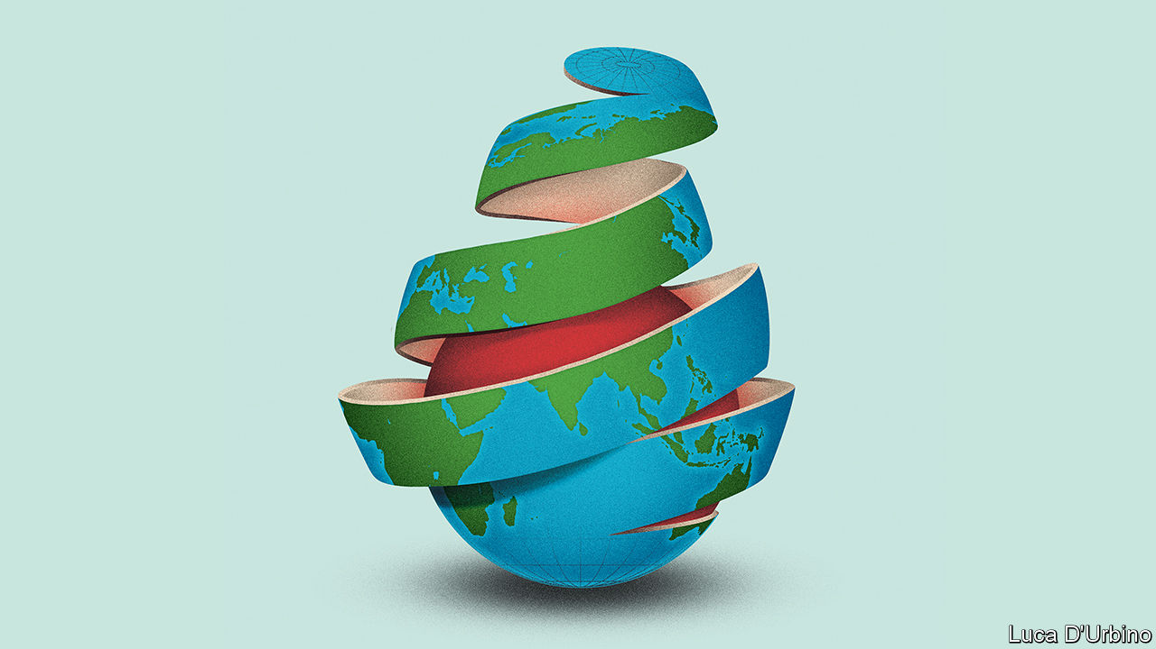

## Another set of three…

First globalisation, then slowbalisation, and now…nobalisation? (“[Goodbye globalisation](https://www.economist.com/leaders/2020/05/14/has-covid-19-killed-globalisation)”, May 16th.)

JOHN MARK WILLIAMS  
London

This article was downloaded by calibre from <https://www.economist.com/letters/2020/06/04/letters-to-the-editor>

|  |  |  |  |
| --- | --- | --- | --- |
|  | Articles | Sections | Next |

|  |  |  |
| --- | --- | --- |
| Letters | Sections | United States |

Briefing

How covid-19 kills: Assault and battery

.

|  |  |  |
| --- | --- | --- |
| Letters | Sections | United States |

|  |  |  |  |
| --- | --- | --- | --- |
|  | Articles | Sections | Next |

#### The paths of destruction

# How SARS-CoV-2 causes disease and death in covid-19

There are direct routes and indirect ones

Jun 6th 2020 |



Editor’s note: Some of our covid-19 coverage is free for readers of The Economist Today, our daily [newsletter](https://my.economist.com/user#newsletter). For more stories and our pandemic tracker, see our [coronavirus hub](https://www.economist.com/news/2020/03/11/the-economists-coverage-of-the-coronavirus)

THE FIRST SET of lungs felt like rubber, says Rainer Claus, so damaged that it was impossible to imagine how any amount of oxygen could get through them. The lungs in the rest of the ten covid-19 victims that he and his colleagues at the University Medical Centre Augsburg, in Germany, autopsied in early April were in similarly awful condition.

This has been, for the most part, the story around the world. People get infected with SARS-CoV-2, the virus which causes covid-19, by breathing in tiny liquid droplets containing virus particles. Those particles gain entry to the lungs, where they start reproducing themselves. If the immune system does not stop it—which it mostly does—the virus causes so much damage that the lungs can no longer do their job, ending up like those in Augsburg.

But there are other facets to the disease not so easily understood. It robs some of the infected of their sense of smell; in others the toes or fingers darken as if bruised. Hearts swell; blood clots; immune systems cripple organs they are meant to be saving. Doctors around the world are trying to find out how much these various symptoms are attributable to direct effects of the virus, to secondary effects of the damage it does to the lungs, or even, in some cases, to the treatments used against it. The more of the story they can disentangle, the better the standard of care is likely to get.

For the virus to attack a cell, the cell’s surface needs to be adorned with a protein which plays a role in the regulation of blood pressure and inflammation called angiotensin-converting enzyme 2 (ACE2). This is found on plenty of cells in the upper respiratory tract and lungs, as well as the linings of blood vessels and the heart, kidneys and intestines. In some cases the virus may get into those intestinal cells directly, having been swallowed. In other cases it seems to get to the gut, and other susceptible organs, via the blood.

Mostly, though, the virus seems to get no further than the ACE2-rich cells of the nose and throat, and perhaps the lungs, before the body’s defences take care of it so well that its presence is never even noticed. Tests which look for genetic material from SARS-CoV-2 in swabs from the nose and throat frequently find it present in people who show no other sign of it at all: in one British survey 70% of those who tested positive were asymptomatic.

Most of those who do fall ill suffer flu-like symptoms, typically with a fever and a cough, sometimes with diarrhoea, that get better after a week or so. But some suffer for longer, failing to shake the infection before getting badly sick. Many of these people will, after a time, start to feel a shortness of breath as the lungs’ ability to oxygenate the blood weakens. About 10-15% of those who are diagnosed—which may mean less than 5% of those infected—eventually become ill enough to need a hospital.

Almost all of those hospitalised have symptoms of pneumonia—the general name for the response of the lungs to a variety of viral, bacterial and fungal infections. When they get deep into the lungs, the SARS-CoV-2 particles find a target-rich environment in the alveoli, tiny air sacs which hang like bunches of grapes off the lung’s branching network of bronchial tubes and are lined with cells festooned with ACE2. It is in these sacs that oxygen from the air breathed into the lungs passes into the blood stream, and carbon dioxide from the blood passes into the lung to be breathed out. The more the virus damages and kills the cells lining the alveoli, the more difficult this exchange of gases becomes. Hence the shortness of breath.

In some covid-19 cases, though, this shortness of breath—a textbook symptom of pneumonia—does not show up. Doctors have got used to seeing patients with blood-oxygen levels so low that they should be dizzy or unconscious, but who show no sign of respiratory distress.

Daniel Johnson of the University of Nebraska Medical Centre says his theory is that SARS-CoV-2 may be affecting the nervous system. That it can do so in some ways, at least, is hinted at by the fact that some patients report a loss of the sense of smell early on in their infection; there are other signs, too. Perhaps the virus has an effect on the part of the brain which tells the lungs to work harder when carbon dioxide builds up in the blood.

## Angles of attack

Another possibility is that the lungs are not the only thing at fault. In some of these atypical patients the perilously low blood-oxygen level “seems to be out of proportion to the overall injury to the lung,” says Joseph Levitt of the Stanford University Medical Centre. The lungs of covid-19 patients feel different, too, he says. Typically, the lungs of patients with severe pneumonia become stiffer, which makes moving air in and out of them increasingly hard. The ventilators on to which such patients are put pump in oxygen under pressure, thus doing some of the lungs’ work for them. The lungs of covid-19 patients with blood-oxygen levels low enough to need a ventilator, though, are not so stiff, says Dr Levitt. They have not exhausted their ability to do their job. But the job is not getting done.

Dr Levitt wonders whether the problem may be in the blood vessels. ACE2’s role in looking after blood pressure depends on its ability to regulate signals that make blood vessels constrict or dilate. The way SARS-CoV-2 binds to ACE2 probably makes it less able to take part in that signalling. Covid-19 may thus reduce the amount of oxygen which gets into tissues not just by damaging the lung, but also by narrowing and damaging blood vessels. If so, drugs to dilate the blood vessels might help, at least in some cases. Finding out what treatment works best along those lines, though, requires clinical trials, says Dr Levitt.

In hospitals the treatment will normally start with extra oxygen supplied through a nasal cannula (a plastic tube with a prong for each nostril) and therapy to combat dehydration: patients have typically had a fever for days and not been drinking enough, leaving their bodies badly short of fluids. Rest, rehydration and extra oxygen, along with drugs for any secondary infections that have taken advantage of the body’s stressed-out state, give the immune system a chance to get the upper hand.

The immune response to a virus starts with infected cells producing a suite of signalling molecules called cytokines. Some of these tell other cells nearby to be on their guard against attack, thus stymying the virus’s ability to replicate itself. Others tell the immune system to come and put some stick about. Thus called to arms, the immune system launches both a prompt all-purpose response—inflammation—and a subsequent targeted counter-attack using antibodies and cells specifically programmed to attack both virus particles and the cells they have infected. Unfortunately SARS-CoV-2 seems able to interfere with the early steps of the immune response. It can apparently counteract the part that dampens replication in nearby cells. It may also enhance inflammation.

Whether the virus helps it along or not, severe inflammation of the lungs often leads to what is known as acute respiratory distress syndrome (ARDS). It is ARDS that sees people rushed to intensive-care units (ICUs) and put on ventilators.

Because it is hard to tolerate having a tube stuck down your throat and into your lungs, patients on ventilators are heavily sedated and unable to do anything for themselves. Nurses must reposition them every few hours to prevent bed sores. Their doctors keep watch for kidney failure, blood clots and heart problems—risks to critically ill patients in ICUs that anecdote has suggested may be more common in covid-19 patients than in others. Those anecdotes are now being backed up by a few studies. However, as Dominic Wichmann of the University Medical Centre Hamburg-Eppendorf points out, this correlation does not necessarily mean SARS-CoV-2 is itself damaging the organs involved.

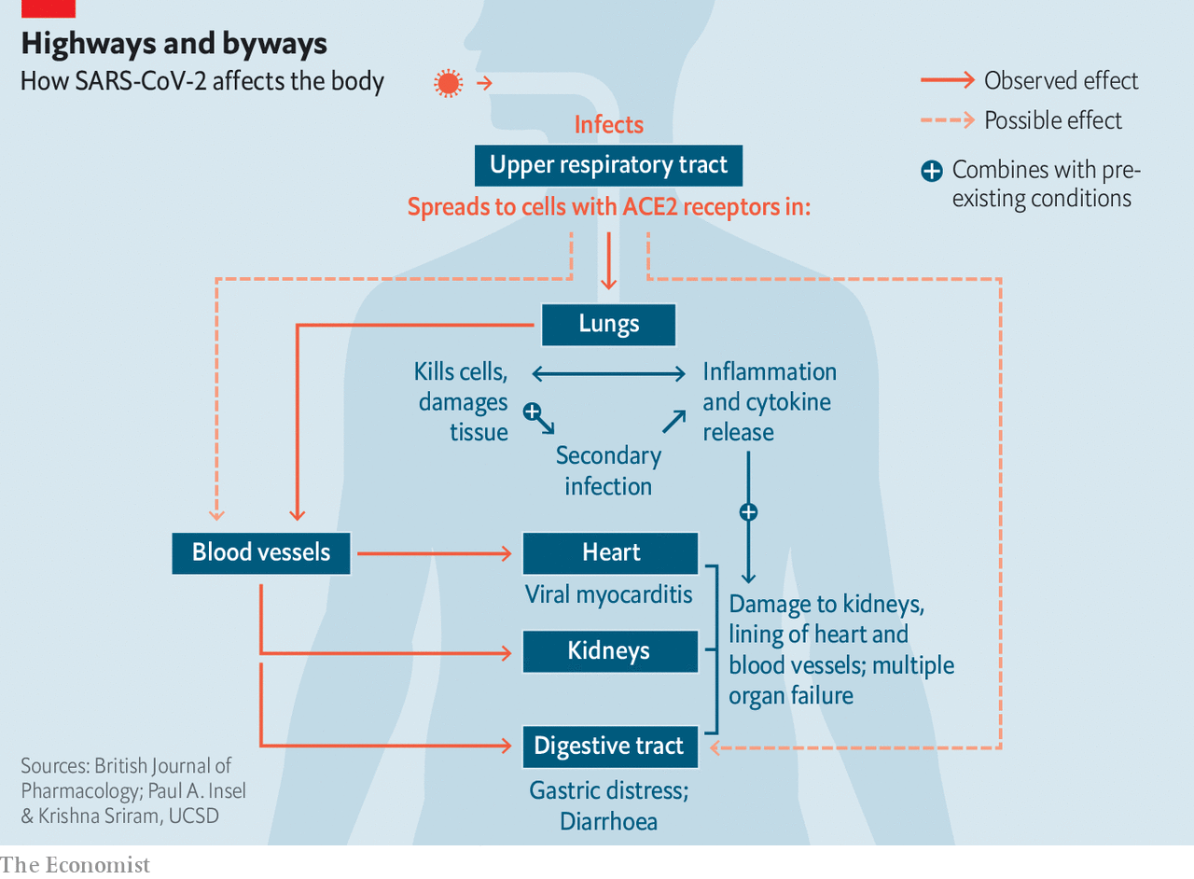

A quarter of covid-19 patients in British ICUs have had kidney problems severe enough to require dialysis. “It’s all part of the second phase of the illness when people, eight to ten days in, suddenly get worse,” says Claire Sharpe of King’s College London. A big part of the problem, she says, is just dehydration, always a risk in ICUs, all the more so when patients are feverish. On top of this, the stress caused to the body by having air pumped in and out amounts to “a double hit on the kidneys”.

## Chains of command

Early in the pandemic critical-care doctors in various countries added to the problem by flushing fluids from the body in order to keep the patients’ damaged lungs from filling with liquid. They appreciated the risk of crashing the kidneys that this involved. Their thinking in doing it anyway, Dr Johnson says, was “I have to do everything I can to try to help their oxygen levels, because if I don’t win that then the whole game is lost.” Once doctors began to see high rates of kidney failure in covid-19 patients, though, they stopped “running them dry”. Dr Johnson, whose unit had the benefit of the experience from New York and other early hotspots, says kidney failure is now no more common in his covid-19 patients than in those with other viral pneumonias.

Blood clots are another worry for patients in ICUs—so much so that mild blood thinners are routinely used as a prophylactic. Again, the problem may be worse in covid patients. Autopsies of the first 12 people to die of covid-19 in Hamburg found that four had died from a blood clot in the lungs. Autopsies by other teams have turned up lots of small clots in the blood vessels traversing the lungs.

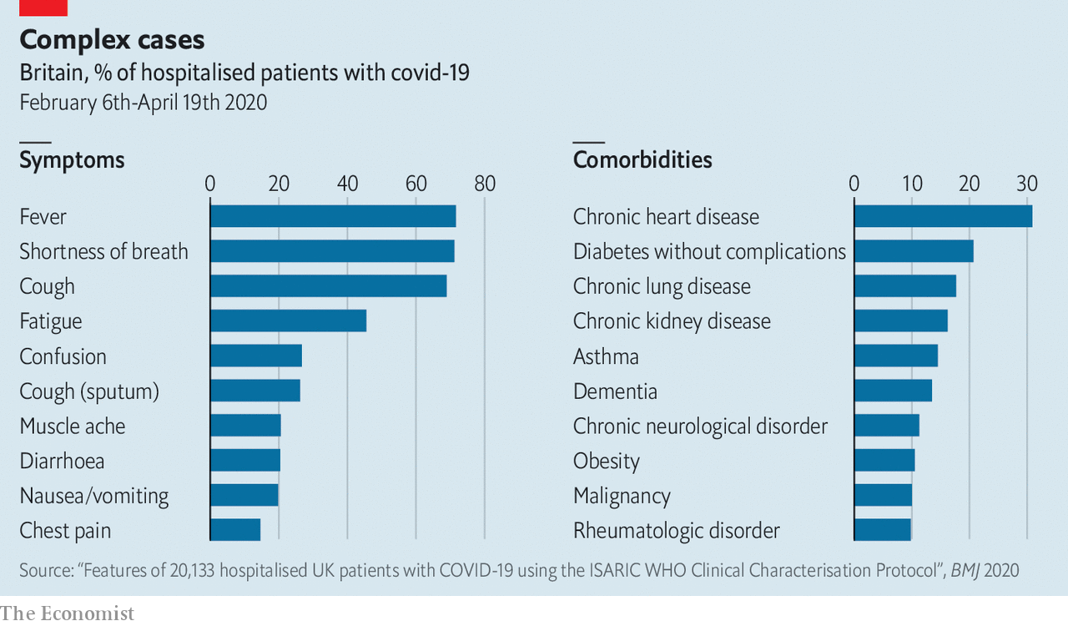

There are lots of reasons why covid-19 patients might be at higher risk of clots in the lung and elsewhere. Immobility is one: patients on ventilators are essentially paralysed, and those with covid-19 tend to stay on ventilators about twice as long as other ICU patients. Dehydration thickens the blood. The severe inflammation seen in covid-19 patients has a big role, too, says Jean Marie Connors of the Harvard Medical School, because clotting substances in the blood tend to increase in lockstep with the chemicals that bring on inflammation. There is also some evidence that the cells which line blood vessels are infected by the virus, she adds. These cells regulate substances that prevent clots—if the virus kills them off clotting can run wild.

## Aftermath

At this stage of the disease, cardiologists are also on high alert. Some covid-19 patients whose lungs start to improve then see an extreme deterioration in their heart function. This is not likely to be simply the effect of being in an ICU. But no one knows whether the damage comes from the virus itself infecting the heart, or from the inflammation it triggers.

Harlan Krumholz of the Yale School of Medicine thinks both the virus and the immune response can be involved. In some people the antibody-making process can go awry, and their newly developed antibodies may confuse a healthy cell for an infected one, marking it for destruction by the immune system. That seems to be what happens in a rare sort of inflammation of the heart seen in some children with antibodies to SARS-CoV-2.

In most cases, though, it is the generalised immune response, inflammation, that goes into overdrive. Why some patients are prone to this problem remains unclear. But as data piles up from hospitals around the world clues about the biological pathways of the disease are starting to emerge.

Some of the clues come from the conditions which predispose people to the disease. “You’d think underlying lung problems or immune system problems will be the greatest risk,” says Dr Levitt. “But it seems the biggest risk factors have been hypertension, diabetes and obesity.” That has led many scientists to suspect that the profound inflammation seen in severe cases of covid-19 may be yet another problem linked to SARS-CoV-2’s fondness for ACE2. People with diabetes, hypertension and heart disease have more ACE2 on their cells as a response to the higher levels of inflammation that come with their condition; ACE2 has an anti-inflammatory effect. When SARS-CoV-2 sticks to ACE2 and reduces its ability to do its job, the underlying inflammation gets worse.



When inflammation gets completely out of control the body enters what is called a cytokine storm. Such storms drive the most severe outcomes for covid-19, including multi-organ failure. There is thus an obvious role for anti-inflammatory drugs. But knowing when to administer them is hard. Go too late, and the storm will be unstoppable; go too early, and you may dampen down an immune response that is turning the tide. A recent article in the Lancet suggests that it would help if covid-19 patients were routinely screened for hyper-inflammation to help identify those who might benefit from anti-inflammatory drugs. But not everyone is convinced today’s drugs have much to offer. “We tried [a range of anti-inflammatory treatment] and it actually didn’t work,” says Rajnish Jaiswal, who has been working on the front line of covid-19 treatment at New York’s Metropolitan Hospital.

All told, just 58% of those who have gone into British ICUs and are not still there have been discharged alive. The rest have died. This mortality rate is double that seen for other viral pneumonias in the past three years.

Many of those who survive a severe bout of covid-19 are likely to have long-term health problems. America’s Society of Critical Care Medicine has identified a collection of health problems including poor muscle strength and sub-par heart and lung function as “post-intensive care syndrome”; people who have had ARDS get it worse than most. Damaged lungs and kidneys can be expected to make good a lot of the harm done to them once a crisis is over, but for some it will take time, and long-term loss of function is possible.

A big worry is what happens to the brain. Sherry Chou of the University of Pittsburgh says that there is no evidence so far that SARS-COV-2 directly harms the brain or the central nervous system, but in parts of the brain, the spinal cord and the nerves the inflammation associated with the disease can lead to muscle weakness and other problems.

The mere fact of being in an ICU can also lead to cognitive impairment. The effect of more than a week in intensive care is comparable to that of a major head injury. The problems are linked to the delirium people often fall into when severely ill and heavily sedated in an unfamiliar environment. Delirium is a particular problem with covid-19, says Dale Needham of Johns Hopkins University. Patients spend a long time in the ICU during which they see no one they know—and the strangers caring for them in heavy-duty protective wear “look like aliens”.

Patients who have come through ARDS may also suffer from anxiety and post-traumatic stress disorder. It all adds up to a bleak prospect. In 2017 a study in the Baltimore-Washington area found that a third of previously employed patients who survived ARDS were not back at work five years on. Covid-19 will cast as long a shadow over some survivors’ lives as it will over those who mourn the dead. ■

This article was downloaded by calibre from <https://www.economist.com/briefing/2020/06/06/how-sars-cov-2-causes-disease-and-death-in-covid-19>

|  |  |  |  |
| --- | --- | --- | --- |
|  | Articles | Sections | Next |

|  |  |  |
| --- | --- | --- |
| Briefing | Sections | The Americas |

United States

Criminal justice: Order above the law

.

African-Americans: Slow progress

.

Global leadership: Groping for the right grouping

.

Fishing: Alaska welcomes hooligans

.

Lexington: Far worse than Nixon

.

|  |  |  |
| --- | --- | --- |
| Briefing | Sections | The Americas |

|  |  |  |  |
| --- | --- | --- | --- |
|  | Articles | Sections | Next |

#### Order above the law

# How to fix American policing

The country’s forces kill too many of those they serve. Here is how to change that

Jun 4th 2020 | WASHINGTON, DC

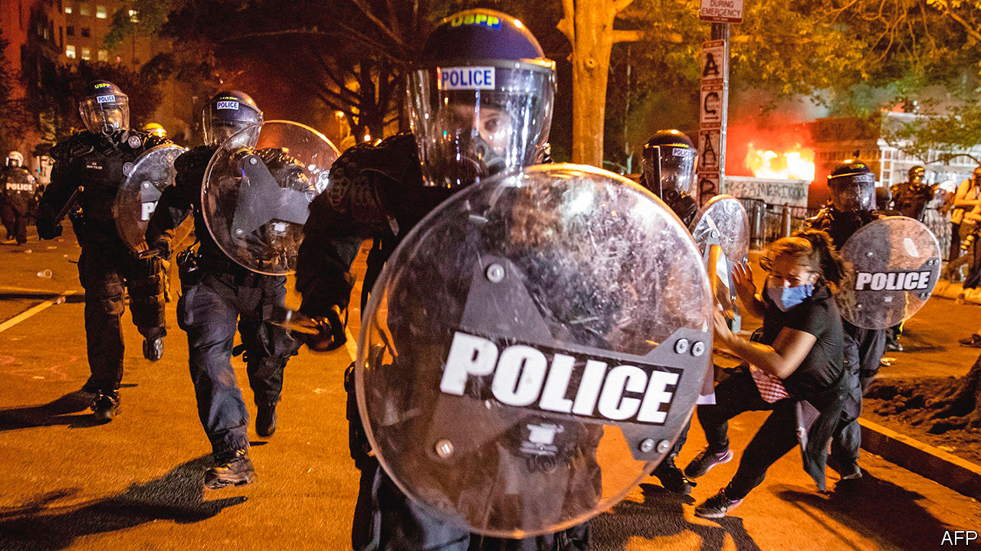

AMERICA IS engulfed in its most widespread, sustained unrest since the late 1960s. It was sparked by an act of police brutality caught on camera. George Floyd, an African-American, allegedly used a counterfeit $20 at a convenience store on May 25th. Derek Chauvin, who has since been fired by the Minneapolis police force and charged with murder, handcuffed Mr Floyd, who, citing claustrophobia, refused to get into a police car. Mr Chauvin, who is white, shoved him to the ground and pressed his knee into Mr Floyd’s neck for almost nine minutes—nearly three of them after Mr Chauvin’s fellow officers failed to detect Mr Floyd’s pulse.

In the days since, Americans have seen their police forces look and act less like public servants sworn to protect their fellow citizens than like an invading army. A policeman in Brooklyn yanked off a protester’s mask to pepper-spray him in the face. One day earlier, also in New York, a police officer reportedly called a young protesting woman a “stupid fucking bitch”, before hurling her onto the pavement hard enough to leave her concussed, with a seizure. A phalanx of police storming down a residential street in Minneapolis paused to shoot paint canisters at a woman on her own front porch. Police across America have tear-gassed peaceful protesters and, according to the Committee to Protect Journalists, there have been around 250 incidents of reporters being punched, attacked with tear-gas canisters and shot with pepper balls.

Such actions have helped fuel and further legitimise the unrest, in which at least 11 people have been killed, hundreds injured and nearly 10,000 arrested across America. In a widely read article published on June 1st, Barack Obama argued that the protests “represent a genuine and legitimate frustration over a decades-long failure to reform police practices”. He is right. But recognising that frustration is much easier than reforming the fiendishly complex institution of American policing.

One reason for that complexity is that, unlike policing in most European countries, American policing is mostly local. There are almost 18,000 law-enforcement agencies, most of them small, only 65 of them federal. All told, they employ around 800,000 officers. Chiefs appointed by mayors head most big-city departments. Elected sheriffs head most county forces.

Also unlike most police forces elsewhere, American police patrol a heavily armed country. That can make their job dangerous—between 2000 and 2014, 2,445 died on duty, compared with just 25 in Britain. But police also return fire, killing around 1,000 people each year. African-Americans are nearly three times likelier than whites to be killed by police. In fact, being killed by police is now the sixth-leading cause of death for young black men. African-Americans are likelier to be convicted, and serve longer sentences than whites convicted of the same crime; they comprise 13% of the adult population, but 33% of the imprisoned population.

Many have cited these disparities as evidence of systemic racism in American policing—and indeed, calls for reform often start with recognising and working to root out such bias. Not everyone is convinced. Robert O’Brien, President Donald Trump’s national security adviser, told CNN on May 31st that though “there are some bad cops that are racist” he did not think there was “systemic racism”. But systemic racism does not mean that all officers are racists or bad people; it means that the system operates in a racially biased manner regardless of individual motivations. Mr O’Brien is doubtless correct that not all officers are racists, but given the vast racial disparities across the criminal-justice system—for which police are the intake valve—his scepticism is difficult to justify.

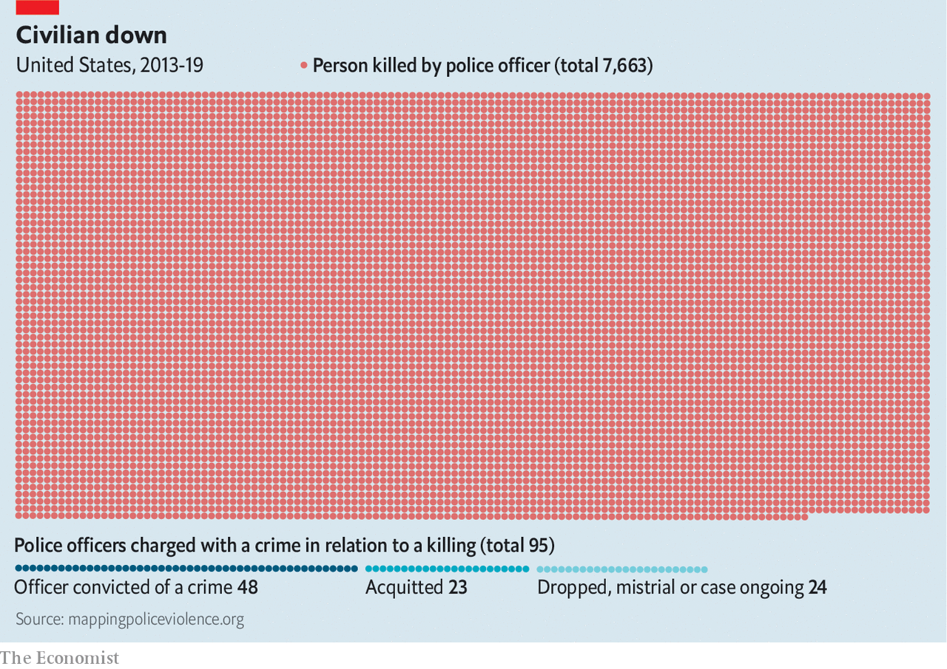

Some argue that education can help root out officers’ implicit biases. But evidence that this works is mixed, not least because many react as Mr O’Brien did, by treating discussion of implicit bias as an attack on individual officers’ character. Phillip Atiba Goff, who heads the Centre for Policing Equity, a think-tank, puts his faith in data and in training.

Unfortunately, reliable data about policing and racial bias are hard to come by, as Mr Goff noted in a paper in 2012, co-written with Kimberly Barsamian Kahn, entitled “Racial Bias in Policing: Why We Know Less than We Should”. The problem is not just that data-collection practices vary widely among law-enforcement agencies. It is also that the data collected are rarely dispositive. As Mr Goff asked in that paper, “If Latinos are arrested at twice their representation in a given population, does that mean that there are too many or too few officers in their neighbourhoods? Similarly, if blacks are stopped at twice their representation in a given population, is that because they are committing more crimes (as those who face discrimination in employment, housing, health care, wealth accruement, and education might), or because the police are biased against them?”

In April the Audacious Project, which funds ambitious ideas, announced it would give Mr Goff’s institute $30m to expand its Compstat for Justice project (Compstat is a statistics-driven management programme used by many police departments), which will track police data, when and where police stopped people or used force, and overlay them with census and geospatial data. Mr Goff hopes to determine when and where changing police policies could improve outcomes.

As an example, he recalls working in Minneapolis, where he found that a disproportionate number of incidents in which police used force involved addicts or the mentally ill. “This doesn’t mean that police policies are targeting folks with serious mental illness,” he explains. Nor does it evince police animus. “To some degree,” Mr Goff says, “we know that it was 911 calls that targeted them, and [when those calls come in], law enforcement can’t say, ‘I think you’re racist; we’re not coming’.” Without better social services, police have to respond, and improving their training for dealing with the mentally ill should lead to fewer uses of force, resulting in fewer injuries and better relations between police and the communities they serve.

## Another Camden afternoon

Some police forces have taken it upon themselves to improve community relations. Many police chiefs—and even more unusually, police unions, which tend not to criticise rank-and-file officers—condemned Mr Chauvin’s actions. In Flint, Michigan, and Camden, New Jersey, senior officers even joined the marchers. “Before Saturday,” when Camden’s march took place, said Joseph Wysocki, the city’s police chief, “I had never done the peace sign ever.” Now, he says, officers and residents flash the sign to each other.

Camden, a city of around 74,000 people just across the Delaware river from Pennsylvania, took an unusual approach to police reform. For years it was among America’s most violent cities, with the country’s fifth-highest murder rate in 2012, when 67 people were killed. The next year it disbanded its 141-year-old police department and reconstituted it as a county-wide force, hiring back most of the officers it had laid off, at lower salaries and with fewer benefits. But the new force expanded—it has over 400 officers, compared with 175 in 2011—and stressed community relations and training, particularly in how to calm a volatile situation without using force.

In some places de-escalation training, like implicit-bias training, has become a box to tick: take a one-day course, and suddenly an officer knows how to de-escalate, or overcome all implicit biases. But, Mr Wysocki stresses, “You constantly have to reinforce training.” His force has a detailed use-of-force policy to which officers are held. When an officer uses force, the watch commander reviews bodycam footage of the incident, as does the internal-affairs department, which briefs Mr Wysocki. The officer and a senior officer then review the footage together.

“When you hit play,” says Mr Wysocki, “their perspective changes. They see it. We slow down and critique what they’re doing.” That seems to work: in 2014 citizens lodged 65 excessive-force complaints. Last year they lodged three. As relations between the police and the community have improved, Camden has grown safer: in 2018 it had fewer than one-third of the murders it did in 2012. As a lawyer who helped a major-city force with its reforms explained, “A community that trusts police more, that’s a community more inclined to give information to police about crime, partner with police about quality-of-life problems, and help the police do what they need to do to keep things safe. Communities that don’t trust the police have lower homicide-clearance rates.”

Camden’s use-of-force policy notes that officers who violate it can face “disciplinary action, up to and including termination”. In much of America, however, police unions make firing or disciplining officers difficult. In Chicago, for instance, officers do not have to provide a statement to investigators until 24 hours after a shooting. Janee Harteau, a former police chief in Minneapolis, complained that the union and union-mandated arbitrators reinstated officers whom she wanted to fire.

Minneapolis’s union skirted a ban that Jacob Frey, the city’s mayor, imposed on “warrior-style training” for police officers. Many blame such training—along with the steady flow of military-style weapons from the Pentagon’s surplus-weapons giveaways—for fostering police militarisation. Among other goodies, the Pentagon’s programme gave the police department that serves Los Angeles’s public schools three grenade-launchers in 2014 (the district returned them, though it kept 61 rifles and a mine-resistant armoured vehicle). A paper by Jonathan Mummolo, a political scientist at Princeton, found that police militarisation fails to enhance public safety while also eroding public trust in the police.

That makes sense: military forces are designed to win wars, not trust. The army’s goals and those of the police differ. The army kills its enemies. Police are supposed to serve and protect Americans without violating their civil rights—and to face consequences for violating those rights.

Yet when it comes to killing, few officers face consequences. Prosecutors are reluctant to bring charges against police. To advance in their careers, they need to win convictions; to convict people, they need police to testify. Police will not help prosecutors who go after cops. A paper by Nicole Gonzalez Van Cleve, a sociologist at Brown University who studies prosecutor-police relations, and Somil Trivedi, a lawyer with the American Civil Liberties Union, describes “an elaborate culture where police created cases for prosecutors who in turn were expected to defer to officers as a professional courtesy.”

Ms Van Cleve noticed that as Mr Chauvin choked Mr Floyd, he “stared straight at the camera. He didn’t look anxious or nervous. He knows he’s being filmed and watched. You don’t do that unless you know that prosecutors aren’t going to charge you.” Under pressure, prosecutors did charge Mr Chauvin. But police officers are rarely convicted for killing someone.

Police also have functional immunity from civil actions, thanks to a doctrine known as “qualified immunity”. This lets public officials have lawsuits dismissed, provided their contact did not violate, as the Supreme Court explained, “clearly established statutory or constitutional rights.” Courts interpret “clearly established” with baffling vigour: an appellate court dismissed a suit against officers accused of stealing hundreds of thousands of dollars in cash and rare coins while enforcing a search warrant, because “there was no clearly established law holding that officers violate the Fourth or 14th Amendment when they steal property seized pursuant to a warrant.”

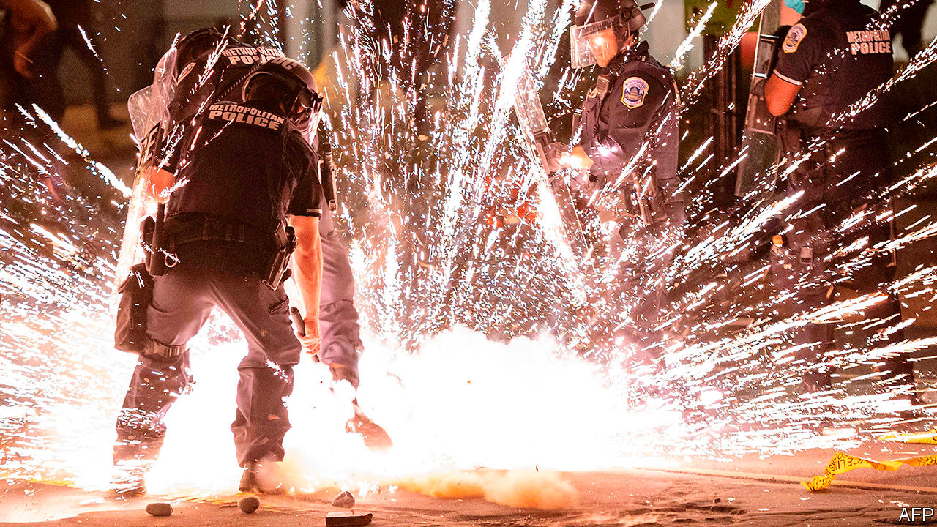

Fielding firecrackers

With courts a narrow avenue for reform, some have started to advocate hitting law-enforcement agencies where it hurts: right in the budget. Advocates in at least 15 cities are waging campaigns to defund the police and use the money on other social services. Alex Vitale, a Brooklyn College professor and defunding advocate, says that people assume “the problem is that individual officers aren’t doing their jobs properly, when the problem really is that they have been asked to do too big a job.” Police have been asked to provide security in schools, respond to people’s mental-health crises and drug overdoses. “Policing is about use of force,” Mr Vitale explains. “It should be a last resort...We don’t want another community meeting with police. We want them out of our lives.”

## Law and orders

Barry Friedman, who runs New York University’s Policing Project, has a simpler suggestion: clear legislation. Fewer than a third of states have passed use-of-force legislation. “Everywhere else in government, we legislate. We set out rules and policies. We don’t just leave it up to the regulated entity to set up their own rules.” In his view, state and city legislators, with public input, should pass laws to regulate police, not the police themselves. That will be a heavy lift: prosecutors and police unions will make life (meaning re-election) difficult for unfriendly politicians, while those who stand to benefit most—lower-income people who interact most often with police—are often politically disengaged.

Because most police agencies are local, regulating them is a local responsibility. But the federal government still has a role in police reform—or at least it did, in previous administrations. The Department of Justice (DoJ) can offer guidance and recommendations. Mr Obama’s administration invested heavily in police reform. In response to the killing of Michael Brown, an unarmed young black man, in Ferguson, Missouri, in 2014, Mr Obama created the President’s Task Force on 21st Century Policing, which produced an extensive set of recommendations on modernising police practices. He also boosted funding for Community Oriented Policing Services (COPS), a DoJ programme to help improve police-community relations which Mr Trump has repeatedly tried to cut.

The federal government can investigate and prosecute departments for violating people’s constitutional rights. Such investigations can lead to consent decrees, which are agreements between the department and the DoJ intended to avoid protracted litigation. Both sides agree on reforms to police practices, which an independent federal monitor oversees. Mr Obama’s administration investigated 25 departments and enforced 14 consent decrees. Mr Trump’s administration has markedly curtailed such investigations.

Mr Trump and his attorney-general, William Barr, have made pro-forma acknowledgments of the legitimacy of the protests, but have been far more enthusiastic about, in Mr Barr’s words, “apprehending and charging the violent radical agitators.” Mr Trump has encouraged mayors and governors to use their police forces to “dominate” protesters. That may work in the short-term. But Times Square is not Tiananmen Square, and America cannot repress its way out of this problem. Legitimate grievances left unaddressed will fester. Americans took to the streets six years ago, after Michael Brown was killed. They should not have to return in another six.■

This article was downloaded by calibre from <https://www.economist.com/united-states/2020/06/04/how-to-fix-american-policing>

|  |  |  |  |
| --- | --- | --- | --- |
|  | Articles | Sections | Next |

|  |  |  |  |
| --- | --- | --- | --- |
| Previous | Articles | Sections | Next |

#### Measuring racial progress in America

# Segregation and poverty have declined among blacks since 1968

Yet deep disparities still persist

Jun 4th 2020 | WASHINGTON, DC

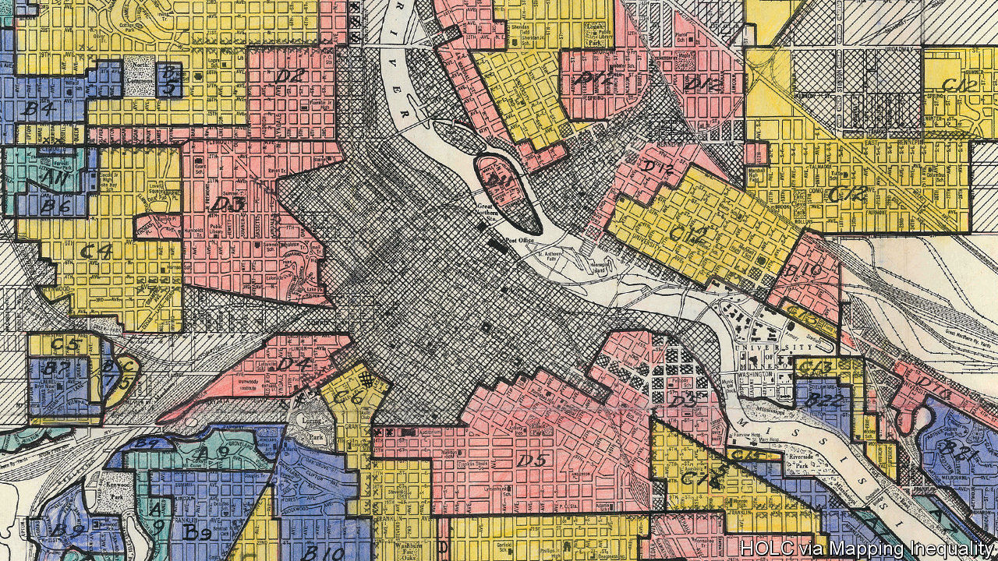

“EVERY TIME I think about it I feel like somebody’s poking a red-hot iron down my throat,” says Bigger Thomas, the poor black boy living in a Chicago slum in the novel “Native Son”. “Goddamit, look! We live here and they live there. We black and they white. They got things and we ain’t. They do things and we can’t. It’s just like living in jail.” Richard Wright penned those lines about the debilitating psychological effects of the ghetto in 1940, before the civil-rights era; before the assassination of Martin Luther King in 1968 and the ensuing widespread racial unrest and riots; and well before the current seething protests against racial injustice in several hundred American cities. How relevant are those sentiments today?

In recent years the most prominent episodes of unrest over the deaths of black men in police custody have erupted in places with histories of segregation that persist to this day. They include Chicago, where Laquan McDonald was killed in 2014; Baltimore, where Freddie Gray was killed in 2015; and now Minneapolis, where George Floyd was killed on May 25th. Ghettos are no longer legally enforced as of 1948, though the proliferation of restrictive single-family zoning rules in cities does not help. Patrick Sharkey, a sociologist at Princeton, evaluated the effects of the civil-rights era on black families and found, depressingly, that “the stark racial inequality in America’s neighbourhoods that existed in the 1970s has been passed on, with little change, to the current generation.”

America did not segregate accidentally. At the beginning of the 20th century, blacks began moving from the rural South to the urban north in large numbers, both for better work in factories and to escape government-sanctioned oppression and lynching. White residents responded by mandating segregated neighbourhoods; when these were struck down by the Supreme Court, private racial covenants between homeowners in effect barred would-be black homeowners from white neighbourhoods. Breaches of the colour line were met with violence.

Urban sociologists use a measure called a dissimilarity index to quantify segregation: the percentage of blacks that would have to move to ensure equal dispersion across a city. In 1970 this number was 93%, according to calculations from census data by the social scientists Richard Sander, Yana Kucheva and Jonathan Zasloff, meaning nearly complete segregation. By 2010, the dissimilarity index had declined to 70%—an improvement, but far from the integrated society that civil-rights activists may have hoped for 60 years ago (see chart). “Brown [v Board of Education] made it clear that we couldn’t have racially separate and equal schools, but we never got to that point with respect to housing,” says Stefanie DeLuca, a professor of sociology at Johns Hopkins University. Segregation by class, both in housing and schooling, has grown in the meantime.

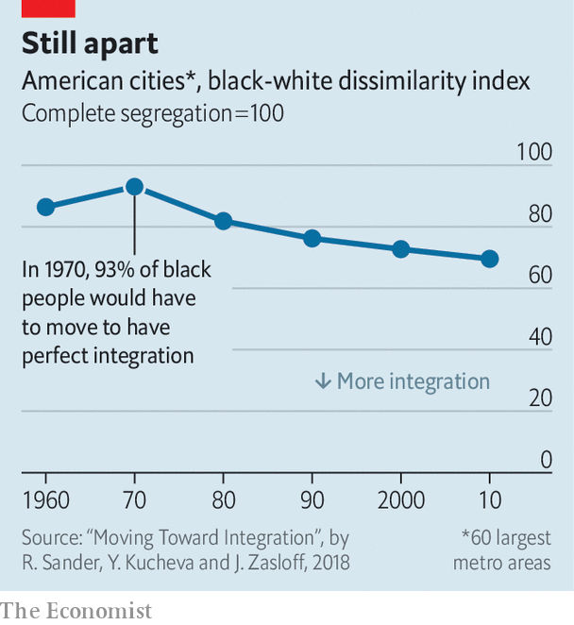

In 1970, according to one more sophisticated measure of poverty calculated by scholars at Columbia University and Mathematica Policy Research, roughly 47% of black Americans were poor. By 2014 that had fallen to 27%—a sizeable drop, but still nearly triple the level experienced by whites. Although this represents some progress, the poor are increasingly clustered together. Since 2000, the number of poor Americans who live in areas of concentrated poverty (defined as places where more than a fifth live below the federal poverty line) has increased by 57%. And black children are seven times as likely as white children to experience this more corrosive form of poverty.

Concentrated disadvantage becomes deeper disadvantage. Social scientists have compiled a mountain of evidence linking life in such neighbourhoods to worse outcomes for health, education, income and risk of incarceration. To live in segregated areas plagued with poverty and violence for generations is to experience continuous loss of opportunity. And it can corrode democratic cohesion as well, by creating separate spheres of race and class—one for “us” and one for “them”.

Three important social indicators for black men have also worsened over the past half-century, even as out-and-out racial animus has declined. Joblessness has become more common. In 1972 nearly 80% of black men above the age of 20 were in the labour force. That rate dropped slowly but substantially over the ensuing decades to 67% on the eve of covid-19, and then to 63% now. The share of births to unmarried couples has increased from nearly 40% to 70%. These family arrangements are highly unstable; about 70% will have broken up five years after a child is born. And incarceration has risen to extraordinary levels. Between 1960 and 2010, it more than tripled for black men.

The three phenomena are interrelated in a complex way. But they probably account for much of the observed extraordinary downward mobility of black boys compared with black girls or whites. Black boys born to families in the top 1% of the income distribution are as likely to go to prison as white boys born in the bottom third. Other stagnant outcomes—whether flat rates of home ownership or unchanged gaps in household wealth—are probably due to the same trends. At some point, glacial progress spills over into anger. “I think America must see that riots do not develop out of thin air,” King argued in 1967. “In a real sense our nation’s summers of riots are caused by our nation’s winters of delay. And as long as America postpones justice, we stand in the position of having these recurrences of violence and riots over and over again.” In 2020, they are indeed happening again.■

This article was downloaded by calibre from <https://www.economist.com/united-states/2020/06/04/segregation-and-poverty-have-declined-among-blacks-since-1968>

|  |  |  |  |
| --- | --- | --- | --- |
| Previous | Articles | Sections | Next |

|  |  |  |  |
| --- | --- | --- | --- |
| Previous | Articles | Sections | Next |

#### Introducing the G11

# Donald Trump is right that the G7 needs updating. But what for?

Tinkering with the world’s top table

Jun 4th 2020 |

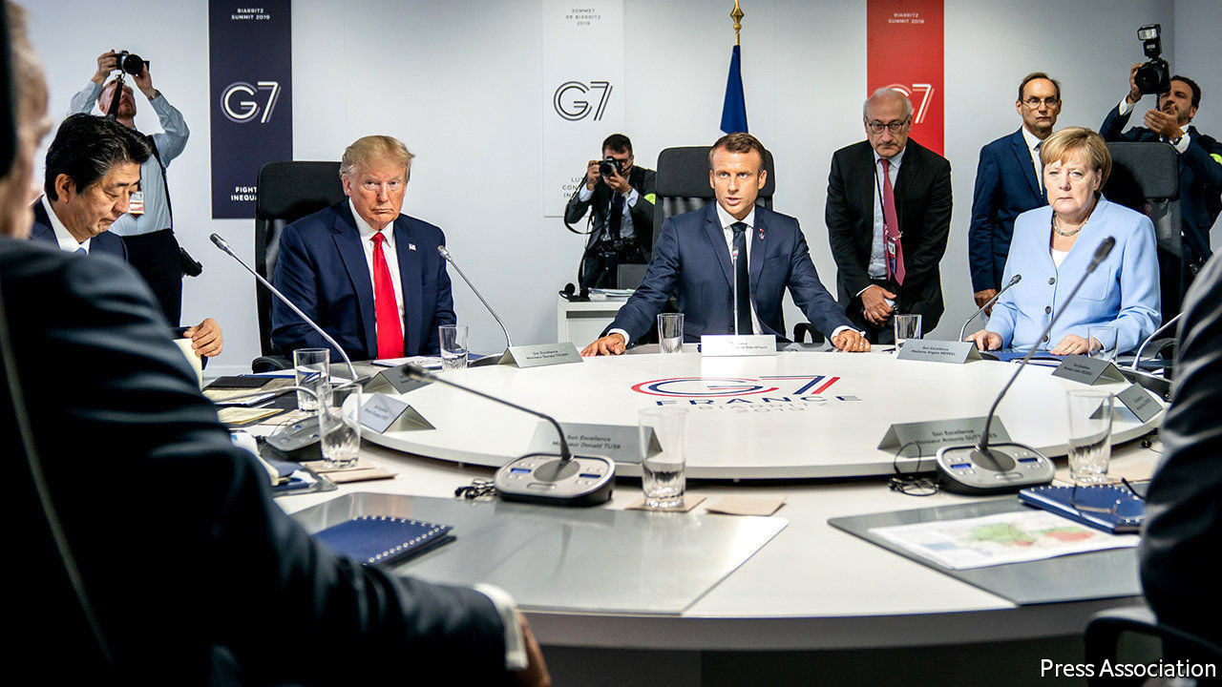

AMERICA’S YEAR of chairing the Group of Seven (G7) club of advanced economies has become something of a soap opera. In the latest episode the star of the show, President Donald Trump, due to host fellow leaders at the presidential retreat of Camp David on June 10th-12th, decided to postpone the summit until at least September, after the leading lady, Chancellor Angela Merkel of Germany, made it clear she was not minded to travel to America during a pandemic. Mr Trump also said he wanted to add to the cast the leaders of Australia, India, Russia and South Korea, since he did not think the current “very outdated” collection of countries “properly represents what’s going on in the world”. That sets up more drama for the coming months.

In an early episode in the series Mr Trump shocked audiences by announcing his intention to hold the summit at one of his own golf resorts; a bipartisan backlash truncated that subplot. In March Mr Trump chaired a videoconference with G7 leaders, after prodding by the French co-star, Emmanuel Macron, who was concerned at the lack of concerted Western leadership in the face of the covid-19 crisis. A virtual meeting of G7 foreign ministers later that month ended in farce. The ministers could not issue a statement because Mike Pompeo, America’s secretary of state, insisted it referred to the “Wuhan virus”.

Now comes controversy over Mr Trump’s proposed expansion of the club. He has long been keen to find a way to bring Russia back into the fold (it joined what became the G8 in 1998 but was suspended after its annexation of Crimea in 2014). Some other G7 members, including France and Italy, might favour that, too.

But Canada and Britain have already said they would veto Russia’s readmission. Justin Trudeau, Canada’s prime minister, said this week that Russia’s continued defiance of international rules meant that it would remain out. The G7’s host is free to invite guests to a summit. Last year, for example, Mr Macron extended a welcome to several African leaders as well as to the prime ministers of Australia and India. But the British government made it clear on June 1st that any decision on membership had to be unanimous, and its opposition to Russia’s was unchanged.

In truth, Mr Trump is right that the G7 could do with rethinking. When it started in 1975—with six members, Canada joining a year later—it represented about 70% of the world economy and was a cosy club for tackling issues such as the response to oil shocks. Now it accounts for about 40% of global GDP. Since the global financial crisis of 2007-09 it has sometimes been overshadowed by the broader G20.

So what is the point of it? With his suggested four extra members, Mr Trump seems to envisage a G11 (or perhaps G12, if Brazil came in too) becoming a China-containment club. But having China’s junior partner, Russia, in the mix would undermine that idea. By contrast, points out Michael Fullilove of the Lowy Institute, an Australian think-tank, “if this is to be the steering committee of the world economy, then China deserves to be included.”

Perhaps it should simply be a modernised version of what the G7 has aspired to be all along, a powerful group of like-minded democracies. With their impressive response to the pandemic, Australia and South Korea can claim to have earned a place at the top table. The problem is that it is less clear how well America itself fits into the club these days. Under Mr Trump, especially since a contentious summit in Canada two years ago, when he withdrew his name from the concluding statement, the group has often looked more like a G6+1. The next episodes should be gripping. ■

This article was downloaded by calibre from <https://www.economist.com/united-states/2020/06/04/donald-trump-is-right-that-the-g7-needs-updating-but-what-for>

|  |  |  |  |
| --- | --- | --- | --- |
| Previous | Articles | Sections | Next |

|  |  |  |  |
| --- | --- | --- | --- |
| Previous | Articles | Sections | Next |

#### Alaska welcomes hooligans

# In praise of the tiny, oily candlefish

Disrupted supply chains make a source of wild food even more welcome

Jun 4th 2020 | KENAI, ALASKA

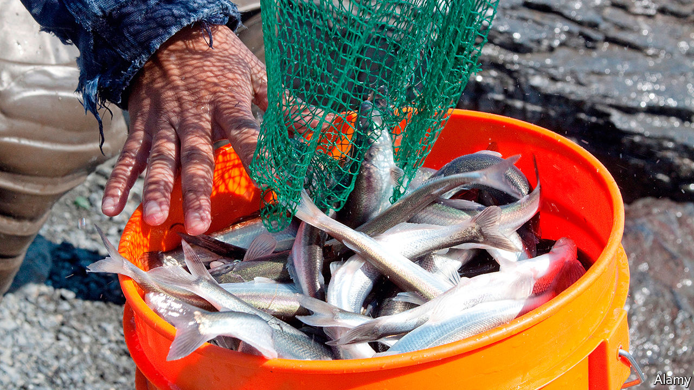

EACH SPRING Alaskans gather on riverbanks wearing chest waders and carrying long-handled nets in search of one of the earliest sources of wild foods in the year: silver, pencil-length smelts called hooligans that are the workhorse of marine food webs and an obsession of many state residents who, coming out of winter, are looking for fresh, local food.

Also called candlefish because they are so oily, you can dry them, insert a wick, and light them like a candle, hooligan school in coastal waters of the North Pacific as soon as the ice breaks up, before running up glacial rivers each spring to spawn. Alaska Natives have long depended on these high-fat fish for oil and food, and traded them with inland tribes across the “grease trails” of southeast Alaska and British Columbia.

Alaskans of all stripes enjoy them baked, pan-fried, smoked, dried, pickled, and canned. No need to remove the head or bones, or the teaspoon of innards they hold inside. Bill Hague has been catching them for more than 20 years. Along the muddy banks of the Kenai River, one of the state’s famous salmon streams, Mr Hague and a dozen others fish beneath a highway bridge hoping to fill their buckets weeks before the salmon arrive.

Extending his net perpendicular to the river’s current, Mr Hague wades waist-deep and slowly walks downstream. Lightweight gill netting hangs like a sheet from the net’s frame, snagging hooligan as they swim upriver. When the handle of the net shudders, it means Mr Hague has caught some fish.

With a genus name—Thaleichthys—that is Latin for “rich fish,” hooligan are golden links in the marine food chain. Belugas nose into the mouths of streams following schools of them. Salmon devour the juveniles. Seabirds gorge on them, as do sea lions, humpbacks and sharks. After spawning, when most die, dead hooligan provide an easy meal for eagles, ravens and bears. Their decomposing bodies fertilise the riverbanks.

For many Alaskans, hooligan usher in the season of harvesting as locals fan out into meadows to gather fiddlehead ferns and wild greens, head to charred sites of old wildfires in search of morel mushrooms and launch skiffs to drop a hook for the first time of the year.

When panic-shopping emptied grocery store shelves earlier in the year, and Alaskans were reminded of the fact that they live at the end of a very long supply chain, many felt a renewed drive to become more self-reliant. While some stores still restrict the amount of meat customers can buy here, there are no limits on hooligan catches.

This article was downloaded by calibre from <https://www.economist.com/united-states/2020/06/04/in-praise-of-the-tiny-oily-candlefish>

|  |  |  |  |
| --- | --- | --- | --- |
| Previous | Articles | Sections | Next |

|  |  |  |  |
| --- | --- | --- | --- |
| Previous | Articles | Sections | Next |

#### Lexington

# Far worse than Nixon

Donald Trump’s pledge to restore America to order recalls Andrew Johnson more than Tricky Dicky

Jun 4th 2020 |

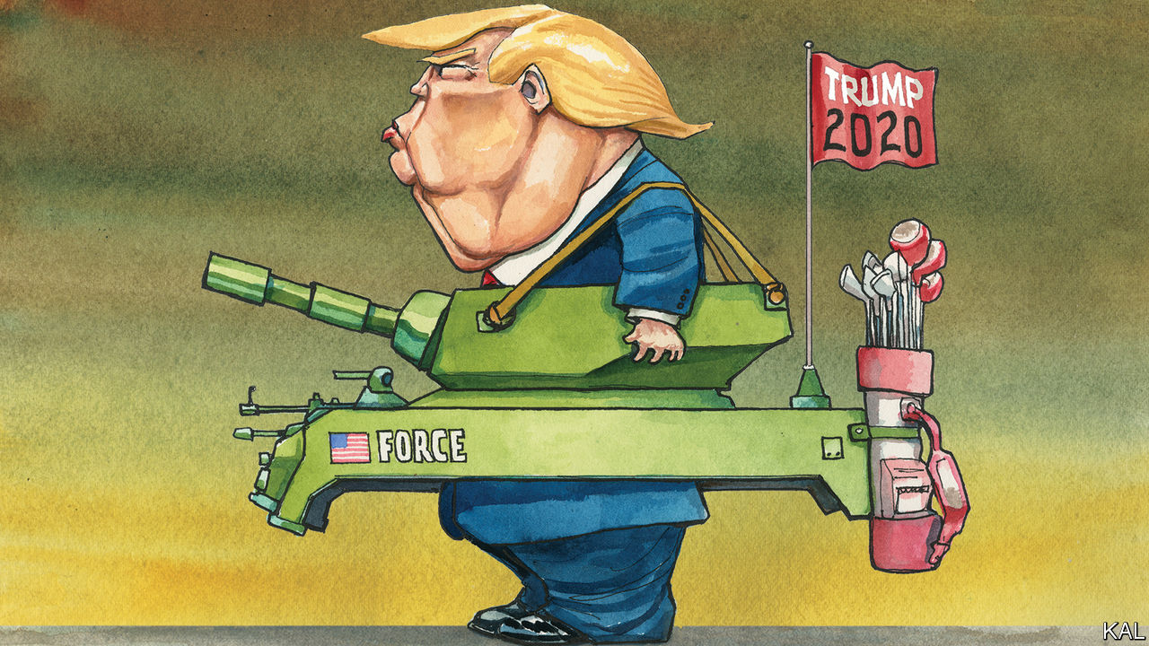

MANY HAVE compared the protests and violence that have consumed America to the conflagration of 1968, which saw the assassinations of Martin Luther King and Robert F. Kennedy and race riots in many cities. None has done so more enthusiastically than Donald Trump.

As the demonstrations against George Floyd’s asphyxiation began to boil in Minneapolis, the president warned that any looters would be shot, using a phrase synonymous with the violence of half a century ago. Emerging from his White House bunker he declared, “I am your president of law and order,” an echo of Richard Nixon campaigning for election that year. “SILENT MAJORITY!” Mr Trump tweeted in a reference to Nixon’s success—and his hopes of emulating it in November. Could the riots help him do so?

They might. The similarities between the dark days of 1968 and today’s partisan, racial, economic and health ruptures are manifest. Pledging to smash rioters has been a winning tactic for Republicans even beyond Nixon’s defeat of Hubert Humphrey. And Mr Trump does not need a majority to win. Given Republicans’ structural advantage in the electoral college, he may need only 46% of the vote, or three points more than his approval rating.

The self-regarding havoc he unleashed in Lafayette Square this week launched his effort to bridge that gap. The administration sent riot police to charge a crowd of peaceful protesters and journalists there in order to clear a path for Mr Trump to be photographed grimly unsmiling, holding a Bible outside a riot-damaged church. The scene took your columnist back to distant assignments in Jakarta and Kinshasa. The administration’s subsequent effort to disperse the bruised and angry remnants of the crowd with the downdraught from a low-flying helicopter took him back to Baghdad. It was deplorable state thuggery. Yet so long as Mr Trump can point to violence by the protesters, of which there has been plenty, including widespread looting and the wounding of four policemen in St Louis, such made-for-TV strongman tactics could work for him. On Fox News that same night, Tucker Carlson, a privileged Washingtonian with a nose for white anxiety, castigated the president for his “weakness” against “the mob”. Mr Trump—watching, no doubt—will have heard that as a political opening.

Yet here are two reasons why his chance of emulating Nixon may be worse than he hopes—starting with the fact that he has much less in common with him than he thinks. Nixon ran as the challenger to a two-term Democratic rule so beset by troubles that Lyndon Johnson had had to abandon his run for another term. The war in Vietnam looked hopeless and the protests it had stirred implacable. When Nixon urged Americans to “vote like your whole world depended on it”—his campaign slogan—he was not only warning of racial grievance but an era of American supremacy that seemed to be slipping away. If any non-partisan American believes that to be the case now, he would logically conclude Mr Trump had failed to arrest the decline; or else blame him for it.

A more skilful politician, as Nixon most certainly was, would try to head off that vulnerability. Even running as an angry challenger, indeed, Nixon’s pitch to America was incomparably more expansive than Mr Trump’s. He leavened his scare tactics with paeans to the “youth of today [who] can change the world!” In a much whiter, more overtly racist country than America is now, he was also far subtler in his race-baiting. Perhaps the most emotive of his 1968 campaign ads, in which he called for “an honest look at the problem of order in the United States”, featured images of marauding white peaceniks, not blacks. Even by today’s standards, a voter deeply concerned about racial inequality could conceivably vote for Nixon. Mr Trump, who suggested black footballers engaged in peaceful protest should be deported and non-white congresswomen “go home”, might seem more of a stretch.

The second reason he may not emulate Tricky Dicky is more positive. It is that his Democratic opponents appear to be constructing the majority he cannot—and the righteous anger behind the protests will probably help them. Over the past four years the share of Americans who correctly say the police are likelier to use excessive force on a black than a white detainee has almost doubled. This liberal shift is a reflection of Democrats’ tightening embrace of racial justice, a response to Mr Trump, and has been evident in the diverse crowds coming out to protest.

Even in Washington, with its large black population, around half the protesters are white. Nor are they the “radical-left anarchists” Mr Trump has decried. In the crowds kneeling and chanting outside the White House this week, Lexington has chatted with young professionals, entrepreneurs and parents with young children. Morgan, a twenty-something aerospace engineer with a Bible under her arm, had been on the streets for the best part of two days, to demand justice for George Floyd and pray with cops and fellow protesters alike. The national capital is a liberal place. But this is not the only indication that Mr Trump’s efforts to rewind history risk fast-forwarding its judgment on him.

## Activating history

With that in mind, he might consider the cautionary fate of a different forebear: his fellow impeachee, Andrew Johnson. An intemperate racist, wont to compare himself to Jesus, Abraham Lincoln’s unworthy Democratic successor campaigned for the 1866 mid-terms by warning that America was heading for another civil war. He blamed “radical Republicans”. But the voters decided that he, by blocking the emancipation of former slaves and stirring his supporters to riot, was the likeliest cause of conflict.

The Republicans won with a landslide big enough to override his vetoes. This allowed them to ratify the 14th amendment to the constitution, granting “equal protection of the laws” to all. It is a tragedy, demanding protest, that this has not yet been achieved. But the past week’s events have perhaps brought it closer.■

This article was downloaded by calibre from <https://www.economist.com/united-states/2020/06/04/far-worse-than-nixon>

|  |  |  |  |
| --- | --- | --- | --- |
| Previous | Articles | Sections | Next |

|  |  |  |
| --- | --- | --- |
| United States | Sections | Asia |

The Americas

Canada: Contenders for a cracked crown

.

Colombia: Medellín’s medical marvel

.

Bello: The empty skies

.

|  |  |  |
| --- | --- | --- |
| United States | Sections | Asia |

|  |  |  |  |
| --- | --- | --- | --- |
|  | Articles | Sections | Next |

#### Cracked crown

# Canada’s Conservative contenders

The job of leading the opposition to Justin Trudeau looks like a thankless one, for now

Jun 6th 2020 | VANCOUVER

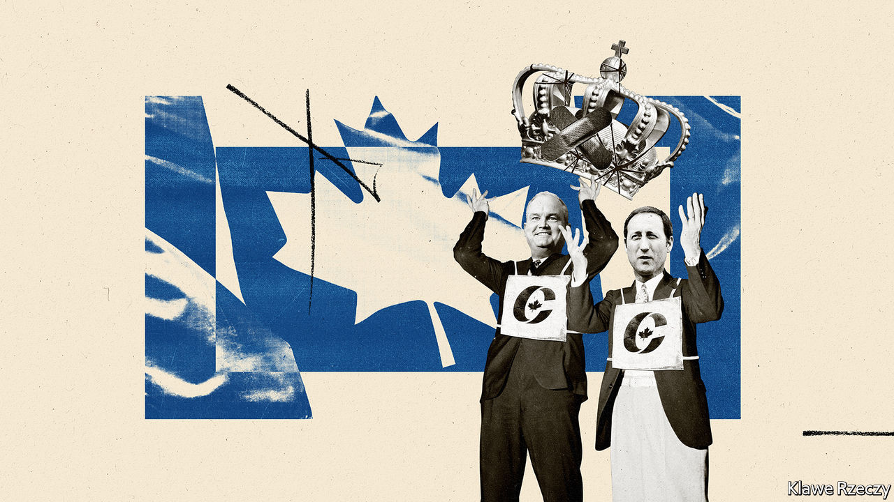

“WE SIGNED UP more new members than have ever been signed up in the history of Conservative Party leadership campaigns.” So said Peter MacKay (pictured right), one of two front-runners to be the party’s leader, in an email to supporters on May 17th. His main rival, Erin O’Toole (pictured left), declared that “our campaign set a record for most membership sales in party history!”

The success in minting Conservatives is deceptive. Canada’s main opposition party is in a funk (see chart). It won 200,000 more votes than Justin Trudeau’s Liberal Party in the parliamentary election last October. But Mr Trudeau won enough seats to remain prime minister at the head of a minority government. Andrew Scheer, the Conservatives’ leader, is bowing out. The postal ballot to choose a successor is expected to produce a result by late August. (The party does not say how many members it has; 141,000 voted in the last leadership election.)

The winner will face a prime minister who looks far more formidable than he did in October. Voters think he has handled the pandemic well. As a share of the population, Canada’s 7,579 confirmed deaths are half that of the United States. Four-fifths have been in old-age homes. More than two-thirds of Canadians approve of the government’s handling of the pandemic, according to EKOS, a pollster. Even in oil-producing Alberta, where the Liberals won no seats, Mr Trudeau’s approval rating has doubled since February to 35%, according to Angus Reid, another polling firm. A snap election could happen “by this time next year”, says Kory Teneycke, who was communications director for Stephen Harper, Canada’s last Conservative prime minister.

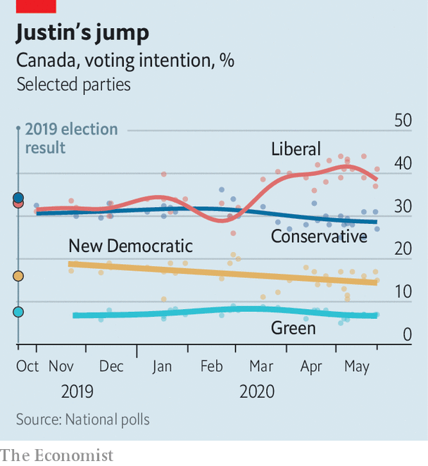

Perhaps as disconcerting for Conservatives is that Mr Trudeau is using covid-19 to remake Canada in unconservative ways. Like many governments, Canada’s is spending lots of money to shield citizens from the pandemic’s economic impact. The Parliamentary Budget Office expects the federal deficit to reach at least C$252bn ($187bn), a record 13% of GDP, in the fiscal year ending in March. The largesse includes grants of C$500 a week for 16 weeks to workers who have been furloughed or laid off or are self-employed. Employers can apply to get subsidies worth 75% of a worker’s wage for up to 24 weeks.

During the global financial crisis of 2007-08 Mr Harper let deficits rise but rebalanced the budget before leaving office in 2015. Conservatives fear that under Mr Trudeau high deficits will become permanent. So might a bigger role for the state in telling industry what to do. “The idea that Canada can just rely on traditional market forces to remain competitive while everyone else is adopting more active industrial strategies is foolhardy,” declares a recent blog post by the Public Policy Forum, a think-tank.

Mr Trudeau may agree. Even before the pandemic, he was an advocate of government support for industries he deemed promising. Left-wing activists are lobbying for the nationalisation of privately owned care homes, where people are more likely to die than in public ones. The idea is popular, even in Alberta, known for its rugged individualism; 54% of Albertans support it, according to Angus Reid.

The front-runners to lead the Conservatives object to the drift towards bigger government. Maintaining direct payments to workers after the crisis would be “unsustainable”, says Mr O’Toole. But neither aspirant is resisting loudly. The time for advocating such Conservative principles as balanced budgets will come after the pandemic recedes.

Even then, neither of the two men is likely to do so with the fervour of Mr Harper. In 2003 he fused his Canadian Alliance Party, which reflected the anti-elitism of the prairies, with the mainly central Canadian Progressive Conservative Party, then led by Mr MacKay, to form the Conservative Party. As prime minister for nearly a decade Mr Harper governed more in the missionary spirit of Ronald Reagan and Margaret Thatcher than with the moderation of past Conservative prime ministers. Mr MacKay and Mr O’Toole are milder men, though to please the party’s base they do not always sound like it. Neither has roots in Alberta, the Conservatives’ heartland (and Mr Harper’s political home). Mr MacKay is from Nova Scotia; Mr O’Toole is an MP from Ontario, the most populous province.

Rather than Mr Harper, they resemble each other. Both studied law at Dalhousie University in Nova Scotia and have fathers who were politicians. Both served in Mr Harper’s cabinet. Mr MacKay, a keen rugby player, had the bigger jobs (foreign affairs, defence and justice) and is better known. Mr O’Toole, once an air-force helicopter navigator, was in charge of veterans’ affairs.

Mr MacKay wants to make the tax system more “competitive” with that of the United States to lure talent back from abroad. Mr O’Toole appeals more directly to the party’s base, promising to reduce federal support for the Canadian Broadcasting Corporation, which many Conservatives accuse of pro-Liberal bias. Both follow Conservative orthodoxy in promising to build oil pipelines and opposing Mr Trudeau’s policy of setting a minimum price on carbon emissions. Both pledge to be tough with China, with which Canada has strained relations.

Neither contender will jeopardise the Conservatives’ claim to be one of the few centre-right parties that supports immigration. Last year Canada admitted 313,000 newcomers, more than any other G7 country as a share of population. But support for immigration could weaken. The unemployment rate nearly doubled to 13% in April. It might now be 20%. Mr O’Toole thinks the number of immigrants may need to come down temporarily. If the pandemic slump persists, that position could prove popular.

Mainstreet Research, a polling firm, puts him nine points behind Mr MacKay among party members. The party uses a ranked ballot, which means that second- and third-choice votes from backers of two long-shot candidates could decide the outcome. The four are due to meet in a debate on June 17th and 18th.

The winner’s task will look thankless at first. It will be hard to tackle Mr Trudeau while Canadians approve of the way he is handling the country’s worst crisis since the second world war. But if hardship worsens he will become vulnerable. The job of leading Canada’s opposition may turn out to be more rewarding than it looks.■

Correction (June 4th, 2020): The original version of this article described Erin O'Toole as a former air-force helicopter pilot. This has been corrected.

This article was downloaded by calibre from <https://www.economist.com/the-americas/2020/06/06/canadas-conservative-contenders>

|  |  |  |  |
| --- | --- | --- | --- |
|  | Articles | Sections | Next |

|  |  |  |  |
| --- | --- | --- | --- |
| Previous | Articles | Sections | Next |

#### Medellín’s medical marvel

# How Colombia’s second-largest city is controlling the pandemic

By acting early and gathering lots of data

Jun 4th 2020 | BOGOTÁ

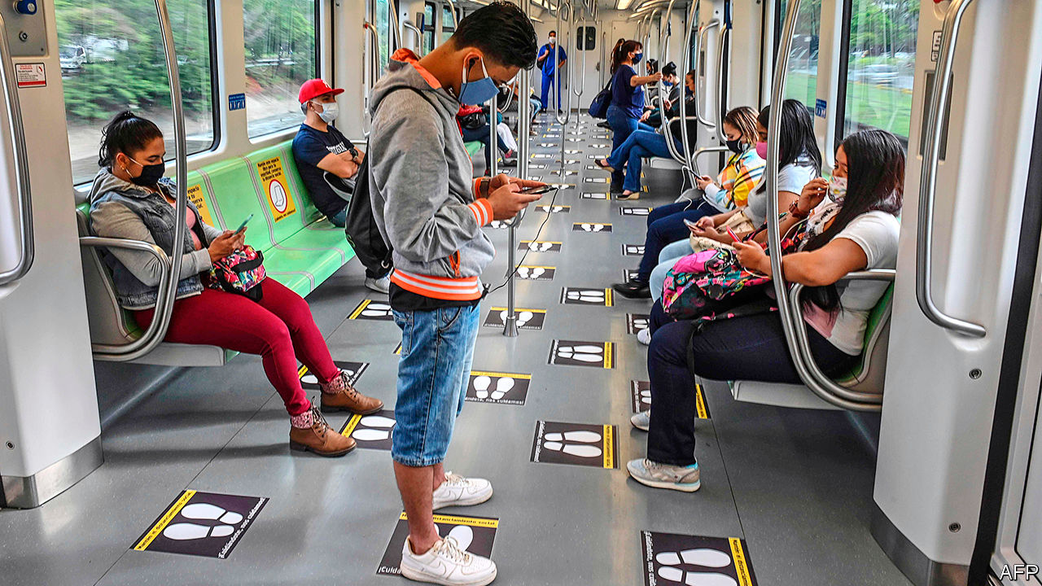

Editor’s note: Some of our covid-19 coverage is free for readers of The Economist Today, our daily [newsletter](https://my.economist.com/user#newsletter). For more stories and our pandemic tracker, see our [coronavirus hub](https://www.economist.com/news/2020/03/11/the-economists-coverage-of-the-coronavirus)

DANIEL QUINTERO, the mayor of Medellín, has had an unusual career. He sold bonsai trees and home-made desserts on the streets to pay university fees, became an engineer and was vice-minister of information and technology in an earlier Colombian government. That biography may help explain his unconventional approach to covid-19. He began to prepare Colombia’s second-largest city in late January. Many Colombians called him paranoid. As February passed with no cases in the country, he wondered if they might be right. When the virus arrived in March, the province of Antioquia, of which Medellín is capital, locked down—five days earlier than most of the country. Mr Quintero acted faster than any other mayor.

The biggest challenge, as in many Latin American cities, is to keep people at home when many get no income if they do not work. Mr Quintero’s programme, called Medellín Me Cuida (Medellín Takes Care of Me), rests on collecting data. Like other big cities, Medellín allocated money to help workers who lost their incomes. Bogotá and Cali struggled to find them. Medellín asked residents to register for help online. To sign up, people must provide a lot of information, including the size of their household and details of their electricity bills. (The billing information stops families from getting more than one aid package.) More than 3m people, nearly 90% of the metropolitan area’s population, have signed up. Those in need have received food or, more commonly, two payments of 100,000 pesos ($28), enough for a family to survive for some weeks when many have suspended paying rent and utility bills. People in Medellín have respected the lockdown more than other Colombians.

When they register, people are asked whether they have symptoms of covid-19 or conditions that would make it harder to treat. They can update the information on a hotline. The city maps the data to identify outbreaks and predict them. Health Promotion Units (EPSs)—mainly private firms that provide health insurance to most Colombians—send teams to test neighbours of covid-19 patients. Officials make sure patients and people exposed to them stay at home. Covid-19 patients get kits with oxymeters, which test their blood oxygen. If it falls to dangerous levels, an EPS sends a team with oxygen. The metro uses Medellín Me Cuida’s data to block cards belonging to patients and their families.

Colombia has controlled covid-19 better than many of its neighbours. It has had 33,466 confirmed cases and 1,099 deaths. In Brazil, Chile, Ecuador and Peru the death rate is at least three times higher. Even by Colombia’s standards, Medellín, once home of the drug lord Pablo Escobar, excels. Just three people in the city have died of the disease and eight are in hospital; 304 people have recovered, more than are sick. In Cartagena, a touristy city on Colombia’s Atlantic coast, hospitals are unable to cope with the caseload. Medellín’s success continues a record of innovation by earlier mayors, such as reducing poverty by improving poor neighbourhoods’ transport links to the rest of the city.

Not everyone is happy with Mr Quintero’s data-gathering. Carolina Botero, director of the Karisma Foundation, which advocates digital rights, says it is not clear what the city will do with its database after the pandemic or how it is being protected. Colombia has a history of state-sponsored spying on journalists, politicians and foreigners. Last month news reports revealed illegal snooping by the army.

Mr Quintero responds that only health officials have access to the information and promises to let people decide what data the city can keep when the pandemic ends. The data gave the city, which sets some lockdown rules, the confidence to begin reopening shopping malls and small shops this week, he says. Mr Quintero expects the number of covid-19 cases to rise, but thinks Medellín will be able to identify the most vulnerable people early. Colombians in other cities are looking on enviously, as they remain under lockdowns that are getting harder to enforce. Few still doubt Mr Quintero’s sanity. ■

This article was downloaded by calibre from <https://www.economist.com/the-americas/2020/06/04/how-colombias-second-largest-city-is-controlling-the-pandemic>

|  |  |  |  |
| --- | --- | --- | --- |
| Previous | Articles | Sections | Next |

|  |  |  |  |
| --- | --- | --- | --- |
| Previous | Articles | Sections | Next |

#### Bello

# Latin America’s empty skies

Airlines are in trouble. The region cannot do without them

Jun 4th 2020 |

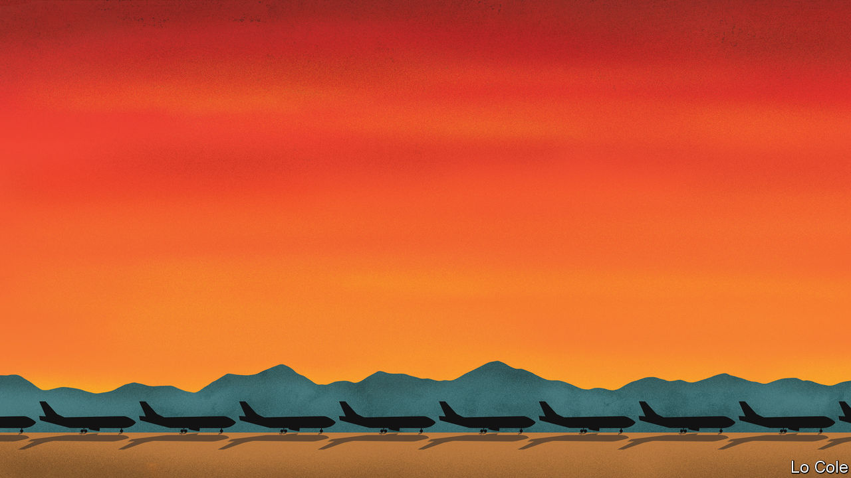

LAST DECEMBER, in a different era, Avianca celebrated its centenary. Based in Colombia, it claims to be the world’s second-oldest airline, and the one that has flown continuously for longest. It is Latin America’s second-biggest carrier by revenues. Now, thanks to covid-19 and its associated lockdowns, Avianca’s planes are parked, its crews and ground staff furloughed. Last month it filed for relief from creditors in a New York court under Chapter 11 of the American bankruptcy code. A fortnight later, LATAM, a Chilean-Brazilian airline that is the region’s biggest, followed suit. Ecuador’s government has liquidated TAME, an ailing state-owned carrier.

This poses a policy dilemma. Governments in Europe and the United States have funnelled billions of dollars to their countries’ stricken airlines. Their counterparts in Latin America have less spare cash and different priorities. They must help tens of millions of citizens who face poverty and unemployment. Air travel in the region has historically been seen as a luxury. With their sometimes irksome pricing and unpunctuality, airlines are rarely loved and are a source of carbon emissions to boot. So far no Latin American government has offered them any financial help.

Flying matters in Latin America perhaps even more than in other regions, as Avianca’s long history testifies. That is partly because of its vast distances and geographical obstacles, characteristics which attracted the interest of pioneers of flight. Antoine de Saint-Exupéry, the author of “The Little Prince”, was a professional pilot between the two world wars. His jobs included carrying the mail between Paris, Buenos Aires and Chile. In a memoir he writes vividly of flying over the Andes, where “blustering gusts sweep through the narrow walls of…rocky corridors and force the pilot to a sort of hand-to-hand combat.”

As a result, the alternatives to flying are often laborious, even within countries. The journey from Bogotá, Colombia’s capital, to Cali, its third city, takes just an hour by air but almost ten hours by road, traversing two Andean ranges. Nowadays there are few passenger trains in the region, and no high-speed ones. The result is that “the airline industry is a public service carried out by private companies,” argues Eliseo Llamazares of the Santiago office of KPMG, a consultancy.

It increasingly serves a mass market. As a new lower-middle class grew, many of its members took to the skies for the first time. Passengers in Brazil began to reflect the country’s racial rainbow. This trend was helped by the arrival of low-cost airlines, which serve around half of Mexico’s domestic market and have also moved into South America. If the cost of international flights remains high, that is because more than half the ticket price is taxes.

Although the expansion in passenger numbers slowed with Latin America’s recent economic stagnation, the region remains one of the world’s growth markets for air travel. That prompted American carriers to move in, as part of a global restructuring of airline alliances. In October Delta spent $1.9bn on a stake in LATAM. United had previously taken control of Avianca after its former owner got into financial difficulties. Before the virus, United planned a broader alliance with Copa, of Panama, the region’s fifth-biggest airline, and Azul, a Brazilian carrier, in which it has a stake.

Consolidation may now accelerate. Entering Chapter 11 is a way for airlines to negotiate with creditors while still operating, without the risk that their planes will be seized, Mr Llamazares points out. He says that even after Latin America’s carriers get back into the sky, perhaps from next month, it may take until 2023 before they return to the passenger numbers and profitability they had in 2019. Even Copa, which is financially strong and does not plan to seek state aid, will operate at only about 40% of capacity in December, according to its boss, Pedro Heilbron.

There are two reasons why governments should worry about all this. First, if the airlines lack cash, that may itself slow economic recovery. And second, competition may be distorted, as subsidised foreign carriers gobble up more international traffic to and from the region. After an initial laissez-faire response, the governments of both Chile and Colombia are considering providing aid. If they do, it should come with strings, such as lowering emissions and trying to stimulate rather than restrict competition in the medium term. Latin America needs its airlines. It does not need to coddle them.

This article was downloaded by calibre from <https://www.economist.com/the-americas/2020/06/04/latin-americas-empty-skies>

|  |  |  |  |
| --- | --- | --- | --- |
| Previous | Articles | Sections | Next |

|  |  |  |
| --- | --- | --- |
| The Americas | Sections | China |

Asia

Covid-19 in South Asia: Deadly tide

.

Marriage in Japan: Knot happy

.

Repressing dissent in Thailand: Voice of treason

.

South Korea: Haunted by Gwangju

.

Indonesian politics: Viral marketing

.

Banyan: The beast from the east

.

|  |  |  |
| --- | --- | --- |
| The Americas | Sections | China |

|  |  |  |  |
| --- | --- | --- | --- |
|  | Articles | Sections | Next |

#### Deadly tide

# Infections are rising fast in Bangladesh, India and Pakistan

Hospitals are already struggling to cope

Jun 6th 2020 | DELHI AND ISLAMABAD

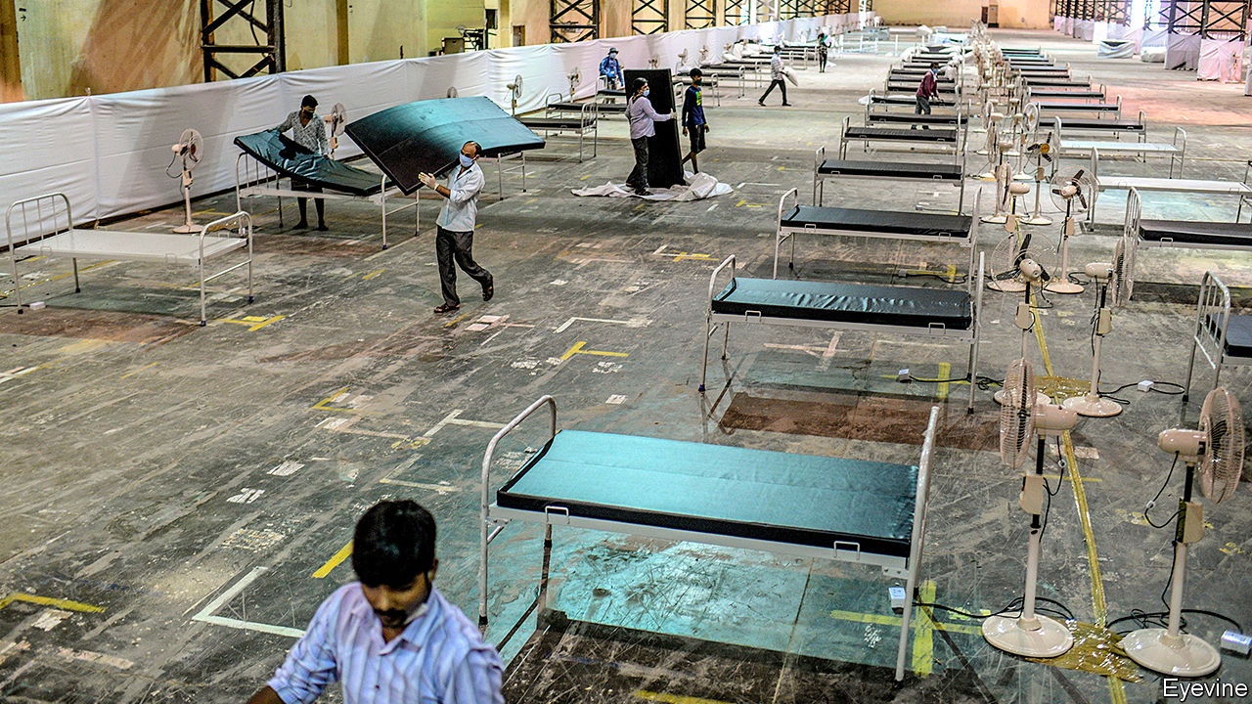

OVER THE past week Bangladesh, India and Pakistan have largely lifted nationwide lockdowns intended to curb the spread of covid-19. The freeing of 1.7bn people—more than a fifth of humanity—from varied restrictions will bring relief to the region’s battered economies. Alas, it promises no relief from the pandemic itself. In luckier countries, stay-at-home rules reduced the number of new infections. In South Asia they managed only to moderate the disease’s acceleration, but not to halt it (see chart). The lifting of the lockdowns, in turn, is likely to hasten its spread again.

With some 350,000 confirmed cases and fewer than 9,000 deaths so far, the region’s toll looks relatively modest. Yet those numbers disguise both widespread undercounting and a rate of growth that was frightening even before the lifting of restrictions. At the current pace, the numbers are doubling every two weeks, suggesting that by the end of July, when some models predict the outbreak will peak, the official number infected may reach 5m and the death toll could approach 150,000.

Low levels of testing mean that the real numbers could be far worse. One foreign health official in Pakistan reckons the death toll is between two and three times the government’s count. John Clemens of ICDDR,B (formerly the International Centre for Diarrhoeal Disease Research, Bangladesh), estimates that Dhaka, Bangladesh’s capital, may already have as many as 750,000 cases, even though the official national tally is less than 60,000.

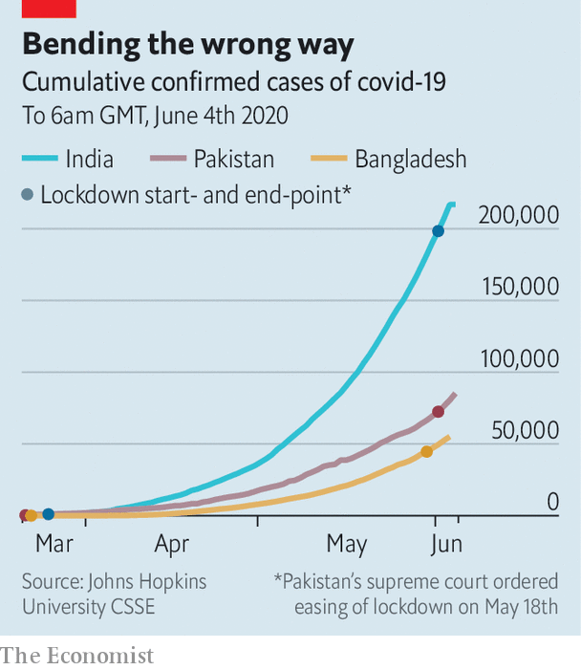

In harder-hit parts of the region, health services are under severe strain. Madhuri, a 46-year-old nurse in Thane, a suburb of Mumbai, had been working 12-hour shifts with no days off from April 1st until she herself caught covid-19 from a patient in May. The government hospital where she works does not treat the disease, passing positive cases to designated covid hospitals. But Madhuri (not her real name) says her colleagues must instead cope with the patients those places no longer treat. “We now do 60-70 deliveries a day, up from 40-50 in normal times, in addition to stab wounds, accidents and so on.” Her hospital’s 20-bed intensive care unit is staffed by just two nurses and its 16-bed isolation ward by just one, she says.

Her experience is far from unusual. Three medical interns at another hospital in the centre of Mumbai recently released a video claiming that they had been left for hours in sole charge of 35 seriously ill covid-19 patients, with no doctors, nursing or cleaning staff to help. Another viral video revealed that corpses wrapped in plastic had been left in a covid ward full of patients, owing to lack of space in a hospital morgue. Staff at hospitals across India have repeatedly protested against unsafe conditions, poor equipment and long working hours. In Delhi, the capital, some 600 health workers have tested positive for covid-19—including 329 at the All-India Institute of Medical Sciences, the country’s grandest government hospital. Overall, India has a ratio of doctors and nurses to population that is half China’s and a quarter of Europe’s. And the virus has now spread from better-served cities to poor rural states such as Jharkhand, where there is one doctor for every 6,000 people.

Doctors in Pakistan say the government’s claim that there are adequate hospital beds is nonsense. “The situation is very, very unsatisfactory,” says Qaisar Sajjad of the Pakistan Medical Association, predicting a surge in cases stemming from the recent holiday marking the end of Ramadan. Zubair Zahir, head of a local doctors’ association in Khyber Pakhtunkhwa province, fears its hospitals could run out of intensive-care beds and ventilators within the next two weeks. The crisis has already squeezed other services: despite a resurgence of polio, an immunisation campaign in the province has been suspended. In India treatment of endemic diseases such as tuberculosis, which kills some 400,000 people a year, has also been impeded.

In normal times, the region’s rich can largely insulate themselves from the implications of decades of puny public spending on health. “If they so much as sneeze they flee to Thailand, Singapore or India,” says a doctor at a private hospital in Dhaka. Now, she says, it is “almost impossible” to gain admission to Bangladesh’s elite hospitals, whether for covid-19 or other illnesses.

Finding places in morgues, cemeteries and crematoria is also becoming a challenge. At the municipal graveyard of Narayanganj, an area with lots of garment factories on the outskirts of Dhaka, a typical month sees fewer than 250 burials. Last month it jumped to 575, only 70 of which were officially recorded as victims of covid-19. Jawahar Baug, the biggest crematorium in Thane outside Mumbai, has seen a similar jump in custom. It has boosted its staff from 30 to 50 men working three shifts a day, while the volume of bodies they manage has grown from four to six a day to sometimes as many as 20. Delhi has relaxed a ban on traditional funeral pyres made of wood, instituted to reduce pollution, because there are too few gas-fired ovens to meet the spurt in demand.

Inevitably, the failure of all three countries to control the pandemic has led to soul-searching and blame-casting. Imran Khan, Pakistan’s prime minister, has loudly pointed out that he was never a fan of the lockdown, which he had warned would hit the poor unduly hard, and could only slow the disease. His detractors respond that a big reason for failure was precisely the half-hearted and inept way Pakistan’s lockdown was enforced. In Bangladesh, inconsistent rulemaking, a collapse in average income in slum areas of an estimated 75% and the mass return to villages of hundreds of thousands of garment-workers undermined any gains from the lockdown.

Perhaps the most egregious errors were made by India’s government. Despite imposing the most stringent and heavily policed restrictions in the region, the government failed to foresee that its measures might prompt a mass exodus from cities of tens of millions of migrant workers made suddenly destitute. The authorities first tried to block the movement, bottling migrants in urban slums with the highest infection rates, and then allowed perhaps 20m workers to leave, spreading the disease across the country. In Bihar, a state whose 110m people are among India’s poorest, more than two-thirds of covid cases identified so far have been among returning migrant workers.

Whatever the cause, the damage is now done. Farid Uddin, a gravedigger in the Bangladeshi port city of Chattogram (formerly Chittagong), comes close to tears as he explains that he and his team have scarcely slept in four days. “There are so many deaths,” he gulps. “We are overwhelmed. Please pray for us so Allah forgives us and takes back this disease.” ■

This article was downloaded by calibre from <https://www.economist.com/asia/2020/06/06/infections-are-rising-fast-in-bangladesh-india-and-pakistan>

|  |  |  |  |
| --- | --- | --- | --- |
|  | Articles | Sections | Next |

|  |  |  |  |
| --- | --- | --- | --- |
| Previous | Articles | Sections | Next |

#### Knot happy

# Covid-19 spurs single Japanese to look for love

Match-making agencies have received a surge of inquiries

Jun 4th 2020 | SUZUKA, MIE PREFECTURE

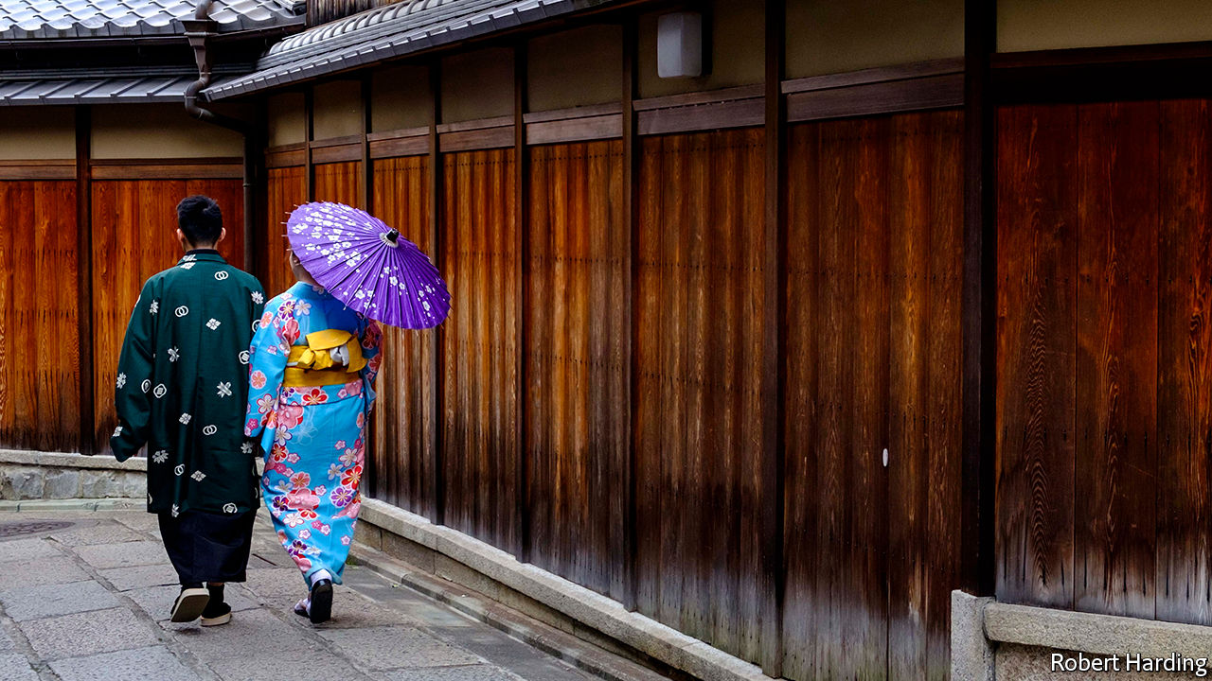

HE HAD ALWAYS imagined he would get married someday. Then covid-19 hit. Yuto (not his real name), a 31-year-old hotel employee from the southern city of Kumamoto, found himself confined to his home, alone. He decided to accelerate his wedding plans, and signed up for an online match-making service to find the love of his life—fast.

Yuto is not alone. Since the pandemic broke out, more Japanese singles have been on the hunt for spouses. Sunmarie, a match-making agency, reported a 30% rise in inquiries in April compared with the year before. Both Sunmarie and O-net, a rival agency, have tried to adapt to the times, offering an online rendez-vous service since early April, when the government began curbing gatherings in much of the country. LMO, another firm, offers drive-through meetings, in which singletons can introduce themselves from their cars, in the empty car parks of wedding halls.

Cooped up in their homes alone for an extended period, singles are getting lonely—hence the surge in business for match-makers, explains Amano Kanako of NLI Research Institute, a think-tank. With covid-19 dominating the news, lonely hearts are also increasingly anxious about the future: they want a partner with whom to face the unknown. “Those who vaguely thought about getting married one day are realising that the time is now,” says Kobayashi Jun of Seikei University.

This marks the reversal of a long trend. Marriage has been in decline for decades. More than 1m couples tied the knot each year in the early 1970s, but only 583,000 did last year. This is not just because the proportion of Japanese in their 20s and 30s (the age at which people most commonly wed) has fallen sharply. In 1970 only 2% of men and 3% of women had never married by 50. By 2015 those shares had climbed to 23% and 14%, respectively.

Interest in matrimony also surged after a terrible earthquake, tsunami and nuclear disaster in 2011. Memberships at match-making agencies soared. The steady decline in weddings was interrupted in 2012, when there were 7,000 more than the year before. The nature and scale of the earthquake and pandemic may differ, but their effect on the unmarried has been comparable, says Nagaoka Masamitsu of O-net. “People are stuck at home and have a lot of time to think about their future.”

Yuto from Kumamoto is already thinking about settling down with a 43-year-old Tokyoite he met online two months ago. Yet the rush to the altar (or shrine) may be short-lived. After the spike of 2012, there were 8,200 fewer weddings in 2013.

This article was downloaded by calibre from <https://www.economist.com/asia/2020/06/04/covid-19-spurs-single-japanese-to-look-for-love>

|  |  |  |  |
| --- | --- | --- | --- |
| Previous | Articles | Sections | Next |

|  |  |  |  |
| --- | --- | --- | --- |
| Previous | Articles | Sections | Next |

#### Voice of treason

# The Thai government tries new ways to curb online critics

But the critics are feeling emboldened, too

Jun 4th 2020 | SINGAPORE

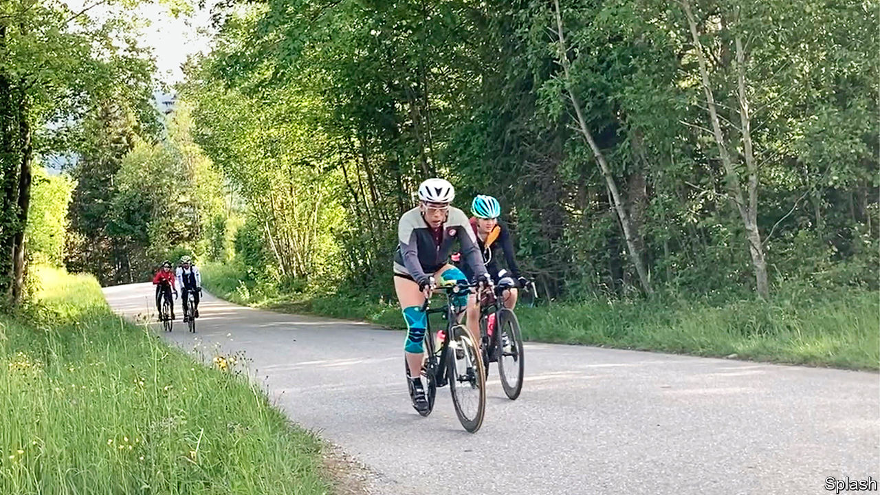

RUNNING A COUNTRY is much easier if you can silence naysayers. Just ask Thailand’s prime minister, Prayuth Chan-ocha. Having seized the job after leading a coup in 2014, he clung to it through an unfair election last year. One of the secrets to his success has been the severe restrictions on what Thais can say about both their government and the monarchy. More than 900 people endured “attitude adjustment” in the years after Mr Prayuth came to power, according to iLaw, a Thai NGO. Approval of a new constitution in a referendum in 2016 was eased by a ban on criticising the draft. As of 2017 at least 100 people were either detained awaiting trial or serving prison sentences for lèse-majesté. But the authorities are not content with the same old gags. They are always coming up with new ways to silence dissent.

The lèse-majesté law, for example, has fallen from favour. It attracted censure from abroad, as anachronistic and repressive. Since last year those writing rude things about King Maha Vajiralongkorn (pictured) or criticising the government have been targeted instead under laws on sedition, computer crimes or defamation. In November the government also inaugurated an anti-fake news centre. An emergency decree passed in March gives the authorities power to prosecute those deemed to be spreading misinformation about covid-19. At the time Mr Prayuth warned Thais against “abuse of social media”.

Online rabble-rousers are sometimes summoned by police or other officials, but not prosecuted for any crime. The intimidating process is often enough to shut them up. One Thai student describes how local authorities contacted his university last month to complain about his Facebook posts querying government spending, before asking him to visit the police and eventually hand over his iPad and Facebook account details. He doesn’t yet know whether he will face charges. But he believes he attracted attention for helping to lead student protests on his campus earlier this year. “If the most active figures are suppressed by the government then this might also result in the ending of the student movement,” he says.

Even as the government’s approach evolves, disgruntled Thais are also changing how they use social media. Frustration over the miserable state of the economy, the king’s antics and the handling of the coronavirus are boiling over online. In recent months netizens have expressed views that would have been unthinkable even a few years ago. “We have never seen this level of open defiance, towards the monarchy in particular, before,” reckons Andrew MacGregor Marshall of Edinburgh Napier University in Scotland.

Notable outbursts include rage on Twitter over traffic jams in Bangkok caused by road closures linked to the movements of royal motorcades. So vehement was the criticism that in January a government spokeswoman announced that the king “has acknowledged the traffic problem and is concerned for the people”. Roads are no longer fully shut for royal motorcades. Another bold move was the creation in April of the “Royalists Marketplace” on Facebook. Its members advertise satirical services to lampoon the monarchy. Its founder, Pavin Chachavalpongpun of Kyoto University, offered pet grooming with a picture of the king’s late poodle, Foo Foo. (In life the animal was made an Air Chief Marshal.) The marketplace has attracted 500,000 members in less than two months. Mr Pavin says at least two of them have lost their jobs for being in the group.

Other Thais are cautious almost to paranoia. Fears last month that Twitter might in some way be sharing information with the Thai government led tens of thousands to switch to an alternative social platform called Minds. “The assertion we’re in co-ordination with any government to suppress speech has no basis in fact whatsoever,” says Kathleen Reen, who works for Twitter in the region.

That will come as a relief to the many Thais who have been using such hashtags as #WhyDoWeNeedAKing and #RIPThailand. “[Thais] have the platforms to release their frustrations,” explains Titipol Phakdeewanich of Ubon Ratchathani University, “but it is not easy to translate that to a real movement.” That suits Mr Prayuth. ■

This article was downloaded by calibre from <https://www.economist.com/asia/2020/06/04/the-thai-government-tries-new-ways-to-curb-online-critics>

|  |  |  |  |
| --- | --- | --- | --- |
| Previous | Articles | Sections | Next |

|  |  |  |  |
| --- | --- | --- | --- |
| Previous | Articles | Sections | Next |

#### Haunted by Gwangju

# South Korea debates a massacre of 40 years ago

Many on the left want to gag those who dismiss the victims as rioters

Jun 4th 2020 | GWANGJU

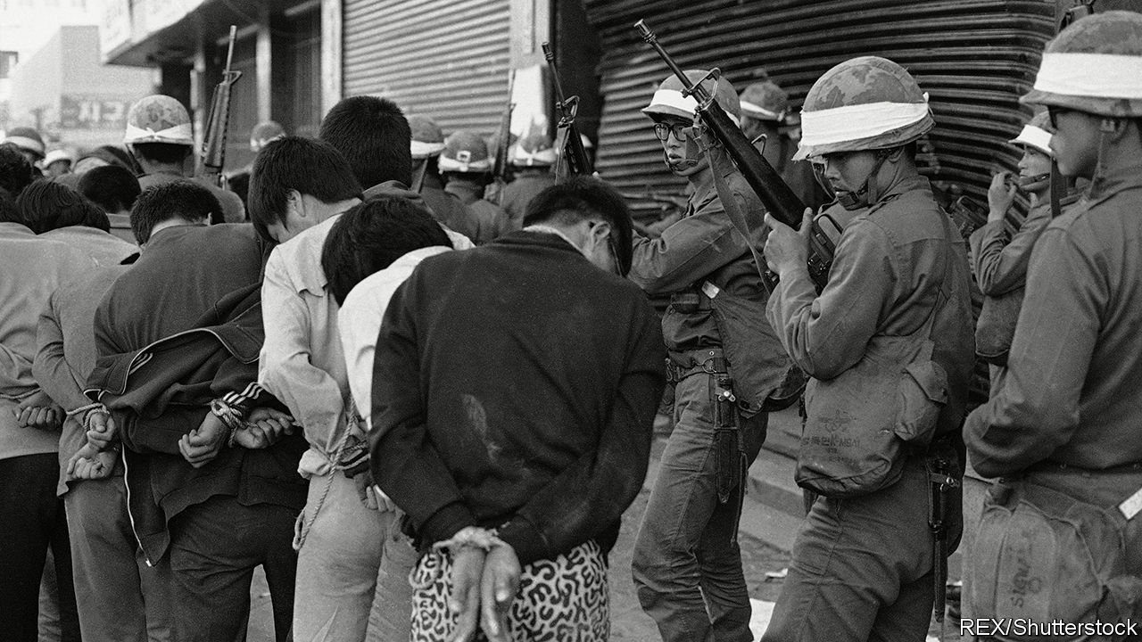

NEARLY HALF of today’s South Koreans were not yet born when it happened. In May 1980 citizens of the south-western city of Gwangju began to protest against an expansion of martial law by the country’s military dictatorship. When security forces tried to suppress the protests, they evolved into an uprising. Civilian militias took control of the city. On May 27th the government sent in helicopters, tanks and soldiers to crush them. Over the course of the uprising, hundreds were killed.

Three months later Chun Doo-hwan, the general who had ordered the crackdown, became president. He remained in power for seven years before pro-democracy protesters forced him to call an election, which another general won after promising democratic reforms. Abroad, many reckon the uprising and its suppression sowed the seeds of South Korean democracy. “It was the first time students, labour activists and regular people got together and said enough is enough,” says Alexis Dudden of the University of Connecticut.

Within South Korea, however, things are less clear-cut. The Chun regime justified the crackdown by presenting the uprising as a riot stoked by North Korean agents and led by local Communists. Support for this version of events endures to this day in some right-wing circles, even though no evidence has ever been found for it. Popular prejudice against people from the south-west, though weaker than it was 40 years ago, complicates matters.

Chun Doo-hwan, now 89, is on trial for slandering an eyewitness to the massacre, and denies he gave the order to shoot at protesters. The army did not apologise for massacring civilians until 2018. It is still unclear how many were killed. Last year lawmakers from the main conservative opposition party repeated the conspiracy theory about North Korean involvement.

Left-wingers, meanwhile, are so incensed by this distortion of history that they are trying to legislate it away. The Democratic party, which the president, Moon Jae-in, led until taking office, wants to criminalise the claim that the uprising was a “riot” stoked by North Korean agitators. Mr Moon, who was himself active in the democracy movement, would like to enshrine the “spirit” of the uprising in the constitution. He has launched a commission to write an authoritative version of the event. In a speech during the annual commemoration of the victims, which has been moved from a cemetery outside Gwangju to the centre of the city, he urged those involved in the crackdown to tell the truth, assuring them that the “path of reconciliation and forgiveness” was open.

Most South Koreans seem to have accepted that the massacre was just that. A majority now believe it deserves a mention in the country’s constitution. Young people are particularly keen. “We should all be grateful for the protesters’ sacrifices,” says Park Ye-eun, a 26-year-old from Seoul. “It’s the reason we’re a democracy today,” says Lee Dong-min, a 26-year-old from Gwangju, before bursting into tears.

Right-wingers seem to be taking note. The leadership of the main opposition party, possibly chastened by a resounding defeat in April’s legislative election, displayed rare contrition about the massacre at this year’s commemoration. They said they were sorry that some of their party’s members had “denigrated” the victims. Some commentators noted approvingly that the right-wing party leader sang loudly along to “March for the beloved”, the unofficial anthem of South Korea’s democracy movement. Members who peddle conspiracy theories about the uprising have been disciplined; one was expelled.

Many in Gwangju, however, will need more convincing. “They killed hundreds of students right in front of our eyes and we couldn’t even talk about it for years, or we would get kidnapped and disappear,” laments an elderly lady who introduces herself as Ms Ji. She says that things have improved since the advent of democracy, but she still does not trust politicians. “They only take our taxes but they don’t really care about us.” ■

This article was downloaded by calibre from <https://www.economist.com/asia/2020/06/04/south-korea-debates-a-massacre-of-40-years-ago>

|  |  |  |  |
| --- | --- | --- | --- |
| Previous | Articles | Sections | Next |

|  |  |  |  |
| --- | --- | --- | --- |
| Previous | Articles | Sections | Next |

#### Viral marketing

# Indonesia’s president has a new rival

Jakarta’s governor has exploited the pandemic to his advantage

Jun 6th 2020 | SINGAPORE

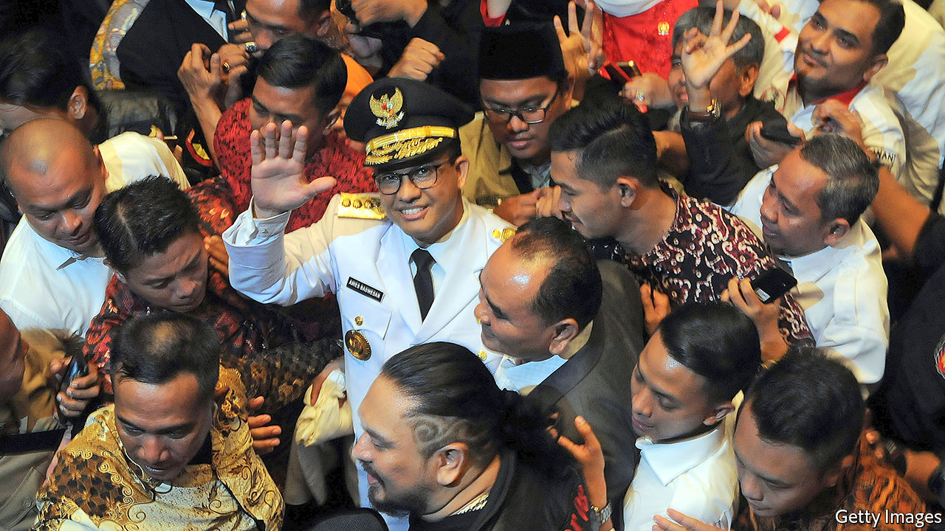

ANIES BASWEDAN was spoiling for a fight. Indonesia’s first case of covid-19 had been confirmed on March 2nd, and for weeks the governor of Jakarta, the capital, had been imploring the central government to act. Yet the government dithered as the virus made inroads, first through Jakarta, then throughout the country. Finally, on March 31st, the president declared a national emergency. Even then, local authorities were told to ask permission before instituting lockdowns—a process festooned in red tape. Mr Anies trumpeted his scorn. “[It’s] as if we are proposing a project that needed a feasibility study,” he told the Jakarta Post. “Can’t the [health] ministry see that we are facing a rising death toll? Is it not enough?”

It was one shot in a salvo of recent attacks that Mr Anies (pictured) has launched against Joko Widodo, Indonesia’s president, better known as Jokowi. He criticised Jokowi’s administration for not acting swiftly and robustly, and repeatedly disputed government data on the number of covid-19 cases. It was “a slap in the face” for Jokowi and his lieutenants, an analyst says. The complaints clearly nettled the president. When Mr Anies attempted to lock Jakarta down after Jokowi had spent weeks refusing to do the same to the whole country, Jokowi declared that the governor had no authority to do so. The following day he announced the onerous procedures required before local governments could limit people’s movement.

Jokowi had not been hectored in that way for a while. In October he appointed as minister of defence Prabowo Subianto, his opponent during his two presidential campaigns. Since then Mr Prabowo has largely toed the government line, leaving the post of chief adversary to the president vacant. Mr Anies seems to have decided to take up the job.

Relations between the two have not always been so fraught. When Jokowi began his first term as president in 2014, he appointed Mr Anies minister of education and culture. But the latter’s expansive political ambition curdled relations, says a former adviser to Jokowi. The president dumped Mr Anies two years later in a cabinet reshuffle.

Mr Anies would get his own back in 2017, when he ran for governor of Jakarta against a protégé of Jokowi, Basuki Tjahaja Purnama or Ahok, as he is better known. Ahok, who is Christian, had been leading in the polls but was accused of blasphemy after he cited the Koran in one of his stump speeches. Mr Anies seized on the ensuing uproar by allying with the Islamic Defenders Front (FPI), a vigilante group that had been organising big protests against Ahok. A wave of sectarian indignation carried Mr Anies to the governor’s mansion, in an embarrassing setback for Jokowi.

Even so Mr Anies initially avoided directly criticising Jokowi, who remained popular, says Alexander Arifianto of the S. Rajaratnam School of International Studies in Singapore. That changed this year, when torrential rains inundated Jakarta in January. Mr Anies tried to deflect criticism of his handling of the disaster by knocking the central government’s response. When covid-19 arrived, Mr Anies turned the full force of his ire against the president.

Edward Aspinall of Australian National University thinks it likely that Mr Anies was genuinely concerned about the impact of covid-19 on his constituents. He also cares about his image as “a public-policy person who thinks seriously about major issues”, Mr Aspinall adds. His efforts to adopt a rigorous, data-driven response to the outbreak enhance that image.

But Mr Anies also understands how to exploit Jokowi’s weaknesses. Many devout Muslims consider Jokowi too secular in his outlook and of dubious piety. They long for a champion to take on his government and seize the presidency in 2024, when Jokowi completes his second and final term. Such voters underpinned Mr Prabowo’s two runs for president, and Mr Anies is already known to many of them because of the Ahok affair. The governor of Jakarta is often in the news, which will help Mr Anies build a national profile. Jokowi himself used the job as a springboard to the presidency. And the easiest way for Mr Anies to define himself is in opposition to Jokowi.

Mr Anies has probably calculated that the pandemic provides a good opportunity to show off qualities many feel Jokowi lacks, such as decisiveness and empathy, says the analyst. The gambit may work. Most presidential candidates will not start their campaigns for another two years. Mr Anies is already courting opposition MPs. Nasdem, one of the parties in Jokowi’s coalition, is getting closer to Mr Anies, says the former aide to Jokowi. It’s a long road to election day. But as Mr Arifianto says, “Anies is just making a head start.” ■

This article was downloaded by calibre from <https://www.economist.com/asia/2020/06/06/indonesias-president-has-a-new-rival>

|  |  |  |  |
| --- | --- | --- | --- |
| Previous | Articles | Sections | Next |

|  |  |  |  |
| --- | --- | --- | --- |
| Previous | Articles | Sections | Next |

#### Banyan

# Central Asian governments do not know how to talk about China

Their citizens are suspicious, but want investment

Jun 4th 2020 |

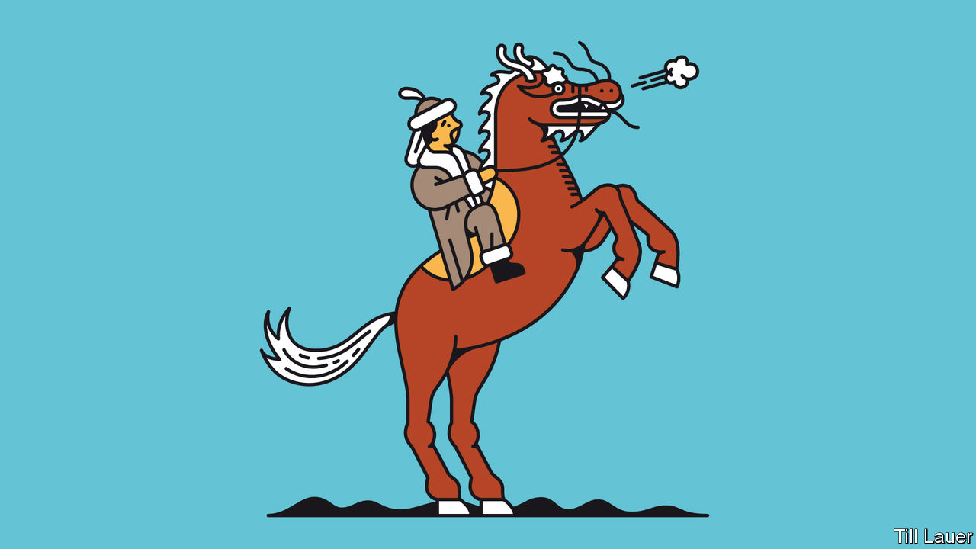

FOR MILLENNIA fierce horsemen from Central Asia harried the Chinese empire’s flank, often setting the terms of engagement with their giant, settled neighbour to the east. In February an echo rolled out of the past when a horde of whooping riders galloped through the town of At-Bashy in south-central Kyrgyzstan, close to the border with China.

Their target was a planned Chinese logistics centre: a $275m investment in roads, malls and warehouses that was touted as a crucial node in China’s Belt and Road Initiative, a funnel for revived trade along the old silk road and a source of future prosperity for the locality. But the horsemen of the pristine valley were having none of it: they feared their land would be grabbed and jobs would go to imported Chinese. Facing such hostility, the Chinese investors angrily pulled out, leaving politicians in Kyrgyzstan with egg on their faces.

The incident highlights a growing tension between rulers and ruled in the Central Asian states of Kazakhstan, Kyrgyzstan, Tajikistan, Turkmenistan and Uzbekistan. China is the chief and sometimes only source of prosperity in the impoverished region. It dominates foreign direct investment as well as commercial and concessionary lending.

When Banyan was last in Nur-Sultan, the capital of Kazakhstan, a foreign-ministry official explained that in return for copious investment in oilfields, infrastructure and manufacturing, the only explicit demand China makes of his government is for vocal support for China’s territorial integrity (see [article](https://www.economist.com/china/2020/06/06/the-pandemic-is-hurting-chinas-belt-and-road-initiative)). In particular, China’s government wants no objections to its campaign against Muslims in the province of Xinjiang whom it deems “terrorists” out to split the motherland.

If that stricture is met, the money flows. In Kazakhstan Chinese investment underpins nearly a quarter of the country’s oil output. Despite the horsemen’s protests, logistics is one of the few ways tiny Kyrgyzstan can earn foreign exchange apart from gold mining—in which Chinese firms are also involved. Though Turkmenistan shares no border with China, it is about the most China-dependent economy in the world, sending eastward four-fifths of its exports (almost entirely gas via the China-Central Asia pipeline). Exports of gas to China also provide crucial revenue for Uzbekistan and Kazakhstan.

But such dependence on a single power—in deals often murkily struck by the countries’ elites—is not always easy to explain to compatriots. Awkwardly, the notion of self-reliance is at the core of the personality cult surrounding Turkmenistan’s strongman, Gurbanguly Berdymukhamedov. All Central Asian governments fete their independence, after centuries under the Russian and Soviet yoke. The dissonance is another reason, if Central Asia’s authoritarian leaders wanted one, to keep a lid on the press and stifle dissent. Without that, complaints about China would be louder.

Yet still they bubble up. In September several anti-China protests erupted in Kazakhstan, over rumours that dozens of obsolete Chinese factories would be relocated to the country, over accusations of land grabs by Chinese firms, and over China’s repression in Xinjiang, where more than 1m Muslims are detained in camps. A more recent grumble in private conversations is Central Asian regimes’ growing enthusiasm for high-tech surveillance and social-control systems, which China is keen to supply.

The grievances will only grow. Not least, the economic picture is worsening as the covid-19 pandemic has brought a sharp slowdown in Chinese investment and demand. In March China claimed force majeure to start negotiating reduced gas imports from Kazakhstan, Turkmenistan and Uzbekistan.

Those hostile to Central Asian governments can piggyback on anti-China sentiment. The protests in Kazakhstan last year were cheered on by an exiled oligarch who needles the regime, Mukhtar Ablyazov. In Kyrgyzstan protests near the Chinese border may be stoked by those who feel left out of immense cross-border smuggling rackets involving customs officials and politicians.

And so the tension between the elites’ priorities and those of ordinary Central Asians will persist. It does not help that the unspoken rule in dealings with China, according to Temur Umarov of the Carnegie Endowment for International Peace in Moscow, is never to acknowledge there is a problem in the relationship. Even less helpful is rulers’ inability to acknowledge a problem over China in their relationship with the ruled.

This article was downloaded by calibre from <https://www.economist.com/asia/2020/06/04/central-asian-governments-do-not-know-how-to-talk-about-china>

|  |  |  |  |
| --- | --- | --- | --- |
| Previous | Articles | Sections | Next |

|  |  |  |
| --- | --- | --- |
| Asia | Sections | Middle East & Africa |

China

The Belt and Road Initiative: Break time

.

Chaguan: Crossing blood lines

.

|  |  |  |
| --- | --- | --- |
| Asia | Sections | Middle East & Africa |

|  |  |  |  |
| --- | --- | --- | --- |
|  | Articles | Sections | Next |

#### Break time

# The pandemic is hurting China’s Belt and Road Initiative

How will Xi Jinping’s biggest project survive?

Jun 6th 2020 |

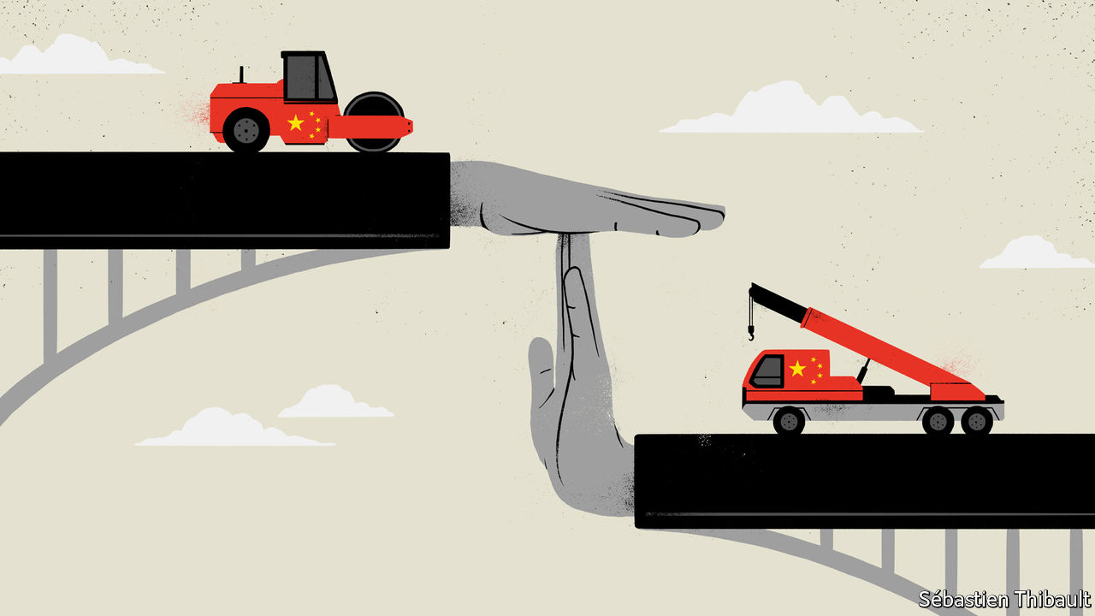

Editor’s note: Some of our covid-19 coverage is free for readers of The Economist Today, our daily [newsletter](https://my.economist.com/user#newsletter). For more stories and our pandemic tracker, see our [coronavirus hub](https://www.economist.com/news/2020/03/11/the-economists-coverage-of-the-coronavirus)

JUST OVER a year ago, at a gathering in Beijing of world leaders who had signed up to his Belt and Road Initiative (BRI), China’s president, Xi Jinping, peppered his speech with proverbs. “The ceaseless inflow of rivers makes the ocean deep,” was one—a reference to how his scheme, involving huge spending on infrastructure in other countries, would promote the global flow of goods, capital and technology and with them, economic growth. Amid the pandemic, many countries may be wishing this were so. But some BRI projects are stalling as countries struggle to repay related debts. China’s own economy is faltering, too. Silk roads are getting bumpier.

The BRI is the centrepiece of Mr Xi’s foreign policy. In 2017 he gave it hallowed political status by having it written into the Communist Party’s constitution. Lauding it thereby became obligatory. China’s state-owned media are duly doing so. “BRI co-operation is entering a stage of high-quality development,” said a headline in Global Times, a party-owned tabloid. “The BRI will become a catalyst for global economic recovery,” said another on the website of the party’s mouthpiece, the People’s Daily.

But the going is rough along the Silk Road Economic Belt and the 21st-Century Maritime Silk Road, to give the scheme its full name. Since 2013, when Mr Xi first began talking about these new silk roads, China has given or promised hundreds of billions of dollars in loans and grants for power plants, ports, railways, roads and other infrastructure in Africa, Latin America, South-East Asia, Central Asia and Europe (see chart 1). But as a result of covid-19, work on some projects has come to a halt. A few have been scrapped. Several that seemed of dubious worth even before the pandemic now look like white elephants. Many of the loans are on the brink of technical default, as debtor countries—hammered by covid-19—seek to defer payments that are coming due.

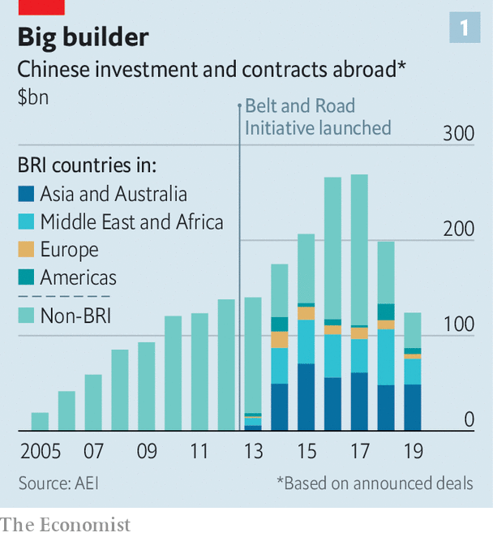

In February Egypt postponed indefinitely China-funded construction of what was to be the world’s second-largest coal-fired power plant, at Hamrawein. The following month Bangladesh cancelled plans for a coal plant at Gazaria. In April Pakistan asked China for easier repayment terms on $30bn-worth of power projects. In April Tanzania’s president, John Magufuli, said he would cancel a $10bn port project at Bagamoyo because it was signed (by his predecessor) with conditions that “only a drunkard” would accept—chiefly, that China would gain full control of the port with a 99-year lease. And in May, Nigerian legislators voted for a review of all of China’s loans for Chinese projects amid concerns that financing may have been agreed on unfavourable terms. African leaders have called for emergency debt-forgiveness from sovereign creditors including China, which is owed about $8bn this year in payments on about $145bn in loans to African countries, many involving BRI projects (see article).

Work has also been delayed by quarantine and safety measures related to the pandemic, including restrictions imposed by some countries on the return of Chinese workers who had gone back to China for the lunar new-year holiday in January. In Vietnam such impediments have delayed a 20-day test of a new metro line in Hanoi—more than 100 Chinese experts involved in building it have been unable to re-enter the country. The project was already at least four years behind schedule and, at a cost of nearly $800m for eight miles of track, massively over budget.

This presents problems for China’s leaders in the realms of economics, diplomacy and politics at home, where the BRI is closely linked with the prestige of Mr Xi. First, there will be financial losses. Many countries raise the cash for BRI projects by exporting commodities. But the pandemic has hit demand for them. Should China reduce the amount owed, as sovereign lenders sometimes do in response to a financial crisis? Or should it try to preserve as many loans and BRI projects as it can by delaying payments and extending terms (its typical approach)? Either way, experts say, a wave of defaults is inevitable.

In April, amid debtors’ growing calls for help, the G20, which includes China, broadly agreed to allow up to 73 countries to suspend debt-service payments totalling about $12bn-14bn until the end of the year. But the devil is in the details. The G20 warns that applying for a suspension of debt-service payments could breach other terms to which a country may have agreed. Unlike members of the Paris Club of big sovereign lenders, who do not require collateral for their development loans, China’s banks do for about 60% of their lending to developing countries, says Carmen Reinhart, the World Bank’s incoming chief economist. In theory a country could apply for debt relief only to find that China could claim the rights to a mine, a port or money held in escrow. This is one reason why China’s banks prefer to renegotiate sovereign loans bilaterally, and in secret. They have leverage, and can choose how to apply it.

But this is where diplomatic risk will loom large for China. Claiming assets from defaulting countries would create a furore. It would damage China’s image in countries that the BRI was intended to help, and strengthen suspicions among Western hawks that China is using the BRI to saddle countries with debt (see chart 2) and thereby gain control of infrastructure that could help it strategically. “If they thought they were facing a backlash now, it would be really severe for them” if they were to seize collateral, says Scott Morris of the Centre for Global Development, a think-tank in Washington. China may decide to tread warily. Until the global economy recovers, there will certainly be fewer new BRI projects. “It feels hard to imagine the initiative maintaining the level of ambition that it had,” says Mr Morris.

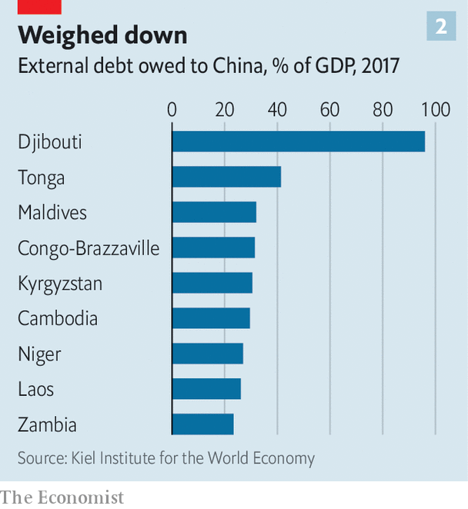

However, given the political importance China attaches to the BRI at home, and the effort it has made to persuade countries to sign documents endorsing it (more than 130 have, most of them non-Western), it is unlikely to let the idea drop. Fortunately for China’s propagandists, the BRI is a shape-shifting concept that allows them to adapt it to changing circumstances. Hitherto its focus has been on building hard infrastructure. But the term is often applied to almost any activity abroad involving big Chinese firms that can be touted as helping to create a “Silk Road of Peace”—in other words, it means anything the Chinese government likes. Amid the pandemic, officials can easily play down the pouring of concrete and stress other kinds of Chinese largesse.

Under the banner of the BRI, officials are now lauding the idea of a “Health Silk Road” to help distribute medical support and food aid. The idea harks back to the first speech Mr Xi gave, in 2013, about his plans for a Maritime Silk Road. In it he recalled at length how, nine years earlier, China had responded to the Indian Ocean tsunami by mounting its biggest-ever relief operation overseas. In Indonesia, he said, many local people had learned to speak Chinese and hailed members of the Chinese rescue team with the words: “China, Beijing, I love you.” China expects that the BRI-branded medical supplies which it is now showering on covid-struck countries will prompt similar expressions of gratitude. Focusing on such assistance makes political sense for China. It can make a big difference to recipients’ efforts to fight the disease, and requires far less cash than a port or railway.

Also gaining more prominence is the vaguely defined idea of a “Digital Silk Road”. It has been adapted for pandemic use to include helping other countries replicate China’s successes with app-based approaches to tracking the coronavirus.

Chinese officials may take advantage of the lull in building-work to think again about which projects are necessary. They have been stung by Western criticism of the social and environmental costs of BRI infrastructure and of the opaque deals involved. At last year’s meeting with world leaders, Mr Xi stressed that the BRI should be “open, green and clean”. The pandemic offers a chance quietly to nix unpopular dams, which can suffer costly delays due to protests, and dirty coal plants, which are not a sound investment anyway. “Nobody on Wall Street will tell you that a coal plant will be affordable 40 years from now,” says Kevin Gallagher at Boston University. Instead, China may push the expansion of solar and wind energy. Mr Gallagher notes that in Pakistan, Chinese firms have built multiple wind farms under the auspices of BRI. “If you ask for that stuff, China has it.”

If done right, without drowning countries in debt, BRI projects may yet provide a welcome boost to the global economy. Before the pandemic the World Bank estimated that BRI transport projects in Asia, including high-speed railways, would boost the GDP of participating countries by up to 3.4% overall. Some of those rail projects have stalled, and China is now preoccupied with its own hard-hit economy. But Daniel Rosen of Rhodium Group, a research firm, argues that China’s policy banks have ample capacity to maintain the present level of BRI lending. It just is not economically prudent for them do so, especially before a global recovery is on track.

When that happens, the BRI may revert to its original focus. And many countries in desperate need of better infrastructure will welcome this. They have few other options. In November America, Japan and Australia announced an alternative to the BRI called the “Blue Dot Network” to fund infrastructure projects in the developing world. But, as with multilateral lenders such as the World Bank, the financial muscle behind it looks puny in comparison. “The BRI has the best promise of meeting the glaring infrastructure gaps in the global economy,” Mr Gallagher says. “There’s no global infrastructure surge without the BRI.” But for the moment, that boost will have to wait. ■

This article was downloaded by calibre from <https://www.economist.com/china/2020/06/04/the-pandemic-is-hurting-chinas-belt-and-road-initiative>

|  |  |  |  |
| --- | --- | --- | --- |
|  | Articles | Sections | Next |

|  |  |  |  |
| --- | --- | --- | --- |
| Previous | Articles | Sections | Next |

#### Chaguan

# For people in China, adopting Chinese children is getting easier

No longer are foundlings given the surnames “Party” or “State”

Jun 4th 2020 |

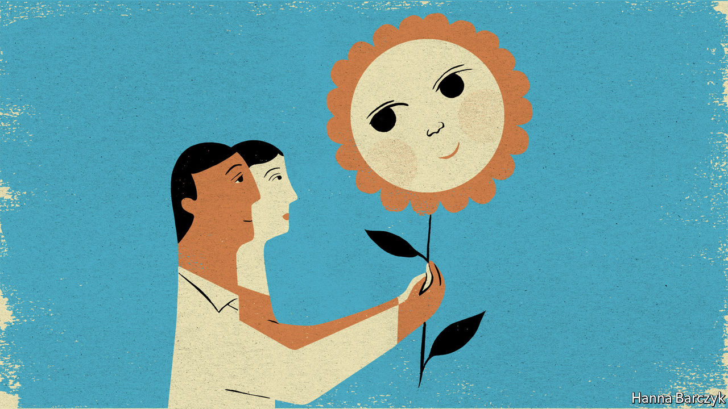

BACK IN 1991, when China passed its first stand-alone adoption law, state-run orphanages routinely gave foundlings the surnames “Dang” (meaning Party) or “Guo” (meaning Country). These unusual names marked children for life and were meant to. That way foundlings would not forget what they owed the Communist Party. Such names were banned in all orphanages only in 2012.

It is a mark of how China has changed that its first-ever Civil Code, a fat volume of laws covering everything from marriage to property rights, approved on May 28th, revises adoption rules to make it easier for children to be raised in private homes. A big change eliminates the rule that—except in special cases, for instance involving adoptions of disabled children from orphanages—only childless Chinese may adopt. From next year, the childless will be allowed to adopt two children, whereas parents with one biological child may adopt another. Those changes reflect a broader easing of laws that, from 1980 to 2016, restricted most urban families to a single child. A further amendment raises the maximum age for being adopted from 14 to 18.

To be sure, the Civil Code is rooted in a conservative vision of family life. The new rule-book has sparked controversy by imposing a 30-day cooling-off period on many couples seeking to end marriages, to prevent “rash” divorces. The code’s approach to adoption is no exception. Fang Yan, a lawyer and member of the National People’s Congress, China’s parliament, backed the clause allowing older teenagers to be adopted. Her not-very-sentimental argument to state media was that parental supervision may prevent “social instability” caused by “rebellious” youths.

Still, it is revealing that China’s rulers, a control-obsessed bunch, are willing to outsource a delicate social problem—the care of abandoned children—to Chinese parents. For three decades officials hid foundlings away in bleak institutions. From the late 1990s onwards, they entrusted thousands of children each year to foreigners not constrained by family-planning laws, most of them Americans. The government’s distrust of its own citizens helps explain that approach. Officials knew that informal adoptions were rampant, especially in rural areas, as a way to get rid of unwanted girls, allowing parents to try again for a son and heir.

Social changes explain why the government is more willing to promote domestic adoption, says a doctor who has spent years bringing ill and disabled orphans to Beijing for treatment. On the one hand, as China becomes more prosperous and educated, urban couples are marrying and trying to start families later, only to find that they cannot. As a result, when healthy babies reach orphanages, perhaps abandoned by young unwed mothers, they are adopted “right away”. Sometimes, such children may never be told that they were adopted, she adds. Other Chinese are more willing to adopt children with treatable conditions like cleft palates.

On the other hand, says the doctor, there are many fewer abandoned children to adopt. Because even remote villages have access to ultrasound scans, disabled children are more likely to be aborted. More cheerfully, younger Chinese are not as superstitious, and so are less likely to believe that a baby born without an anal opening, for example, must be cursed and fit only for abandonment.

Official statistics bear the doctor out. They show that there were 343,000 children in orphanages in 2018, down from 570,000 in 2012. Registered adoptions peaked 20 years ago, with over 52,000 in 2000. That number fell to just over 15,000 in 2018. Today, just one-eighth of adoptions are by foreigners, who may take only disabled or older children. Yet child welfare remains sensitive, which is why so many in the field decline to speak on the record, from the Beijing doctor to lawyers who handle adoption cases.

Zhuang Ju, a therapist who works with autistic children in Beijing, is an exception. Traditionally, the Chinese have been cautious about formally adopting non-relatives, he explains. But informal versions of the practice have ancient roots. Before China urbanised, many households in the same village might collectively feed, clothe and care for an orphan. That said, to take a boy with no blood ties into a family, giving him that family’s surname, was a major commitment, creating an heir with inheritance rights. “In China the first and foremost connection is by blood,” he says.

## There’s more than one way to honour ancestors

Mr Zhuang, who is 49, is not so traditional. Some 14 years ago he and his wife, another therapist, adopted a two-and-a-half year old, Lele, with symptoms of autism. They believed, correctly, that the boy was still young enough to respond to therapy. His mother, a nurse, scanned Lele’s medical records and spotted that he had a heart condition, possibly explaining his abandonment in the poor, mountainous province of Qinghai. Then Lele (the name means “happy”) was diagnosed with hepatitis. Undismayed, the Zhuangs, helped by a charity, paid for months of hospital treatment. Then they forked out the extra fees demanded by schools in Beijing to educate someone without a local hukou, or residence permit. Being adopted does not earn provincial children a Beijing hukou.

Mr Zhuang concedes that his father is a bit more conservative. But the old man was mollified by the fact that he has a biological grandson, Lele’s older brother (and doting protector, growing up). As for Mr Zhuang’s friends, they had already watched him quit the safe government job he earned after graduating from Beijing Normal University, one of China’s best, to become a therapist. That career change was such a “completely odd and unreasonable decision” that adopting a child barely startled them, he laughs.

Today, Lele is 16 and sometimes helps his father give therapy to autistic children. Not once does Mr Zhuang suggest that he and his wife deserve praise. Instead, he calls adopting his son an opportunity which they could not miss. The Zhuangs may be an uncommonly brave and open-hearted family. The public response to China’s new adoption laws will show if they have company.■

This article was downloaded by calibre from <https://www.economist.com/china/2020/06/04/for-people-in-china-adopting-chinese-children-is-getting-easier>

|  |  |  |  |
| --- | --- | --- | --- |
| Previous | Articles | Sections | Next |

|  |  |  |
| --- | --- | --- |
| China | Sections | Europe |

Middle East & Africa

Yemen and covid-19: The invisible outbreak

.

Israel: Empty empires

.

The Hirak: Streets with no rage (for now)

.

Boko Haram: No rain, slow gains

.

Women and politics in Uganda: Hell yeah, I’m a feminist

.

Debt relief: Thanks, but no

.

|  |  |  |
| --- | --- | --- |
| China | Sections | Europe |

|  |  |  |  |
| --- | --- | --- | --- |
|  | Articles | Sections | Next |

#### The invisible outbreak

# Covid-19 quietly sweeps across Yemen

The authorities either cannot test for the virus—or do not want to

Jun 4th 2020 | BEIRUT

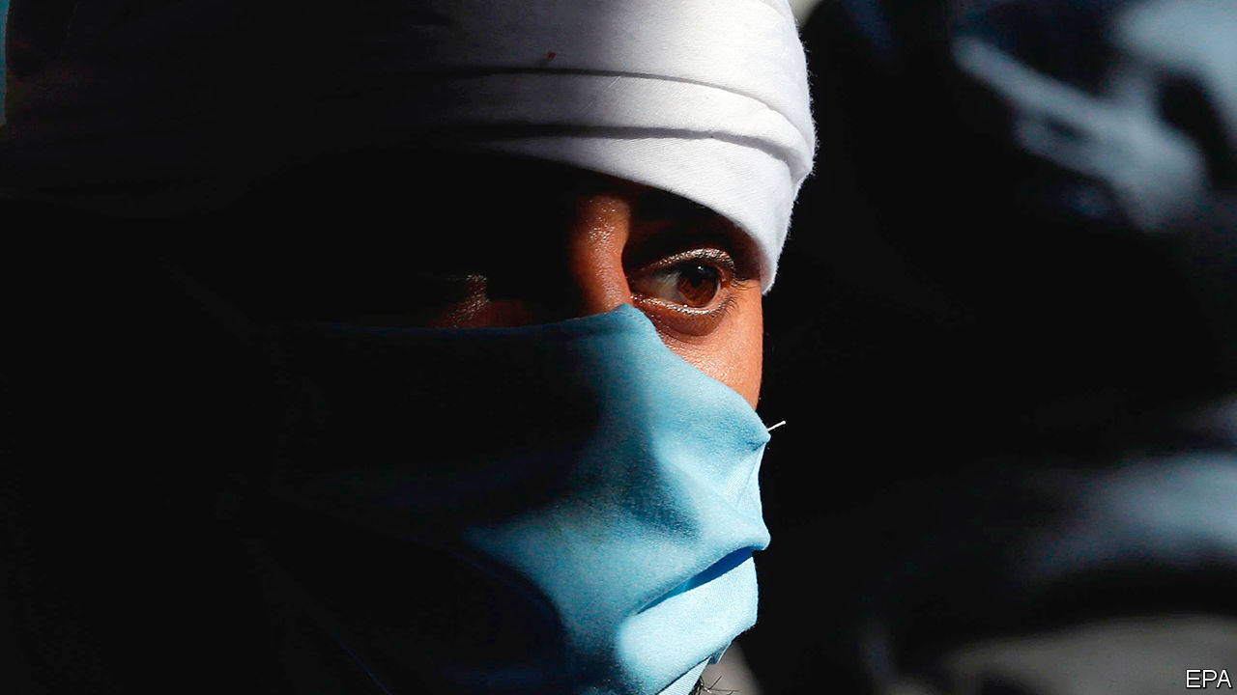

Editor’s note: Some of our covid-19 coverage is free for readers of The Economist Today, our daily [newsletter](https://my.economist.com/user#newsletter). For more stories and our pandemic tracker, see our [coronavirus hub](https://www.economist.com/news/2020/03/11/the-economists-coverage-of-the-coronavirus)

THERE ARE no daily news conferences about covid-19 in Yemen, no charts or maps or deluge of data. There are barely any tests. But there are bodies. Silently but steadily the virus has taken root in the Arab world’s poorest country. Its spread can be glimpsed in anecdotes from doctors and snippets on social media. In one city aid agencies say gravediggers work overtime to keep up with the dead, most of them middle-aged men. In another city doctors who talk about the pandemic are threatened with arrest or worse.

If you judge by the official numbers, Yemen has largely been spared. It has reported just 419 coronavirus infections and 95 deaths. But no one believes those numbers. Ravaged by years of war, the health-care system has all but collapsed. Authorities lack the ability to track the outbreak—and in parts of the country, they do not want to.

Yemen was singularly ill prepared for a pandemic. Even now, after shipments of extra supplies, it has just 675 intensive-care beds and 309 ventilators, says the UN. Hospitals and clinics have been bombed throughout a five-year war between a Saudi-led coalition and the Houthis, a Shia militant group. Medical staff have fled the country, leaving one in six of Yemen’s 333 districts without any doctors. Millions of people cannot properly wash their hands because they lack clean water. A cholera outbreak has infected more than 2m people and killed 4,000 since 2016.

The country has been split in two since the coalition invaded in 2015, a campaign meant to topple the Houthis, who had seized the capital months earlier. The south is formally controlled by Saudi allies loyal to the president, Abd Rabbo Mansour Hadi (see map). In April, though, secessionists seized the port city of Aden and declared the region autonomous. The two camps have spent weeks fighting for control; the health ministry, split along the same lines, was paralysed as the virus approached.

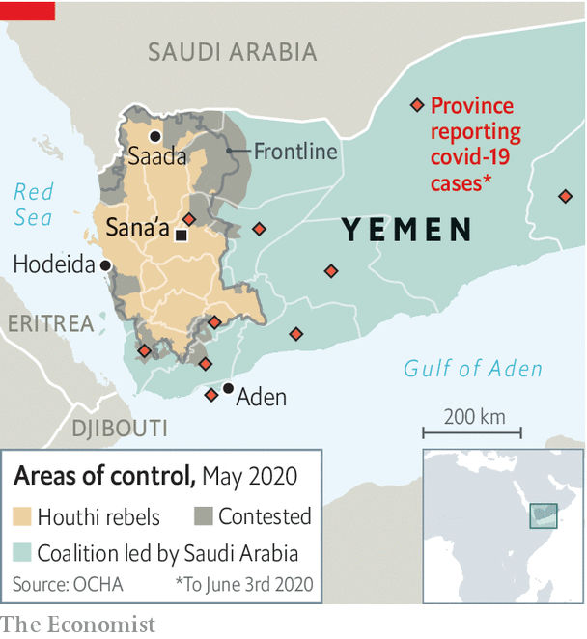

Doctors say more than 500 people have died recently in Aden alone, many with respiratory symptoms that look a lot like covid-19. They cannot know for sure: tests are scarce. As of May 30th Yemen had screened just 2,678 people for the virus, from a population of 28m. Some clinics have closed rather than treat people who may be infected. Cases go unnoticed because symptoms can resemble mosquito-borne diseases such as dengue fever, already endemic in south Yemen and now spreading rapidly after floods that inundated Aden in April.

The Houthis, who control the north, claim the situation is far better in their fief. They reported their first case of covid-19 on May 5th, perhaps two months after the virus reached Yemen. At the end of May they claimed, absurdly, a total of four infections in Sana’a (one of them fatal) and none in outlying provinces. There have been isolated closures, but the Houthis have refused to impose a full lockdown. Doctors keep quiet for fear of reprisals.

On social media, though, Yemenis post stories of death: at least a dozen in the capital, dozens more in outlying provinces. Some families have been unable to bury their relatives, their bodies trapped in morgues by the Houthis. The UN has pulled about half of its foreign staff out of Sana’a.

Aid agencies have offered help. The World Health Organisation (WHO) and other groups are shipping hundreds of ventilators, thousands of tests and other kit. But cash is short. Earlier this year America cut $73m in humanitarian aid to Yemen, noting (accurately enough) that the Houthis profit from it. Some agencies have been forced to trim services. The World Food Programme halved the rations it provides to 8.5m people in the north. The WHO stopped payments to doctors and nurses, many of whom have not received government salaries for years. A Saudi-led donors’ conference on June 2nd, meant to raise money for a covid-19 response and other aid programmes, netted $1.4bn, well below its target of $2.4bn.

Yemenis in all parts of the country struggle to afford protective gear. Disposable face-masks, if replaced daily, would eat up about half the monthly income of a typical family of four. The better N95 masks cost about $8 each, several days’ pay even for doctors, who often must supply their own gear. Residents of Sana’a cannot find hand-sanitiser and other necessities.

The outbreak is not only exacerbated by economic crisis—it also worsens it. Saudi Arabia has been the biggest donor to Yemen, contributing billions even as it simultaneously bombs the country. In 2018 it deposited $2bn in Yemen’s central bank to pay for imports. Only a tenth of that is thought to remain. With the kingdom facing a deep deficit brought on by lockdowns and low oil prices, few in Yemen expect the money to be replenished, so the currency will probably depreciate. The slump in wealthy Gulf states has also hurt remittances to Yemen, which last year amounted to $3.8bn (13% of GDP). Oxfam, an aid agency, estimates that the volume of remittances has dropped by 80% in the first four months of 2020.

All of this comes as the war itself seemed to be winding down. The United Arab Emirates, which led the fighting in the south, withdrew most of its troops last summer. The Saudis want to find a face-saving escape from a costly war that seems unwinnable. But they would leave behind a country bitterly divided, between north and south and between Mr Hadi and the separatists. Even if the bombs stop, disease and hunger will take their own toll. ■

This article was downloaded by calibre from <https://www.economist.com/middle-east-and-africa/2020/06/04/covid-19-quietly-sweeps-across-yemen>

|  |  |  |  |
| --- | --- | --- | --- |
|  | Articles | Sections | Next |

|  |  |  |  |
| --- | --- | --- | --- |
| Previous | Articles | Sections | Next |

#### Empty empires

# Binyamin Netanyahu has bought loyalty with meaningless titles

But don’t tell the new minister of community empowerment and advancement

Jun 4th 2020 | JERUSALEM

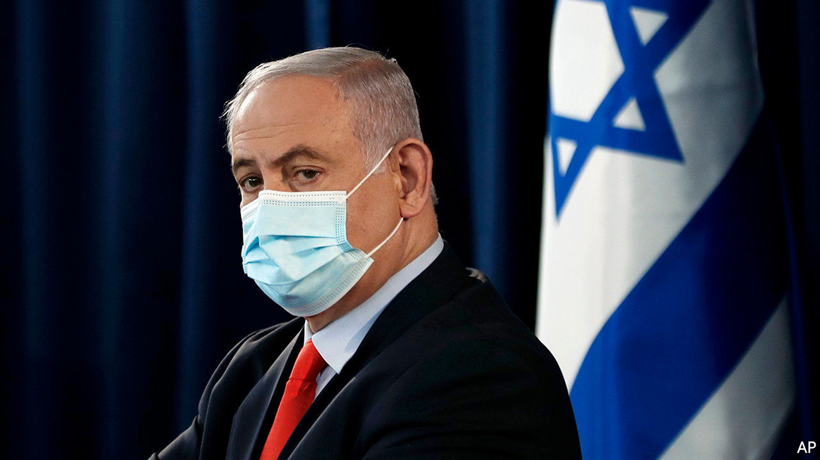

IT TAKES ABOUT a dozen ministries to run Sweden, a country of 10m people. Austria, with a population of 9m, has a similar number. Israel is about the same size, but apparently it needs a bigger government. The one sworn in on May 17th features at least 34 ministries, and as many ministers (over a quarter of all lawmakers), many of whom seem to share the same tasks or have little power.

There is, for example, a minister of education and a minister of higher education. There is a minister of cyber and national digital matters, though the police handle cybercrime, the army does cyber-warfare and a separate ministry deals with science and technology. The ministry of community empowerment and advancement has just been created, in case having a ministry in charge of social services and a ministry for social equality was not enough.

Half a century ago Israel had many fewer ministries (see chart). But the country’s proportional-representation system makes it difficult to form a stable governing coalition—just ask Binyamin Netanyahu, the prime minister. Three elections in the span of a year produced nothing but gridlock until Mr Netanyahu convinced his former opponent, Benny Gantz, to join him in government. Now the prime minister must keep politicians from eight parties happy. So, like past leaders, he has broken up existing departments and created new ones in order to reward allies and buy off opponents.

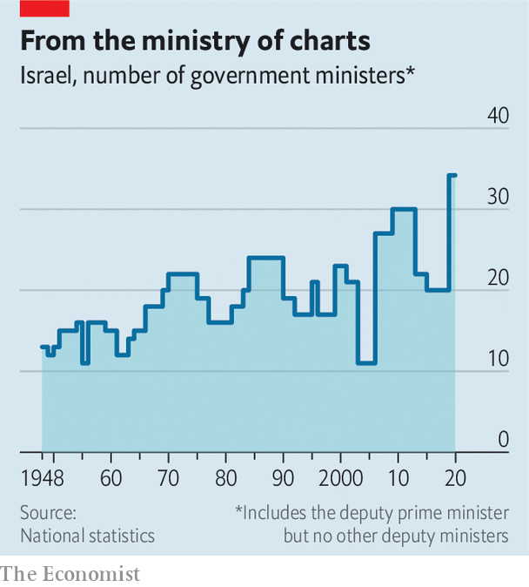

Mr Netanyahu has thus formed the biggest government in Israeli history. Several new ministries aim to satisfy loyal members of his Likud party. The ministry of community empowerment and advancement was invented to reward a defector from the opposition, Orly Levy-Abekasis. It is responsible for preventing drug abuse and violence against women and children, tasks previously handled by the ministry of public security (which still exists). Ms Levy-Abekasis will also oversee projects to strengthen Arab neighbourhoods. Her credentials include supporting Mr Netanyahu’s plans to annex parts of the occupied West Bank and breaking away from an alliance of left-wing parties because it was backed by a predominantly Arab party.

The proliferation of ministries has the potential to create confusion. Take the ministry of strategic affairs, which was created in 2006 by Ehud Olmert, then prime minister, to reward Avigdor Lieberman, leader of the Yisrael Beiteinu party. The ministry was meant to keep an eye on Iran and other threats. Of course, so were the ministries of defence, foreign affairs, and public security (which was the one Mr Lieberman actually wanted to lead). The strategic-affairs ministry was closed in 2008, after Mr Lieberman left the government—and reopened in 2009 by Mr Netanyahu, who had become prime minister. An article in the Jerusalem Post at the time asked: “Who’s in charge of whom and over what?”

Recently the ministry of strategic affairs has tried to undermine the international campaign to influence Israel through “BDS”—boycott, divestment and sanctions. That, predictably, caused tensions with the foreign ministry. Turf battles are common, and could increase given the government’s strange bedfellows. Mr Gantz will be taking the positions of alternate prime minister and defence minister. In 18 months he is supposed to swap places with Mr Netanyahu. Until then he has the right to veto nearly anything the government does.

Each ministry comes with its own budget and team of bureaucrats. The cost of Mr Netanyahu’s new creations is 85m shekels ($24m) a year, to be taken from existing departments. Despite criticism, he hasn’t even tried to claim that the new ministries are necessary. But, he says, they are worth it to avoid another election, which would cost 2bn shekels. And there may be other benefits for the imperious prime minister. “The more ministers he has, the less he has to take us seriously,” says a disconsolate member of the new cabinet.

This article was downloaded by calibre from <https://www.economist.com/middle-east-and-africa/2020/06/04/binyamin-netanyahu-has-bought-loyalty-with-meaningless-titles>

|  |  |  |  |
| --- | --- | --- | --- |
| Previous | Articles | Sections | Next |

|  |  |  |  |
| --- | --- | --- | --- |
| Previous | Articles | Sections | Next |

#### Streets with no rage

# Algeria’s protest movement considers how and when to come back

People are fed up with a repressive government that cannot help them

Jun 4th 2020 |

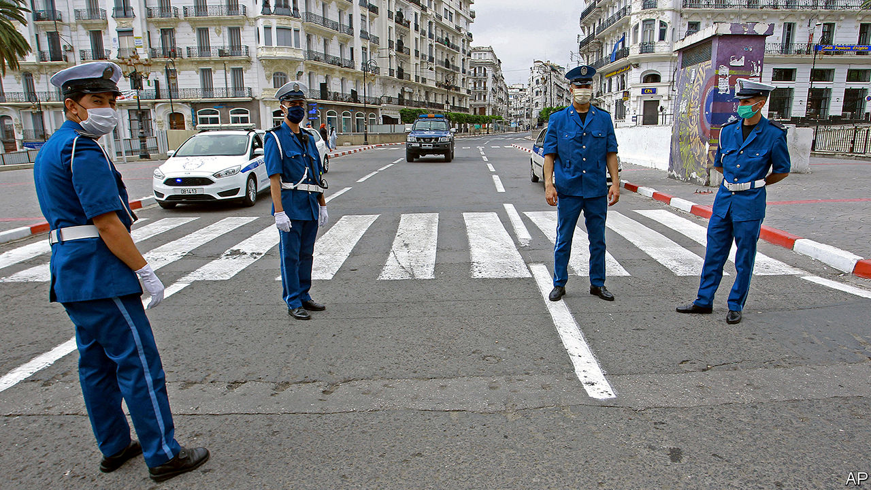

COVID-19 HAS killed around 700 people in Algeria, says the government, but the real toll is surely higher. The pandemic has also crippled the country’s economy. Last month President Abdelmadjid Tebboune announced that the state budget would be cut in half because of plummeting oil revenue. The virus, though, has helped Mr Tebboune in at least one way. With the country locked down to prevent its spread, protesters have been forced off the streets. Hundreds of thousands of them had been marching for over a year, even after toppling the previous president, Abdelaziz Bouteflika, in April 2019. Their work was unfinished: many of the old economic, political and military elite remained in power. The nature of the system had not changed. Now the protesters must decide how and when to try to finish the job.

Like other countries, Algeria banned all public gatherings in response to the virus. But, unlike elsewhere, the authorities seem in no hurry to loosen things up again. Mr Tebboune recently extended the lockdown, including a 5pm curfew, until June 13th. The government has used the outbreak to repress the Hirak, as the protest movement is known, blocking critical websites, banning what it calls “fake news” and arresting some who moved their opposition online. Many of the movement’s leaders were already in jail, charged with vague crimes such as “harming national unity” or attacking “the integrity of national territory”. Efforts to reduce prison overcrowding during the outbreak by freeing some detainees have excluded Hirak leaders (though two will soon be freed, says the leader of an opposition party).

## Constitutional concerns

For years the Hirak organised, while the government of Mr Bouteflika, an ailing octogenarian, did little. Now it is the protesters who feel incapacitated. Many want to return to the streets before Mr Tebboune can do more harm. They had considered him a weak president, the victor of an election in December that most voters boycotted. But, with no active opposition, he has drafted a new constitution that maintains his existing powers, such as the authority to hire and fire prime ministers and judges, and adds some extra ones. Activists refused to take part in discussions of the document, questioning the president’s timing and doubting his intentions. Meanwhile, the old ruling parties are regrouping.

But the Hirak also spies an opportunity. The lockdown has exacerbated many of the socioeconomic grievances that prompted the protests in the first place. Millions are jobless in a country which has no unemployment benefit. The government has given the poorest families a one-time handout of 10,000 dinars ($78), equal to about two weeks of the minimum wage. With oil revenues plummeting, Mr Tebboune lacks the money to soothe a growing sense of hogra (alienation from the regime). The Hirak wants to tap into that frustration.

Protesting is risky while the threat of the virus persists, and not just for health reasons. The lockdown could give the generals an excuse to open fire, which some have long wanted to do. That might, in turn, trigger a violent response from the protesters, who have remained remarkably peaceful and united. Old divisions could re-emerge, between liberals and Islamists, Berbers and Arabs, rich and poor. If the people fear another civil war, like the one that killed tens of thousands in the 1990s, they may abandon the Hirak.

Some are already taking to the streets, though. Before the pandemic the biggest protests were in Algiers, the capital. Today the provinces are stirring. In Bejaia, a city in the Berber heartland about 200km east of Algiers, business owners have protested against the lockdown and activists have blocked the police from arresting their friends. In nearby Kherrata, which was the first town to rise against French colonial rule, demonstrators chanted anti-government slogans during Eid al-Fitr celebrations last month. Protests are expected to resume soon in Algiers, too. “It’s going to be a hot summer,” says a businessman in the capital. ■

This article was downloaded by calibre from <https://www.economist.com/middle-east-and-africa/2020/06/04/algerias-protest-movement-considers-how-and-when-to-come-back>

|  |  |  |  |
| --- | --- | --- | --- |
| Previous | Articles | Sections | Next |

|  |  |  |  |
| --- | --- | --- | --- |
| Previous | Articles | Sections | Next |

#### No rain, slow gains

# In the dry season, Nigeria’s army puts Boko Haram on the back foot

But the coming rains could bog it down and let the jihadists regroup

Jun 4th 2020 | LAGOS

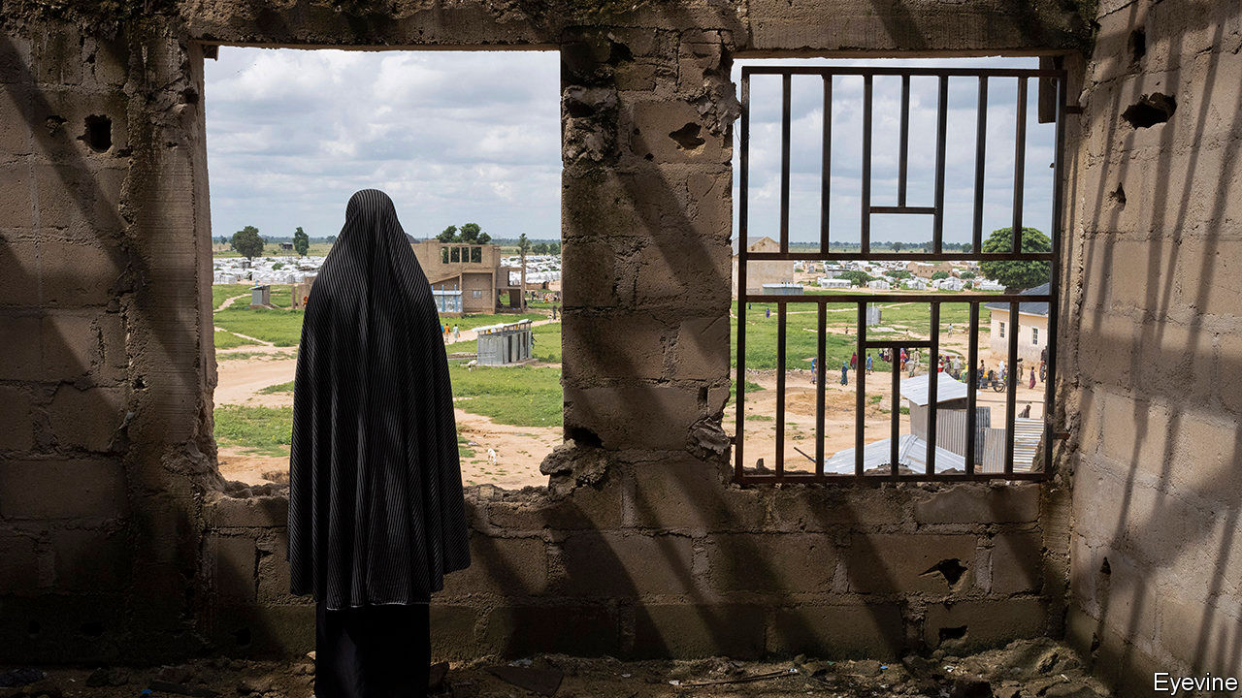

THE CHIEF OF STAFF of Nigeria’s army, General Tukur Buratai, has often declared victory over Boko Haram, a jihadist group known for kidnapping girls and strapping bombs to children. But it was only in April, after soldiers from neighbouring Chad attacked the rebels’ bases, that he felt confident enough to move his headquarters from Abuja, the sleepy federal capital, to Borno state, the heart of the insurgency. It was intended as a signal that Nigeria was entering the final stages of a bloody war that has raged for more than ten years and cost perhaps 40,000 lives, according to the Armed Conflict Location & Event Data Project (ACLED), a non-profit organisation based in America.

Nigerian forces claim to have made big advances and to have killed more than 1,000 insurgents in recent weeks. Few Nigerians believe the government’s numbers or that it is winning the war, since it has been saying so since late 2015. But audio messages released by Abubakar Shekau, the leader of Boko Haram’s main faction, since April suggest the group is indeed hard-pressed. In one of them he wept and prayed for protection from the “devilish” army as he urged his men to stand firm.

But some Nigerian soldiers, casting a weather eye at the horizon, are less confident that the army can keep up its advance in the months ahead. In the dry season, which runs roughly from October to April, the cloudless sky is ideal for air strikes. The ground is baked hard enough for armoured vehicles to move around. Leaves and grass shrivel up, enabling government troops to spot insurgents far away.

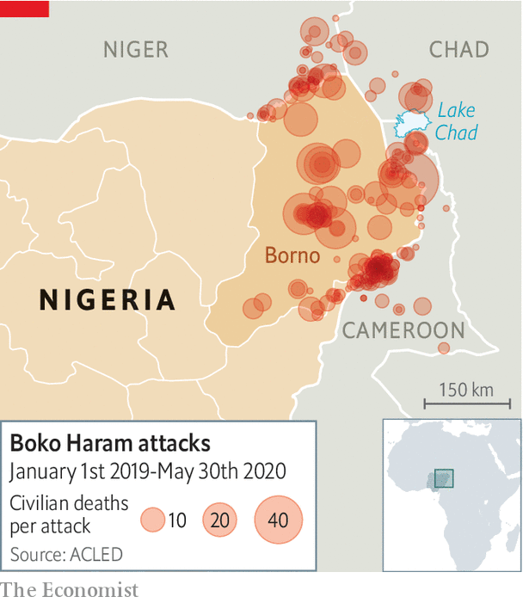

The coming rains, though, will turn the earth to knee-deep mud, says a staff sergeant in the army. Soldiers in bogged-down trucks will become sitting ducks. The insurgents, who often zip around on motorbikes, may regain the initiative. “The only thing we do in the rainy season is ambush,” says the sergeant. Artillery shells often fail to detonate when hitting the damp soil, leaving a trove of explosives that the rebels turn into roadside bombs, says Ahmad Salkida, the editor of HumAngle, a digital news site.

The seasonal ebb and flow of the war is becoming wearingly familiar. ACLED data suggest that government attacks on Boko Haram pick up in the dry season. At this time the group lies low, leaving most of the attacking to Islamic State West Africa Province, a splinter group with links to jihadists in Syria and Iraq.

In the rainy season the army usually retreats into its base camps dotted across Borno. But last year several of them were overrun. Some reckon that 750 soldiers and police were killed in 2019, almost twice as many as have been killed in any other year of the war (the government withholds figures). As a result, the army retreated even farther, into a handful of “super camps”. The lull let Boko Haram recruit men and raise funds.

Yet there is some hope that this time the seasonal cycle may be broken. After Mr Shekau’s faction killed 92 Chadian troops in March, Chad retaliated fiercely with an offensive that killed 1,000 rebels and led to the capture of huge weapon caches. Nigerian forces are also adapting their tactics to the weather, swapping their heavy trucks for lighter Toyota pickups, says Murtala Abdullah, a security analyst. These may have lighter armour and firepower but are less likely to get bogged down. Much will depend on whether the army keeps up the pressure or takes another rain-check. ■

This article was downloaded by calibre from <https://www.economist.com/middle-east-and-africa/2020/06/04/in-the-dry-season-nigerias-army-puts-boko-haram-on-the-back-foot>

|  |  |  |  |
| --- | --- | --- | --- |
| Previous | Articles | Sections | Next |

|  |  |  |  |
| --- | --- | --- | --- |
| Previous | Articles | Sections | Next |

#### “You can’t just say ‘please’”

# How Ugandan feminists make themselves heard

Asking nicely will not stop sexism, some say

Jun 4th 2020 | KAMPALA

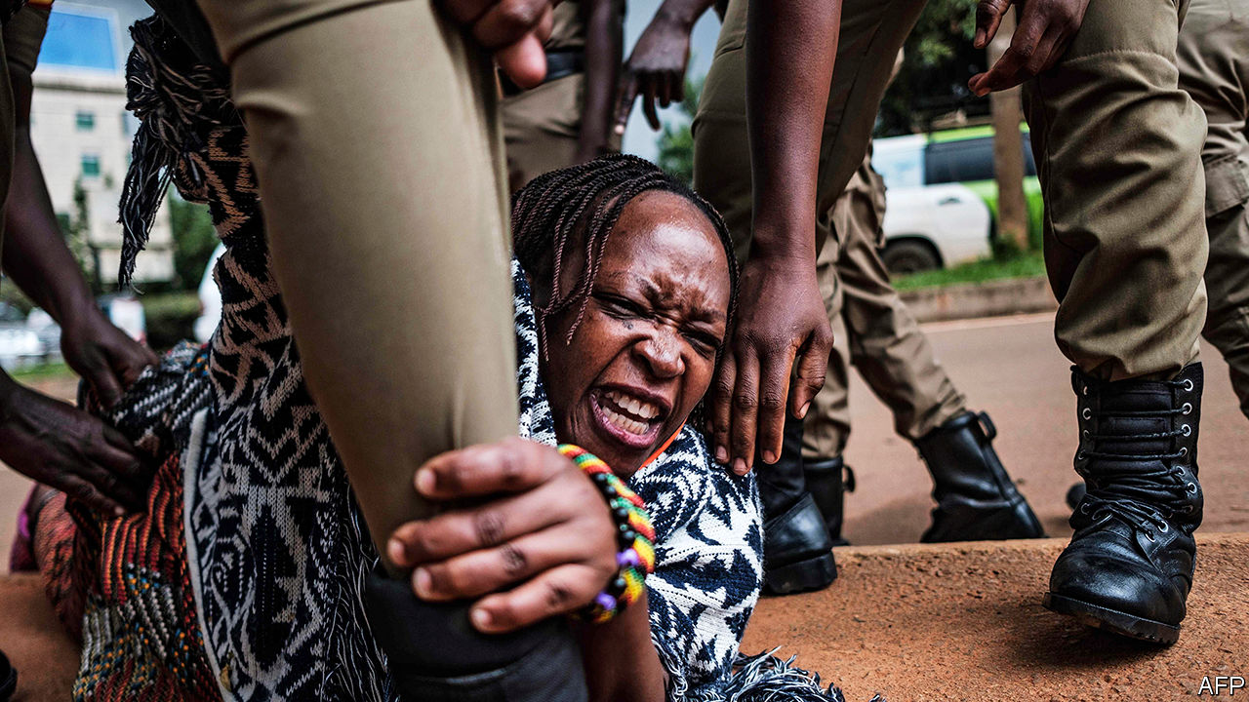

SAMANTHA MWESIGYE, a Ugandan lawyer, used to take offence when people called her a feminist. Everybody knew that feminists were loud, rude and a little bit mad. But then she decided to go public with allegations against her boss, the deputy solicitor-general, who she says ridiculed and victimised her after she would not have sex with him. He denied it—while claiming that her clothing was “unacceptably revealing and seductive”—and was later cleared by a committee. Feminist groups took out a full-page advert in a national newspaper declaring that they believed her. She wept when she read it. If that is how to get heard, she says, then “hell yeah, I’m a feminist.”

A new wave of activism is spreading in Uganda, rippling through WhatsApp groups and Twitter hashtags, as young women push back against harassment and unequal treatment. Those who call themselves feminists are a tiny minority. And Ugandan politics are still largely a power struggle between men. But Ugandan feminists are determined to make their views heard. “Political change is nothing if there’s no social change in the way men perceive women,” says Rosebell Kagumire, the editor of African Feminism, a website.

There is much to do. At Makerere University, young women recall their time in high school. One was trained to sit and talk “like a woman”. Another recounts how older boys would vet potential prefects: “They start making you turn around to see how big your butt is.” A student activist remembers a call from a female administrator advising her to leave serious business to the men. “It’s hard to be a feminist,” says Marion Kirabo, a law student. “It becomes a constant war between you and society.”

The state is both priggish and prurient. It orders female civil servants not to wear short skirts. But it also organised a “Miss Curvy” beauty contest to entice foreign tourists. Women whose nude photos are shared online without their consent have been arrested. Meanwhile, a senior policeman recently blamed women who “wiggle their butts seductively” for causing road accidents. He added that “unnecessary exposure of [female] flesh amounts to sexual assault”—on the men who see it.

Social conservatism divides the women’s movement itself. Many campaigners describe themselves as “gender advocates” rather than feminists, because they reject permissiveness on issues such as abortion, says Eunice Musiime of Akina Mama wa Afrika, Uganda’s most influential feminist group. She describes meetings where some attendees would refuse to sit next to a gay person or talk to a sex worker.

However, more radical voices are finding each other online. Stella Nyanzi (pictured), an activist with more than 200,000 Facebook followers, likens social media to “a gym in which feminists grow muscles”. Several women have made accusations against abusers online; one was even arrested for doing so. Twitter and Facebook have “taken the movement out of NGO boardrooms”, says Godiva Akullo, a lawyer.

Ugandan feminists talk about race as well as sex. Many draw as much inspiration from #BlackLivesMatter as from #MeToo. Ms Kagumire notes ways in which black women are doubly disadvantaged. For example, Western embassies interrogate single African women applying for visas, assuming that they are seeking a husband.

Online organising amplifies offline struggles. In 2018 hundreds of people marched through Kampala to protest about the police’s failure to stop the kidnapping and murder of scores of young women. And women are taking the lead in wider struggles. Last year Ms Kirabo and her fellow students led what started out as a women’s protest against rising tuition fees. Male students joined them in demonstrations that halted lectures for weeks.

Their protests draw on a decades-long tradition of women-led resistance. For at least a year market vendors have fined traders who harass them. And for generations rural women have used nudity to protest against injustices such as land theft.

The fearless Ms Nyanzi has clashed with the president himself. In 2017 she lambasted Janet Museveni, the education minister (and the president’s wife), who had said there was no money in the budget to buy sanitary pads for schoolgirls. Ms Nyanzi later spent 16 months in prison after writing a poem about the vagina of the president’s mother. She shouts, strips and swears. “You can’t just say ‘please don’t do it,’” she has said. “You’ve got to say ‘fucking don’t do it’ and shake your dreadlocks like a crazy woman and throw off your dress.” ■

This article was downloaded by calibre from <https://www.economist.com/middle-east-and-africa/2020/06/04/how-ugandan-feminists-make-themselves-heard>

|  |  |  |  |
| --- | --- | --- | --- |
| Previous | Articles | Sections | Next |

|  |  |  |  |
| --- | --- | --- | --- |
| Previous | Articles | Sections | Next |

#### A borrowers’ catch-22

# African governments face a wall of debt repayments

But many are surprisingly reluctant to accept relief

Jun 6th 2020 |

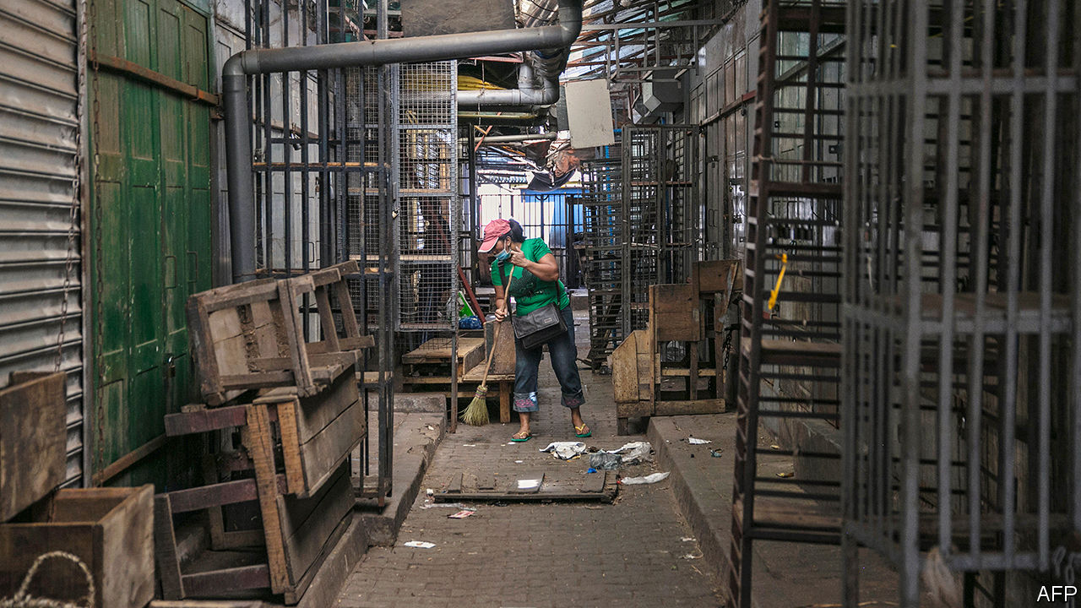

IT IS ALMOST a law of nature. Just as the female praying mantis eats her mate after copulation, so too can borrowers and lenders fall swiftly out of love. One minute they are sweetly wooing each other to consummate a deal. Then, the moment it is done, they are at each other’s throats.

So it is odd that African governments and their creditors have not yet fallen out. They have plenty to quarrel about. Africa’s debt crisis has been simmering for some time. Two years ago the IMF was already anxious about a growing number of African countries in “debt distress” or at high risk of it. This crisis was brought to the boil by covid-19, which has caused economies to shrink and tax revenues to plunge. Governments have ramped up spending to fight the virus. Investors are scared. In recent weeks the bonds of nine countries have traded at prices indicating that they might not be repaid.

The IMF and World Bank have lent emergency cash, but a financing gap of at least $44bn remains. Various bigwigs have called for debt relief, including Abiy Ahmed, Ethiopia’s prime minister, and Larry Summers, a former American treasury secretary. Yet neither borrowers nor lenders seem enthusiastic.

The G20 club of countries has agreed to suspend bilateral debt-service payments for the rest of this year for the world’s 73 poorest countries, if they ask. Yet uptake has been low. In seven weeks fewer than half of eligible countries have requested assistance. Only seven have been given it.

Struggling governments are not asking for help because they fear being seen as deadbeats. “We need to make sure we are protecting our hard-earned access to international capital markets,” says Amadou Hott, Senegal’s minister of economy. “The best way to do it is, at any cost, to protect our commitments with private creditors.” This, he adds, is the view of all the African finance ministers to whom he has spoken.

Most of the 21 African countries that have sold bonds abroad have done so for the first time only in the past decade. Long-term borrowing is even more recent, but in 2018 eight African countries successfully issued 30-year bonds. This borrowing is expensive. Interest rates on foreign-currency government bonds sold by African countries are roughly seven percentage points higher than those sold by rich countries, because investors see them as riskier.

Asking for help could confirm that view. Romuald Wadagni, Benin’s finance minister, writes that taking advantage of the G20 offer could be treated as a default by private creditors, even though they are not directly involved. Moody’s, a credit-rating agency, says it may downgrade its assessment of Cameroon, Pakistan and Ethiopia because they went for it. To avoid this fate, Senegal plans to shun the offer. Kenya says it will do likewise, because the small print would restrict its ability to borrow commercially.

Even if African countries were to take up the offer of help from bilateral creditors (these are usually governments or their export-finance arms), including the biggest of them all, China, they would still have other worries. Roughly a third of sub-Saharan Africa’s government debt is owed to private investors. Bondholders alone are owed $115bn. The mere act of asking private creditors for leniency would probably lead to a credit downgrade. And actually renegotiating repayment terms would probably be classed as a default, say rating agencies.

For the most troubled countries, such as Zambia, the point is moot. In 2012 it was able to borrow more cheaply than Spain. Now it is priced right out of the market and has hired Lazard, a financial advisory firm, to help it restructure its debt. Angola, which needs to hand over $500m to private bondholders this year and almost certainly more to China, has also begun talks.

But for countries such as Ivory Coast, Ghana and Senegal, which owe private creditors as well as G20 governments, the judgments are tougher. Stopping payments for a while would free up funds to fight the coronavirus. But after the crisis they will need cash from investors.

Under pressure from the G20 to offer debt relief, private creditors have come up with a grudging proposal. The Institute of International Finance, an industry group, has proposed allowing struggling governments to take a payment holiday. Afterwards, they would have to pay back everything they owe, including extra interest. This resolves little, since it would simply store up trouble, leaving weary countries with an even bigger mountain of debt to climb. And even in the short run it locks African governments into a catch-22. To have even a slim chance of avoiding being deemed in default, they will have to agree to new repayment terms that leave creditors no worse off than now. But if they ask, they risk a downgrade with no guarantee that private creditors will agree.

Vera Songwe of the UN Economic Commission for Africa hopes to find another solution. She favours creating a new body that would borrow cheaply and then lend money to governments. However, it would need backers with deep pockets willing to guarantee that private lenders would not take a loss. It has found few volunteers.

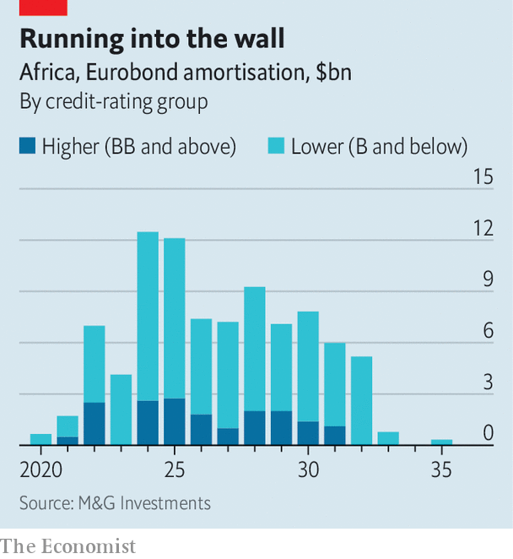

There is not much time to act. African bond issuers face a wall of payments starting in 2022 (see chart). Many hope they are just experiencing a short-term cash crunch. But unless their economies rebound quickly—or they get more help from the rich world—a wave of defaults seems inevitable. If so, it may be better to take the hit and restructure debt now, while hoping that credit markets have short memories. Ken Ofori-Atta, Ghana’s finance minister, pointed out in a webinar hosted by Harvard University that rich countries were taking extraordinary measures to protect their economies, while telling Africans to stick to the rules. “You really feel like shouting: ‘I can’t breathe,’” he said. ■

Editor’s note: Some of our covid-19 coverage is free for readers of The Economist Today, our daily [newsletter](https://my.economist.com/user#newsletter). For more stories and our pandemic tracker, see our [coronavirus hub](https://www.economist.com/news/2020/03/11/the-economists-coverage-of-the-coronavirus)

This article was downloaded by calibre from <https://www.economist.com/middle-east-and-africa/2020/06/06/african-governments-face-a-wall-of-debt-repayments>

|  |  |  |  |
| --- | --- | --- | --- |
| Previous | Articles | Sections | Next |

|  |  |  |
| --- | --- | --- |
| Middle East & Africa | Sections | Britain |

Europe

Inequality and the pandemic: Widening spread

.

Spain: A more equal country

.

Poverty in Italy: Hitting the poorest hardest

.

France: Time for a reboot

.

Germany: Social distancing and sex work

.

Slovenia: Barbarians at the gates

.

Turkey and covid-19: Strength in numbers

.

|  |  |  |
| --- | --- | --- |
| Middle East & Africa | Sections | Britain |

|  |  |  |  |
| --- | --- | --- | --- |
|  | Articles | Sections | Next |

#### Disparate impact

# Covid-19 threatens Europe’s success at fighting inequality

Only the richer countries can do much about it

Jun 6th 2020 | AMSTERDAM

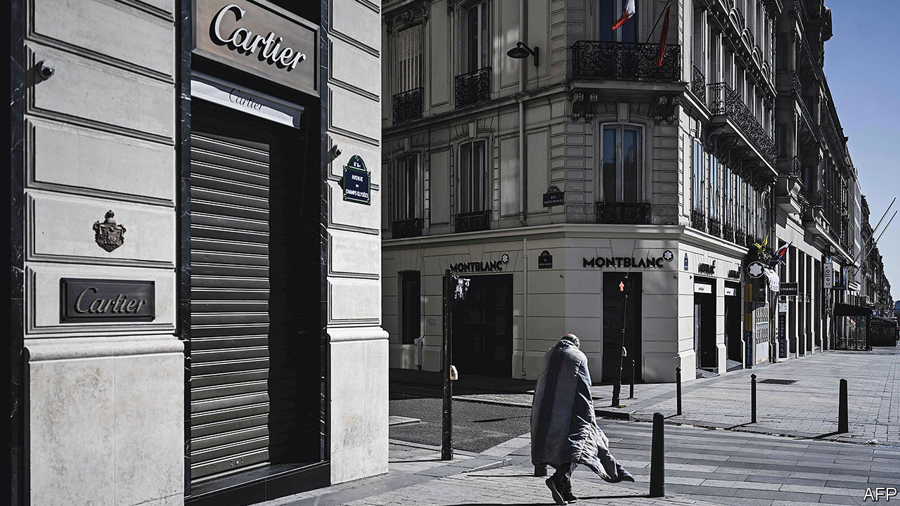

Editor’s note: Some of our covid-19 coverage is free for readers of The Economist Today, our daily [newsletter](https://my.economist.com/user#newsletter). For more stories and our pandemic tracker, see our [coronavirus hub](https://www.economist.com/news/2020/03/11/the-economists-coverage-of-the-coronavirus)

CARNIVAL SEASON in the southern Netherlands is a week-long spectacle of Rabelaisian debauchery. On February 28th Leon Elsjan of Wipper, a freelance sound technician, was running the sound system at the carnival-ending dance party in the town of Uden, watching costumed revellers consume vast amounts of beer. It would be his last gig for some time. This year’s carnivals were super-spreader events that introduced covid-19 to the Netherlands. In Uden, the death toll rivalled those in northern Italy, and the national government cancelled all public festivals until September.

Mr Elsjan of Wipper did not fall ill, but as a freelance, he was vulnerable in another way. To cope with the economic fallout from covid-19, the Netherlands introduced a wage-support programme similar to Germany’s Kurzarbeit system. The state pays 90% of the salaries of workers at hard-hit firms. But self-employed workers (12.5% of the labour force) are not covered. For them, the government created a bare-bones programme. Mr Elsjan of Wipper gets the maximum: €1,050 ($1,170) per month.

For decades, Europe’s vaunted welfare states have kept inequality relatively low. The covid-19 recession threatens that success in three ways. First, it hits badly paid workers harder than well-paid ones. Second, lockdowns create new forms of inequality. Some sectors stay open while others shut down, and some people can work from home while others cannot. Third, the severity of the downturn has revealed holes in Europe’s welfare systems. Some countries are patching them, but others are having trouble.

Quantifying inequality is hard, but Europe is clearly relatively egalitarian. One metric is the Gini coefficient, measured from zero (perfect equality) to one (perfect inequality). For income after taxes and transfers in 2017 (the most recent year available for comparison), the Gini coefficient of the EU was about 0.30. In America it was 0.39, while east Asian countries like Japan and South Korea fell in between.

Before taxes and transfers, the picture is different: on this basis Germany’s Gini, for example, is roughly the same as America’s. Europe’s tax systems are not particularly progressive, so economists have long put its success in fighting inequality down to large transfer programmes. But scholars at the World Inequality Lab (WIL), an academic project, argue that this is a mistake. European transfers look so generous partly because European pensions are mostly public, while in other countries they are mostly private. Treat pensions as earned income and the apparent size of European welfare states shrinks—yet the transatlantic inequality gap remains.

Other analysts dispute the WIL’s data, especially on America. But according to the lab, in 1980 the income shares of the bottom half and the top 1% of earners in America and Europe were similar. By 2017 America’s rich and poor had flipped, whereas in Europe the bottom half still earned more. “The European social model is mostly effective through ‘predistribution’: investments in education, universal health care, and regulations of labour markets that compress the wage scale,” argues Lucas Chancel of the WIL. In many countries unions strike wage bargains covering entire sectors of the economy. The Nordics are the most equal. Western European countries like France, and southern ones like Italy, rely more on redistribution. Eastern Europe does little predistribution or redistribution, and its inequality levels are higher.

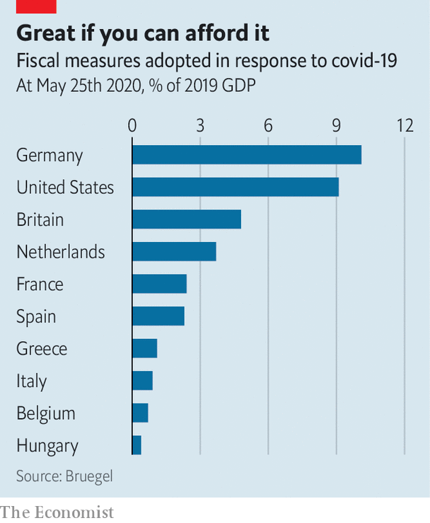

In some countries inequality was rising before covid-19, partly because labour regulations have been liberalised. In Germany, the income shares of the top tenth and the bottom half of earners were equal when labour reforms passed in 2004; by 2017 the top decile earned more. Other countries, such as the Netherlands and Italy, had rising numbers of part-time or gig workers, who enjoy fewer protections and benefits.

Covid-19 has made such gaps painfully visible. Spain’s government realised it had no mechanism to support the incomes of the large percentage of the population that works informally. That prodded the country’s Socialist-led government to introduce a guaranteed minimum income law, which was issued as a decree last week (see [article](https://www.economist.com/europe/2020/06/06/spains-embattled-government-proposes-a-new-anti-poverty-scheme)). In Italy, workers in the country’s huge informal sector may have trouble accessing its emergency covid-19 benefits.

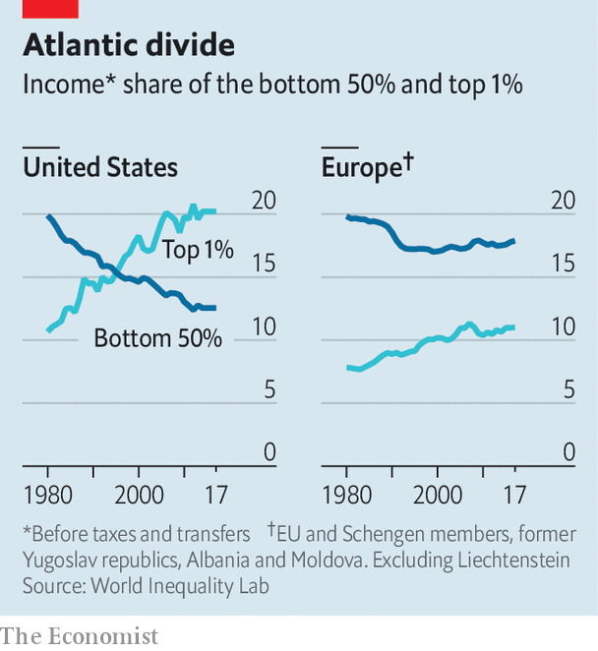

Italy’s central bank thinks the country’s Gini coefficient rose from 0.35 to 0.37 in the first quarter. This was partly because of lockdowns, a problem that will certainly have become worse in the second quarter as the lockdown continued. Among the top income quintile, only about half of employees were in occupations hard to pursue from home; in the bottom quintile almost 90% were. Other inequalities are geographical. “Southern Italy has barely any covid-19 deaths, but because it is reliant on tourism it is being hit much harder,” says Carlo Bastasin, an economist at the LUISS university in Rome.

Three-quarters of Europe’s income inequality, measured at a continental level, is caused by differences within individual countries. The gap between poor Sicily and wealthy Milan is more important than that between Milan and Paris. But that could change. The covid-19 recession opens up a split between countries that have the fiscal capacity to rein in inequality and those that do not—notably in central and eastern Europe. Germany’s government intervention has amounted to almost 10% of GDP. Italy and Spain, constrained by debt, have done much less. Hungary has barely raised spending; Poland has done so mainly to prop up companies, not to subsidise workers or the unemployed.

In recent years, some economists have argued that wars and pandemics can lower inequality by destroying the wealth of the rich and creating opportunities for the masses. In a paper last month, economists from the IMF found that for epidemics, this did not hold: the big ones of the past century raised inequality. Mr Elsjan of Wipper does not count on his industry coming back: “When I talk to younger guys, I tell them to think about another career.” ■

This article was downloaded by calibre from <https://www.economist.com/europe/2020/06/06/covid-19-threatens-europes-success-at-fighting-inequality>

|  |  |  |  |
| --- | --- | --- | --- |
|  | Articles | Sections | Next |

|  |  |  |  |
| --- | --- | --- | --- |
| Previous | Articles | Sections | Next |

#### Raising the floor

# Spain’s embattled government proposes a new anti-poverty scheme

A permanent top-up for the incomes of the worst-off Spaniards

Jun 4th 2020 | MADRID

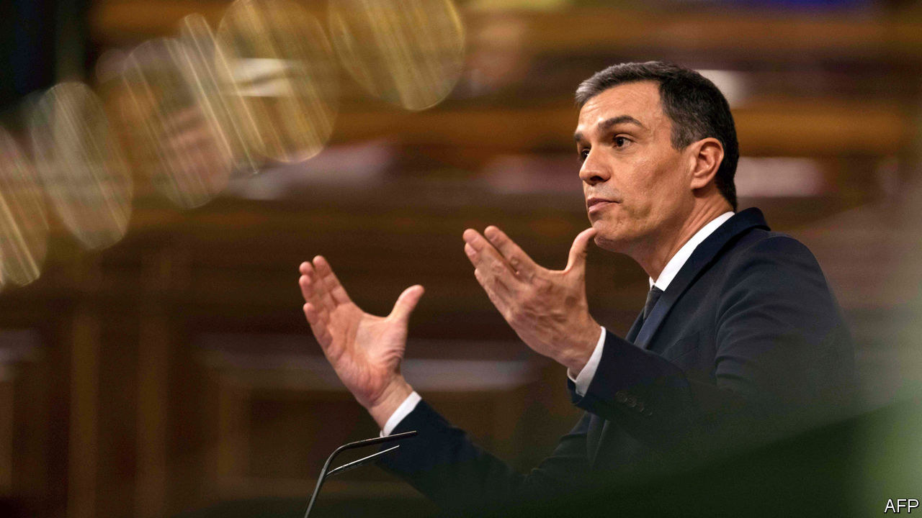

IN WORKING-CLASS southern Madrid there are queues for food at community centres and parish soup kitchens. Caritas, a Catholic charity, reports a surge in demand for its help. Covid-19 has exposed holes in Spain’s welfare state, just as the slump after 2008 did. This time, though, the government is trying to plug the gaps. Some of the aid is temporary: almost 4m furloughed workers have been getting 70% of their wages paid by the state, which has also made emergency payments to 1.2m self-employed people.

On May 29th the government, a left-wing coalition headed by Pedro Sánchez, approved something big and permanent: a minimum income for those who fall through the cracks. Backdated to June 1st, the new scheme will pay up to €1,015 per month to families and €461.50 to single people who are “severely poor”. (The government defines this as making less than 40% of the median income of €1,050 per person each month.) José Luis Escrivá, the social-security minister and architect of the scheme, thinks 850,000 households or 2.3m people will qualify, mostly women and children.

Spain has long had a poverty problem, partly because successive governments have concentrated on transport infrastructure, in a large and mountainous country, rather than social assistance. Before the virus struck, 12.4% of Spaniards fell below the 40% of median income threshold. In the EU as a whole, only 6.9% of people do.

Until now social assistance has been the purview of the regions, and varies greatly. The rich Basque country is generous; poor Andalucía is not. “Something that was designed to reduce inequality had the opposite effect,” says Mr Escrivá. The regions will now be free to redirect their spending. The new scheme has innovative features. To identify those eligible the government is enlisting the help of NGOs as well as town halls. To provide incentives, the payment will be tapered if earned income increases.

Podemos, the far-left member of the coalition, initially championed a broad universal basic income. Mr Escrivá’s scheme is the “opposite”, he says: a tightly targeted top-up costing, he thinks, around €3bn a year (0.24% of GDP). Some in the opposition worry that even that may not be affordable when Spain is heading for a huge budget deficit. Nevertheless, the scheme has been broadly welcomed. Only Vox, a hard-right party, says it will vote against it.

For Mr Sánchez’s minority government, that is balm after a rough fortnight. Spaniards are reeling from one of the world’s worst covid-19 epidemics. By the (disputed) official count, 28,000 people have died. A strict lockdown has brought the virus under control. Officials are defensive over accusations that they were slow to impose it. The interior minister sacked the head of the civil guard in Madrid, prompting two guard generals to resign, after he sent a report to a judge which confirmed that claim (although the evidence was flimsy).

As well as being accused of undermining the police, Mr Sánchez, a Socialist, has struggled for parliamentary support to continue the state of emergency which he thinks is needed to enforce his deconfinement plan. The coalition parties last month reached an agreement with a Basque separatist party, which abstained in return for a promise to tear up a job-creating labour reform from 2012. That infuriated the opposition and private business, and prompted open dissent from the economy minister, Nadia Calviño.

This week Mr Sánchez secured a final extension of the emergency, until June 21st, but only by agreeing to let regional governments fix most of the rules. Long after these rows have faded, the income-supplement scheme should make Spain a more equal country. ■

This article was downloaded by calibre from <https://www.economist.com/europe/2020/06/04/spains-embattled-government-proposes-a-new-anti-poverty-scheme>

|  |  |  |  |
| --- | --- | --- | --- |
| Previous | Articles | Sections | Next |

|  |  |  |  |
| --- | --- | --- | --- |
| Previous | Articles | Sections | Next |

#### Hitting the poorest hardest

# Italy’s informal workers fall back on charity

When covid-19 kills their jobs, they cannot expect much state help

Jun 6th 2020 | LIVORNO

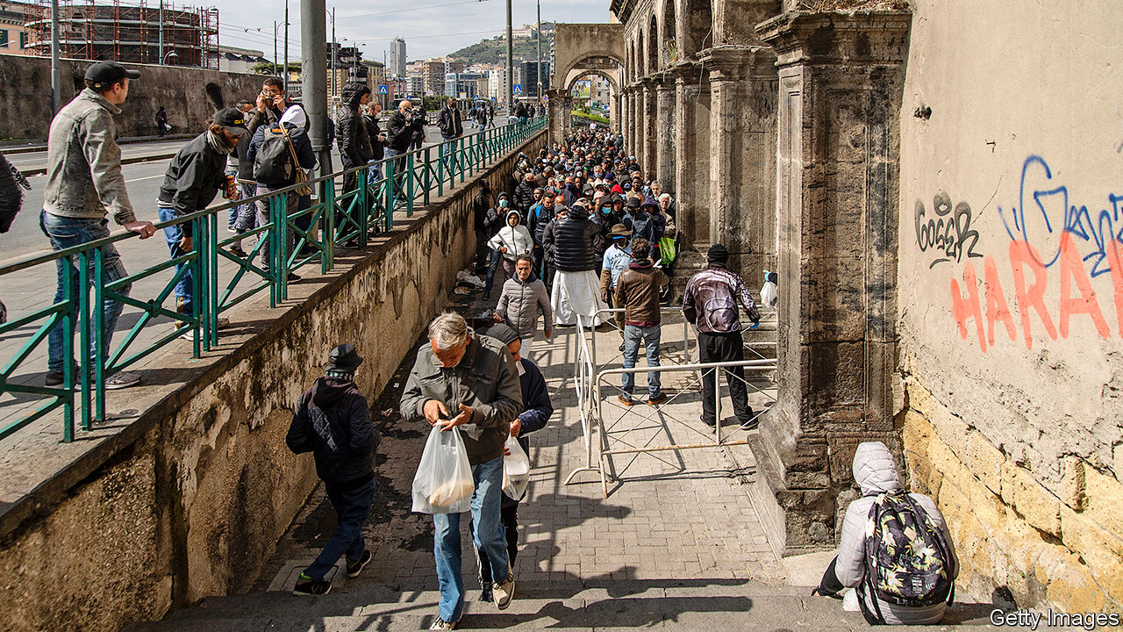

UNDER ITALY’S stringent lockdown, Chiara Bosi spent almost three months with her husband and four children in a flat of only 45 square metres. (“More of a hole than an apartment,” she says.) On June 3rd the last restrictions were lifted. Italians were freed to travel abroad and between regions. But Ms Bosi and her family no longer have enough to live on.

She was working without a contract in Italy’s vast “informal” economy, as a cook in beachside bars and restaurants. Now, she says, her former employers have so few customers they can get by with just two or three staff. Her husband is a casual worker in the port of Livorno. Last month, he got only one shift.

“I had four children, expecting to lead a comfortable life. I didn’t expect to be rich,” says Ms Bosi. “But this? This is humiliating.” She has come to the entrance of their rundown apartment block to receive a food parcel from a local NGO, Amici della Zizzi.

Amici was founded to take care of children from poor families, helping 30 to 40 families in normal times. But as the virus spread, says Riccardo Ripoli, its president, it was inundated with appeals. His volunteers began collecting donations of food outside supermarkets. At one point, Amici della Zizzi was distributing food to around 500 families.

“But now people are getting a bit fed up with donating,” says Mr Ripoli. “A lot are frightened that they too could soon be on the breadline.” The pandemic may be petering out in Italy, which is now recording daily covid-19 deaths in only double figures. But the poverty crisis has only just begun in a country that is by one measure the most unequal in the euro zone. (The persistent economic weakness of southern Italy compared with the north is the main reason for this.)

At first glance, Italy is well placed. Furloughing, a novelty in a number of countries, has long been standard practice in Italy for companies in temporary difficulty. Thanks to the anti-establishment Five Star Movement, part of Giuseppe Conte’s left-leaning coalition government, many of the poorest in society can claim a “citizenship income” to top up their earnings or pensions. And the government has introduced numerous measures to deal specifically with the coronavirus crisis. These include emergency payments to the neediest, mortgage freezes and a ban on evictions from homes.

But in other ways Italy is acutely vulnerable. Its informal economy is vast, accounting for around 14% of total output. Those who work in it often have no claim to state welfare. The rest of the labour market depends heavily on short-term contracts. One of the categories most at risk in the current situation comprises workers whose contracts expired during lockdown. A large number of irregular immigrants are also vulnerable. On June 1st the authorities launched a process that is expected eventually to regularise around 220,000 people. But some estimates of the total number of irregular immigrants currently in Italy exceed half a million.

Italy has generally been able to withstand periodic crises because of its high level of savings. But even though many Italians continue to believe they belong to a nation of savers, the truth is markedly different. According to the OECD, an organisation of mainly rich nations, Italian households set aside only 2.5% of their disposable incomes—less than half of the euro-zone average of 5.7%.

Federica De Lauso, a researcher at Caritas, a Catholic charity, says a further handicap has been delay. Furlough payments to workers on contract have had to go through a tortuous bureaucratic procedure that has only recently been simplified. “But there are people who have not received anything since March, and they include many who have turned to us,” she says. ■

Editor’s note: Some of our covid-19 coverage is free for readers of The Economist Today, our daily [newsletter](https://my.economist.com/user#newsletter). For more stories and our pandemic tracker, see our [coronavirus hub](https://www.economist.com/news/2020/03/11/the-economists-coverage-of-the-coronavirus)

This article was downloaded by calibre from <https://www.economist.com/europe/2020/06/06/italys-informal-workers-fall-back-on-charity>

|  |  |  |  |
| --- | --- | --- | --- |
| Previous | Articles | Sections | Next |

|  |  |  |  |
| --- | --- | --- | --- |
| Previous | Articles | Sections | Next |

#### Time for a reboot

# France’s President Emmanuel Macron mulls a reshuffle

Some think he will ditch his prime minister

Jun 6th 2020 | PARIS

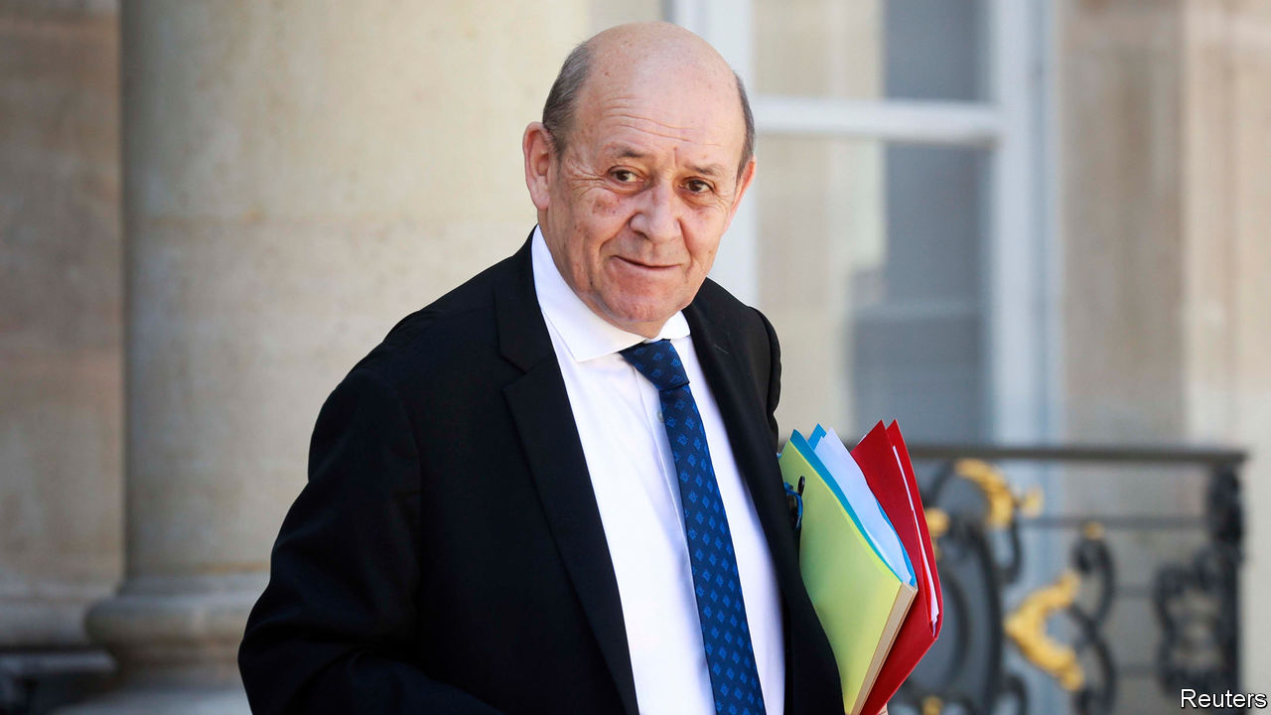

WHEN EMMANUEL MACRON ran for president in 2017 as a first-time campaigner, sceptics repeatedly asked: but which party would he govern with? The 39-year-old had no deputies, few allies and a new-born movement. Against the odds, he went on to crush the established parties and secure a parliamentary majority for his centrist La République en Marche (LREM). Three years later, however, the cracks are showing. Mr Macron’s party has lost its absolute majority, and is facing disaster in coming local elections. The president is again struggling in the polls. As he searches for a way to reboot his presidency, Mr Macron could even decide to change his prime minister, Edouard Philippe, before the summer is out.

A sign of discontent within the governing party emerged last month when a group of deputies quit LREM to set up a new parliamentary group, “Ecology, Democracy, Solidarity”. The 17-member faction is almost entirely composed of former Macron supporters, disillusioned with what they consider to be an excessively centre-right government. The group has not formally joined the opposition, but says it will freely vote against Mr Philippe’s government if it dislikes what it sees.

By itself, the loss of LREM’s absolute majority will not affect Mr Macron’s policymaking. The government retains a solid working majority in parliament, thanks to the formal backing of 46 deputies belonging to a centrist party, MoDem, as well as over a dozen other deputies on the centre-right. Yet it is symbolically and structurally damaging. It is “not the end of the world”, says Roland Lescure, an LREM deputy, “but it does reveal that we are still missing an ideological backbone.”

Four years after Mr Macron founded a movement designed to be “not on the left, not on the right”, a cohesive unifying purpose is proving elusive for LREM. The party barely exists outside Paris. New strains are emerging in advance of the second round of local elections on June 28th, postponed from March due to covid-19. To the consternation of LREM, Gérard Collomb, a close ally of Mr Macron’s and his former interior minister, has teamed up with the right for the second round of voting in Lyon. LREM has withdrawn its backing from Mr Collomb’s candidacy. Mr Macron’s hopes of winning the Paris town hall, meanwhile, have evaporated after his candidate, Agnès Buzyn, came a disappointing third. Anne Hidalgo, the Socialist mayor, is likely to keep her job.

To try to get a grip, Mr Macron is now mulling over ways to reset the presidency for his remaining two years in office. Elected on a promise of disruption, he wants a purpose more suited to turbulent times. The president has already suspended—probably indefinitely—an unpopular pension reform, which in effect raised the retirement age and prompted weeks of strikes. France is bracing for a rude economic shock, with the government now expecting a drop in GDP of 11% in 2020. The covid-19 pandemic has pushed quite different concerns to the fore: safety, security, self-sufficiency and a stronger state. Mr Macron has installed a committee of international economists under Olivier Blanchard and Jean Tirole to help come up with ideas. In a televised address, the president said enigmatically that it was time for “reinvention, of myself first of all”.

Despite the post-partisan idea behind LREM, there is now a strong push among some insiders to shift the centre of gravity to the left, where Mr Macron is politically vulnerable. “He’s already captured the vote on the right, but he needs to regain credibility on the left, where there is a feeling that he has betrayed them,” says one supporter. A former right-hand man to Alain Juppé, a conservative ex-prime minister, Mr Philippe is indelibly linked to the right in French minds. So is Bruno Le Maire, the finance minister, another former conservative. As rumours swirl around Paris about a reshuffle, various names circulate as putative prime ministers. One is Jean-Yves Le Drian (pictured), the 72-year-old foreign minister. A former Socialist president of Brittany, he has strong provincial roots and is “a bit of a father figure”, says an LREM deputy; the antidote, in some ways, to the know-it-all, micro-managing president.

The irony is that Mr Philippe is emerging from the pandemic more popular than his boss. His poll ratings have risen, even as Mr Macron’s have dropped. But the prime minister’s whitening beard betrays the stress of the job. “He is exhausted,” says an LREM deputy. Mr Philippe also happens to be running in elections for his old job as mayor of Le Havre, a northern port. So an exit may be available, should it be needed.

Nobody can quite know what Mr Macron has in mind. A surprise cannot be ruled out. The president can make bewildering nominations and is often reluctant to ditch colleagues. As he turns these options over, he will know better than most that, once outside government, a former ally can turn into a rival. Which is exactly what Mr Macron did when he decided to quit his ministry, set up a party and run for the top job. ■

This article was downloaded by calibre from <https://www.economist.com/europe/2020/06/06/frances-president-emmanuel-macron-mulls-a-reshuffle>

|  |  |  |  |
| --- | --- | --- | --- |
| Previous | Articles | Sections | Next |

|  |  |  |  |
| --- | --- | --- | --- |
| Previous | Articles | Sections | Next |

#### Social distancing and prostitution

# Germany helps sex workers idled by covid-19

But they are still much worse off than before the pandemic

Jun 4th 2020 | BERLIN

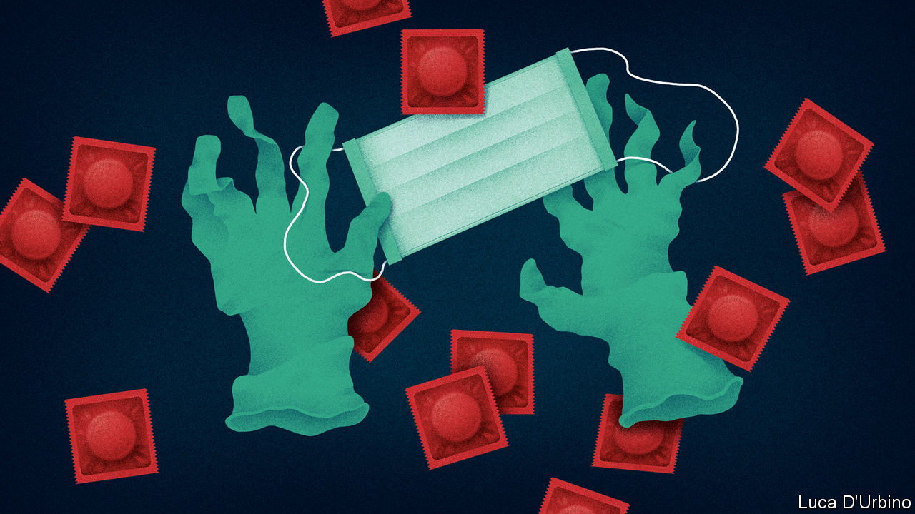

THE EVENING sun is beating down on a small crowd gathered in Schöneberg, a district of Berlin, to mark the 45th International Whores’ Day. But Isabelle, a Macedonian transgender prostitute, is gloomy. “I remember how it was before,” she says. Cis women walked the streets north of the railway bridge, trans women to the south. Not these days. “I feel depressed,” says Isabelle. “It’s our job, you know?” Colleagues describe overbearing police, price-gouging hotels and clients seeking outrageous “corona-discounts”.

Few industries have been as pummelled by covid-19 as sex work, which in Germany is legal and regulated. Like many workplaces, brothels had to close in March. Yet although massage parlours and nail salons have reopened, prostitutes have been left in limbo. Some, such as Undine de Rivière in Hamburg, are innovating with hands-off services like fetish videos or erotic-hypnosis recordings. But it is hard to make a living that way, and few have the skills to try. Many migrants from eastern Europe, who are thought to make up more than half of Germany’s 400,000-1m sex workers, went home before the borders closed.

Others have been forced underground. Emma, a recent arrival from America, got a tongue-lashing from two regulars she suggested meeting after the ban took effect. “I’m trying to keep food on the table,” she says. Some have drug habits to feed, or families abroad to support. The state has offered one-off grants of up to €9,000 ($10,000) to freelances, and unlike in most countries sex work is covered. But foreign prostitutes are typically ineligible and many others do not know how to apply, or do not want to, says Andrea Hitzke of the Dortmund Midnight Mission advice centre. Most are self-employed, and so cannot get furlough pay. Lobby groups like the Professional Association for Erotic and Sexual Services (BesD) have set up funds for sex workers facing penury.

Politicians who think legalisation fosters trafficking and violence spot an opportunity. In May 16 MPs called for Germany to adopt the “Nordic” model, which criminalises the buying, rather than the selling, of sex. Many prostitutes hate this idea, since it pushes them into the shadows. Sex-worker groups want the state to allow them to work again.

The BesD’s proposed hygiene code would ban prostitutes from kissing or other “oral services”, oblige them to wear gloves during certain acts and to keep their heads a forearm’s distance from their clients’ at all times. Face-masks would be obligatory. Customers would have to leave contact details, perhaps in sealed envelopes. Similar rules will apply in Austria if its brothels reopen on July 1st, as planned. “It’s not very sexy,” admits Ms de Rivière. “But it’s necessary.”

Editor’s note: Some of our covid-19 coverage is free for readers of The Economist Today, our daily [newsletter](https://my.economist.com/user#newsletter). For more stories and our pandemic tracker, see our [coronavirus hub](https://www.economist.com/news/2020/03/11/the-economists-coverage-of-the-coronavirus)

This article was downloaded by calibre from <https://www.economist.com/europe/2020/06/04/germany-helps-sex-workers-idled-by-covid-19>

|  |  |  |  |
| --- | --- | --- | --- |
| Previous | Articles | Sections | Next |

|  |  |  |  |
| --- | --- | --- | --- |
| Previous | Articles | Sections | Next |

#### Barbarians at the gates

# Slovenia’s prime minister hunts for enemies

Janez Jansa is copying his Hungarian chum, Viktor Orban

Jun 4th 2020 |

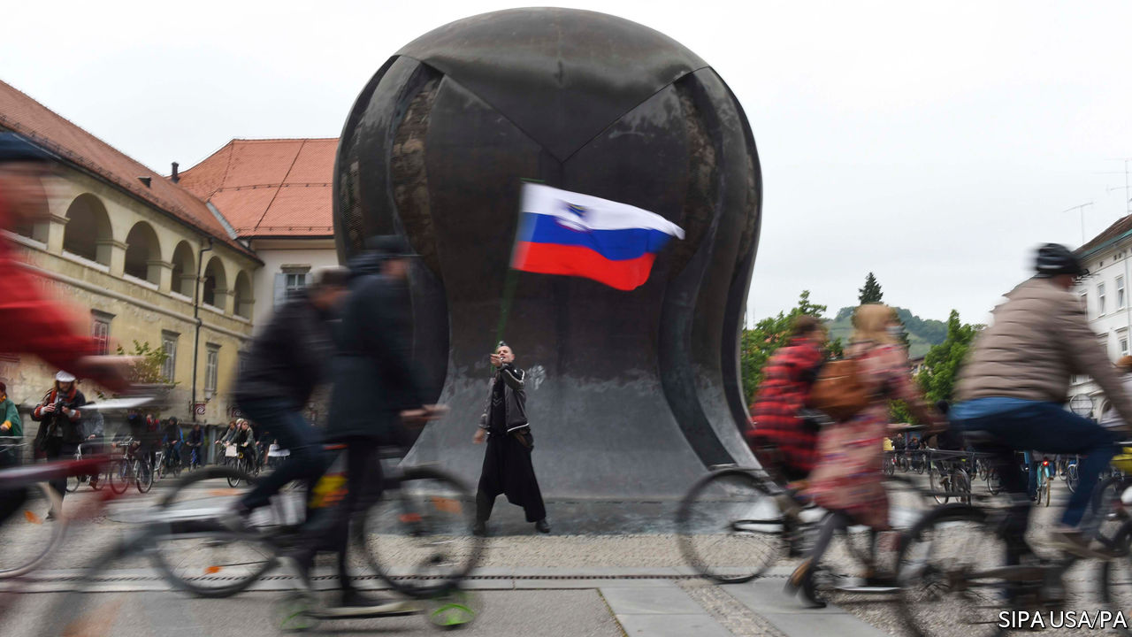

“VICTORY!” SLOVENIA HAS CONQUERED COVID-19, shouts the cover of a magazine that backs Janez Jansa, the prime minister. On June 1st American military jets helped the country to celebrate by streaking across the sky, while three propeller planes from Slovenia’s air force puttered along too. Now is the time, says Mr Jansa, who became prime minister for the third time in March, to ensure that recession does not turn into depression and that Slovenia preserves its reputation as “a safe and orderly country”.

Mr Jansa, whose entire adult life has been entwined with the history of modern Slovenia, has a point. His country does indeed have a good reputation. Since its ten-day war for independence when he was defence minister during Yugoslavia’s collapse in 1991, it has drawn little attention. Considered neither fully central European nor properly Balkan, Slovenia is often seen as the goody-two-shoes that emerged unscathed from the wreckage of Yugoslavia, and duly joined NATO and the EU in 2004.

But its politics are ugly. Its society is riven by divisions as deep as those elsewhere in Europe. Anuska Delic, an investigative reporter who in 2011 exposed neo-Nazi links to Mr Jansa’s party, says he is bent on making the country another “illiberal democracy” in the mould of neighbouring Hungary under his friend Viktor Orban.

If that were to happen, it would be unlikely to do so quickly, since Mr Jansa has only a wafer-thin majority in parliament. In any event, like Mr Orban, he reckons he knows who his enemies are—and is determined to bring them down.

First in his line of fire are Slovenia’s public broadcaster and parts of the press. Some of the media outlets that support him are part-owned by Hungarian friends of Mr Orban. Among their targets, as in Hungary, is the liberal billionaire philanthropist George Soros. Another butt of Mr Jansa’s hostility is the judiciary. “Key functions” of it, he says, are controlled by people determined “to protect the elite, the deep state, economic crime and tycoon networks”. They are an “octopus of clientelism”. Every Friday several thousand people, fearing a slide into autocracy, protest against him by biking around Ljubljana, the capital.

Meanwhile he hails Slovenia’s fight against covid-19, comparing it to the heroic struggle against Yugoslavia a generation ago and accusing the protesters of treacherously sporting Yugoslav symbols. In fact, Slovenia’s performance against the virus has been about average in the region: around52 people per million population have died so far, compared with 25 in neighbouring Croatia to the south and 74 in Austria to the north. Moreover, there was a whiff of scandal when the agency charged with procuring masks and other vital equipment was accused of having to sign dodgy contracts, a charge it denies.

In 2014 Mr Jansa went to jail for corruption. The constitutional court annulled his conviction, but a proposed retrial never took place. In prison he wrote a novel about brave proto-Slovene warriors and their sexy maidens defending their homeland from marauding eastern tribes two millennia ago. Nowadays, just like Mr Orban, he attacks today’s migrants, hoping that the theme of barbarians at and within the gates will keep him on the throne. ■

This article was downloaded by calibre from <https://www.economist.com/europe/2020/06/04/slovenias-prime-minister-hunts-for-enemies>

|  |  |  |  |
| --- | --- | --- | --- |
| Previous | Articles | Sections | Next |

|  |  |  |  |
| --- | --- | --- | --- |
| Previous | Articles | Sections | Next |

#### Strength in numbers

# What Turkey got right about the pandemic

It helps not to keep old people in nursing homes

Jun 4th 2020 | ISTANBUL

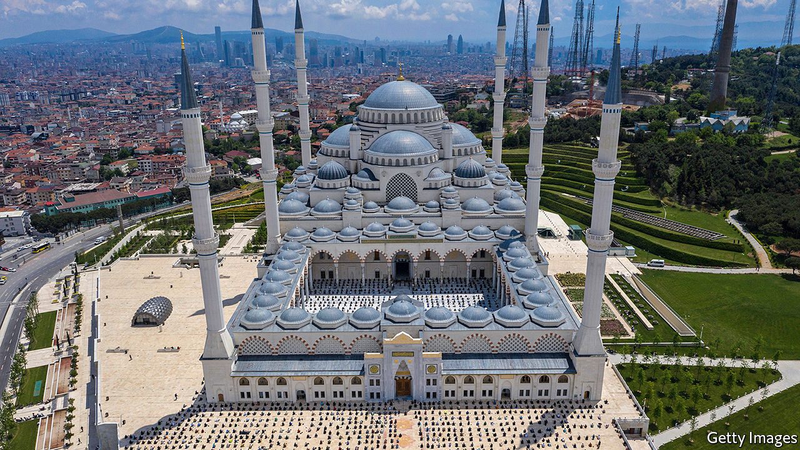

Editor’s note: Some of our covid-19 coverage is free for readers of The Economist Today, our daily [newsletter](https://my.economist.com/user#newsletter). For more stories and our pandemic tracker, see our [coronavirus hub](https://www.economist.com/news/2020/03/11/the-economists-coverage-of-the-coronavirus)

IN EARLY MARCH, before Turkey had formally registered its first case of covid-19, Sabah, a pro-government newspaper, praised the country for setting a “leading example” in the fight against the novel coronavirus. Some 160,000 confirmed cases later, the fanfare is rather quieter. Still, as the country emerges from lockdown, there is some cause for cheer. Turkey’s government has a reputation for throttling dissent and picking fights with its European and American allies. But it has handled the pandemic better than many.

Turkey has defied lockdown orthodoxy. Rather than place the whole economy in a coma, the authorities ordered the young and the elderly to stay at home and asked everyone else, aside from those in consumer-facing businesses, to show up for work. The biggest cities were placed under a blanket curfew on weekends and holidays. Some domestic flights resumed on June 1st, and cafés, restaurants, beaches and parks reopened, but children and people 65 and over are still not allowed outdoors for more than a few hours a week.

The strategy seems to have worked. The most vulnerable escaped the worst of the pandemic, while those infected, mostly working-age adults, generally recovered. Despite a high number of cases, the death count (under 4,600 as of June 2nd) has been low, even given the likelihood of serious underreporting. New cases have plateaued at around 1,000 a day since mid-May, down from a high of over 5,000 a month earlier. Deaths have never topped more than 127 in a single day. Turkey has ended up with roughly the same testing rate as France and a death rate ten times lower than Britain’s. Demography mattered. Among OECD countries, only Mexico and Colombia have a lower proportion of people aged 65 and over than Turkey does. Few elderly Turks live in nursing homes, which became breeding grounds for the virus in Europe and America.

Any country that keeps its factories open during a pandemic had better make sure its health system can cope with the consequences. Turkey’s rose to the challenge. Over the past couple of decades, Mr Erdogan and his governments have poured tens of billions of dollars into health care, most recently by building a network of hospitals the size of international airports. The latest of these opened on May 21st, boasting nearly 2,700 beds, about a sixth of them in intensive-care units. Some of the contracts were awarded to cronies, and the hospitals may end up bleeding cash. But the extra capacity has helped. The wave of covid-19 infections never came close to overwhelming the health system and medical supplies never ran out. Credit is due not just to Mr Erdogan and his impressive health minister, Fahrettin Koca, but also to opposition mayors, especially in Istanbul and Ankara, who have raised funds and organised the distribution of masks.

Mr Erdogan muzzles the media, locks up critics and flouts some of the most basic norms of democracy. But there is another reason why he and his ruling AK party have not lost a general election in almost two decades. As even its critics acknowledge, AK works hard and gets things done. If opposition parties were ever to take power—and whether Mr Erdogan would allow such a thing is the biggest unspoken question in Turkish politics—they would have to prove they can work just as hard. ■

This article was downloaded by calibre from <https://www.economist.com/europe/2020/06/04/what-turkey-got-right-about-the-pandemic>

|  |  |  |  |
| --- | --- | --- | --- |
| Previous | Articles | Sections | Next |

|  |  |  |
| --- | --- | --- |
| Europe | Sections | International |

Britain

The United Kingdom: One nation, under covid

.

Hong Kong: A warm(ish) welcome

.

Ethnicity and covid-19: Doubly unlucky

.

Lifting lockdown: A risky reopening

.

Religion: Your own personal Jesus

.

Parliament: The mother of all queues

.

Documenting the pandemic: How history is made

.

Bagehot: The new victims

.

|  |  |  |
| --- | --- | --- |
| Europe | Sections | International |

|  |  |  |  |
| --- | --- | --- | --- |
|  | Articles | Sections | Next |

#### Ignore the squabbling

# Devolution has become less dysfunctional during the pandemic

The four nations of the United Kingdom are working surprisingly well together

Jun 6th 2020 |

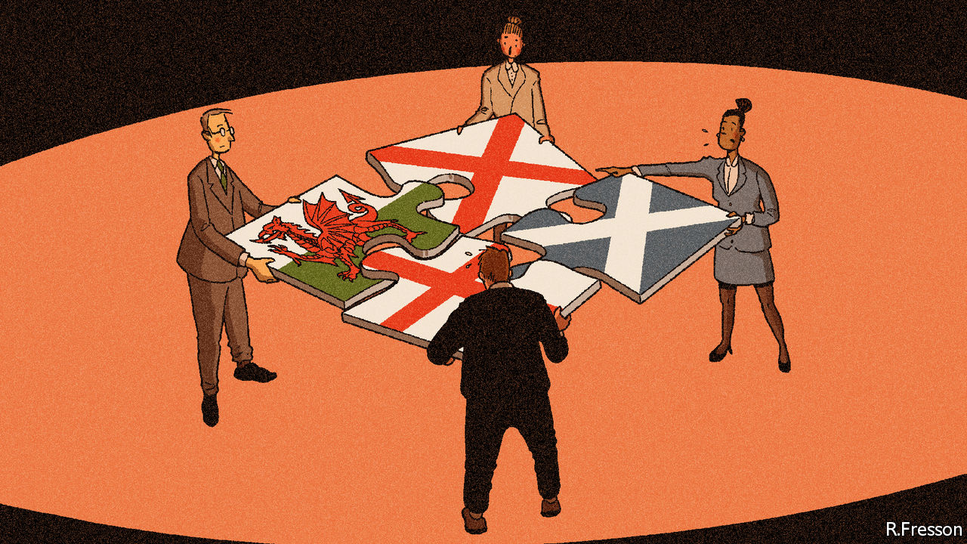

Editor’s note: Some of our covid-19 coverage is free for readers of The Economist Today, our daily [newsletter](https://my.economist.com/user#newsletter). For more stories and our pandemic tracker, see our [coronavirus hub](https://www.economist.com/news/2020/03/11/the-economists-coverage-of-the-coronavirus)

OVER THE past fortnight, Britons fired up their barbecues, as fine weather coincided with a loosening of the covid-19 quarantine. But the etiquette of lockdown cook-offs varied by geography. In England six people have been able to gather in gardens since June 1st. In Scotland rules introduced three days earlier permit eight people from two households to meet, although they are urged to bring their own food and refrain from using the host’s toilet. There are no restrictions on the distance travelled by guests in England, but in Wales they should not go more than five miles. Schools in England have begun to open, but they will stay shut for longer elsewhere. Masks are endorsed in Scotland and England, but not in Wales.

Much of the United Kingdom has been governed from Edinburgh, Cardiff and Belfast since 1998. Yet some still struggle with a patchwork of laws. English day-trippers, unaware of Wales’s stricter travel rules, have been turned away by local police. Simon Hart, the Welsh secretary, blames journalists for the confusion: “I sit in front of my television at five o’clock and yell ‘England only!’ at the screen.” More seriously, Boris Johnson failed to tell leaders of the devolved administrations that he was dropping the “stay home” slogan they shared. Some in Westminster suspect the divergence in rules is mere posturing. Nervous union-watchers think rifts over coronavirus indicate a coming break-up.

The pandemic came at a difficult time. Devolution was built when Labour ruled in London, Edinburgh and Cardiff, and problems could be fixed with a phone call between comrades. Today relations are more fraught. The British government has ignored Scottish and Welsh protests over Brexit. The Northern Irish executive remains fragile. Mr Johnson asserts the indivisible sovereignty of the Westminster Parliament, which sits uneasily with the claim of shared sovereignty in the devolved nations, says Philip Rycroft, formerly the civil servant overseeing devolution.

Yet, though much of Britain’s response to the pandemic has been poor, devolution has become less dysfunctional under the stress. The four nations have been able to adopt distinct policies, which enjoy public support because they are backed by their elected leaders. But they have also drawn on the cash, muscle and expertise of the British government.

The result has been unexpectedly coherent. A joint action plan drawn up in early March looked like “something you’d see more often in more mature federal or multilevel systems,” says Akash Paun of the Institute for Government, a think-tank. The Coronavirus Act, which created emergency powers and was passed on March 25th, required deep collaboration, with clauses tailored to each administration.

One reason for this coherence is the new machinery of government. Devolution contains structural weaknesses. Most powers engaged in a crisis—national security, foreign policy, borders and the currency—sit in London. But the pandemic strikes at health services and local government, which are run by the devolved administrations. Britain lacks counterparts to American federal agencies such as FEMA and the CDC, which support state governments during crises. The Joint Ministerial Council (JMC), where the four nations talk, meets irregularly, cannot take decisions and is usually fractious.

It has been sidelined. The First Ministers of Scotland, Wales and Northern Ireland sit with Mr Johnson on COBRA, the national emergencies committee. Four more committees dedicated to the pandemic include devolved ministers and meet several times a day. “We’ve made our way through the coronavirus crisis patching together arrangements as we go along, rather than have a set of routine arrangements that we are all used to,” says Mark Drakeford, the first minister of Wales. “There has been a fleetness about it that you wouldn’t have seen in normal circumstances.” Ministers in Dublin, London and Belfast meet in a forum known as “the quad” to manage the response across the Irish border.

Whitehall departments with little exposure to devolution are on a steep learning curve. The differences between national strategies are small, which reflects the tight relationship of the four chief medical officers. Boffins from each nation sit on the Scientific Advisory Group for Emergencies (SAGE), the government’s expert panel. Scotland and Wales also run their own committees, which fine-tune but do not duplicate SAGE’s modelling.

The crisis has pushed the British government into devolved terrain. The army is running mobile testing units, booked through a British government website. (The policy upset Northern Irish republicans, but even ardent Scottish and Welsh nationalists do not object.) Whitehall has taken charge of procuring antibody tests, and the Joint Biosecurity Centre, an outbreak-monitoring unit, will cover the whole country.

The errors have been shared, too. Nicola Sturgeon’s administration in Edinburgh was no more alert to the looming risk than London. Outbreaks have hit care homes across Britain. It is not obvious why an independent Northern Ireland, Scotland or Wales would have responded much better.

Coronavirus is only one force pushing the union together. Scotland has run its own welfare since 2018, which needs co-ordination with London. Brexit will bring new powers over fisheries and chemicals to Britain, which will require joint decision-making. Edinburgh and Cardiff want to give the JMC more clout. Andrew Dunlop, who has prepared a report on the future of the union for Mr Johnson, says a change of culture could make it a “front-footed” forum to deal with shared problems.

But politics pushes the other way. The economic recovery will be more contentious than the medical emergency. The Treasury will effectively call the shots on when lockdowns end, as it funds the furlough scheme. A plan to restrict English students going to universities in other nations to mitigate a drop in foreign students doesn’t look neighbourly. And Ms Sturgeon hopes to use Scotland’s elections next year to secure a second independence vote. The new age of collaboration may survive the pandemic, but it will take political will. ■

This article was downloaded by calibre from <https://www.economist.com/britain/2020/06/06/devolution-has-become-less-dysfunctional-during-the-pandemic>

|  |  |  |  |
| --- | --- | --- | --- |
|  | Articles | Sections | Next |

|  |  |  |  |
| --- | --- | --- | --- |
| Previous | Articles | Sections | Next |

#### A warm(ish) welcome

# Britain opens its doors to Hong Kongers

But it is unclear how wide

Jun 4th 2020 | HONG KONG AND LONDON

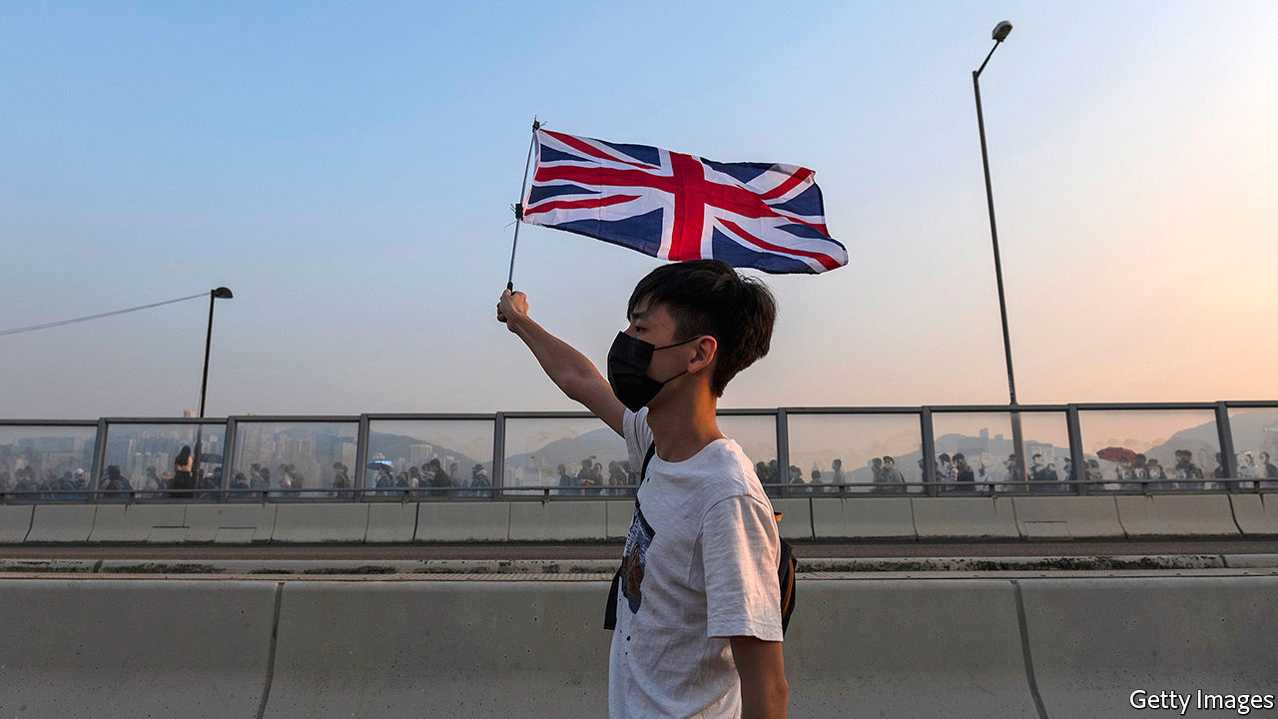

ON JUNE 3RD Hong Kongers woke to an article by Britain’s prime minister Boris Johnson in the South China Morning Post. It carried a threat to Beijing: if China imposed its national-security law, tightening its grip on the city, Britain would change its immigration rules. British Nationals (Overseas) (BNOs), a category created for those born in the British colony before it was returned to China in 1997, would gain additional rights, including one to work, “which could place them on a route to citizenship”. The Home Office has said the offer would extend not just to the 350,000 holders of BNO passports, but to all 2.9m who qualify for one. According to Mr Johnson, “This would amount to one of the biggest changes to our visa system in history.”

The offer was a bold gesture, destined to upset China (whose foreign ministry fired off an angry memo). Pro-democracy Hong Kongers celebrated. Craig Choy, a lawyer and campaigner, says he drew comfort from the fact “that we actually have the UK backing us up”. Watching British lawmakers offer their support was “very touching,” he adds. Yet locals will not be packing their bags soon, for the kind words bely a lack of detail about exactly what is on offer.

Britain is one of the few countries that makes a distinction between citizens and nationals. The passports held by British nationals look identical to those belonging to citizens, but carry fewer benefits. BNOs can ask for support from British embassies (except in China). They can also visit Britain for six months without a visa. There is not much more on offer. BNOs have no automatic right to live, work or study in Britain. They are subject to immigration controls upon entering. Just like Indians or Nigerians, they must apply for work authorisation, as well as pay hefty fees and a health surcharge. For its part, Beijing considers those who also hold Hong Kong passports to be Chinese citizens only.

Mr Johnson’s offer is to extend the period for which BNOs can come to Britain from six to 12 months, and to give arrivals the right to work. Yet it is unclear whether they would need a job offer, a sponsor and to meet a minimum-salary threshold, as most migrants do, or if they would be able to arrive and look for work like EU citizens. “If it requires sponsorship it actually means nothing,” says Mr Choy.

Nor is it clear how long BNOs would need to live and work in Britain before applying for settlement. Most migrants must spend five years in Britain on an eligible visa before doing so. Hong Kongers will want some security that, if an extension is denied after 12 months, they will not be deported back. One immigration lawyer says the current offer is “respite” not “refuge”.

Moreover, only Hong Kongers born before the handover in 1997 are eligible for BNO status. That leaves out younger people, who are the most vocal opponents of China. Jimmy Lai, a billionaire supporter of the pro-democracy movement, tweeted that Hong Kong’s youth “should be given the priority, over old people like me”. Seen from mainland China, this dulls the force of Britain’s threat.

Even if the finer points of immigration law were ironed out, Hong Kongers would be unlikely to move to Britain en masse. British nationality is best thought of as a “lifeboat”, says Emily Lau, a legislator. “If things go wrong, you have a place to go to. But if things are okay...nobody wants to up sticks and move.” For now, Mr Johnson’s offer looks more like a geopolitical gambit than detailed immigration policy. ■

This article was downloaded by calibre from <https://www.economist.com/britain/2020/06/04/britain-opens-its-doors-to-hong-kongers>

|  |  |  |  |
| --- | --- | --- | --- |
| Previous | Articles | Sections | Next |

|  |  |  |  |
| --- | --- | --- | --- |
| Previous | Articles | Sections | Next |

#### Doubly unlucky

# British Pakistanis and Bangladeshis have been hit hard by covid-19

Cramped homes and self-employment are a bad combination

Jun 6th 2020 | LUTON

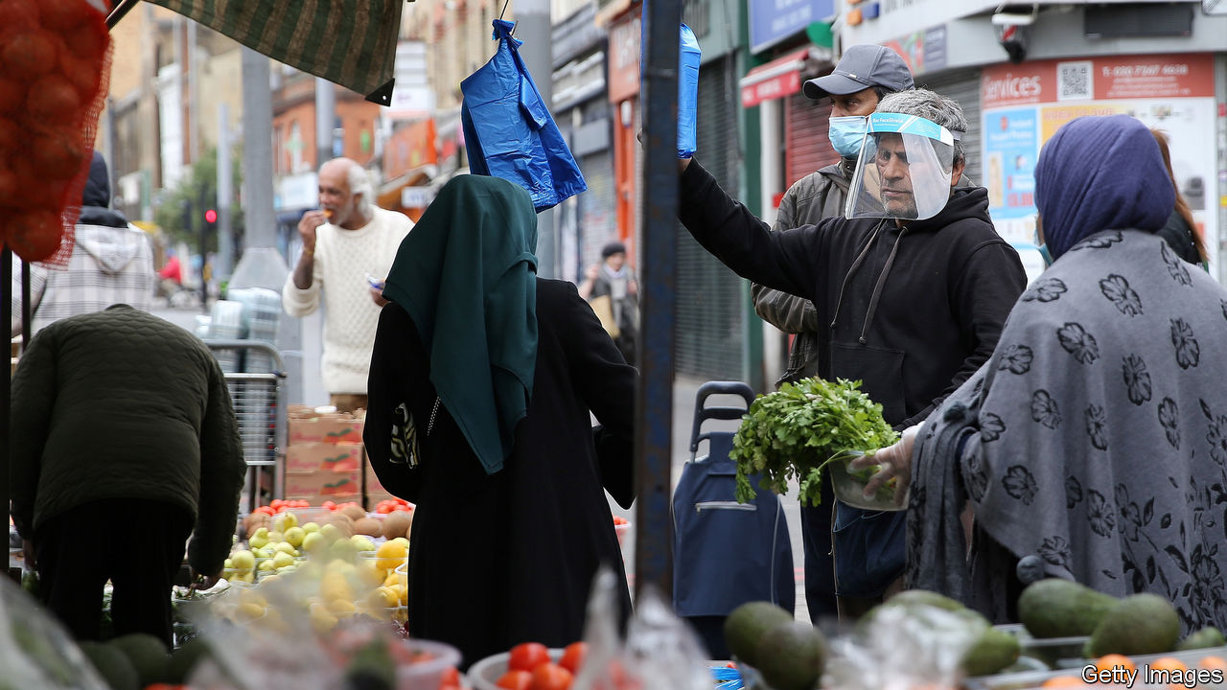

THREE TAXIS wait outside Luton railway station. All are driven by middle-aged Pakistani men; all have been idle for hours. “There’s no work,” says Ash. “Honestly, I’m just here to pass the time.” Over the last week, he reckons, he has earned just enough money to pay for cigarettes.

Covid-19 has not been a walk in the park for anybody, but it has hit Britain’s ethnic minorities harder than whites. In particular, it seems to have singled out ethnic Pakistanis and Bangladeshis (who may be British-born or immigrants). They make up just 3% of the population of England and Wales, but more than half of all Muslims.

It has been known for a while that Pakistanis and Bangladeshis are unusually susceptible to the coronavirus. On June 2nd Public Health England added more detail. Controlling for age, poverty and other factors, Bangladeshis who are diagnosed with covid-19 are twice as likely to die of it than others. Pakistanis are 1.4 times as likely to die. No other ethnic group faces a higher risk than those two.

Pakistanis and Bangladeshis tend to have worse health to begin with, making them more vulnerable to the new disease. They also have less personal space than other ethnic groups, raising their risk of exposure. Fully 30% of Bangladeshis and 16% of Pakistanis live in overcrowded homes, compared with a national average of 3%. And, as Alyas Karmani, an imam, points out, many live in three-generation households—a dangerous arrangement.

Those who have dodged the bug appear to have been struck badly by the economic downturn. Few Pakistanis and Bangladeshis hold the sort of well-paid, computer-oriented jobs that can be done remotely. Nor do they commonly work in the public-sector roles that tend to fare better in a crisis. Only 25% of Pakistani and Bangladeshi workers are employed in public administration, education and health, compared with 30% of whites and 44% of blacks. Instead they are highly concentrated in two trades: taxi driving (for Pakistanis) and restaurants (for Bangladeshis). Both of these have slumped.

Many women do not work at all, especially if they are married. In the first three months of this year, 43% of working-age Bangladeshi women and 44% of Pakistani women were economically active—much higher than two decades ago, but less than white, black or Indian women, all of whom scored above 70%. The Institute for Fiscal Studies, a think-tank, estimates that nearly a third of Bangladeshi men work in a shut-down industry and have a partner who does not work, compared with 1% of white British men.

Many are being kept afloat by the state or by relatives. Some, though, have turned to their fellow Muslims. Iqbal Nasim, who runs the National Zakat Foundation, says that applications for zakat (a form of Islamic aid that is more like welfare than charity) have quadrupled in the past two months. Before Ramadan, he says, the organisation hit up previous donors, asking if they might contribute again. Some not only said they could not, but admitted that they would be asking for help this year. ■

Editor’s note: Some of our covid-19 coverage is free for readers of The Economist Today, our daily [newsletter](https://my.economist.com/user#newsletter). For more stories and our pandemic tracker, see our [coronavirus hub](https://www.economist.com/news/2020/03/11/the-economists-coverage-of-the-coronavirus)

This article was downloaded by calibre from <https://www.economist.com/britain/2020/06/06/british-pakistanis-and-bangladeshis-have-been-hit-hard-by-covid-19>

|  |  |  |  |
| --- | --- | --- | --- |
| Previous | Articles | Sections | Next |

|  |  |  |  |
| --- | --- | --- | --- |
| Previous | Articles | Sections | Next |

#### A risky reopening

# England emerges from lockdown

But experts and public worry it is too much, too soon

Jun 6th 2020 |

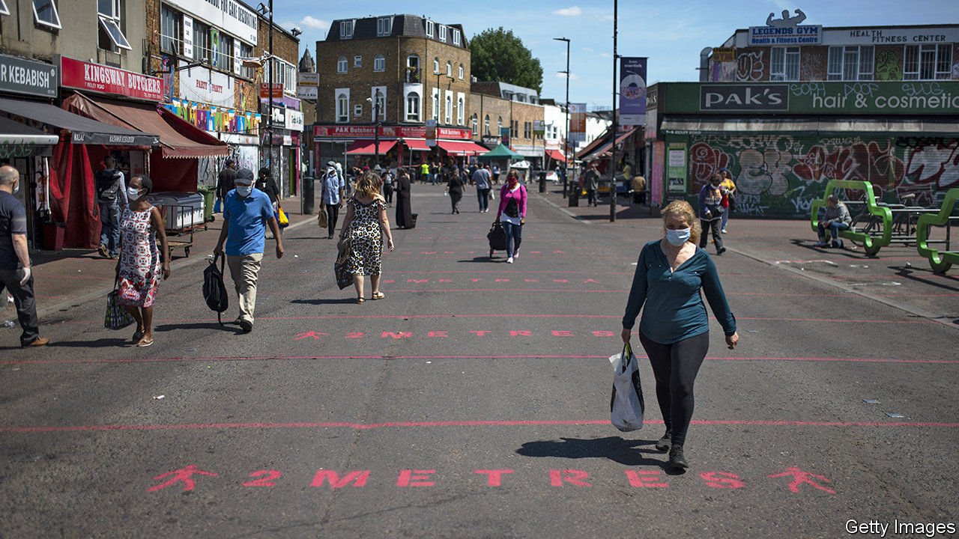

Editor’s note: Some of our covid-19 coverage is free for readers of The Economist Today, our daily [newsletter](https://my.economist.com/user#newsletter). For more stories and our pandemic tracker, see our [coronavirus hub](https://www.economist.com/news/2020/03/11/the-economists-coverage-of-the-coronavirus)

A LOT CHANGED in England on June 1st. After more than two months, people could sit outdoors in groups of no more than six, primary schools began to reopen (at least for some year groups), and government advice for vulnerable people changed, allowing them to step out of their front doors. A day later Parliament ended its experiment with virtual voting. High-street shops will soon welcome customers. Weeks after the rest of Europe, the country is emerging from confinement.

When Boris Johnson laid out his plans for leaving lockdown, he promised to be guided at all times by “the science”. Now that restrictions are being lifted, what science dictates is unclear. In the days running up to England’s reopening, several members of the government’s Scientific Advisory Group for Emergencies (SAGE) warned that things were moving too quickly. The Association of Directors of Public Health and Sir David King, the country’s former chief scientific adviser, agreed. Observers suspect the government’s focus has switched from protecting health to protecting the economy.

The decision is ultimately a political one about risk. In parts of England the virus appears under control; elsewhere it is more widespread (see chart). Before the government lifted restrictions, SAGE advised that the reproduction number was below one, which means cases would have been expected to continue to decline. But estimating the spread of the virus is an inexact science, and there may have been little wriggle room. The lockdown was looser than in other countries, with people out and about more than in places like Italy and Spain.

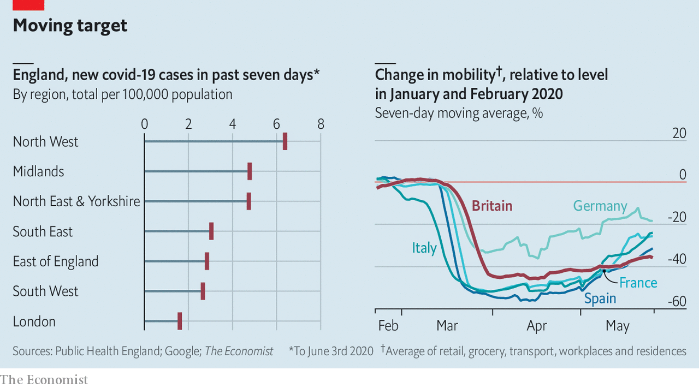

As John Edmunds, an epidemiologist and one of the dissenting SAGE members, has noted, much now rests on the country’s track-and-trace infrastructure. That consists of a mobile app, as well as some 25,000 human contact tracers charged with finding people who have been in contact with infected patients. Along with widespread testing, it is supposed to allow health authorities to monitor and quickly suppress outbreaks. Mr Johnson promised a “world-beating” system by June 1st.

Yet the app has still not been released, with no word on when it is due. John Newton, the testing chief, admitted on June 1st that the contact tracers were “not fully occupied”. Promises to turn all tests around in less than 24 hours are yet to be fulfilled. On June 3rd Dido Harding, who is in charge of the track-and-trace programme, was unable to provide the health and social care select committee with crucial information on tests or tracing. Not surprisingly, Britons appear nervous. A poll by YouGov found that almost two-thirds thought ministers were not being cautious enough in easing measures. Still, the government marches on. ■

This article was downloaded by calibre from <https://www.economist.com/britain/2020/06/06/england-emerges-from-lockdown>

|  |  |  |  |
| --- | --- | --- | --- |
| Previous | Articles | Sections | Next |

|  |  |  |  |
| --- | --- | --- | --- |
| Previous | Articles | Sections | Next |

#### Your own personal Jesus

# Online services swell the Church of England’s congregations

But conservatives worry they undermine church worship

Jun 4th 2020 |

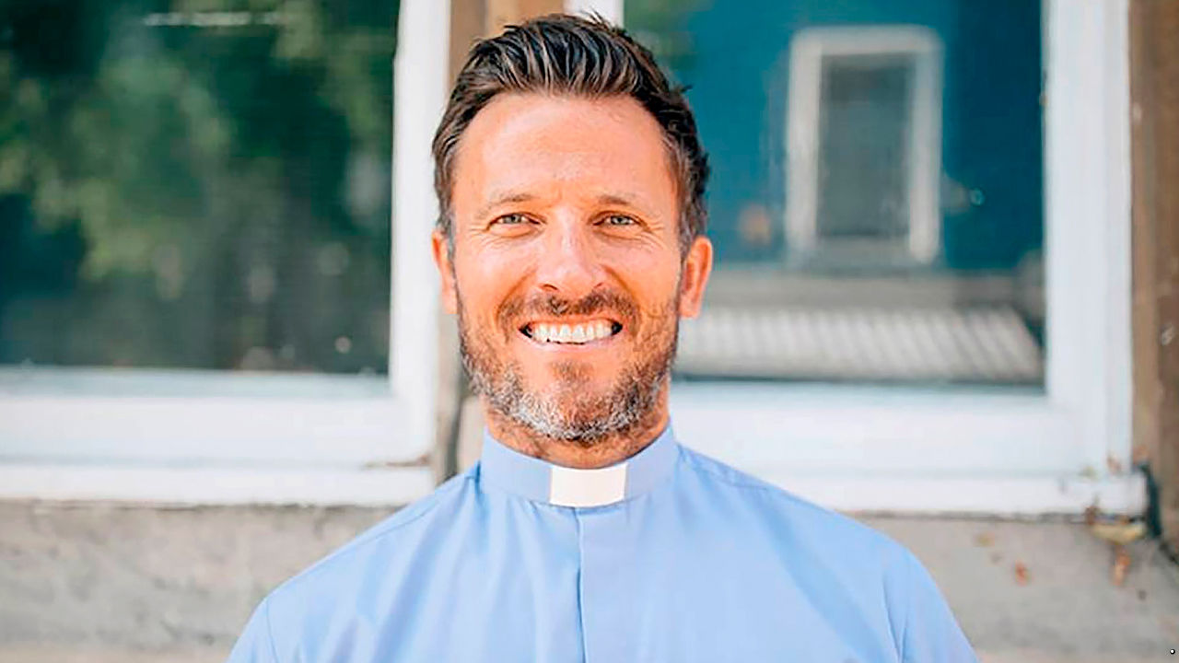

“WHEN I HEADED out to Portobello Road, I didn’t know if I was going to get told to get lost or have rotten tomatoes thrown at me,” says Pat Allerton (pictured), vicar of St Peter’s church in west London. But the muscular, chisel-jawed man of the cloth has become an unlikely lockdown celebrity, turning heads for more than just his sermons. Thousands follow online as he goes from street to street playing “Amazing Grace” on a sound system. His looks, he insists, are irrelevant. “You can have the best-looking people in front of a camera, but if they don’t have God’s anointing, then they will only touch a few people.”

Many vicars were reluctant to close their churches when covid-19 began to spread in Britain. But empty pews in the Church of England have been replaced by packed-out virtual congregations. A quarter of Britons have attended an online religious service since lockdown began, providing a boost to a faith that has seen dwindling church attendance. “The Holy Spirit can work through Zoom,” explains Rev Nicky Gumbel of Holy Trinity Brompton, a group of four churches. Its total weekly congregation has doubled to nearly 10,000. He draws a parallel with the early days of the church, noting that pandemics during the Roman empire boosted the faith’s power as worshippers’ networks of mutual aid left them with fewer casualties.

This newfound popularity is exposing a gulf between clergy who think of online services as a necessary (and temporary) evil and those who want to innovate. The government has said churches should remain closed until at least July, but liberal vicars are keen for change to outlast the crisis. Some even think churches, with their fussy hierarchies, get in the way of spreading the Lord’s message. “In the New Testament, Peter talks about every Christian as a living stone,” says Mr Allerton. “God is building his house out of living stones.”

Several clergy are having fun finding new ways to connect with their parishioners. Helen-Ann Hartley, the Bishop of Ripon, has been blessing pets online. “My screen was filled with cats being entertained, there was a lady Zooming in from a horse she was riding, and there was a sofa full of chickens,” she laughs. “I was like, ‘Woah, there’s something in this.’”

Yet conservatives fear their liberal peers are exploiting the crisis to challenge the dominance of church worship in the Christian faith. “This is a drum some have been beating for a long time,” says Rev Marcus Walker. Conservatives cite scripture from the Old Testament: “Don’t forsake the gathering of the brethren.” Some have taken this message further than Mr Walker thinks necessary. A group of religious leaders are taking the government to court for keeping churches closed.

Polls suggest the flock agree. One found two-thirds of regular churchgoers want churches open before July. That is more proof, say conservatives, of a gulf between liberal clergy and their congregation. Some liberals seem to have doubts about how sensible their parishioners are, says Mr Walker. “The arguments have been: ‘Well, we can’t trust them not to come to church if they’re supposed to be shielding.’”

Liberal priests are having none of it. If churches reopen, and innovations keep going, they believe they can attract more people to the faith. “My friends from the gym don’t ever come to church with me,” admits Mr Gumbel. “But I ran past one of them and he said, ‘I’ve been watching all your services online’—that is amazing.” ■

This article was downloaded by calibre from <https://www.economist.com/britain/2020/06/04/online-services-swell-the-church-of-englands-congregations>

|  |  |  |  |
| --- | --- | --- | --- |
| Previous | Articles | Sections | Next |

|  |  |  |  |
| --- | --- | --- | --- |
| Previous | Articles | Sections | Next |

#### Parliamentary procedure

# The British government shows how not to return to work

In-person voting is cumbersome when MPs must remain two metres apart

Jun 6th 2020 |

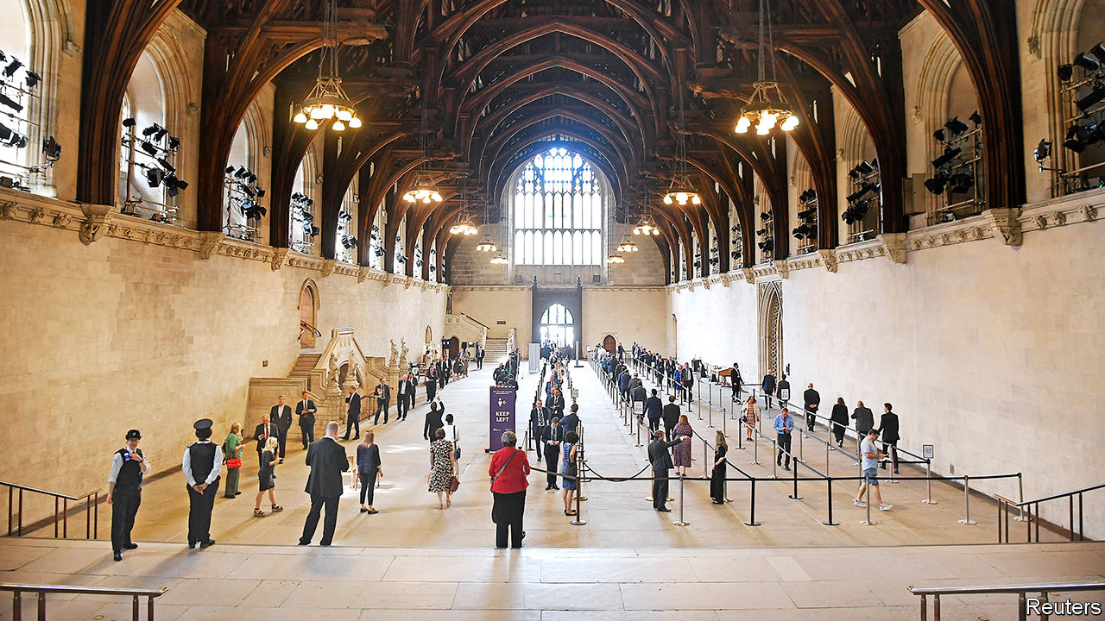

Editor’s note: Some of our covid-19 coverage is free for readers of The Economist Today, our daily [newsletter](https://my.economist.com/user#newsletter). For more stories and our pandemic tracker, see our [coronavirus hub](https://www.economist.com/news/2020/03/11/the-economists-coverage-of-the-coronavirus)

AT A TIME of upheaval, a jittery government under assault from a reinvigorated opposition calls a vote. MPs rush back from all over the country. So unwell is one that a paramedic wheels him in to have his vote “nodded through”. “Is he even alive?” asks a Tory whip. “Doesn’t matter,” replies his Labour counterpart. “There’s the bell, and he’s here.”

So concludes one scene in “This House”, an account of government in the 1970s. The play’s revival, streamed online on May 28th, was timely. A few days later, antediluvian parliamentary procedures were back in the spotlight. The government ditched the online voting system for MPs that was introduced in April. Since social-distancing measures are still necessary, the queue for the first vote snaked for 1,421 yards, leaving the House of Commons. Voting lasted 45 minutes. It was, at least, sunny.

Jacob Rees-Mogg, the leader of the House of Commons, was concerned that the new online approach, which is seen to have worked well, could become permanent. That would be a problem. “Voting while enjoying a sunny walk or watching television does democracy an injustice,” he explained. “The solemn decisions we take together affect the lives of millions of people in this country.” No matter that his preferred method would force MPs who are vulnerable to covid-19 to choose between shielding from the virus and representing voters. Or that it is an absurd waste of time.

Boris Johnson conceded on June 3rd that vulnerable MPs should be able to vote by proxy. Later that day, the business secretary came down with symptoms of covid-19. Observers expect further U-turns. Parliament has a history of silliness. Indeed, the Habeas Corpus Act of 1679 passed only when a chubby peer was put down for ten votes. Even so, the current mess is probably too much for MPs to bear.

This article was downloaded by calibre from <https://www.economist.com/britain/2020/06/06/the-british-government-shows-how-not-to-return-to-work>

|  |  |  |  |
| --- | --- | --- | --- |
| Previous | Articles | Sections | Next |

|  |  |  |  |
| --- | --- | --- | --- |
| Previous | Articles | Sections | Next |

#### Making history

# How British museums are documenting the pandemic

The buildings may be closed, but curators are hard at work

Jun 4th 2020 |

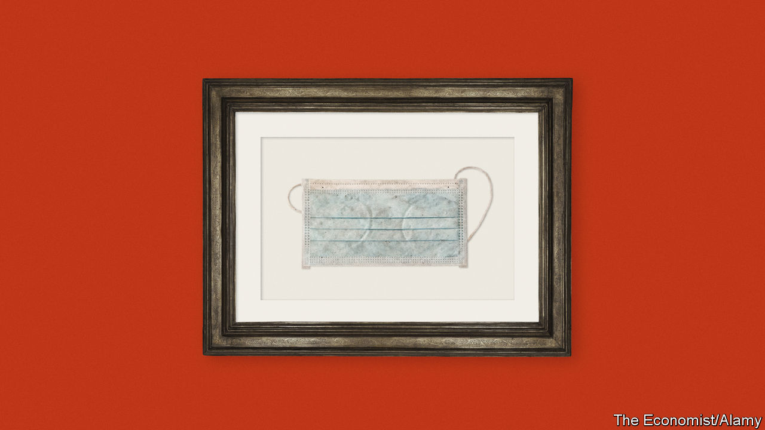

AT THE END of March, the prime minister sent a letter to every household in Britain. Printed on headed paper and signed by Boris Johnson, 30m of them went out, telling Britons “you must stay at home”. One of them is now in the collection of London’s Science Museum in South Kensington. Tilly Blyth, the museum’s principal curator, explains that her job is about “making sure we bring a personal experience to the science”. At the other end of central London, in Euston, Mel Grant of the Wellcome Collection, which focuses on health and medicine, says the letter is something “we wouldn’t actively go out and take”. The difference in approach between two museums whose subjects are at the heart of the crisis raises a question that institutions across the country are grappling with: How do you document history that you are living through?

There are three ways of thinking about an answer. The first is speed. The Victoria and Albert Museum (V&A), an engraved gemstone’s throw away from the Science Museum, has had a “rapid response collecting” strategy since 2014. Its collection includes a “pussyhat” of the sort worn by women in a protest the day after Donald Trump’s inauguration in January 2017. The aim is to ensure that everyday items are retained along with more uncommon ones. “It’s very easy for things we might consider mundane to get thrown away at times like this,” says Ms Blyth.

A related problem is that digital materials, while seemingly eternal, often disappear. “The nature of digital collecting means that information is frequently published, amended and removed quickly. If material is not captured at the time, it may be lost forever,” says Jason Webber of the UK Web Archive, a joint project of Britain’s six legal deposit libraries that aims to archive all British websites annually. The archive does not gather most social-media posts or any personal collections, however, which falls to other curators. For example, people take lots of pictures on their phones but don’t necessarily save them. They cannot be rediscovered in a dusty attic years later, says Matt Brosnan, the head curator at the London Transport Museum, so must be gathered now.

Understandably, “there’s a real temptation to come running in and grab everything that you possibly can,” says Ms Blyth. That is a non-starter. Museums have limited space to stash stuff. Digital materials require storage and maintenance, too. All that costs money, and museums are accountable to the public, whose funds they draw upon, or to donors. They must also be mindful of the ethics of collecting things—such as face masks—that are in short supply. And once something has formally entered a public collection, “you can’t get rid of it,” says Tristam Hunt, director of the V&A, as the paperwork is horrendous.

That points to the second way of thinking about what to collect, which is focus. The pandemic has touched every sector, industry and region in Britain. It has also spurred all sorts of museums into action. The National Army Museum is documenting the army’s role in the crisis. The Florence Nightingale Museum is looking at the emergency Nightingale hospitals. The London Transport Museum is collecting stories from key workers still using the Underground, as well as contemporary signage from the Tube, in buses and elsewhere. Local museums from Ulster to Cardiff to Leeds are documenting the experiences of their communities. But any new material must fit with the existing collection, says Sharon Heal of the Museums Association, an umbrella group. That is why what counts as significant for Ms Blyth at the Science Museum does not for Ms Grant at the Wellcome Collection.

Some museums, such as the National Football Museum in Manchester, have a particularly tricky task: they must document the absence of something. Wiebke Cullen, the collections manager, says she is interested in what people are doing instead of watching or playing football. Stevenage FC, for example, sent pictures of the squad delivering sandwiches and activity packs to their local areas. She is also collecting things like programmes from cancelled games, kit from the postponed Euro 2020 tournament and minutes of meetings from the Football Association. “We want objects to evoke some kind of emotion when people see it,” she says. “We’re also looking at it if it is a good story. If it’s an image and we don’t know who the people are, we’re probably not collecting it, because you can’t tell a story.”

That is the third and most important way of thinking about what to collect. The V&A promises treasures of design, the Wellcome Collection offers histories of health and the National Football Museum is a soccer stocker, but at their core, like every other museum in the world, they are in fact places where societies store their stories. “We tend to think of the 3D objects that museums acquire, but the strong way of acquiring is to think about the stories that come around a subject,” says Ms Blyth. “So rather than just acquiring a ventilator, wouldn’t it be interesting to talk to a medical team about where that ventilator was based, or maybe to talk to a patient about what it felt like to need a ventilator?” Every Briton who comes out of the pandemic will do so with their own personal stories, based on their unique histories, experiences and ideas of themselves. The same is true of the country’s museums. That is how history is made. ■

This article was downloaded by calibre from <https://www.economist.com/britain/2020/06/04/how-british-museums-are-documenting-the-pandemic>

|  |  |  |  |
| --- | --- | --- | --- |
| Previous | Articles | Sections | Next |

|  |  |  |  |
| --- | --- | --- | --- |
| Previous | Articles | Sections | Next |

#### Bagehot

# Why Conservatives have embraced victimhood

It offers a means of turning failure into electoral success

Jun 6th 2020 |

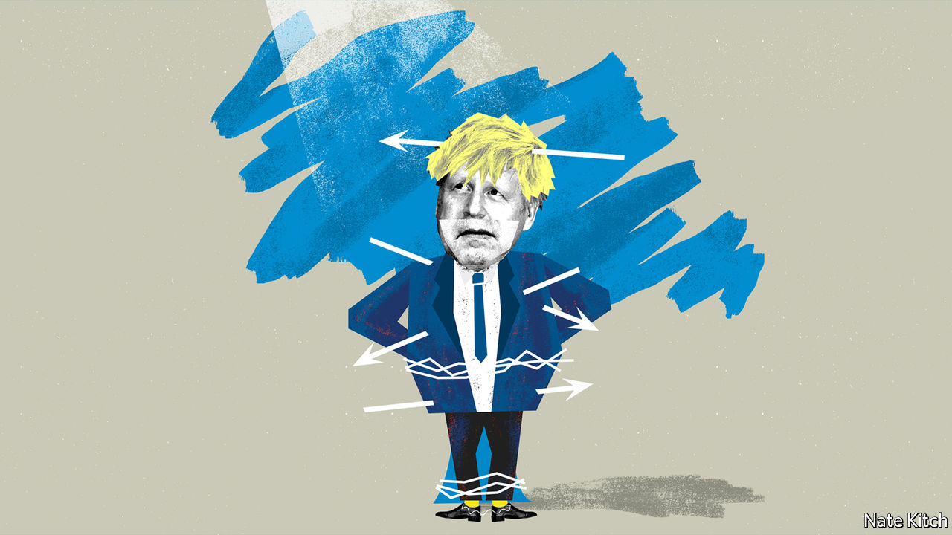

IN HIS “LIFE OF THESEUS” Plutarch tells the story of the ship which carried Theseus and his crew back to Athens from their adventures in Crete. Awed by their heroism, the Athenians preserved the ship for several centuries by removing the old planks as they decayed and replacing them with new ones. Eventually the ship consisted entirely of new material. This led to a great debate among the philosophers: did the restored ship remain the same ship? Or was it a new one?

The current Conservative Party poses Theseus’s paradox in even starker form. The Conservatives have not only replaced the old planks. They have frequently refashioned them entirely. A party that was once a party of pragmatism is now a party of ideology. A party that was once a party of tradition is now a party of radical upheaval. Is this really the Conservative Party we have before us? Or a new party that simply has the same name?

One of the most striking changes concerns the subject of victimhood. Conservatives used to relish accusing radicals of “playing the victim card”—hunting down victims to champion and treating British history as a history of oppression. But today they can’t resist playing the victim card themselves, even as they celebrate a decade in government. They present themselves as champions of the left-behind and looked-down upon. They rail against “entitled” elites. They do battle with forces of history that are intent on hurling them into the abyss.

The Dominic Cummings affair provided a perfect illustration of this attitude. For many people (including, to be fair, lots of Tory MPs) this was a story of an entitled official breaking the rules. But to many Conservatives it was a story of a Brexit martyr being persecuted by the media establishment who wouldn’t shut up about the subject and by street protesters who gathered outside his house. Downing Street turned itself into a bunker to defend Mr Cummings. Seven out of ten party members backed him against his critics, according to a poll by ConservativeHome, a Tory blog.

The sense of embattlement reached new levels when Emily Maitlis, a BBC presenter, delivered an on-air sermon against Mr Cummings. Thousands of people wrote to the BBC complaining (with some justice) that Ms Maitlis had broken the public broadcaster’s impartiality rules. Right-leaning publications bristled. Tony Parsons wrote in the Sun that his “fury, contempt and anger” burned at a corporation that “pockets £4bn a year from the Brexit-voting, Tory-supporting nation who they loathe”. Tom Slater of Spiked, an internet magazine that is close to the outraged spirit of modern conservatism, complained about a “metropolitan media class that has become so self-important that it is blind to its own biases, confused about the difference between opinion and facts, and increasingly hysterical when it doesn’t get its way”.

A new book on conservatism, Ed West’s “Small Men on the Wrong Side of History”, gives a good sense of this state of mind. Mr West tells the story of how he became “conserve-curious” as a young man and eventually forged his career as a conservative journalist. An amusing writer, Mr West eschews the ranting and whingeing that has become the hallmark of too many young conservatives. But his is nevertheless a story of defeat and marginalisation.

Conservatives have lost all the big cultural wars in his lifetime, he notes, quoting Bridget Jones’s aphorism: “Labour stands for sharing, kindness, gays, single mothers and Nelson Mandela”. They have also become a figure of fun in his age group of people in their late thirties. Mr West predicts that this pattern of defeat will intensify as his peers take an already leftish establishment further to the left. Conservatives will become like the practitioners of the Old Catholic faith in Protestant England: marginalised people living in remote provinces while the future of the country is forged in liberal entrepots.

This might sound a bit far-fetched. The right has pulled off two big victories in recent years, the Brexit referendum in 2016 and the general election of 2019. Social innovations such as gay marriage might well be classified as the extension of the conservative institution of marriage to a once marginalised population. Yet there is enough truth in the argument to give it some bite.

The Conservative Party is increasingly winning votes from lower social classes. Since the early 2010s it has enjoyed consistently stronger support among the lower-middle and working classes than among the higher ones. It is also losing support from the administrative and even corporate establishment. Look at the balance of power from the perspective of Antonio Gramsci—an Italian Marxist who argued that what matters is control of the culture rather than parliamentary majorities—and Conservatives are clearly on the wrong side of history. A poll in 2019 by Times Higher Education found that 54% of university employees planned to vote Labour, 23% Liberal Democrat and only 7% Conservative, just two percentage points above the Greens. In 1964 35% of academics voted Conservative. When the Reuters Institute at the University of Oxford conducted a survey of journalists in 2016, just 23% said they were “right of centre”.

## Life is too short to be little

This turn to victimhood makes one yearn for the old Disraelian Tory party where the greatest virtue was to make people laugh and the greatest sin to appear earnest. But it may nevertheless be a significant electoral asset in a world in which everybody has an axe to grind and a wrong to right. Playing the victim card allows the party to forge links with two disparate groups: older voters who feel marginalised by the leftward drift of the culture and poorer ones who feel left behind by a global economy. The past couple of months look as if they’ve been disastrous for the Tories’ re-election chances. But consider another paradox to go along with Theseus’s: the more the Conservative Party appears to fail the more it may be storing up political capital for another electoral success. ■

This article was downloaded by calibre from <https://www.economist.com/britain/2020/06/04/why-conservatives-have-embraced-victimhood>

|  |  |  |  |
| --- | --- | --- | --- |
| Previous | Articles | Sections | Next |

|  |  |  |
| --- | --- | --- |
| Britain | Sections | Business |

International

Fake news: Return of the paranoid style

.

Speech online: The moderator’s dilemma

.

|  |  |  |
| --- | --- | --- |
| Britain | Sections | Business |

|  |  |  |  |
| --- | --- | --- | --- |
|  | Articles | Sections | Next |

#### Return of the paranoid style

# Fake news is fooling more conservatives than liberals. Why?

As with the coronavirus itself, some people seem to be more vulnerable than others to the infodemic

Jun 4th 2020 |

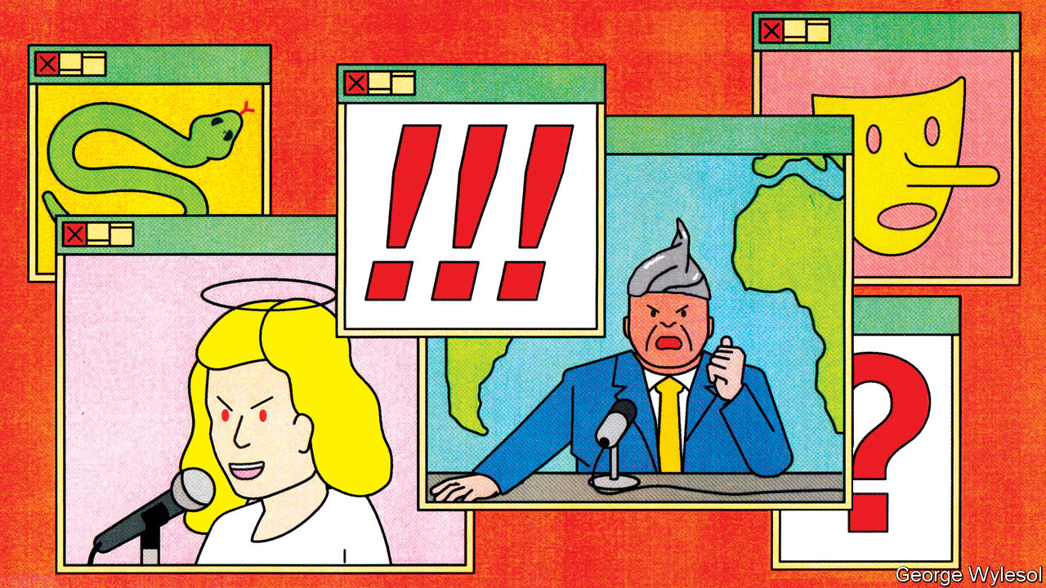

“DOCTORS NEED three qualifications: to be able to lie and not get caught; to pretend to be honest; and to cause death without guilt.” So wrote Jean Froissart, a diarist of the Middle Ages, after an outbreak of bubonic plague in the 14th century. Fake news then meant rumours that the plague could be cured by sitting in a sewer, eating decade-old treacle or ingesting arsenic.

The “infodemic” around covid-19, declared by the World Health Organisation (WHO) in February, is not the world’s first outbreak of misinformation. This time the myths include the notion that the disease can be cured by drinking methanol, which has led to more than 700 deaths in Iran, and that it is spread by 5G transmitters, which has convinced arsonists in Britain to carry out more than 90 attacks on phone towers. Just as the virus lodges in people’s lungs, dangerous ideas are infecting their minds.

One big difference between the infodemics of the 1300s and 2020 is the rapid worldwide transmission of today’s nonsense, enabled by the internet. In March a poll by Gallup of 28 countries in four continents found that in all of them, at least 16%—and as many as 58%—of people thought covid-19 was being deliberately spread (see chart 1). A clip of a film called “Plandemic”, which claims that a shadowy elite started the outbreak for profit, was uploaded on May 4th; within a week it had been seen 8m times and its star, Judy Mikovits, had topped Amazon’s bestseller list.

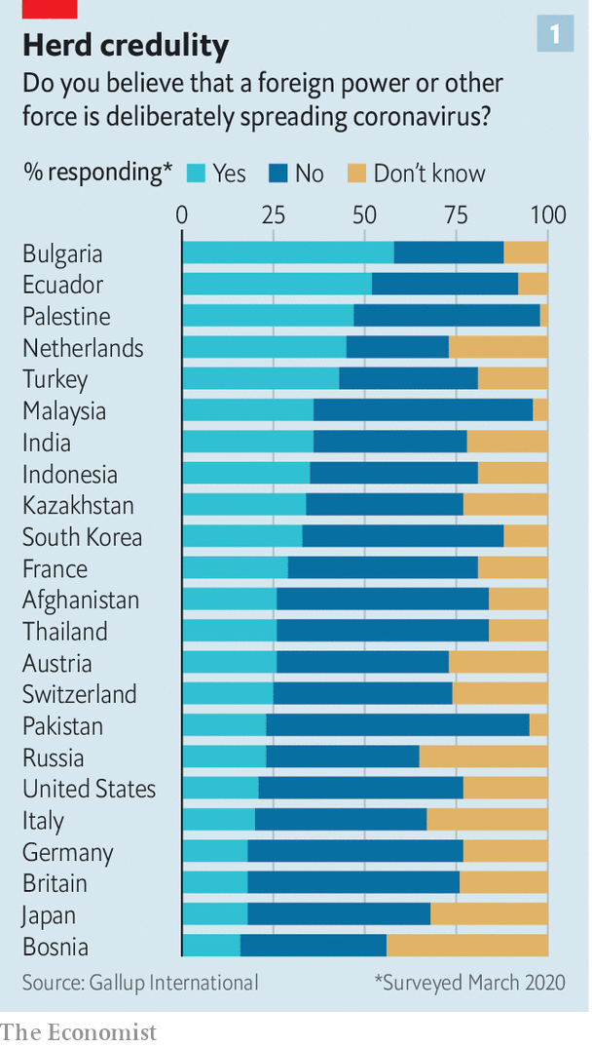

Social media enable people to share true news as well as the fake sort. But the fabulists seem to be winning. A study published in Nature in May found that, although pro-vaccine Facebook users outnumber anti-vaccine ones, the anti-vaxxers are better at forging links with non-aligned groups like school parents’ associations, so their number is growing faster. Among Americans, exposure to social media is associated with a greater likelihood of believing that the government created the virus or that officials exaggerate its seriousness, according to a recent paper in the Harvard Kennedy School’s Misinformation Review.

Broadcasters in many countries need a licence and must convince regulators that they try to report the news truthfully. Few such constraints apply to the internet. In April Britain’s broadcasting watchdog, Ofcom, censured a tiny TV station called London Live for airing part of an interview with David Icke, a conspiracy theorist who believes the pandemic is a hoax. The broadcast had been watched by only 80,000 people. Yet at the time of Ofcom’s ruling 6m had viewed the full interview on YouTube, which is outside Ofcom’s jurisdiction.

YouTube has since taken the video down, along with many others. Section 230 of America’s Communications Decency Act absolves tech firms of responsibility in that country for fact-checking uploaded content. But President Donald Trump wants to change this (see [article](https://www.economist.com/international/2020/06/06/donald-trump-has-reignited-a-debate-about-regulating-speech-online)). Even if he is blocked by the courts, public opinion favours more intervention. In America 84% say social networks should delete posts that they suspect contain inaccurate information about covid-19. Half that number say they should do so without confirming the posts are false. Tech firms have thus begun to add warnings to false information and signposts to reliable sources.

Covid-19 may seem a relatively straightforward subject on which to play censor. Compared with, say, politics, “it’s easier to set policies that are a little more black and white and take a much harder line,” Mark Zuckerberg, Facebook’s boss, told the New York Times in March. Yet it is proving tricky. The science is changing rapidly. In February America’s surgeon-general tweeted that facemasks were “NOT effective in preventing general public from catching coronavirus”. Now he says they are.

Worse, any hope that the pandemic would be politically uncontentious has evaporated. In March Mr Zuckerberg said Facebook had no problem taking down “things like ‘You can cure this by drinking bleach.’ I mean, that’s just in a different class”. Yet weeks later Mr Trump suggested it might help to inject disinfectant. Facebook, Twitter and YouTube have removed videos posted by Brazil’s president, Jair Bolsonaro, declaring hydroxychloroquine an effective treatment. So far clips of Mr Trump praising (and even claiming to take) “the hydroxy” remain up. The firms say the difference is that Mr Trump stopped short of saying that the drug was a proven cure.

## Left v right v wrong

Just as misinformation is not new, nor is its political use. In 1964 an essay by a historian, Richard Hofstadter, on the “paranoid style” in American politics described “the sense of heated exaggeration, suspiciousness, and conspiratorial fantasy” running through everything from 18th-century protests against the Illuminati to the anti-Masonic movement. Yet whereas Hofstadter argued that the paranoid style came as easily to those on the left as on the right—for instance, he cited the rumours of a slave-owners’ plot that were propagated by some abolitionists—today’s infodemic appears to be spreading more easily among the world’s conservatives than its liberals.

In America the Pew Research Centre found in March that 30% of Republicans believed the virus was created intentionally, nearly twice the share of Democrats. Last month a poll by YouGov found that 44% of Republicans think Bill Gates wants to use covid-19 vaccines to implant microchips in people; 19% of Democrats agree. In France a poll by Ifop found that 40% of those who support Marine Le Pen’s National Rally (once the National Front) believed that the virus was made by design, twice the share among backers of the far-left Unsubmissive France party. Supporters of the Dutch right-populist Freedom Party and the Forum for Democracy (FvD) are 40% more likely than backers of the far-left Socialist Party to say covid-19 is a biological weapon.

Wilder conspiracy theories aside, conservatives also seem more likely than liberals to question the official line on the pandemic. In late March, with Britain freshly locked down, a quarter of Tories but only 15% of Labour supporters believed that covid-19 was “just like the flu”.

The reluctance of so many conservatives to believe the conventional narrative of covid-19 is part of a more general suspicion of mainstream sources of information in some places. In America there is a yawning partisan gap in trust (see chart 2). The widest gulf concerns journalists, the next academics. These professions have long been conservative targets. Rush Limbaugh, an American talk-show host, speaks of the “four corners of deceit”: the media, scientists, academia and the government.

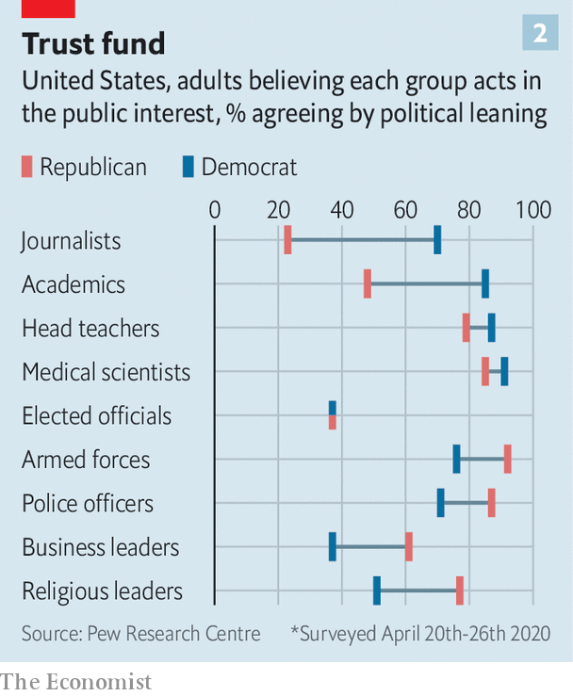

Such language is echoed by European populists of the right. Thierry Baudet, leader of the FvD, declared last year that “we’re being destroyed by the people who should protect us and undermined by our universities, by our journalists.” He has set up a “hotline” to report left-wing academics, and scoffs that the Dutch public broadcaster “obediently nods for the powers that be”. In France Ms Le Pen claims that “the government has been the biggest provider of fake news since the start of this [covid] crisis.” And in Britain, Brexiteers have questioned the impartiality of journalists, academics and civil servants, their attitude summed up by then justice secretary Michael Gove’s remark that people “have had enough of experts from organisations with acronyms saying that they know what is best and getting it consistently wrong”. British Conservatives have less faith than others in most of the media, as well as in international institutions. In April an Opinium poll found they were twice as likely as Labour voters to mistrust Tedros Adhanom Ghebreyesus, the head of the WHO.

Elite-bashing is hardly unique to conservatives. Andrés Manuel López Obrador, Mexico’s populist left-wing president, continually lays into the media. So did Labour’s former leader, Jeremy Corbyn, who talked darkly about an “establishment” that mysteriously kept causing him to lose elections. Democrats are likelier than Republicans to believe that 9/11 was an inside job. And the left is partial to corporate conspiracies, including the myth that AIDS was invented by Big Pharma and the CIA. One prominent peddler of covid-19 myths, according to NewsGuard, which vets sites for accuracy, is @OrganicLife, whose tweets combine vegan nut-milk recipes with paranoia about 5G transmitters.

Conspiracy beliefs are associated with ideological extremism of any variety, argues Karen Douglas, an expert on conspiracy theories at the University of Kent. Yet she says there is an “asymmetry”. People on the right believe in them more often, and entertain a broader range of theories, particularly those that accuse the other “side” of plotting, whether that be left-wingers, foreigners or other groups.

Structural shifts may explain why conservative voters seem to be more prone to the infodemic, and why conservative leaders have more reason—and are more likely—to undermine reliable sources. For one thing, conservatives’ complaints that elites are not on their side have become more plausible. In many countries the old left-right political divide, based on economics, has been replaced by a liberal-conservative split, based on culture. This largely pits liberal graduates against conservative school-leavers. And elites—whether in the media, the civil service, science or academia—are dominated by graduates. This doesn’t necessarily make them partial. But when Brexiteers complain that the civil service is a nest of Remainers, or Republicans growl that America’s universities are stuffed with liberals, they are right.

Conservatives have responded by tuning in to their own media sources, which have found that there is money to be made in amplifying their fears. American talk-radio punctuates paranoid chat with ads for dubious health remedies (Alex Jones, a Texas-based radio host, was recently ordered to stop selling toothpaste which he claimed “kills the whole SARS-corona family at point-blank range”). Cable channels such as Fox News and websites like Breitbart have drawn audiences by bringing fringe theories into the mainstream.

Most recently, social networks’ algorithms have steered people towards polarising content, which is more likely to provoke “engagement” and thus generate ad impressions. In 2018 an internal report at Facebook warned that users were being pointed to divisive material. Yet plans to highlight less controversial posts—a project dubbed “Eat Your Veggies”—were sidelined, partly because of concerns that the changes would affect conservative users more than others, according to the Wall Street Journal. Some 16% of Americans get their covid-19 news directly from the White House; three-quarters of those who do so think the media have exaggerated the seriousness of the pandemic.

Another cause of conservative mistrust is that, in some countries, the electoral system gives conservative politicians a particular incentive to encourage polarisation. Liberals tend to be concentrated in cities; conservatives are more spread out. In winner-takes-all systems, this puts liberal parties at a disadvantage, as they pile up huge majorities in cities while conservative parties win more seats by lower margins elsewhere. In America this means the Republicans can win the electoral college with a minority of the popular vote (as they did in 2000 and 2016). In Britain it means Brexit supporters are in the majority in nearly two-thirds of constituencies but make up only about half of voters. The upshot, argues Ezra Klein in a new book on America, “Why We’re Polarised”, is that ultra-partisanship works better for conservatives. Liberals have to win votes from moderates; conservatives can prevail by just getting out their base. As politics becomes more polarised, energising the base gets easier, and winning over moderates harder.

The lessons from history are gloomy. Hofstadter believed that political paranoia “may be a persistent psychic phenomenon, more or less constantly affecting a modest minority of the population.” But, he warned, “certain historical catastrophes or frustrations may be conducive to the release of such psychic energies, and to situations in which they can more readily be built into mass movements or political parties.” Like the Iraq war and the global financial crisis, the pandemic may prove to be exactly that kind of catastrophe. ■

This article was downloaded by calibre from <https://www.economist.com/international/2020/06/04/fake-news-is-fooling-more-conservatives-than-liberals-why>

|  |  |  |  |
| --- | --- | --- | --- |
|  | Articles | Sections | Next |

|  |  |  |  |
| --- | --- | --- | --- |
| Previous | Articles | Sections | Next |

#### The moderator’s dilemma

# Donald Trump has reignited a debate about regulating speech online

The pandemic has already prompted social-media firms to monitor more online content

Jun 4th 2020 | SAN FRANCISCO

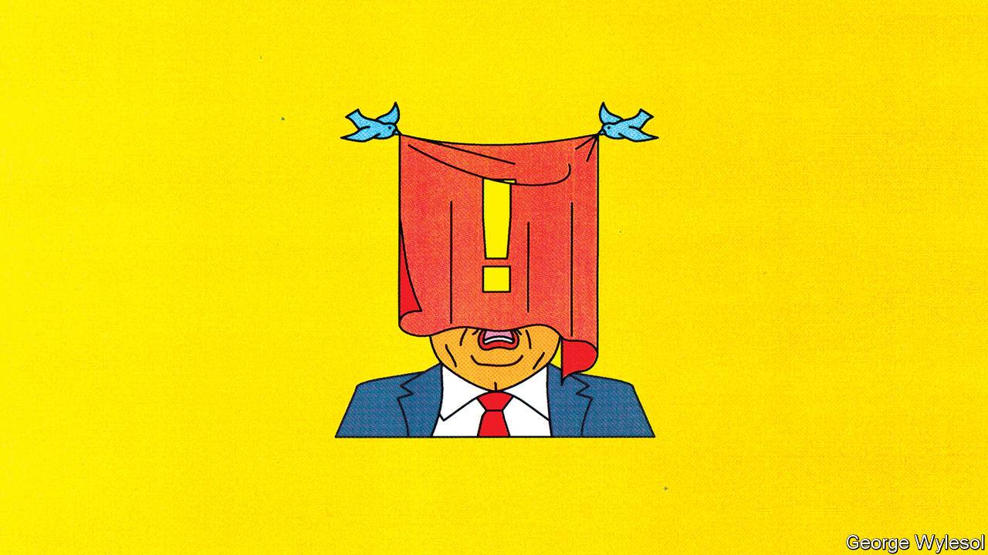

HASTILY DRAFTED, legally flawed and unworkable. Experts poured scorn on the executive order Donald Trump signed on May 28th in reaction to a decision by Twitter, a microblogging service, to flag one of his tweets as unsubstantiated. The company had put warnings on a pair of tweets in which the president said: “There is NO WAY (ZERO!) that Mail-In Ballots will be anything less than substantially fraudulent”. Social-media firms are not liable in America for the content published on them, thanks to section 230 of the Communications Decency Act (CDA). Mr Trump seems to be arguing that if they do not remain—at least in his view—politically neutral, they should lose that protection.

To many, the document seemed like a blatant attempt to bully Twitter, Facebook and other big tech firms into abandoning any efforts to fact-check the president’s online utterances ahead of the election in November. In this, if nothing else, the executive order may succeed. But it will not end the debate over how to regulate speech in the virtual realm.

Section 230 and its analogues elsewhere were crafted to solve what might be called the “moderator’s dilemma”. In the mid-1990s regulators worried that online firms would refrain from policing their services for fear this would make them liable for the content and open them up to costly lawsuits. To solve this problem, section 230 stipulated that, even if firms moderated content, they could not be held liable for it. It does not, however, eliminate all liability for online content. Material that is copyrighted or violates federal criminal law must still be taken down. And those posting offending content can be sued, though this is often difficult and costly.

Much has changed since the CDA was passed in 1996. Few predicted back then the flood of invective and misinformation that now sloshes around online. Nor did they guess that social-media firms, fixated on growth and profitability, would do little to stem the tide until the negative effects became too egregious to deny. Big tech firms now employ armies of moderators and use artificial intelligence to police their services, but governments, particularly in Europe, want them to do more. Meanwhile, civil libertarians worry about the stifling impact on free speech. (And so, he claims, does Mr Trump.)

Section 230 and similar regulations have already gone through one round of mini-reforms. In May 2016 the European Union (EU) agreed to a “Code of Conduct” with Facebook, Microsoft, Twitter and YouTube to counter online hate speech. It includes a commitment to deal with most offensive content within 24 hours. In 2017 Germany made compliance with such rules mandatory, while giving firms some leeway in how they apply them. And in 2018 Congress added communications that promote sex-trafficking to the list of content that is exempt from immunity.

A second round of reforms has now begun. The EU intends to follow the example of Germany, which itself is in the process of tightening its law, the Netzwerkdurchsetzungsgesetz. Britain may soon get similar legislation. In America calls are growing to scrap section 230—on the left as well as the right. Joe Biden, the presumptive Democratic presidential candidate, is not a fan. But without such legislation social-media firms will probably err on the side of caution and become the “ministries of truth” that so many fear.

Governments, particularly in Europe, where limits on free speech are more acceptable, seem to be urging online firms to police their platforms more. Tech titans are unlikely to put up much resistance, since they have already begun monitoring more content in the wake of the pandemic (see [article](https://www.economist.com/business/2020/06/06/twitter-and-facebook-have-differing-business-models)). Groups charged with overseeing the companies’ decisions will become more common. They may be public agencies, as is planned in Britain, or semi-independent self-regulatory groups, such as Facebook’s “oversight board”, also known as its “supreme court”, which in early May welcomed its first batch of judges. Perhaps one day Mr Trump can look forward to their rulings.■

This article was downloaded by calibre from <https://www.economist.com/international/2020/06/04/donald-trump-has-reignited-a-debate-about-regulating-speech-online>

|  |  |  |  |
| --- | --- | --- | --- |
| Previous | Articles | Sections | Next |

|  |  |  |
| --- | --- | --- |
| International | Sections | Finance & economics |

Business

The sharing economy: What’s mine is yours

.

Floating not drowning: IPOs stay afloat

.

Video gaming: Command & reconquer

.

IKEA: Part of the furniture

.

Bartleby: Cultural challenge

.

Schumpeter: Boffins v the bug

.

|  |  |  |
| --- | --- | --- |
| International | Sections | Finance & economics |

|  |  |  |  |
| --- | --- | --- | --- |
|  | Articles | Sections | Next |

#### What’s mine is yours

# The sharing economy will have to change

But that will help it survive the pandemic and thrive afterwards

Jun 4th 2020 | SAN FRANCISCO

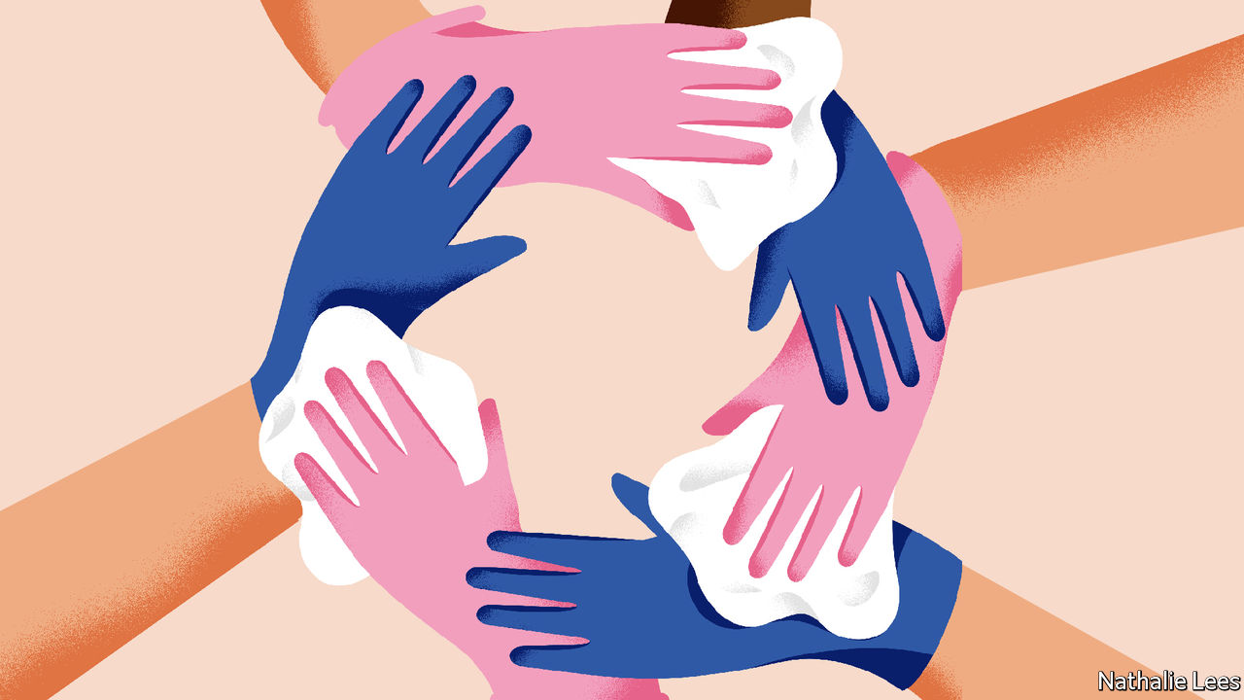

“I THOUGHT WE were dead.” Emmanuel Bamfo, the boss of Globe, a six-person startup founded a year ago, began thinking about what job to do next when the coronavirus hit in March. His firm acted like a short-term Airbnb: its app let people rent out their homes or even only parts of them, such as the bedroom or the bathroom, for a few hours. This became an unattractive proposition during a pandemic.

Mr Bamfo quickly adapted his service instead. Now the app’s users can buy time in empty flats that would in normal circumstances be rented out for longer periods on other sites. It costs between $25 and $125 an hour to rent a flat in San Francisco, offering an escape for those who want to work for a while without children underfoot or need a change of scenery. Demand appears high, though supply less so. The company’s app shows a worldwide waiting list of more than 113,000 (the firm needs to check potential renters’ identities) and it claims to have 10,000 hosts.

Globe’s ultimate success remains uncertain. Officials in San Francisco wrote to the company pointing out that its service violates the city’s shelter-in-place order. But Globe’s early achievements after adapting show that predictions of a covid-induced demise for the “sharing economy” may turn out to be exaggerated. Rather than putting an end to it, the virus is forcing the sector to reinvent itself. That may even involve a return to its socialist roots.

The Great Recession in the wake of the financial crisis of 2007-09 did much to create the ideological impetus to use technology to build an economy in which consumption would be more social, frugal and sustainable. Instead of owning things, the thinking went, people should share access to them using apps and other online services. “I don’t want stuff, I want the ... experiences it fulfils,” said Rachel Botsman, one of the champions of the trend.

Using peer-to-peer services to share and barter things, from books and CDs to power tools and cars, never took off. Most of these businesses did not generate enough cash to sustain themselves. But they paved the way for another sharing economy that seeks to make money by creating online marketplaces to match supply and demand. Startups of that sort could, in the lingo, be “blitz-scaled” into large global businesses. Such size promised big profits, attracting oodles of venture capital.

Airbnb, Uber and Bird were the poster children of the new sharing economy. Together the world’s biggest providers of holiday rentals, taxi rides and e-scooters, respectively, raised over $30bn in funding and their valuations added up to more than $100bn at their peak. Airbnb and Uber had at one time been expected to stage some of the most lucrative ever public listings of technology startups. Yet even before the virus hit, the stars of the sharing economy had started to lose their shine.

Making money proved to be harder than expected. Uber’s rides required heavy subsidies. Maintaining a fleet of e-scooters turned out to be more expensive than Bird had imagined. Flush with venture capital, these companies also moved into other markets. Uber sought to develop autonomous cars and to deliver food. Airbnb considered producing television programmes as well as running hotels.

By the time Uber went public in May last year, it had lost a total of $16.6bn between 2016 and 2019. It said that it would lose more cash before turning a profit, a big reason why its initial public offering was not as successful as many had predicted. Even Airbnb, whose business model of taking a cut of rental fees meant that it had made profits for some time, began losing money—$322m in the first nine months of 2019. The pandemic has interrupted its plans for a flotation, which had been expected to take place in April or May.

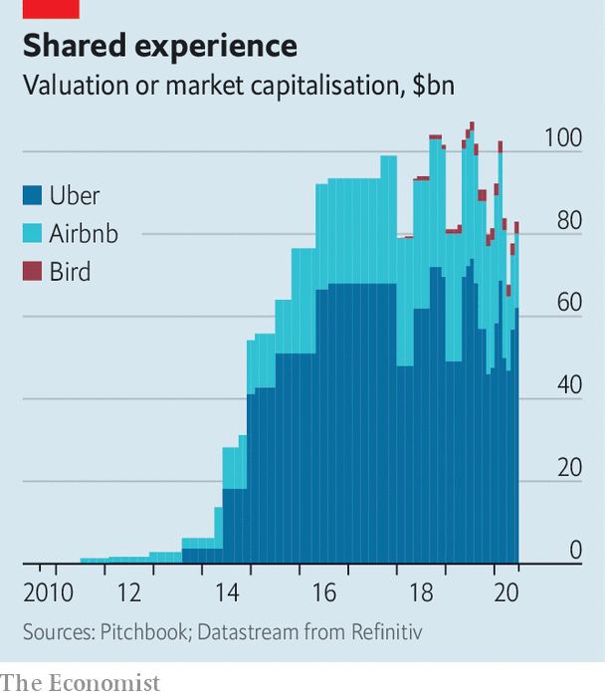

A focus on profitability with an emphasis on cutting costs was already in the air when the pandemic brought businesses almost to a halt. Airbnb faced 1m cancellations and $1bn in refunds. The number of Uber rides plummeted by as much as 80% in April compared with a year ago. Bird, feeling a similar pinch, reacted in late March by laying off over 400 employees, a third of its workforce. Airbnb followed in early May, sacking 1,900 staff, a quarter of its workforce. Uber also dismissed a quarter of its staff, around 6,700 workers. Lyft, its main rival in America, made cuts that were only slightly less savage.

## Cleaning up

Aside from lay-offs, these firms are attempting to rejig their businesses to restore the confidence of customers. Increased cleanliness is the main focus. Airbnb advises hosts on how to clean rooms and has introduced a 24-hour vacancy period between bookings. (It is not mandatory, but guests will be able to see online which hosts are following it.) Bird’s scooters get a regular “bath”. Uber is checking whether drivers wear a mask by having them take a selfie (its app can automatically detect whether they have one on).

Firms have also used the crisis as an opportunity “to go back to basics”, in the words of Brian Chesky, Airbnb’s boss. His firm is now concentrating on hosts who rent out their private homes rather than professional ones with several properties, which had been a growing part of the firm’s business. Uber has ditched several businesses, including a planned credit card for drivers and its e-bike service. It wants to concentrate on being the firm that “moves people and things in cities”, Dara Khosrowshahi, its chief executive, said recently.

The big question is whether being cleaner and leaner will be sufficient for these firms to bounce back when the lockdowns are lifted or whether the “isolation economy” will change habits to an extent that sharing is pushed to the margins. Is ownership destined to make a comeback?

All three firms expect demand to rebound, but in different places and for different reasons. Mr Chesky predicts that instead of making short trips to the world’s bigger cities, people will stay closer to home for longer. The average length of stay in an Airbnb has nearly doubled, to a week. The share of domestic reservations has more than doubled, to over 80%, and stays less than 200 miles (320km) from home, which used to account for 33% of bookings, now generate 56%. Mr Chesky also expects to benefit if working from home remains widespread, allowing people to relocate for a while. “A lot of people are saying: ‘Well, in that case, maybe I don’t need to live in the city right now’.”

Uber and Bird expect a move from public transport to cars and scooters. People may feel nervous about taking buses and trains—if they are available, given the future budget constraints in many cities. There is already some evidence of that. Rides on Bird’s scooters are now on average 50% longer than before the pandemic.

Uber also intends to gobble up competitors. Despite getting out of e-bikes it has invested in Lime, Bird’s biggest e-scooter rival. It also wants to buy Grubhub to boost an existing food-delivery business that it hopes will thrive. “In difficult times consolidation makes sense,” says Mr Khosrowshahi, who excelled at this task during his previous job as boss of Expedia, an online travel site that hoovered up rivals.

Smaller sharing-economy firms are surprisingly optimistic, too. In places which have already lifted some lockdown restrictions, such as Germany, activity has quickly picked up again, reports Nicolas Brusson, who runs BlaBlaCar, which offers long-distance peer-to-peer ride-sharing in 22 countries. The coronavirus recession, he reckons, will increase demand for cheap rides further. The pandemic has also forced his company “to look at its assets in new ways”, he says. In future it wants to offer more services to its community of drivers and riders. It has already developed a new app, called BlaBlaHelp, which lets people ask others to do grocery shopping for them.

If there is one example of how the pandemic may push the sharing economy back to its roots, it is Olio. Motivated by a mission to reduce food waste, the London-based service lets its users share groceries and other items they no longer need with neighbours. “We first had a moment of panic: can a neighbour-to-neighbour sharing app continue to exist?” explains Tessa Clark, who runs the firm. But after changing the service to no-contact pickup, sharing surged by about 50% for food and 200% for other things.

Firms building on activity that existed before the internet, such as sharing food with neighbours, will fare better after the crisis than online marketplaces that are more artificial new creations, predicts Sonali De Rycker, a partner at the European arm of Accel, a venture-capital firm, which has invested in both BlaBlaCar and Olio. If anything, she says, after the pandemic consumers will be even keener to save money or to make some on the side by renting things out. Expect more of yours to be mine and mine to be yours, even if it has to be thoroughly cleaned in between.■

This article was downloaded by calibre from <https://www.economist.com/business/2020/06/04/the-sharing-economy-will-have-to-change>

|  |  |  |  |
| --- | --- | --- | --- |
|  | Articles | Sections | Next |

|  |  |  |  |
| --- | --- | --- | --- |
| Previous | Articles | Sections | Next |

#### Floating not drowning

# Companies are still raising cash by floating

And more may join in when the pandemic recedes

Jun 4th 2020 |

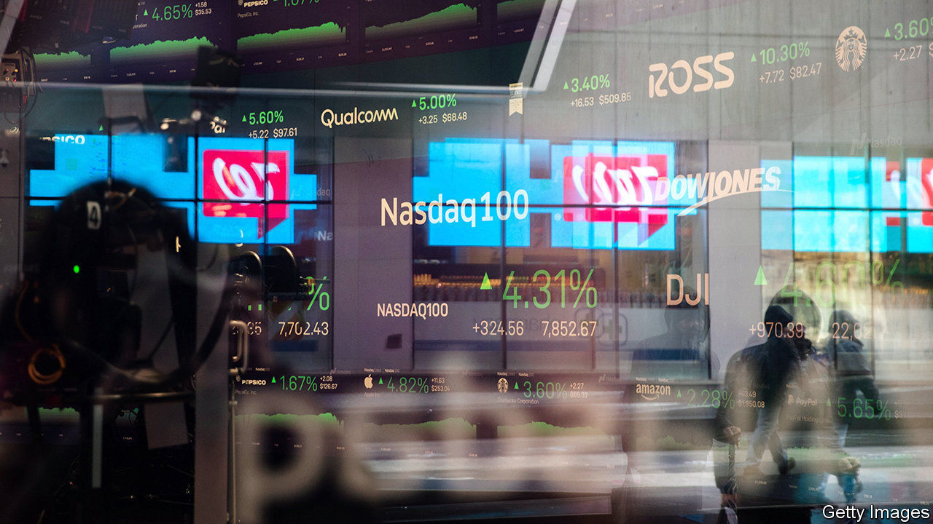

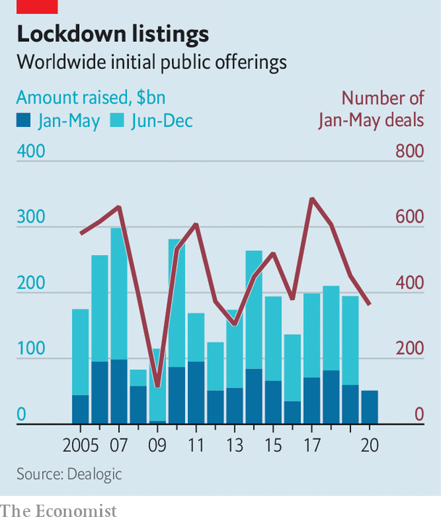

A GLOBAL PANDEMIC would not seem like the best time to bring a business to the stockmarket. But several initial public offerings (IPOs) are afoot. On June 3rd Warner Music started trading in New York having raised $1.9bn—a healthy wodge even in good times. IPOs have had a slow but hardly catastrophic start to the year, according to data from Dealogic. The $51bn raised by the end of May is about a quarter lower than the average over the past decade and nothing like the cratering of 2009. Some are predicting a bumper year as firms pile in after holding off as markets convulsed. Soon to join stock exchanges are an Italian mask-maker and a Korean K-pop impresario.

This article was downloaded by calibre from <https://www.economist.com/business/2020/06/04/companies-are-still-raising-cash-by-floating>

|  |  |  |  |
| --- | --- | --- | --- |
| Previous | Articles | Sections | Next |

|  |  |  |  |
| --- | --- | --- | --- |
| Previous | Articles | Sections | Next |

#### Command & reconquer

# The video-games industry raids its back catalogue

Risk aversion is one reason for a rush to revamp old games

Jun 4th 2020 |



“COMMAND & CONQUER” chronicles a war between the Global Defence Initiative and a band of techno-terrorists called the Brotherhood of Nod. The video game was cutting-edge in 1995, when it was first released on a pair of compact discs. Their vast capacity (for the time) allowed a high-fidelity soundtrack and cheesy videos with human actors which advanced the plot between levels. Players could challenge their friends using a new-fangled technology called “the internet”. It got rave reviews and sold an estimated 3m copies.

That number will rise further when a revamped version called “Command & Conquer Remastered” is released on June 5th. It is the same as the old one in nearly every respect, except that the cartoonish 2D graphics of the original have received a high-resolution makeover.

The music business milks fans with remixes, remasters and special editions of famous albums. Film studios sell extra-long “director’s cuts”. Revisiting products may seem a riskier strategy in a medium where the state-of-the-art advances as fast as it does in video gaming. But it is an established trend. More than 30 revamped games have been released in the past year. Some have topped sales charts. “Final Fantasy VII Remake” a reimagining of a PlayStation game from 1997, sold 3.5m copies in three days after its release on April 10th.

Nostalgia is one explanation. The video-game business is now middle-aged, giving it a deep back catalogue. Many of its customers have fond memories of the games they played in their youth. That can make for exacting critics. “Warcraft III: Reforged”, released by Blizzard Entertainment in January, was panned by fans for unwelcome tweaks to gameplay and the removal of features from the 2002 original.

Remaking games also helps keep valuable franchises in the public eye while new games are in development, says Morris Garrard of Futuresource, a consultancy. He also points out that console gaming is governed by the release of new hardware. Refreshed games can do well at the end of a cycle when there is less competition from flashy new boxes. The deluge may slow as Sony and Microsoft, the dominant firms, are releasing new consoles soon.

Remakes appeal for another reason, too. The cost of developing high-end video games has ballooned. Budgets can exceed $100m for the glitziest titles. The industry has thus become afflicted by the same risk-aversion that keeps Hollywood churning out endless franchise films and sequels. Remixing an old game, which has sold well once and will probably do so again, is quicker and cheaper than coming up with a new one.

This article was downloaded by calibre from <https://www.economist.com/business/2020/06/04/the-video-games-industry-raids-its-back-catalogue>

|  |  |  |  |
| --- | --- | --- | --- |
| Previous | Articles | Sections | Next |

|  |  |  |  |
| --- | --- | --- | --- |
| Previous | Articles | Sections | Next |

#### Part of the furniture

# The boss of IKEA on dealing with the fallout of the covid crisis

The Swedish giant tries not to let a crisis go to waste

Jun 4th 2020 | BERLIN

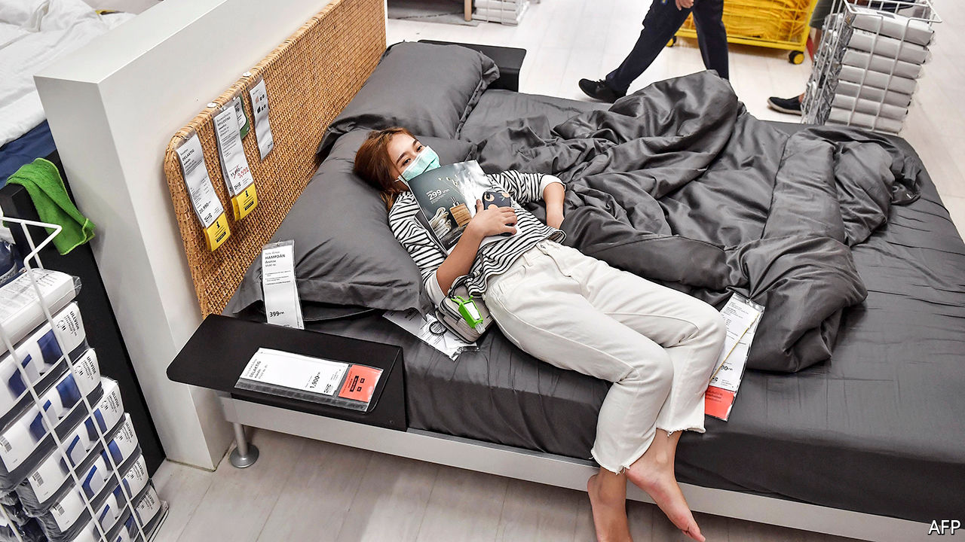

IKEA IS KNOWN all over the world as the biggest furniture retailer, the most successful Swedish brand—and the cause of family quarrels over the assembly of BILLY bookshelves or HEMNES wardrobes. It has so far never made a name for itself as a place of worship. But on May 24th the car park of an IKEA shop in Wetzlar, a city in Germany, welcomed hundreds of Muslims for a Sunday prayer to mark the end of Ramadan, against the backdrop of the blue-and-yellow storefront. It was a nice gesture in times of social distancing.

Like all non-food retailers, IKEA needed a lift. Around 80% of its 433 shops in 50 countries had to shut and many are still closed. Its shops in Germany only reopened their doors in early May, after two months of pandemic lockdown.

Another important pick-me-up is that shoppers have returned in force, starting in China. Having entered lockdown before the rest of the world, Chinese consumers also emerged from it earlier—and plenty of them immediately hit IKEA shops. Many bought big and expensive items, says Jesper Brodin, chief executive of Ingka Group, the parent company that holds and operates most IKEA shops (as well as running Ingka Centres, which manages the group’s shopping malls, and a fund called Ingka Investments).

To Mr Brodin’s surprise, reopenings in Europe have involved “an effort in crowd control”. In Germany, Austria and Switzerland customers thronged to IKEA once its shops were allowed to open. They were undeterred by long queues: all three countries have strict limits on the number of people permitted in a shop at the same time. In Germany and Austria, for example, one customer is allowed per 20 square metres (215 square feet) of floor space. People, it seems, are as desperate as ever for home improvements and kitchen utensils—more so, perhaps, after a period of confinement in which home-cooking revealed domestic inadequacies.

IKEA’s online-shopping figures tell the same story. Internet sales were growing fast before the pandemic, by 43% last year compared with 2018, to 10-11% of total sales. In the past couple of months they jumped to 60% of all sales on peak days of the lockdown across the group. In America, where the furniture giant is planning to start reopening its 50 shops in June, IKEA started to bring back its furloughed workers to look after online orders and provide customer service.

Despite the European crowds, Mr Brodin expects the shift online to continue. Surveys in Europe suggest that consumers will continue to shop online for furniture in greater numbers even once the virus has faded. He is also soldiering on with two other pre-pandemic plans. The first is expansion into city centres. Ingka Centres already owns 45 malls (with an IKEA store as anchor) in Europe, China and Russia. The firm is experimenting with 25 different “touch points” in cities, ranging from the IKEA planning studio on Manhattan’s posh Upper East Side to a mini-store that will open next spring in West London. In the next couple of years it is planning to expand in large cities in America. Falling commercial-property prices resulting from pandemic-induced business failures may bring bargains.

The second bet is on greenery. IKEA began making an effort to be kinder to the environment earlier than rivals. It is planning to be “climate positive” by 2030, which means that it will reduce greenhouse-gas emissions by more than its supply chain emits. To that end Ingka Group has invested €2.2bn ($2.5bn) in renewable energy, some of which it could sell back to the grid, and in forests, which suck up carbon from the air. All this makes business sense in a world of increasingly climate-conscious consumers, according to Mr Brodin. He cites surveys showing that 70% of shoppers profess to be deeply concerned about the climate.

Last year IKEA’S retail sales grew by 6.5% compared with 2018, to €41bn—and Ingka Group’s revenues grew by 5% to €36.7bn. This year sales will dip, though it is hard to say by how much. The company is in sound financial health. It has plenty of liquidity and, in line with the thrifty philosophy of its late founder, Ingvar Kamprad, no net debt. During the global financial crisisIKEA also took a hit, says Mr Brodin, but increased its market share after the recovery. Swedes are a hardy bunch.■

This article was downloaded by calibre from <https://www.economist.com/business/2020/06/04/the-boss-of-ikea-on-dealing-with-the-fallout-of-the-covid-crisis>

|  |  |  |  |
| --- | --- | --- | --- |
| Previous | Articles | Sections | Next |

|  |  |  |  |
| --- | --- | --- | --- |
| Previous | Articles | Sections | Next |

#### Bartleby

# A guide for foreign workers at Chinese firms

When Western workers meet Chinese bosses

Jun 4th 2020 |

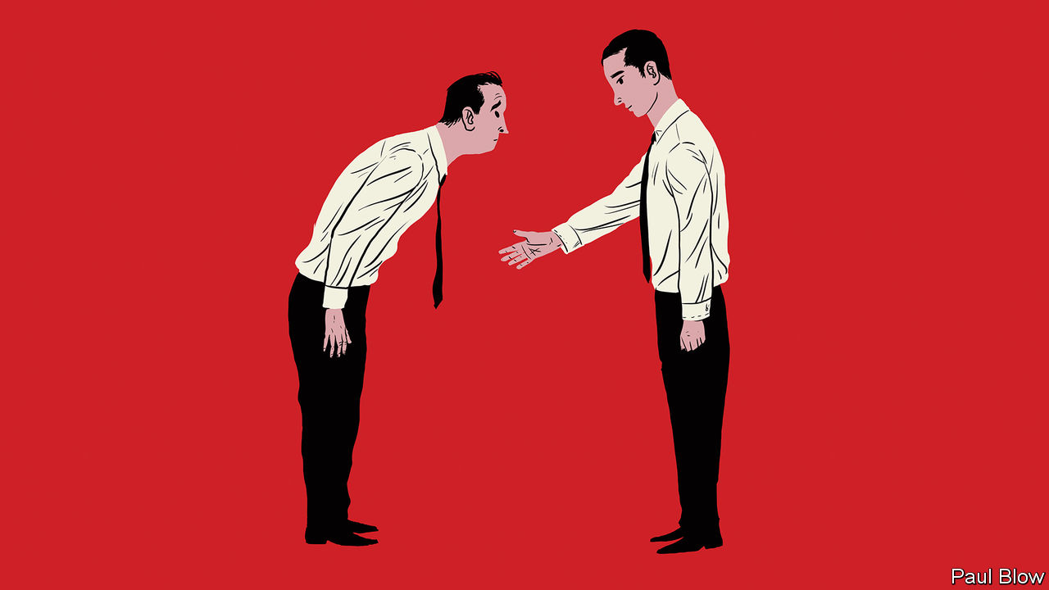

THE CORONAVIRUS pandemic has led to some testy moments in diplomatic relations between China and the democratic world. But in the long run, China’s economic power is likely to increase and that means more foreigners may end up working for Chinese corporations.

In a fascinating and detailed book, “Barriers to Entry: Overcoming Challenges and Achieving Breakthroughs in a Chinese Workplace”, Paul Ross, an executive who has worked in China, describes some of the difficulties workers face. There is plenty of scope for misunderstandings. A common complaint of foreign employees working for Chinese firms is that they do not always understand what is expected from them nor do they find the guidance they receive from Chinese managers satisfactory.

That may be down to differences in corporate culture. Sociological studies show that Chinese culture is more collectivist and displays a greater respect for authority than elsewhere (although a nation of 1.4bn people will not have a uniform mindset). Mr Ross says Chinese workers rely on informal communication for information and guidance, obviating the need for more formal definitions of their duties. As a result, one American who worked for a Chinese group concluded that the ideal Western candidate was someone who was comfortable with uncertainty, rapid and unexpected change, and taking the initiative to find their own direction.

Workers cannot count on getting lots of positive feedback either. But Mr Ross counsels that Chinese bosses who come across as too critical may just be struggling to find their footing.

The relationship between manager and staff is more hierarchical than Western workers might expect, the author says. Chinese managers occasionally ask staff to run errands or do small, personal jobs. Challenging the boss is not a good idea. Mr Ross says employees should never shoot down a boss’s idea directly. If there is a difficulty in implementing the plan, they should blame it on outside factors.

Working long hours seems to be a way of expressing group solidarity in Chinese companies even though it is not always the most efficient use of time. Reviews by Western employees on Glassdoor, a website where workers can write about their companies, suggest that a lack of work-life balance is the most negative factor. In particular, employees are expected to attend after-work functions as a way of showing team spirit. Chinese companies spend a lot of money on events that are designed to bring workers together. Mr Ross says that such shindigs are an important way of transmitting the corporate culture to their staff. So recruits need to take part.

Even so, foreign workers may struggle to be accepted. One person who worked at the Belgian outpost of ZTE, a telecoms-equipment provider, recalled that the Chinese staff sat in a large open space in the middle of the office while the local staff occupied a small office at the end of the hall. Mr Ross suggests offering to teach colleagues English as a way to establish relationships, leading to collaboration in other areas.

Another problem is that foreign employees can find it hard to work their way up the career ladder. One game developer at Tencent concluded that leaving the company for a competitor and then rejoining at a higher level was the best way of getting promoted.

A further cultural difference is in the style of presentations. Chinese executives don’t reveal anywhere near as many personal details in their speeches as Western CEOs. Presenters don’t tend to make eye contact with the audience but read the text off a laptop they bring on stage. Slides tend to be packed with detail as a way of imparting information. Western-style slides with lots of space are seen as lacking useful content.

Despite all these differences, the trend for foreign workers to join Chinese companies is likely to continue, even if businesses from the People’s Republic are barred from making acquisitions abroad. Many foreigners want to work for a Chinese firm because they think it will enable them to develop skills and knowledge that would help their careers.

Furthermore, Chinese companies want to employ foreign staff to deal with overseas clients, because of the cultural sensitivity and linguistic ability they bring. A number of Chinese companies now provide “onboarding” programmes to help overseas recruits adjust. To update Horace Greeley’s 19th-century motto, the advice for the future might be “Go east, young man”.

This article was downloaded by calibre from <https://www.economist.com/business/2020/06/04/a-guide-for-foreign-workers-at-chinese-firms>

|  |  |  |  |
| --- | --- | --- | --- |
| Previous | Articles | Sections | Next |

|  |  |  |  |
| --- | --- | --- | --- |
| Previous | Articles | Sections | Next |

#### Schumpeter

# The quest for a vaccine could restore faith in big pharma

The boffins of AstraZeneca are showing the way forward

Jun 4th 2020 |

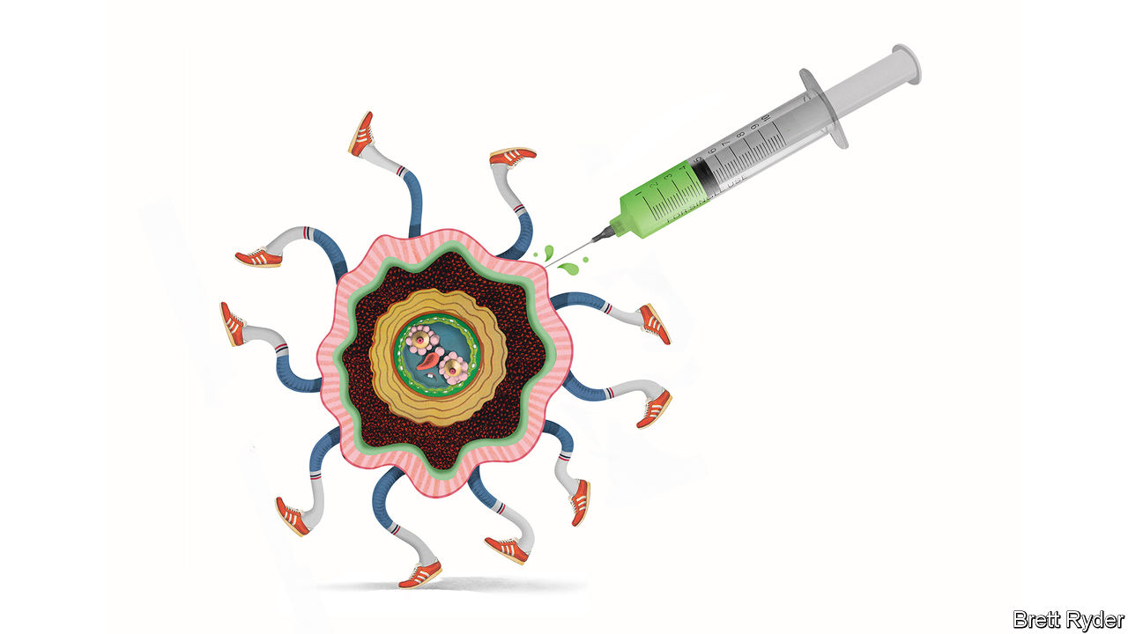

UNPRECEDENTED IS AN overused word. But to find a parallel for the response of the pharmaceutical industry to the covid-19 pandemic, it is necessary to go back to the start of the second world war, another time when countries were desperate for miracle cures. Back then big pharmaceutical companies, especially in America, were as unproductive and unloved as they are today. People were appalled at the mis-selling of addictive narcotics, as they have been during the opioid crisis. And in pre-war Britain, scientists had discovered what they believed could be a wonder antibiotic—penicillin. Yet they could not find any firm, even in America, prepared to take the risk of producing it at scale.

Then came Pearl Harbour and everything changed. As Gerald Posner writes in a new book, “Pharma: Greed, Lies, and the Poisoning of America”, the war effort led American firms like Merck, Squibb and Pfizer to pool their research on penicillin. Mass-producing the antibiotic became as much of a national-security priority as building an atom bomb. By D-Day in 1944, there was enough penicillin to treat 40,000 troops. It was a turning point. The pharma industry emerged from the war revelling “in the glow of its collaborative wartime penicillin programme”.

As the title of his book suggests, Mr Posner is no fan of the industry as it exists 75 years later. Yet even he would have noticed the return of a halo-like glow, albeit via Zoom, as the bosses of some of the world’s best-known pharmaceutical firms gathered on May 28th to recount their collaborative efforts to find a covid-19 vaccine. The talk was of “racing against the virus, not against each other”, of altruism, and of pride in a mission that is critical for saving lives and livelihoods. One of the bigwigs was Pascal Soriot, the 61-year-old French chief executive of AstraZeneca, an Anglo-Swedish firm. His presence was telling. Until the coronavirus, the company barely dabbled in the $60bn-a-year vaccine business. Yet now he is leading the effort not just to create a vaccine, but also to bring big pharma back in from the cold.

Under Mr Soriot, a trained veterinarian who took over at AstraZeneca in 2012, the firm is bucking a decade-long trend of drugmaking fatigue in the industry, in which acquisitions have often made up for a lack of innovation. He credits its success to a faith in science. His pride and joy is AstraZeneca’s research-and-development centre under construction in Cambridge, which he displays on his Zoom wall. The address, he enthuses, is Number One Francis Crick Avenue, named after the molecular biologist and Nobel laureate. In 2014 he used science as a justification to fend off a $118bn takeover bid by Pfizer, arguing it would derail cancer treatments the firm had in development. On May 28th AstraZeneca’s booming oncology business further vindicated that conviction when it revealed that new data from tests of its bestselling drug, Tagrisso, showed that it reduced the risk of relapse in some early-stage lung cancers by a staggering 83%. Though its returns are still below the industry average, such successes have made AstraZeneca Britain’s biggest listed company, now worth £112bn ($141bn).

Yet it is in the quest for the vaccine that Mr Soriot’s faith in innovation could be most consequential. In April the firm struck a landmark deal with Oxford University to distribute a potential jab. Within three weeks it had secured manufacturing capacity for 1bn doses, with the aim of beginning deliveries in September. It received $1bn from BARDA, an American drug-development authority, to gain access to supplies by the autumn. Such funds help it pay in advance for access to the vats and vials it needs to make and ship the vaccine in vast quantities. It is building parallel supply chains around the world to ensure the vaccine is available everywhere. For an industry that usually takes a decade to launch a new vaccine, this is remarkable speed.

Other companies are also building supply chains, but in clinical trials, vital for regulatory approval, AstraZeneca is ahead. After early trials of AZD1222, as the vaccine is known, the firm has started testing it on 10,000 people in Britain to see whether it prevents covid-19. It will expand this to 30,000 people in America. In this effort, the bigger the headstart the better. In Britain, as the number of infections fades, the chances of getting conclusive results on the vaccine’s efficacy are only 50%, says Adrian Hill, director of Oxford’s Jenner Institute, AstraZeneca’s partner. That may mean conducting trials in countries where the disease is still rampant.

It is a nerve-racking challenge. The biggest risk, Mr Soriot says, is politics. Vaccine nationalism means countries will bully drugmakers to secure supplies, though AstraZeneca, like its peers, says it is determined to distribute the vaccine equitably. Whatever that means, there are several other hurdles. The speed of development means the risks of mishaps are high. Initially there will only be enough jabs to treat the most exposed people, such as health-care workers, which may breed resentment. Firms like AstraZeneca hope to forestall criticism by producing the vaccine without profit for the time being. But investors will eventually want to reap rewards. The firms are pushing back against an initiative by the World Health Organisation to pool intellectual property on covid-19 to make sure poor countries have access.

## Stick to the vax

For now, such hindrances seem like a price worth paying. As Mr Soriot says, “there are times in life when you need to stand up and say it’s time to help.” There are already pay-offs. The race for the vaccine has galvanised staff, he says. It answers those who criticise the industry for high prices and profits. “This is what a successful, healthy pharmaceutical industry can do,” he insists. Expect that point to be rammed home in the future when governments again turn their wrath on big pharma over high prices. But hope that the industry develops a new thirst for innovation, as happened with penicillin. The post-war years were golden ones for drug discovery. It would be laudable if a post-covid-19 age were, too. ■

This article was downloaded by calibre from <https://www.economist.com/business/2020/06/04/the-quest-for-a-vaccine-could-restore-faith-in-big-pharma>

|  |  |  |  |
| --- | --- | --- | --- |
| Previous | Articles | Sections | Next |

|  |  |  |
| --- | --- | --- |
| Business | Sections | Science & ... |

Finance & economics

America’s public pensions: Counting the cost

.

Prudence in the pandemic: Americans saved a record chunk of their incomes in April

.

Sustainable finance: Social climbing

.

Buttonwood: The options gambit

.

Women in the workforce: This time is different

.

Free exchange: Land of the rising sum

.

|  |  |  |
| --- | --- | --- |
| Business | Sections | Science & ... |

|  |  |  |  |
| --- | --- | --- | --- |
| Previous | Articles | Sections | Next |

#### Counting the cost

# America’s public-pension funding crisis worsens

Funding ratios have fallen and the cost of provision has risen

Jun 4th 2020 |

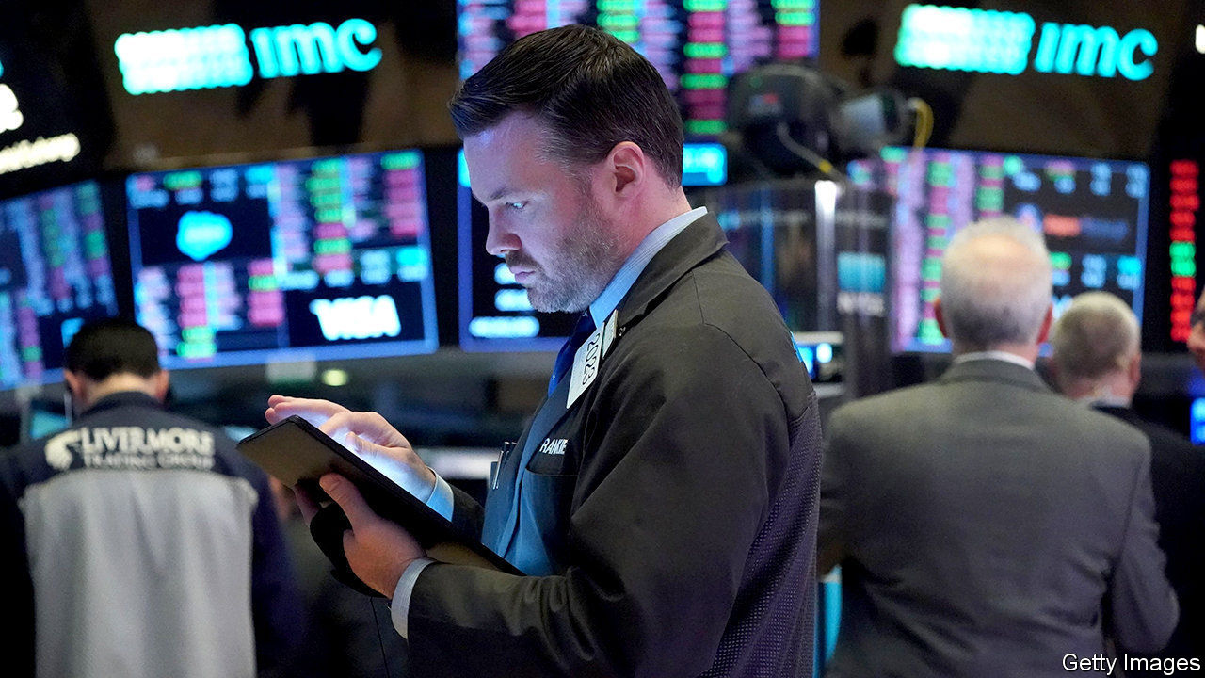

SHARE PRICES may have rallied from the depths they plumbed when the coronavirus pandemic was spreading rapidly around the world. But the S&P 500, America’s main stockmarket index, is still below its level at the start of the year. That is bad news for pension funds, which rely on their investments to pay out benefits to retired people.

Unless markets recover fully, the Centre for Retirement Research (CRR) in Boston estimates, the average funding ratio of American state and local-government pension plans for the fiscal year ending in June 2020 will be 69.5%. That is the lowest level this century. Back in 2000 the average plan was fully funded.

Even that measure relies on the generous way that public-sector plans can calculate their pension liabilities. The cost of paying pensions stretches decades into the future; those expected payments must be discounted in order to calculate the current funding cost. The higher the discount rate, the lower the current cost appears to be. Private-sector pension funds must use corporate-bond yields, currently low, as a discount rate; public-sector funds are allowed to use the expected rate of return on their investments. Many assume a rate of 7-7.5%, which makes the current cost of funding pensions look lower.

In the long run, however, accounting conventions cannot lower the actual cost of providing pensions. Many companies in the private sector have abandoned offering pensions linked to workers’ final salaries because of the increased expense. The CRR figures show that the cost has been steadily rising for public-sector funds as well. Back in 2002 they paid an average of 7.8% of payrolls to fund pensions; in 2020 that contribution is likely to be 19.7%, the highest so far this century. If a more conservative accounting treatment were used, closer to the private-sector approach, that rate would double. Even assuming public pension funds continue to use their current approach, the CRR estimates, the contribution may rise to 29.1% of pay by 2025 if markets are slow to recover.

This is a slow-motion crisis, precisely because the liabilities stretch out over many decades. But by 2025 eight funds may have only enough assets to cover less than four years of benefits, the CRR estimates; three of these funds—Chicago Municipal, Dallas Police and Fire, and New Jersey Teachers—will have a mere two years’ worth. If that happens, taxpayers will simply have to stump up more money to keep benefits flowing. ■

Editor’s note: Some of our covid-19 coverage is free for readers of The Economist Today, our daily [newsletter](https://my.economist.com/user#newsletter). For more stories and our pandemic tracker, see our [coronavirus hub](https://www.economist.com/news/2020/03/11/the-economists-coverage-of-the-coronavirus)

This article was downloaded by calibre from <https://www.economist.com/finance-and-economics/2020/06/04/americas-public-pension-funding-crisis-worsens>

|  |  |  |  |
| --- | --- | --- | --- |
| Previous | Articles | Sections | Next |

|  |  |  |  |
| --- | --- | --- | --- |
| Previous | Articles | Sections | Next |

#### Prudence in the pandemic

# Americans saved a record chunk of their incomes in April

The economic recovery depends on their willingness to splash the cash

Jun 4th 2020 |

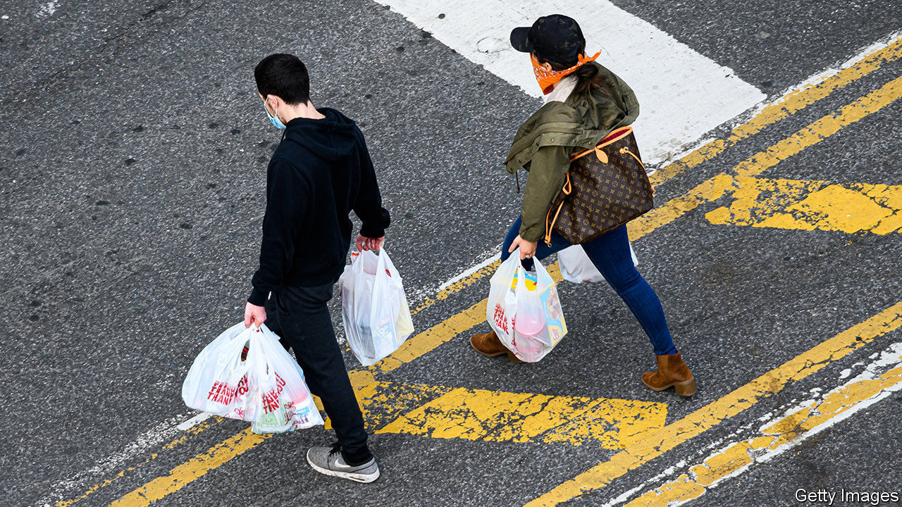

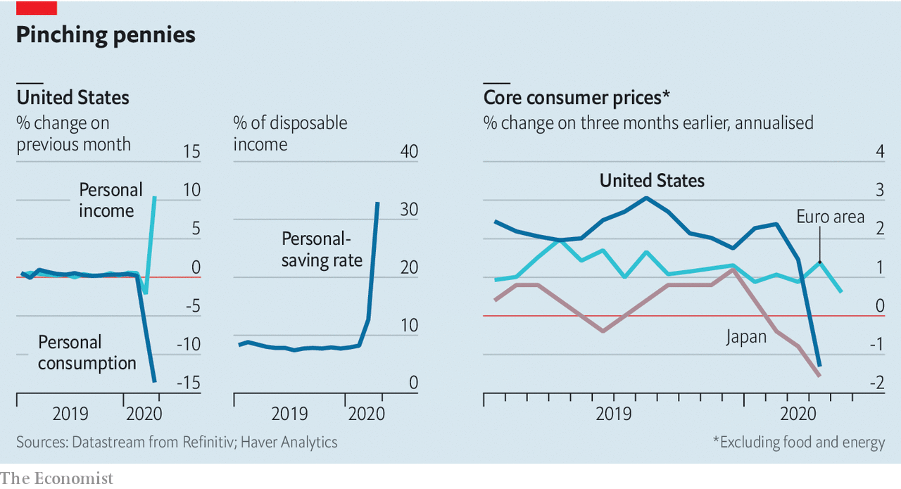

STIMULUS CHEQUES arrived in April, but lockdowns gave Americans little chance to splurge. Instead they squirrelled away a third of their incomes—their highest saving rate ever. The collapse in demand probably weighed on inflation: even excluding oil-price declines, consumer prices fell in America and Japan. The extent to which activity rebounds as lockdowns end will depend on whether consumers stay cautious, perhaps because of an uncertain jobs market, or whether they splash the cash.

This article was downloaded by calibre from <https://www.economist.com/finance-and-economics/2020/06/04/americans-saved-a-record-chunk-of-their-incomes-in-april>

|  |  |  |  |
| --- | --- | --- | --- |
| Previous | Articles | Sections | Next |

|  |  |  |  |
| --- | --- | --- | --- |
| Previous | Articles | Sections | Next |

#### Social climbing

# ESG investors get their heads around social risks

Thanks to covid-19, these woolly risk factors are in the limelight

Jun 4th 2020 |

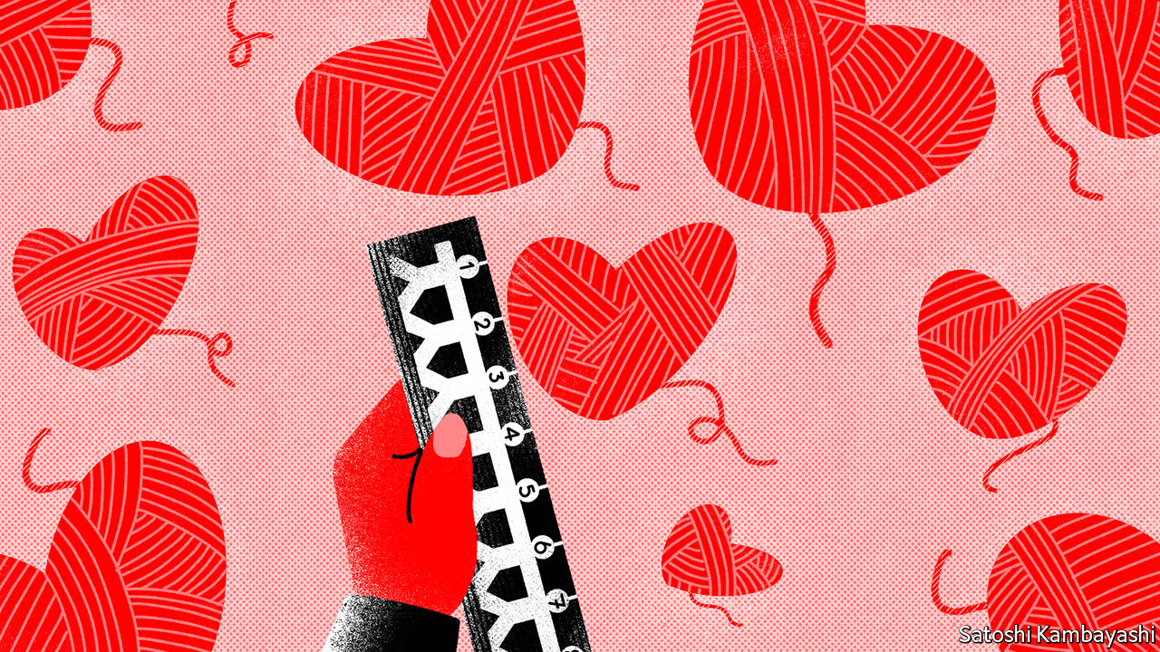

COVID-19 HAS brought out the best and the worst of the corporate world. Carmakers are producing ventilators, and consumer firms are making hand-cleaning gels. Some others, though, have drawn complaints for their treatment of their employees during the pandemic.

Such considerations touch on what sustainable investors call “social” risks, part of the environmental, social and governance (ESG) basket of factors that has grown popular in recent years. Climate change and corporate scandals have led investors to focus on the “E” and the “G”. The pandemic brings the “S” into the limelight.

Social issues can range from the impact of demography on a firm to its relations with the local community. Moody’s, a rating agency, says that $8trn of the debt it rates is exposed to social risks—four times that exposed to environmental ones.

Some investors use social factors in the hope of improving the world: these invest in small listed firms, such as educational outfits, or in private projects. Others do so to improve returns. But there is little consensus on which social risks matter. A green asset manager can assess a firm’s carbon footprint; few gauges exist for socially minded investors. One exception is employee satisfaction, which studies link to a company’s performance. But a focus on that alone can lead to perverse outcomes, by simply giving greater weight to companies with relatively few employees. A recent study by Vincent Deluard of INTL FCStone, a broker, found that ESG-focused funds did precisely this.

Other social factors, such as a company’s culture, are harder to quantify. As a result, ESG-rating firms rely on inputs rather than outputs to calculate their scores, says George Serafeim of Harvard Business School. Instead of measuring gender balance, for instance, they ask if firms have a policy on diversity. Of the 61 questions underlying one rating firm’s social score, 24 look at whether companies have a specific policy or code of conduct.

Whizzy data analysis might fill the gap. Thinknum Alternative Data, a research firm, looks at online reviews of companies written by staff members. Before employees at Wells Fargo, a bank, were found to be setting up fake customer accounts, they were complaining about having to do so. RepRisk, another data firm, analyses news articles and think-tank reports. Its risk ratings for Johnson & Johnson, Purdue Pharma and Teva Pharmaceuticals were already high in 2017, before America’s opioid crisis hit the headlines. All have since been sued for allegedly playing down the risks of prescribing opioids.

A third data firm, Truvalue Labs, assesses the sentiment of news coverage. Using this, Mr Serafeim and researchers from State Street, an asset manager, found that positive coverage of a company’s response to covid-19 was linked to smaller-than-average subsequent declines in stockmarket returns in February and March, controlling for size and industry.

The rigour is helpful, but the challenge will be showing that such data can be consistently useful for investors. New social risks will arise as lockdowns end—for instance, relating to how companies make offices covid-proof. Plenty still to keep the number-crunchers on their toes. ■

This article was downloaded by calibre from <https://www.economist.com/finance-and-economics/2020/06/04/esg-investors-get-their-heads-around-social-risks>

|  |  |  |  |
| --- | --- | --- | --- |
| Previous | Articles | Sections | Next |

|  |  |  |  |
| --- | --- | --- | --- |
| Previous | Articles | Sections | Next |

#### Buttonwood

# Is there a role for options insurance in equity portfolios?

Nassim Taleb and Cliff Asness, two high-level thinkers on finance, disagree

Jun 4th 2020 |

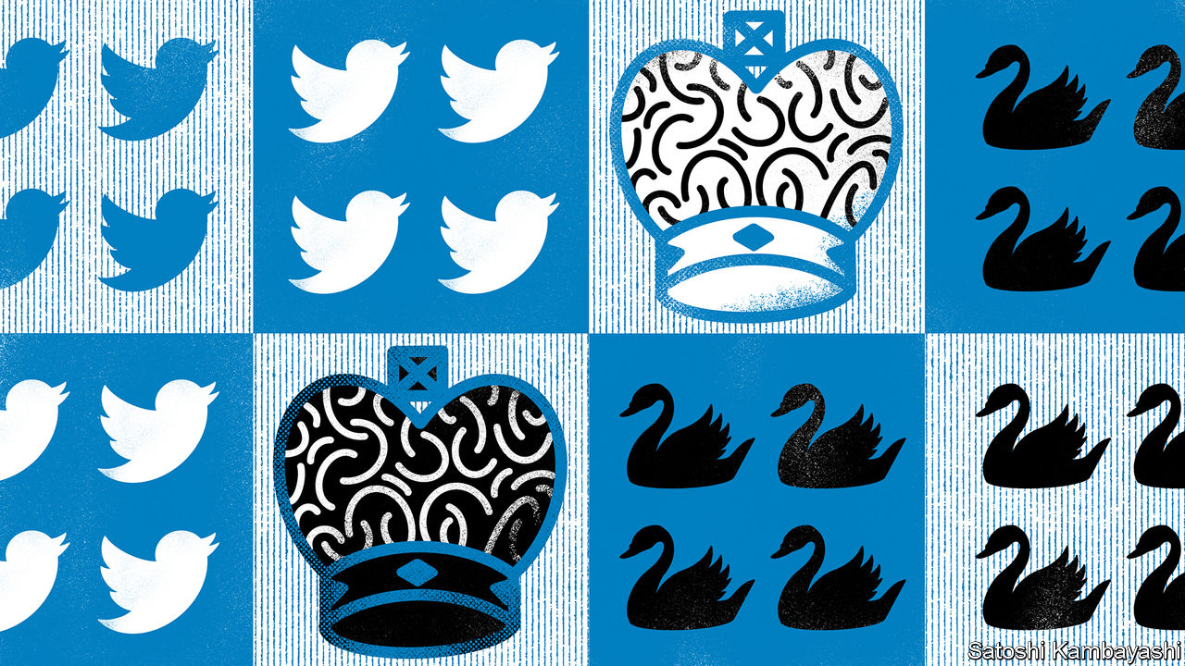

IN 1993 Nigel Short, a British chess player, became an unlikely TV star. This was a consequence of the staging in London of a chess match between Mr Short and Garry Kasparov, the world’s best player. Channel 4 carried highlights. Sustaining interest was a challenge, though. Two men hunched over a board is not a great spectacle. A bigger problem was the baffling complexity of top-level chess. Even a club-level player could not easily work out who was winning.

This brings us to a more recent battle of the brainboxes. Nassim Nicholas Taleb and Cliff Asness, two high-level thinkers on finance, had a forthright exchange of views on social media about the efficacy of buying options to hedge a portfolio of risky shares. Mr Taleb, author of “The Black Swan” and adviser to Universa Investments, an options specialist, says it is the only robust way. Mr Asness, founder of AQR Capital Management, says there are better methods.

Mr Asness’s case is backed by empirical work by AQR eggheads, the gist of which is that people overpay for insurance in the long haul. Not yet proven, is the judgment on Mr Taleb’s view. Everybody loves a highbrow Twitter row. The grandmasters will debate the subtleties. But even the club-level investor can take something away. It is a spur to thinking about how to build sturdier portfolios.

Start, as even grandmasters must, with an opening: you buy a broad index of shares. You are now exposed to the volatility of equity prices. Stocks may fall sharply in downturns. You might usefully balance your portfolio with government bonds. When recession hits, these tend to rise in price as interest rates fall. Bonds are thus a form of insurance. And normally, at least, they pay the insurance-holder a small return: the yield.

A recent paper* from AQR looked at the worst periods for a “60/40 portfolio” (60% equities; 40% bonds) since 1971 to see if options-based insurance did any better. Unsurprisingly, options-protection pays off handsomely in crashes, like the one in February-March this year. Indeed an options-protected portfolio did better than 60/40 in bad periods lasting up to three years. But equity prices tend to recover from crashes eventually. And over time the insurance premiums demanded by options sellers add up to a drag on performance. By the ten-year horizon, 60/40 trumps the options-based portfolio. Other risk-mitigation strategies did even better than 60/40 over time.

On AQR’s reckoning, then, passively buying equity options has been a relatively dear way of mitigating risk over long periods. This is valuable knowledge. It also makes intuitive sense. When you buy home insurance, you know the odds are stacked in the insurer’s favour. The firms are in it to make a profit. Yet that does not make buying insurance foolish: it allows you to take on the risk of a big mortgage.

So might financial-options insurance sometimes make sense, too? In some cases, only a direct form of insurance will do. Take a hypothetical producer of beef. He might expect an annual return of 10% on his business over ten years. But those returns are volatile. Their sequence matters. If beef prices were to slump for two straight years, say, it would mean bankruptcy. The cost of insuring his output using options might lower his average yearly return to, say, 6%. But he might judge that worthwhile to be sure he would stay in business. A similar logic applies to a retiree living off a lump sum. A big drop in share prices would cut deeply into her income. She might not be able to wait for other risk-mitigation methods to come good. Nor is there a guarantee that they would work as well as in the past. Bond yields are close to all-time lows, for instance, implying less scope for them to pay off if the stockmarket takes another lurch downwards.

The price of equity options varies greatly over time. It can make sense to use them when they are relatively cheap, says Vineer Bhansali of LongTail Alpha, a firm that specialises in risk mitigation. In principle, more judicious options buying—finding those with the best potential payoff for the price, including options on other financial assets—could lower the cost of insurance. It is a big ask for the club-level investor, though it may be possible for grandmasters.

Complex situations can befuddle even the best minds. After a few dozen moves in one of the Kasparov-Short games, the grandmaster pundits agreed that Mr Short had lost. As he rose from the board, they thought he had conceded. But no: the game was a draw.

*“Portfolio Protection? It’s a Long (Term) Story”.

This article was downloaded by calibre from <https://www.economist.com/finance-and-economics/2020/06/04/is-there-a-role-for-options-insurance-in-equity-portfolios>

|  |  |  |  |
| --- | --- | --- | --- |
| Previous | Articles | Sections | Next |

|  |  |  |  |
| --- | --- | --- | --- |
| Previous | Articles | Sections | Next |

#### This time is different

# Downturns tend to reduce gender inequality. Not under covid-19

Women’s unemployment has risen more than men’s

Jun 4th 2020 | AMSTERDAM

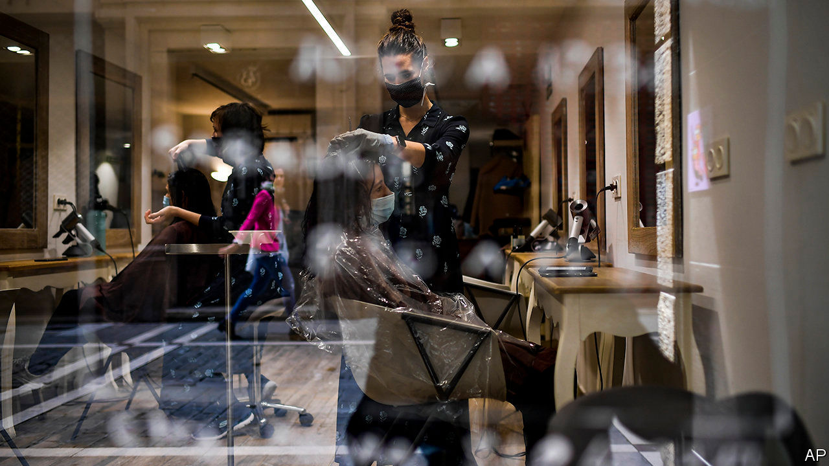

HAIR SALONS tend to be recession-proof. People always need haircuts. During the financial crisis of 2007-09 the number of hairdressers in America even rose. For Sylvia, who owns a small salon in Amsterdam, that crisis was very different from today’s. “Lockdown came out of nowhere and I had no buffer.” She is heartened that regulars phoned in when she reopened. “If it had lasted any longer”, she says, fighting back tears while disinfecting the previous customer’s seat, “I would have gone under.”

Women have borne the brunt of the economic disruption caused by the pandemic. In America, despite making up less than half of the workforce, they accounted for 55% of jobs lost in April. In Britain mothers are one-and-a-half times as likely as fathers to have lost or quit their jobs during lockdown, according to the Institute for Fiscal Studies (IFS), a think-tank.

The unevenness reflects the fact that women are more likely to work in services that require interacting with people. But hotels and shops have shut, and the work cannot be done from home. And crèches and schools have closed, leading some women to stop work and others to work less, in order to look after their children. If job and productivity losses persist, they could reverse progress towards gender equality in the workplace.

Today’s picture is in stark contrast to past recessions (see chart). Men are usually worse affected, because they dominate sectors such as manufacturing and construction, which tend to be badly hit. Matthias Doepke of Northwestern University and Michele Tertilt of the University of Mannheim estimate that three-quarters of all cyclical employment fluctuations in 1989-2014 were owing to men losing and gaining jobs. Women, by contrast, have acted as stabilisers. Employment in services, which is female-dominated, tends to be less volatile. And wives take up work or increase their hours when husbands lose jobs.

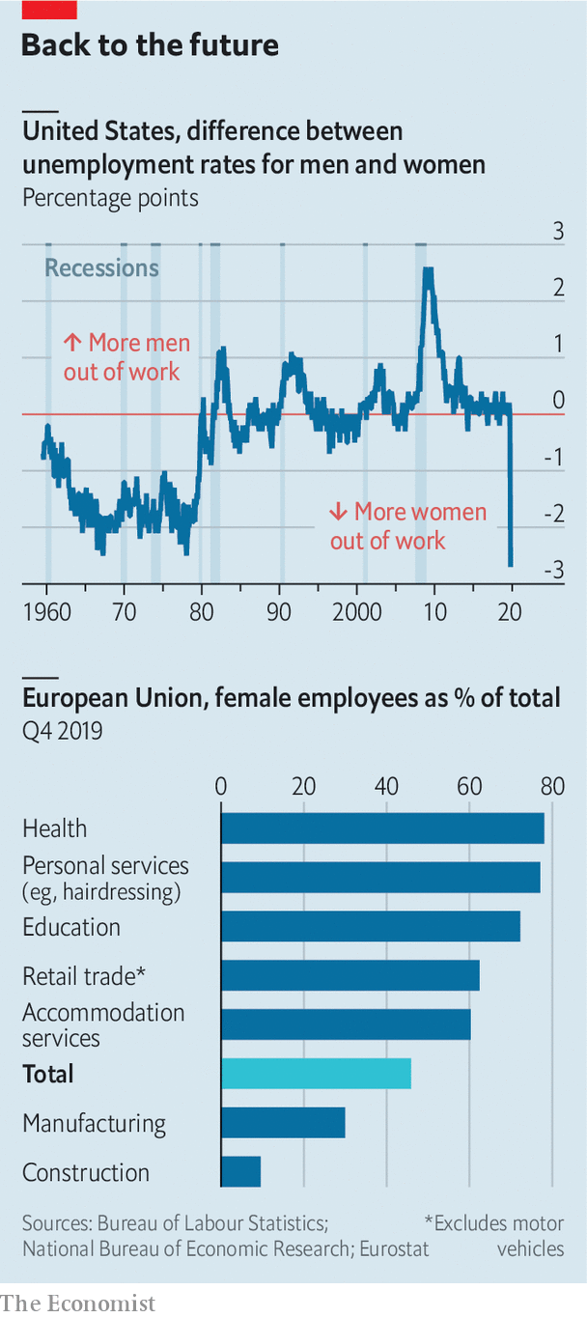

This time, though, industries involving face-to-face interaction, such as hospitality, have suffered most. In America health care and education have not been spared, with five times as many women losing their jobs as men. Firms run by women are also concentrated in customer-facing areas, which is why female small-business founders are much more likely than men to expect a drop in sales owing to covid-19, according to a survey by Nicholas Bloom and Robert Fletcher of Stanford University.

Whether the hit to so-called “pink” sectors persists depends on whether customers flock back as restrictions are lifted. Structural shifts could well mean fewer air hostesses or event organisers, for instance. Temporary lay-offs could become permanent as firms go bust. (The pink crisis could also turn purple: in Canada, job losses in “blue” sectors seem to be catching up.)

Sex segregation alone cannot explain why women have been hit hardest, though. Even after controlling for it, women in Britain were 15% more likely to have lost their job and 8% more likely to have been furloughed, according to research led by Abi Adams-Prassl of Oxford University. Possible explanations include discrimination, or that, bereft of child care, some mothers chose to leave their jobs.

Higher-skilled women are less likely to lose their jobs than lower-skilled ones. Many are juggling working from home with child care. British households with young children are doing an extra 40 hours of care and schooling a week, find Almudena Sevilla of University College London and Sarah Smith of the University of Bristol. Mums do two-thirds of this, on average.

The gradual emergence from lockdowns could do particular harm to women’s careers, worries Claudia Goldin of Harvard University. With workplaces reopening before crèches fully do, couples could be forced to decide who returns to work and who minds the kids. The lower earner, often the woman, might stay home.

Meanwhile, mothers working at home are 50% more likely to be interrupted than fathers, according to the IFS. This “Mu-u-um” pattern, evident even when the woman is the higher earner, could harm pay and promotions. “I fear we’ll see the impact in two to three years’ time in a widening gender pay gap,” says Vera Troeger of Warwick University. Academia offers a glimpse of what may come. Several journals report fewer submissions by women during the pandemic; male submissions to some journals have picked up.

The pandemic has, at least, made remote working normal. Before it, only one in 50 Americans worked from home full-time. By April, more than one in three did. With the concept tested, says Mr Bloom, “we’re never going back to the old world.” That would be good news for mothers, who tend to pick jobs that fit around their children, with more forgiving hours and shorter commutes. But it will mainly benefit university graduates, whose jobs are easier to do from home. Less-educated women cannot count on such a silver lining. A loss of employer demand and extra child-care duties make their job prospects bleaker. ■

This article was downloaded by calibre from <https://www.economist.com/finance-and-economics/2020/06/04/downturns-tend-to-reduce-gender-inequality-not-under-covid-19>

|  |  |  |  |
| --- | --- | --- | --- |
| Previous | Articles | Sections | Next |

|  |  |  |  |
| --- | --- | --- | --- |
| Previous | Articles | Sections | Next |

#### Free exchange

# Japan probes the limits of economic policy

Including loan guarantees, fiscal support this year will amount to 40% of GDP

Jun 4th 2020 |

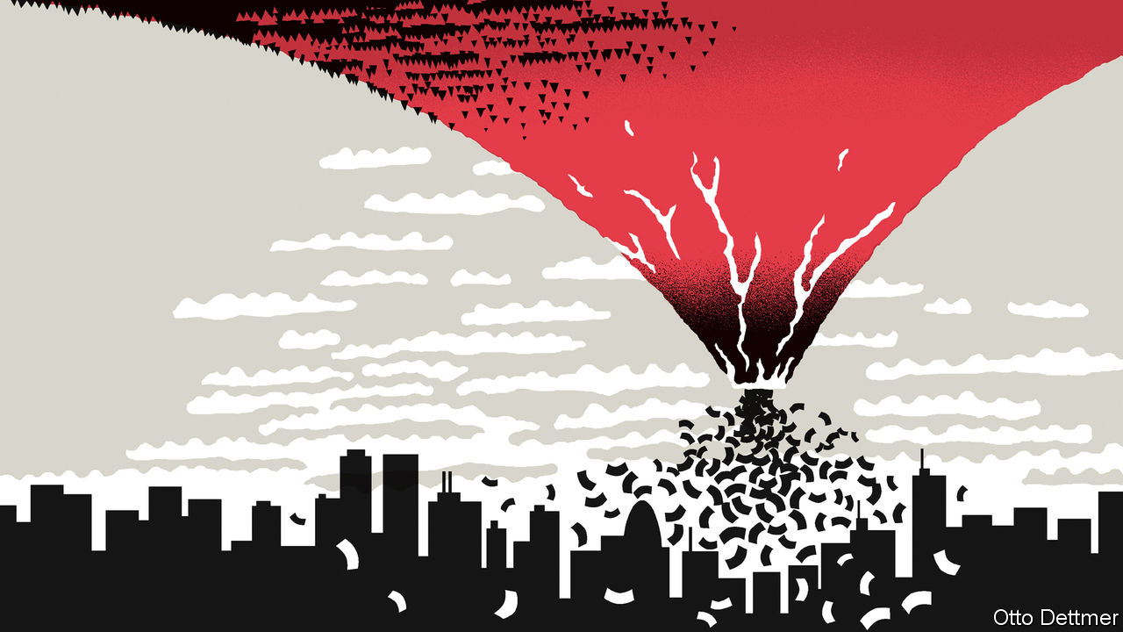

IN THE 1990S Japan seemed to offer a cautionary tale, an example of how feckless macroeconomic management could lead to troubles that other governments had long ago learnt to avoid. By the 2000s many economists came to see it as a harbinger. The path its leaders took in their efforts to lift weak growth, chronically low inflation and near-zero interest rates has been followed, repeatedly, by others in the rich world. Japan’s trailblazing has helped reveal that the limits to extreme policy are much farther away than economists had thought at first. This path-finding may well continue. At the end of May the government announced spending plans that will take total fiscal support for the economy this year to 40% of GDP. (Because the measures include loan guarantees, the budget deficit will probably amount to less than half of that.) The colossal figure might bolster queasy politicians elsewhere. But even as it does so, Japan’s fiscal radicalism exposes the limits to what government borrowing can achieve.

Japan’s experience of covid-19 has been remarkably mild. Despite its older population, a rash of cases early in the epidemic and a reluctance to impose strict lockdowns, its recorded infection rate is among the lowest in the rich world: just 134 per million, less even than in widely touted success stories like South Korea and New Zealand. It began its battle against the economic effects of the pandemic from an especially weak position, though. In most countries the coronavirus interrupted an economic boom, but Japan’s downturn began last year. An increase in consumption tax last autumn, part of an effort to repair the government’s finances, was followed by a drastic pullback in spending. Output shrank at an annual rate of 7.1% in the last quarter of 2019, compared with the previous three months, and by 3.4% in the first quarter of 2020. As in much of the rest of the world, the pace of contraction is likely to have been far more dramatic in the second quarter.

In the face of this bleak outlook, the Bank of Japan has continued to provide extraordinary monetary support. It has led efforts to revive the Japanese economy since Abe Shinzo, the prime minister, entered office in 2012. Its policy of yield-curve control, introduced in 2016, caps ten-year government-bond yields at 0% (the idea is gathering some support in America). Bonds with longer maturities yield less than 1%. Like many other central banks, the Bank of Japan has made emergency loans to vulnerable firms. Furthermore, it has bought about ¥62trn ($600bn) in assets, taking its already swollen balance-sheet to more than 110% of GDP.

More remarkable, though, has been the extent of fiscal support. In April Mr Abe’s government unveiled spending and guarantees worth ¥117trn, or roughly 20% of GDP, one of the most extreme responses to the pandemic. Perhaps feeling the pressure from a public that has become increasingly frustrated with the government’s handling of the crisis, Mr Abe announced another package in late May, which is roughly the same size as the first. As a consequence, the flow of red ink this year tests the limits of comprehension. Japan will issue government bonds worth roughly 40% of the size of its economy. All else being equal, borrowing could account for nearly 60% of the government’s revenue in 2020. A third spending programme cannot be ruled out. Soaring borrowing and falling output together promise to push Japan’s level of gross government debt well above the already vast level of about 240% of GDP.

Markets have yawned in response. Share prices in Japan have risen steadily from their lows in March—no doubt influenced by the central bank’s large-scale purchases of exchange-traded funds—but so have stock indexes in most of the rest of the rich world. Government-bond yields have barely stirred. The Bank of Japan’s yield cap partly explains that. But the central bank’s pace of government-bond purchases has slowed since March and April, amounting to just ¥5trn between May 20th and 31st. The yen has been surprisingly well behaved. At the moment, punters do not seem to have become more worried about Japan’s fiscal sustainability or the risk of inflation.

Investors’ indifference to such borrowing may come as a relief to other rich-world governments seeking to breathe life back into their economies. Since the global financial crisis of 2007-09, economists have become more comfortable with the notion that large-scale government borrowing is needed to fight economic weakness. But the awesome scale of debt issuance created by the response to the pandemic risked deterring some governments from borrowing as much as needed. Japan’s benign experience should provide some reassurance.

## The Abe shoe drops

There is a risk of over-interpreting the lessons of Japan’s trailblazing, though. Debt issuance of 40% of GDP, tacitly financed, in large part, by central-bank easing, will probably influence debates around the world about the extent to which sustained borrowing can be used to fund generous social programmes. But all its stimulus notwithstanding, Japan’s economy is hardly roaring ahead. Its output per person, in real terms, is unexceptional by the standards of the rich world.

In fact, Japan has been able to borrow so much, now and in more placid times, because the rest of its economy spends so little. High levels of net saving by households and firms—that is, savings less investment—are a persistent problem, and represent forgone consumption and unused economic capacity. Demography is partly to blame. People approaching retirement save more, and that surely discourages companies from making large investments at home. But corporate thrift also represents a failure of reform, and of ambition; an inability to take full advantage of the country’s capabilities and its attractiveness to would-be immigrants, for instance. Japan has shown the rest of the world a policymaking route that is seemingly sustainable. That does not mean it is worth following. ■

This article was downloaded by calibre from <https://www.economist.com/finance-and-economics/2020/06/04/japan-probes-the-limits-of-economic-policy>

|  |  |  |  |
| --- | --- | --- | --- |
| Previous | Articles | Sections | Next |

|  |  |  |
| --- | --- | --- |
| Finance & economics | Sections | Books & arts |

Science & technology

Human space flight: The shape of things to come

.

Archaeology: Taking soundings in Teotihuacan

.

Climate feedbacks: Fire down below

.

|  |  |  |
| --- | --- | --- |
| Finance & economics | Sections | Books & arts |

|  |  |  |  |
| --- | --- | --- | --- |
|  | Articles | Sections | Next |

#### The shape of things to come

# The Crew Dragon mission is a success for SpaceX and for NASA

The most eagerly anticipated space mission for a decade or more

Jun 4th 2020 |

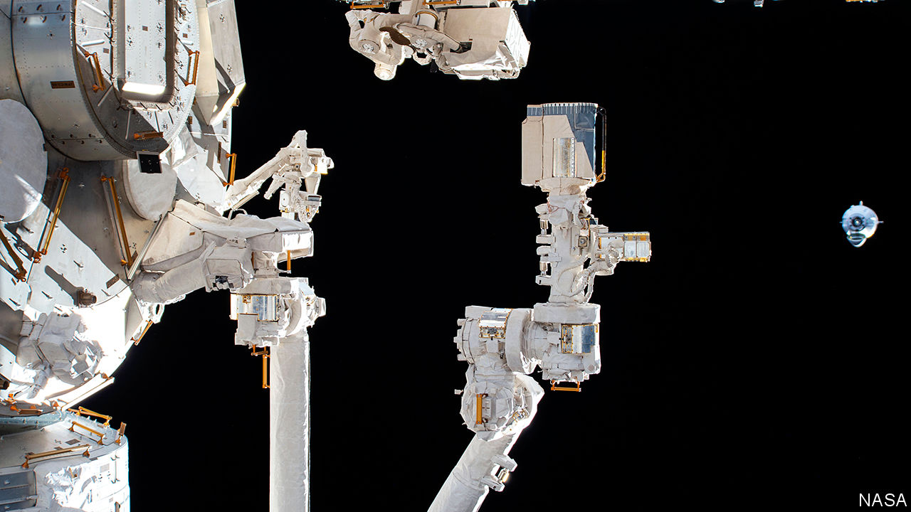

THE ECHOES were obvious. The first launch of an Apollo spacecraft with a crew took place in 1968, an election year in which the country was reeling from assassination and riot, at war abroad and divided at home. To some on both sides of that divide, the Apollo programme remained an inspiration, a revelation of what the nation could do if determined to. It was “Man’s noblest venture”, declared Ralph Abernathy, a civil-rights leader, as he demonstrated outside the Kennedy Space Centre in Florida—but moving and heroic as it was, he went on, it threw into sharp relief the priorities of a nation which badly needed to improve the lot of its poorest people. Others were less magnanimous about what they saw as a distraction. “Was all that money I made last year”, asked the poet Gil Scott-Heron, “for Whitey on the Moon?”

On May 30th, in the most eagerly anticipated space mission for a decade or more, a Falcon 9 rocket launched a new space capsule, the Crew Dragon, from the same Florida launch pad that saw those Apollo missions blast off to the Moon. Less than a day later the spacecraft delivered her crew, Robert Behnken and Douglas Hurley, to the International Space Station.

America’s first crewed spacecraft since the space shuttle, which first flew in 1981 and was retired in 2011, had done its job perfectly. This coup for NASA, America’s space agency, which President Donald Trump wants to see land people on the Moon by 2024, might in other circumstances have been much ballyhooed. The return to space could even have been a boost to the morale of a nation reeling from disease—had it not been for protests and violence 400km below bringing to mind other aspects of 1968.

The mission was eagerly anticipated for two reasons. One is that it has been something of an embarrassment for America to go so long without the capacity to launch its own astronauts, relying instead on rides into space provided by the Russians (and paying handsomely for the privilege).

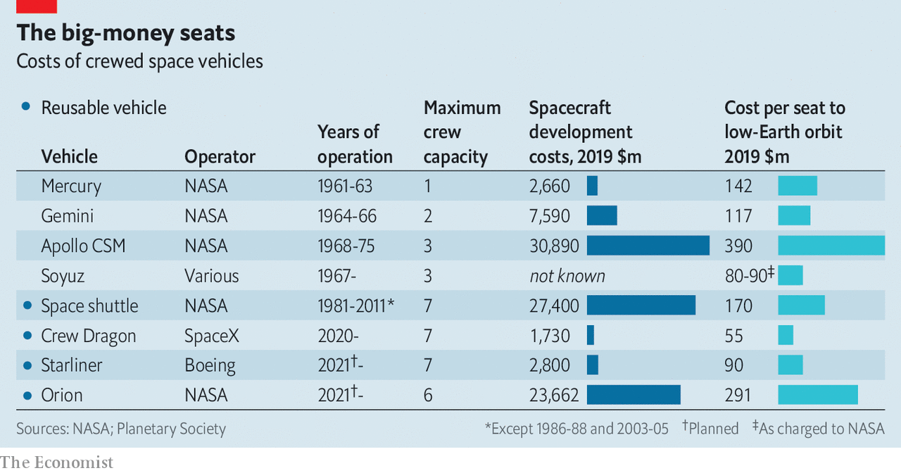

The other, deeper, reason for excitement was that the Crew Dragon programme proved that human space flight can be far cheaper than NASA’s previous record would lead you to expect. The Planetary Society, which lobbies for space exploration, reckons the Dragon cost NASA just $1.7bn, making it the cheapest crewed spacecraft developed in America (see chart).

Dragon is cheap largely because of the way it was procured. Previous NASA practice was to offer “cost plus” contracts for building rockets and spacecraft which met specific design requirements. There was little competition involved and few incentives to keep costs down, not least because the giant defence contractors which won such contracts have many friends in Congress happy to see NASA spend generously as long as it does so in their own districts and states.

This produces programmes like the Space Launch System (SLS), which has been made integral to NASA’s Moon plans. The SLS is a very big rocket conceived as part of George W. Bush’s plans for missions to the Moon and Mars. Barack Obama had no time for those plans, but the Senate made sure that a version of the rocket was kept in development regardless. According to NASA it will have cost at least $17bn by the time of its first mission, slated for 2021. Developing the Orion spacecraft that the SLS is meant to launch has cost even more.

In the mid-2000s Mike Griffin, then NASA’s administrator, began experimenting with a new approach. Instead of specifying what a rocket or spacecraft should look like, NASA would tell firms what it wanted and agree to pay for some of the R&D which might be required while allowing them much more room for manoeuvre when it came to choosing technologies and making trade-offs in design.

That approach opened the door for companies beyond the established military-industrial complex—including SpaceX, a firm founded in 2002 by Elon Musk in order to further his dream of establishing a civilisation beyond the Earth. When Dr Griffin left NASA in 2009, SpaceX had launched just one small payload into orbit. But it had also become part of NASA’s Commercial Orbital Transportation Services programme. By 2012 money from NASA, some earned by meeting specified R&D milestones, had allowed it to use a new rocket, the Falcon 9, to launch a new cargo spacecraft, the Dragon, to the space station. The investment by NASA had not only given SpaceX new capabilities, it had also helped build up a truly innovative company in an area sorely bereft of innovation.

## Rewriting the rocket equation

A spacecraft for humans was the next step. Not everything went to plan. The crewed version of Dragon was supposed to fly in 2015 but was delayed by technical problems and funding constraints. But NASA’s new, cost-saving approach now has a human-rated spaceship to add to its list of accomplishments. It should soon add a second. The programme which saw SpaceX develop Crew Dragon has seen Boeing, a giant defence contractor, develop something similar, the Starliner. But a test flight last December went badly, and no crewed flight is expected until 2021. The next Crew Dragon flight—the first of six routine crewed flights that NASA has signed contracts for—is due in August.

Now NASA is applying a similar approach to its lunar ambitions. In April it announced it was spending $1bn with three industry groups to develop the capacity to take humans from lunar orbit down to the surface. One group is led by Blue Origin, owned by Jeff Bezos, the founder of Amazon. Blue Origin has yet to fly a rocket to orbit, but its technology appears first-rate. Mr Bezos, like Mr Musk, thinks that developing a human presence in space will assure him a place in the history books of a civilisation too grand for a single planet.

The second recipient of funds was a consortium led by Dynetics, a subsidiary of Leidos, a defence contractor formerly known as SAIC. The third was SpaceX, which offered a version of Starship, a new spacecraft it is developing off its own bat. The Starship and its booster are designed to be as capable as the SLS and also fully reusable. Things have not, so far, gone smoothly: four test vehicles have blown themselves apart, the most recent on May 29th.

None of these three lunar-lander options requires the SLS to get into orbit. Starship would be launched with a new booster SpaceX is designing for exactly that. The Blue Origin lander could be launched on the company’s New Glenn rocket, somewhat more powerful than the Falcon 9, or on Vulcan, a similarly sized booster made by Boeing and Lockheed which is Dynetics’s ride of choice: both launchers are due to make their debuts next year. But the SLS and its Orion capsule are still integral to NASA’s Moon plans. They will fly the astronauts to lunar orbit before the new spacecraft takes them to the surface.

This looks even less sensible now than it ever did. With a big SpaceX rocket—the Falcon Heavy—already available, two new big boosters due to debut next year and Starship being developed, American industry offers a number of options for getting astronauts up to the Moon. A programme truly aimed at improving the state of the spacefaring art, demonstrating a unique national capability or providing a shared experience around which Americans could, in principle, unite needs no more. And it would cost much less. The idea that a trip to the Moon might heal national wounds looks even less likely now than it did half a century ago. But it could at least take less of the money that Scott-Herron’s heirs earned last year. ■

This article was downloaded by calibre from <https://www.economist.com/science-and-technology/2020/06/04/the-crew-dragon-mission-is-a-success-for-spacex-and-for-nasa>

|  |  |  |  |
| --- | --- | --- | --- |
|  | Articles | Sections | Next |

|  |  |  |  |
| --- | --- | --- | --- |
| Previous | Articles | Sections | Next |

#### Palaeo-musicology

# The lost instruments of Teotihuacan will soon be heard again

An ancient city is about to have its “soundscape” recorded

Jun 4th 2020 |

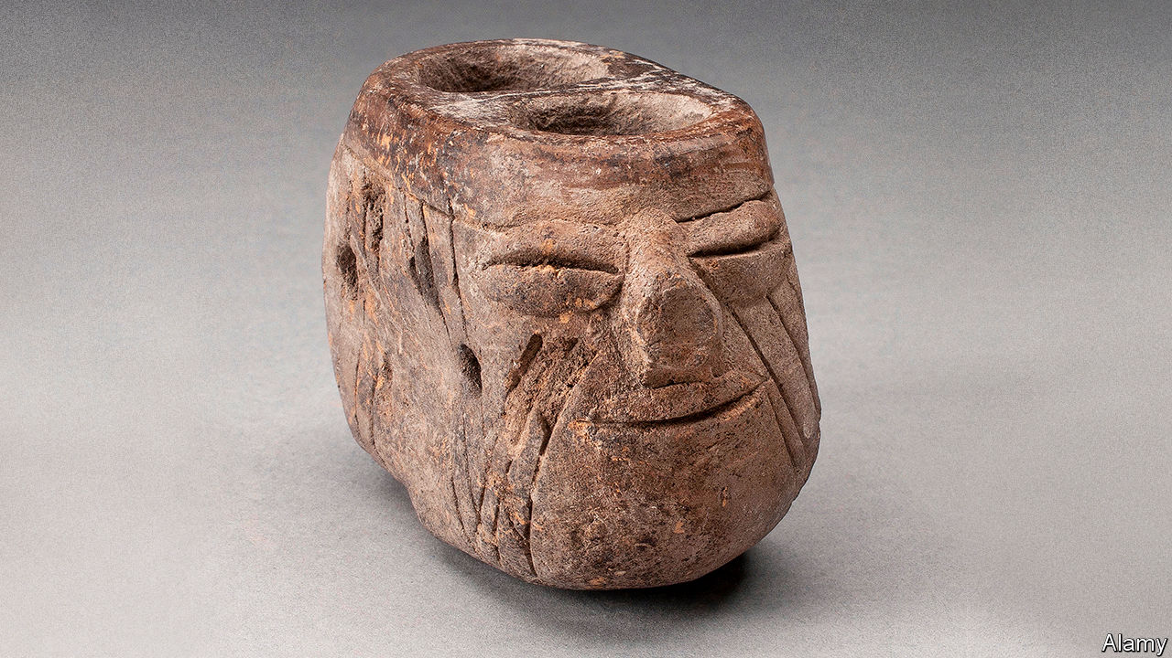

ONE AFTERNOON last December Arnd Adje Both, a researcher at Huddersfield University, in Britain, stood on top of the Pyramid of the Moon at Teotihuacan, in Mexico, and blew into a conch-shell trumpet, sounding a note that echoed in the plaza far below. Later this year—covid-19 permitting—he hopes to return with a group of colleagues to conduct an aural examination of the site using replicas of the ancient instruments dug up there.

Teotihuacan is a mysterious place. Once home to more than 100,000 people, at its zenith around 1,500 years ago it was among the biggest cities in the world. Its inhabitants, though, had no known system of writing. Even the city’s original name is unknown. “Teotihuacan”, meaning “birthplace of the gods”, is what the deserted settlement was called by the Aztecs, who took over control of what is now central Mexico in about 1300AD, some 650 years after the city was abandoned. All that is known about Teotihuacan’s inhabitants and their culture is what archaeologists have pieced together from the remaining buildings and other artefacts.

Dr Both’s curiosity about the music-making of these elusive people goes back to the 1990s. He took part in one of his first excavations at Teotihuacan. While doing so he got to know a group of Mexican musical-instrument makers and became interested in crafting replicas of the site’s double-chambered water-sounding vessels (pictured above), which whistle when water moves from one chamber to the other, quadruple flute pipes and other strange instruments. He has since spent many months in the collections of the National Anthropology Museum in Mexico City, and other institutes, plotting the dimensions and workings of these finds.

Since the genuine articles are too delicate and valuable to play, he has teamed up with Osvaldo Padrón, an instrument-maker in Amsterdam, to create replicas. He is not looking to reproduce pre-Columbian tunes on these facsimiles. The inhabitants’ apparent societal aliteracy extended to musical notation, so there are no scores to interpret. But by recording the replicas being played in their native site he nevertheless hopes to gain a better purchase on how sound moved around the ancient city.

Creating such “soundscapes” is a trendy if somewhat esoteric idea in archaeology at the moment. Kristy Primeau and David Witt of the State University of New York, for example, have mapped the spread of the sound of voices and conch-shell trumpets around the ancient Puebloan dwelling-sites of Chaco Canyon, New Mexico. To do so they modified programs employed for environmental-impact studies—specifically, for the modelling of levels of noise from vehicle engines that might be perceived in a wilderness area as a result of economic development. Using this software they have shown that the sites of platform mounds built in the canyon were not chosen accidentally. Rather, they are well placed to propagate sound through the area’s now-abandoned settlements.

Similarly, a team led by Margarita Díaz-Andreu of the Catalan Institution for Research and Advanced Studies has discovered that spaces in rock shelters in western Spain that are decorated with prehistoric art also have striking acoustic properties of reverb and echo—whereas undecorated areas used for shelter at the same time did not. And Miriam Kolar of Amherst College, in Massachusetts, has shown that the top of a towering central platform in the Inca city of Huánuco Pampa was not just a place from which to address the masses. It also had excellent internal acoustic properties. It would have made a good private venue for the local elite.

When Dr Both returns to Teotihuacan, he and his colleagues will play their replicas from spots on the Sun and Moon pyramids, and from other places among the palaces and temples that line the city’s main thoroughfare, the Avenue of the Dead. Rupert Till, Huddersfield’s professor of music, who is also a recording engineer, will record these from various places and attempt to build a model showing how sounds change in the city as the listener moves from one place to another. Or the listener can stop this virtual tour, turn off the sound of the instrument and hear the breeze blowing over the stones.■

This article was downloaded by calibre from <https://www.economist.com/science-and-technology/2020/06/04/the-lost-instruments-of-teotihuacan-will-soon-be-heard-again>

|  |  |  |  |
| --- | --- | --- | --- |
| Previous | Articles | Sections | Next |

|  |  |  |  |
| --- | --- | --- | --- |
| Previous | Articles | Sections | Next |

#### The fires within the deep

# Have Siberian fires been smouldering underground all winter?

If so it could be a warning

Jun 4th 2020 |



SEEN FROM the sky, the northern stretches of Siberia in early May were a splodgy white, their thinning winter snow cover interrupted by the brown veins of meandering rivers. Nestled within some of these curves, though, satellites picked up patches of soil warmer than the ground around them. The patches grew and multiplied as the month went on. Before it was over, some were visibly ablaze.

Fires are not unheard of in the Arctic, even at this time of year. But the extraordinary fires seen last summer have put researchers on high alert for oddities. In June, July and August 2019 fires within the Arctic Circle pumped 173m tonnes of carbon dioxide into the atmosphere. The 182m tonnes emitted over the year as a whole smashed the previous record of 110m tonnes, set in 2004. Dense clouds of smoke smothered Siberian cities. The fires consumed not just trees and grasses but also peat which would normally have been frozen. Alaska experienced an unusually active fire season, too.

Last year’s inferno makes this year’s early-season hotspots and blazes particularly interesting. Fires can overwinter underground, particularly if they find their way to pockets of peat which offer the fire just enough oxygen for slow smouldering beneath the snow. After a wildfire singes a network of submerged layers of peat its descendant embers can pop up months later: though purists frown on the term, they have become known as “zombie fires”.

A recent Dutch study of overwintering-fire data, presented at a meeting of the European Geosciences Union held the same week that the satellites were seeing hotspots in Siberia, suggests that they are more likely to happen in years after large burns. Though such fires can travel some distance under the surface, and so do not have to reappear where last seen, most stay put. The fact that some of this May’s flames were in areas that burned last year and are rich in peat is thus suggestive. On-the-ground observations will be required to settle the matter, though.

If the fires did overwinter, that is not in itself a bad omen; the Dutch study did not find that overwintering fires make a new year particularly fire-prone. Exceptional fire seasons are normally preceded by hot, dry early summers, as last year’s was. Happily, the ground around the Arctic Ocean currently appears wetter than average, except in the north-eastern-most reaches of Siberia. That said, in Siberia and Greenland April’s temperatures were well above the 1981-2010 average—in places by more than 10°C. A warm, damp spring could yet become a hot, dry summer.

Arctic fires garner less attention than those in Brazil, which the world has been worrying about for decades, or California, Australia and the Mediterranean, which are more densely populated. But regional and global feedbacks make them peculiarly alarming. By leaving dark scars on the land they burn and spreading soot much farther afield they increase the land’s capacity to soak up summer sun, thus making the region warmer still. The warmer it gets, the more flammable it is—and the more carbon dioxide and methane get emitted.

On the scale of what humans do, last year’s 173m tonnes of carbon dioxide is appreciable—about 30 big coal-fired power stations working flat out for a year—but not overwhelming. There are, though, hundreds of billions of tonnes of carbon stored up in the Arctic, a region already warming at twice the global rate. It is a tipping point to watch. ■

This article was downloaded by calibre from <https://www.economist.com/science-and-technology/2020/06/04/have-siberian-fires-been-smouldering-underground-all-winter>

|  |  |  |  |
| --- | --- | --- | --- |
| Previous | Articles | Sections | Next |

|  |  |  |
| --- | --- | --- |
| Science & ... | Sections | Economic & ... |

Books & arts

Russian literature: Rapture on the battleground

.

Morality: Hearts of gold

.

Socially distanced art: The floor lines of beauty

.

Home Entertainment: Hayao Miyazaki’s flights

.

Home Entertainment: Rereading “Jane Eyre”

.

Perspectives: Of covid and kin

.

|  |  |  |
| --- | --- | --- |
| Science & ... | Sections | Economic & ... |

|  |  |  |  |
| --- | --- | --- | --- |
|  | Articles | Sections | Next |

#### A quarantine rhapsody

# For Alexander Pushkin, lockdown was liberating

The poet’s spell in isolation because of cholera in 1830 was the most productive period in his life

Jun 4th 2020 |

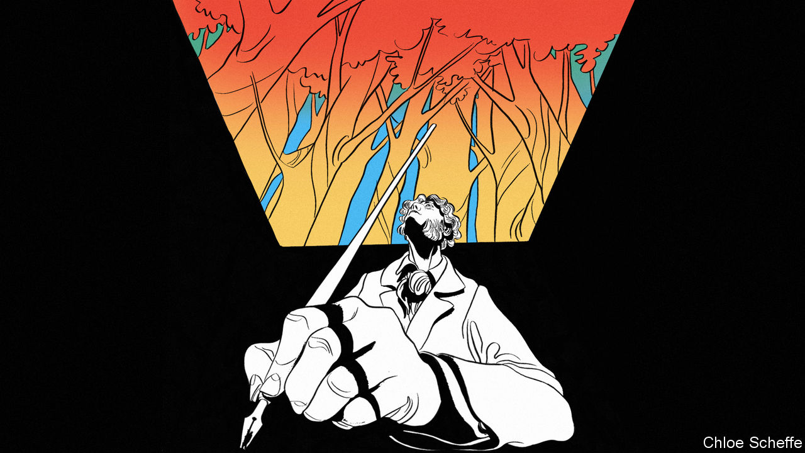

BY THE END of the summer of 1830 Alexander Pushkin was in a state of anguish and spleen. The news of cholera spreading from Asia into Russia was the least of his worries. His engagement was on the brink of breaking down, his finances were under strain and his ambivalent relationship with the tsar was becoming untenable.

Nicholas I, a humourless and ruthless autocrat, had begun his reign by executing five aristocrats who had led the Decembrist uprising against him in 1825; another 120 conspirators were exiled to the far reaches of the Russian empire. Many were close friends of Pushkin. He had himself been exiled to his mother’s estate a year earlier on account of his atheistic ideas. Had he been in St Petersburg he would have been among the rebels, he candidly acknowledged when summoned to meet the tsar.

Releasing and pardoning the country’s most popular poet was meant to mollify the Russian elite. Nicholas also pledged to act as Pushkin’s patron and personal censor, in place of the regular one. In practice, Pushkin had to clear every piece of writing with the tsar and endure the attentions of Count Alexander Benckendorff, the founder of Russia’s secret police. Pushkin felt suffocated and restless. He requested permission to travel, to Europe or China or anywhere else, but was invariably turned down. A short trip to the war in the Caucasus—in Russia, the favourite danger zone of the romantic age—resulted in a humiliating rebuke from Benckendorff.

These political tensions were jeopardising his wedding plans. At 30, Pushkin longed for a private family life, shielded from both the state and his admirers (if that impulse violated the romantic notion of the poet as heartbroken loner, so did his view of literature as a profession). But his prospective mother-in-law was nervous about marrying her beautiful 17-year-old daughter, Natalia Goncharova, to a man under surveillance. At Pushkin’s request, Benckendorff wrote to say he was merely giving friendly counsel to the poet, not snooping on him. Still, there was another hurdle: Natalia’s mother insisted on a dowry, and since her finances were in disarray, the groom would have to provide it. But Pushkin, who made his living by his pen, had no spare funds to indulge her pride.

Amid these dramas, he was obliged to travel to Nizhny Novgorod province, 250 miles east of Moscow, to take formal possession of Boldino, a small estate where his grandfather had lived and which was now a wedding present from his father. Just before he set out, and after a nasty run-in with Natalia’s mother, he told his friend and publisher Pyotr Pletnev that he felt sad and tormented: “The life of a 30-year-old fiancé is worse than 30 years in the life of a gambler…Devil possessed me to think about happiness as though I am made for it.”

## Une très jolie personne

He faced one final source of frustration: autumn was Pushkin’s favourite and most productive season. It was when he wrote best. Now, it seemed, he would spend it preparing for a wedding that might never happen. On September 1st he left Moscow, expecting to be back in a couple of weeks. His muses must have been smiling.

Pushkin travelled light, taking a few manuscripts and a volume of English verse containing “dramatic scenes” by Barry Cornwall, an English poet whose real name was Bryan Procter, and John Wilson, a Scot. After three days he arrived at Boldino, an 18th-century estate surrounded by monotonous, woodless steppe dotted with poor peasant dwellings, plus a graveyard spiked with dark wooden crosses. He planned to stay no longer than he had to.

Five days later, on September 9th 1830, he found himself in lockdown. The cholera epidemic had reached Nizhny Novgorod province and the area was cordoned off to stop it spreading. Suddenly, Pushkin felt contented and relieved. All his prior anguish—and its causes—receded. “My dark thoughts have dissipated: I am now in the country and enjoying myself,” he wrote to Pletnev. “You cannot imagine how joyous it is to run away from a fiancée and to sit here and write poetry…You can ride horses as much as you want, write at home as much as you please, and be disturbed by no one.”

That day he wrote “The Undertaker”, a grotesque short story about a coffinmaker who invites his dead customers to a housewarming party. Pushkin was playful and mischievous. He hung out with peasant girls and went to the local church to deliver a prank sermon. “The cholera has been sent to you, brothers, because you don’t pay your levies and drink too much,” he told the peasants. “If you carry on like this you will be whipped. Amen.”

Stuck behind several quarantine cordons, besieged by a raging disease (“une très jolie personne”, as Pushkin termed it), he felt as free and as happy as he ever had. The three months he spent at Boldino were the most productive in his life. He at last finished “Eugene Onegin”—an ingenious novel in verse that he had been working on for seven years and would become a classic of Russian literature—as well as a series of dramatic sketches based on the British efforts he had brought with him, which he entitled “Little Tragedies”.

## A strange and savage joy

Pushkin, who would never be allowed to travel outside Russia and was now stranded in the countryside amid “rain, snow and mud up to your knees”, leapt across historical epochs, countries and genres—from the medieval French tower in “The Miserly Knight” to Vienna in “Mozart and Salieri”. “The Stone Guest” swept from the gates of Madrid to the balcony of one of Don Juan’s lovers, where (in James Falen’s translation) “the night/Of laurel and of lemon smells; the moon…/All gleaming in the deep and darkling blue…/The watchman calling out his long: All’s well!” As Dostoyevsky put it, Pushkin was able to “accommodate the geniuses of other nations within his soul as if they were his own”.

This surge of creativity was not due only to his escape from nagging concerns. The threat of cholera and the risk of death exhilarated him. As Yuri Lotman, a literary scholar, explained, for a generation of Russian aristocrats born in the late 18th and early 19th centuries, shaped by romanticism and inspired by the Napoleonic wars and European revolutions, death was associated with youth and bravery rather than old age and illness. “Wounds were a subject of envy rather than pity,” Lotman wrote of Pushkin’s time.

In an era and a country in which surveillance, censorship and humiliation were the norm, the risk of being killed by an enemy bullet, or even in a natural disaster, offered a perverse prospect of dignity and freedom—the two things Pushkin valued most. This sense of personal liberty and defiance is the leitmotif of “A Feast During the Plague”, the last and shortest of the “Little Tragedies” that he wrote at Boldino.

He introduced the piece as “an excerpt from Wilson’s tragedy, ‘The City of the Plague’.” Set in London during the pestilent summer of 1665, Wilson’s play paints a morbid picture of an empty city traversed by “a miserable cart/Heap’d up with human bodies”. Pushkin, however, focused on a single scene, in which a group of youngsters carouse in a spontaneous street party and toast a deceased friend. The centrepiece is a hymn of Pushkin’s own devising, dedicated by the “master of revels” to the plague, which has already claimed the character’s wife and mother:

There’s rapture on the battleground,  
And where the black abyss is found,  
And on the raging ocean main,  
Amid the stormy waves of death,  
And in the desert hurricane,   
And in the Plague’s pernicious breath.  
For all that threatens to destroy  
Conceals a strange and savage joy—   
Perhaps for mortal man a glow  
That promises eternal life;  
And happy he who comes to know  
This rapture found in storm and strife…  
We’ll sip the rosy maiden wine  
And kiss the lips where plague may lie!

When his confinement was over, the poet finally married Natalia. In 1837, after his brother-in-law tried to seduce her, Pushkin would be killed in a duel. But he did not have a death-wish, exactly—rather, the proximity of death made him feel alive. When a second wave of cholera struck in 1831 Pushkin was on honeymoon in an idyllic imperial residence near St Petersburg. From there he wrote again to Pletnev, who was succumbing to depression:

Spleen is worse than cholera. The one only kills the body, the other kills the soul…Life is still rich…Your daughter will grow and turn into a bride, we will turn into old fogeys, our wives into old grunts, but our children will be nice...The cholera will pass and, should we still be alive, we will also have joy.

This article was downloaded by calibre from <https://www.economist.com/books-and-arts/2020/06/04/for-alexander-pushkin-lockdown-was-liberating>

|  |  |  |  |
| --- | --- | --- | --- |
|  | Articles | Sections | Next |

|  |  |  |  |
| --- | --- | --- | --- |
| Previous | Articles | Sections | Next |

#### Hearts of gold

# Are humans innately good? Rutger Bregman thinks so

In “Humankind” he tries to refute the idea that people are naturally prone to wickedness

Jun 6th 2020 |



Humankind. By Rutger Bregman. Translated by Elizabeth Manton and Erica Moore.Little, Brown; 480 pages; $30. Bloomsbury; £20.

AS THE SON of a Dutch Protestant cleric, Rutger Bregman was brought up in a religious tradition that regards mankind as incorrigibly prone to wickedness, yet called by the Creator to veer towards goodness, a transformation that the faith promises to abet. As a young, bestselling proponent of catchy ideas about history and economics, he has rejected parts of that outlook while retaining others.

Mr Bregman does not believe wickedness is innate, but, on the contrary, that people are naturally inclined to good and helpful behaviour. In the original Dutch version of his new book, its title means something like “most people fit”; he uses a verb, deugen, that conveys not self-sacrificial courage but having a decent, sensible attitude that meets the needs of society. To support his thesis, he tries energetically to discredit pieces of evidence cited by others to demonstrate humanity’s badness, which range from dodgy psychological research to supposedly egregious real-life events and dark interpretations of history.

In every case, Mr Bregman insists, the true story is different. Take the famous experiments in which subjects were persuaded to administer painful electric shocks to strangers: that research was dishonestly conducted and reported, he argues passionately. Or consider the brutal murder in 1964 of a young woman in New York, who might have survived if somebody had alerted the police in time. That, he says, was also misreported. A stranger comforted the victim before she died.

And he assails one explanation for an anthropological mystery—the near-deserted state of Easter Island in the Pacific. The theory he detests is that there was a catastrophic war between two resident groups. For eco-pessimists, Easter Island foreshadows the destiny of the Earth: as its population grows and resources dwindle, humans may annihilate each other. But Mr Bregman thinks the premise is wrong. There never was a big war on the island.

He cannot deny that people sometimes commit unspeakably evil acts. One section looks at the character of Adolf Eichmann, the Nazi war criminal who was hanged in 1962; what strikes the author is the monster’s adamant, twisted belief that he was doing good. Mr Bregman also considers why Nazi troops went on fighting tenaciously when their cause seemed doomed. Like most soldiers, he concludes, they persevered not out of ideological belief, nor even fear of their commanders, but from loyalty and love for each other. Perhaps so, in many cases; but one of the weaknesses of his book is that it fails to grapple frankly with the wrenching moral tests posed by 20th-century totalitarianism—tests that many people failed. (In the shadow of their country’s past some Germans were sceptical about his project, he confides.)

At times, readers of “Humankind” will sense Mr Bregman wrestling with his heritage, stamping on pessimistic aspects but affirming positive bits in a tone some will find starry-eyed. For example, he likes the Christian admonition to “turn the other cheek” in the face of violence. His argument that news reports are too downbeat, and should focus more on positive stories, could come from a Sunday sermon. When he writes about the dawn of human history, he correctly asserts that agriculture and fixed settlements transformed warfare. But his confidence that before those changes hunter-gatherers were getting along fine, and loved meeting strangers, sounds naive.

Still, in a world of sophisticated pessimism, the book is a refreshing change. Where Mr Bregman grates is in his claim to be the first to wrestle with deep, paradoxical truths about mankind. In the opening lines, he says he is presenting an idea “denied by religions and ideologies” yet of vital importance, for example in management theory or criminal justice.

Well, some religions and some ideologies. In one strand of the Judeo-Christian tradition, including Dutch Calvinism, Adam’s and Eve’s disobedience to God underpins a theory of original sin in which every human is born guilty. But another strand emphasises a different part of the Genesis text, affirming humanity’s creation “in the image and likeness” of a benign deity. As for ideologies, Karl Marx took on the notion that acquisitiveness was universal, maintaining that its roots were only as old as modern capitalism.

Both Mr Bregman and Marx are too sure of a lost—but real—Eden in which people lived co-operatively before the sudden rise of factors that distorted human goodness. In both cases, the resulting worldview is atheistic yet intensely religious, an odd mix. But 21st-century readers are short on prophets, especially the optimistic kind, and will give this one a cheerful hearing. ■

This article was downloaded by calibre from <https://www.economist.com/books-and-arts/2020/06/06/are-humans-innately-good-rutger-bregman-thinks-so>

|  |  |  |  |
| --- | --- | --- | --- |
| Previous | Articles | Sections | Next |

|  |  |  |  |
| --- | --- | --- | --- |
| Previous | Articles | Sections | Next |

#### The floor lines of beauty

# The first big art show of the covid era is a vision of the future

The Raphael exhibition in Rome is stunning. But how many people will see it?

Jun 4th 2020 | ROME

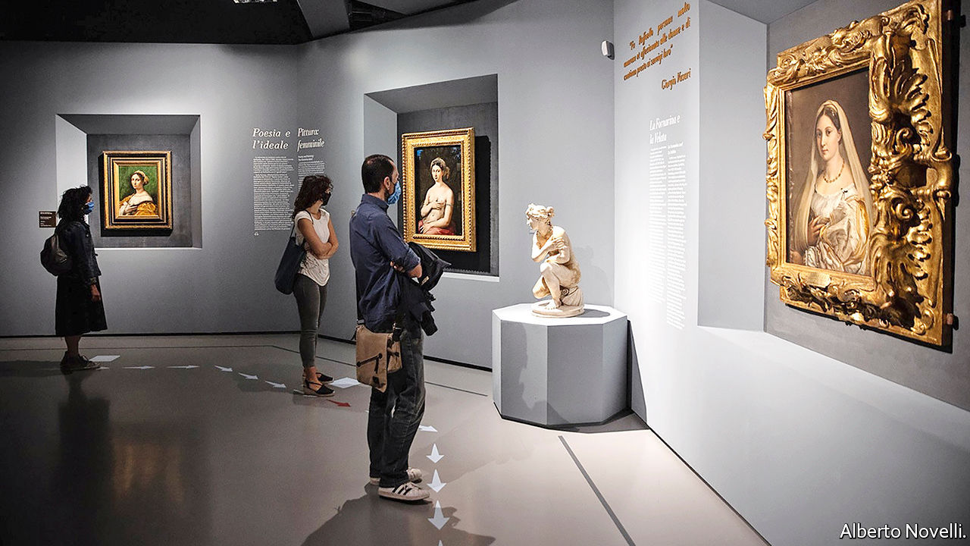

“WE EXPECT A lot of discipline,” says Mario De Simoni, president of the Scuderie del Quirinale, as he points to the disinfectant mat on which visitors are obliged to step as they enter the exhibition centre in Rome. The first prominent art show since covid-19 shut galleries around the world reopened at the Scuderie on June 2nd (it had managed three days in March before the pandemic intervened). A celebration of the Renaissance master Raphael, it aims to burnish the reputation of an artist once seen as greater even than Leonardo da Vinci or Michelangelo. But it is also a test for art in an era of social distancing.

Visitors are being admitted in parties of six every five minutes, and the aim is to keep them two metres apart throughout. The Duomo (cathedral) in Florence has introduced necklaces that flash and vibrate if wearers get too close, but the Scuderie rejected those as unacceptably intrusive. Instead, attendants will accompany, and supervise, every group. As they arrive in each space, people will be asked to take up positions marked on the floor—which is where difficulties could arise. Will a scholar wanting to linger over the so-called Tempi Madonna and Raphael’s cartoon version of it (displayed together for the first time) be content to move on after a brief inspection?

Playfully entitled “Raffaello 1520-1483”, the show begins with its subject’s death 500 years ago, aged 37, and ends with his earliest known work. The first exhibit is a replica of his tomb in the Pantheon, the last an exquisite drawing the 14-year-old Raffaello Sanzio made of his hand, accompanied by what is probably a self-portrait.

The curators aim to demonstrate how Raphael generated his distinctive style. “He was able to fuse influences from other painters in a way very few artists have managed to do,” says Eike Schmidt, director of the Uffizi gallery, which reopened its own doors in Florence on June 3rd. Mr Schmidt loaned about a quarter of the works on display, including Raphael’s portrait of his papal patron, Leo X—which prompted the resignation of the Uffizi’s entire scientific committee. Its members thought that painting too fragile to move.

Raphael’s artistic alchemy mingled and transmuted the emotion in da Vinci’s glances, the athleticism of Michelangelo’s nudes and the softness of Perugino’s Madonnas into an oeuvre that, until late in the 19th century, was widely seen as greater than those of his High Renaissance contemporaries. It was only with the advent of Impressionism and, later, the 20th-century avant-gardes that Raphael’s representational mastery lost a little of its lustre. This show, running until August 30th, proves that his genius still has the power to astound. Raphael was the Mozart of art, capable at the age of 22 or less of producing a work as mature and accomplished as his “Young Woman with Unicorn”.

As Italy emerges from lockdown, said Dario Franceschini, the culture minister, at the reopening, the country is “looking to its strengths: art, beauty and history”. Appetite for those is undimmed. Around 900 visitors were ushered through the show on the first day, the maximum now allowed. But far fewer will get to see this revealing exhibition than if the pandemic had not struck. In 2010 the Scuderie’s Caravaggio show clocked up almost 6,000 a day.

That raises the question of how galleries and museums can survive financially on such small numbers. The publicly owned Scuderie has big reserves, but Mr De Simoni acknowledges that other institutions might respond with sharply increased entrance charges. In the age of covid-19, art, like air travel, could once more become a privilege of wealth. ■

This article was downloaded by calibre from <https://www.economist.com/books-and-arts/2020/06/04/the-first-big-art-show-of-the-covid-era-is-a-vision-of-the-future>

|  |  |  |  |
| --- | --- | --- | --- |
| Previous | Articles | Sections | Next |

|  |  |  |  |
| --- | --- | --- | --- |
| Previous | Articles | Sections | Next |

#### Home Entertainment

# For Hayao Miyazaki, flight is a metaphor for freedom

Discover the consoling imagination of a star Japanese animator

Jun 6th 2020 |



HAYAO MIYAZAKI has spent his career conjuring up fantastical worlds full of outlandish creatures. “Spirited Away” (2001), which won an Oscar for best animated film, is set in a magical realm ruled by a bejewelled witch and populated by talking frogs, gremlins made of soot and a vaporous creature who emits gold nuggets from his fingertips. Amid today’s pandemic, one feature of Mr Miyazaki’s escapist movies is particularly intoxicating: his obsession with flying.

Flight is in Mr Miyazaki’s blood. He was born in 1941 in Tokyo, where his father ran a firm that manufactured parts for Japanese fighter planes during the second world war. He whiled away boyhood hours inventing his own aircraft; at night he dreamed of gliding above the city. Most imaginations become more earthbound with age, but as an adult Mr Miyazaki thought up a squadron of wondrous flying machines with designs that embody their pilots’ personalities. “Castle in the Sky” (1986) features a rag-tag family of pirates who buzz around in “flaptors”, contraptions with transparent, flapping wings that resemble giant mosquitoes.

He is a connoisseur of the sensory thrill of flight. His characters swoop over mountainous landscapes and arc through cerulean skies full of billowing white cumulus, leaving vapour trails twisting like ribbons in the air. When they dive into the clouds for cover, they make a splash as though sinking into clots of heavy cream.

In these animations, flying is about more than ingenious designs and sumptuous images. It also provides Mr Miyazaki’s deepest metaphors, standing for confidence, independence, the power of the imagination itself. Most of his protagonists are children undergoing rites of passage—the dislocation of moving house or trouble in the family. Take Mei and Satsuki, the young sisters in “My Neighbour Totoro” (1988) who have just relocated with their father to rural Japan. Exploring their new home, they discover a tubby woodland spirit in the roots of a camphor tree. A benevolent presence, Totoro soars above the countryside on a spinning top and takes the girls along for the ride. Gradually, as it emerges that their mother is gravely ill, these adventures seem more than mere flights of fancy. They are a form of solace.

That is what Mr Miyazaki’s enchanting stories offer as the world waits for borders to reopen and planes to take off again. His most resonant film is “Kiki’s Delivery Service” (1989), which follows a charmingly wilful 13-year-old witch who rides around on a broom. Determined to find her way in the world, she sets up a courier company to profit from her ability to fly. But when business slows and she suffers her first bout of boy trouble, she loses heart and her powers of levitation, too. “We fly with our spirit,” she says as she tries to restore her confidence, take to the skies and get her life going again. Sound familiar? ■

This article was downloaded by calibre from <https://www.economist.com/books-and-arts/2020/06/04/for-hayao-miyazaki-flight-is-a-metaphor-for-freedom>

|  |  |  |  |
| --- | --- | --- | --- |
| Previous | Articles | Sections | Next |

|  |  |  |  |
| --- | --- | --- | --- |
| Previous | Articles | Sections | Next |

#### Home Entertainment

# Jane Eyre, like many people, is at her best alone

“The more friendless, the more unsustained I am,” says Charlotte Brontë’s heroine, “the more I will respect myself”

Jun 4th 2020 |



ONE OF THE great thrills of reading is encountering a situation that is familiar in feeling yet alien in context. So it is on reaching chapter nine of “Jane Eyre”, in which the narrator, a malnourished orphan in a grim Victorian charity school, describes how life is upended by a typhus epidemic. Liberated from the classroom, she is left to her own company and the outdoors, as millions of others have been in the age of covid-19. The school is set in glorious countryside, and it is May: “All this I enjoyed often and fully, free, unwatched, and almost alone.”

All Charlotte Brontë’s protagonists are solitary to some degree, and her habit of addressing the reader directly heightens that sense: it is as if her characters have no one else to confide in. But whereas in “Villette”, another great novel about an outsider, solitude is mostly a source of misery, in “Jane Eyre” (first published in 1847) it is often a positive state, or at least a productive one.

It forges Jane’s character. Bullied by her guardian aunt, excluded by her horrible cousins and friendless until she is sent to school at the age of ten, she turns inward for direction. Though she often speaks in the language of the Bible, her sense of moral purpose, which drives the plot, is entirely her own and often explicitly connected to her loneliness.

At key moments she is by herself. When, after becoming a teacher, she leaves the school to work as a governess for Edward Rochester, a rich landowner, she is “quite alone in the world”, though “the charm of adventure sweetens that sensation” and “the glow of pride warms it”. Later, when she realises she must leave Rochester, with whom she has fallen in love, because he is already married, she makes isolation, even of the most dreadful sort, sound revivifying: “I care for myself. The more solitary, the more friendless, the more unsustained I am, the more I will respect myself.”

True, in the course of the novel, Jane has intense relationships with others: first with Helen Burns, a saintly and consumptive school friend who dies in her arms, and later with Rochester, with whom she engages in implausibly polished repartee. The portrayal of their affair—and especially of their reunion—is superlatively moving. But it is as a person alone in a hazardous world that Brontë’s heroine offers readers her most important lessons, as well as some of the book’s most enjoyable passages.

Though she wishes to escape it, solitude gives her a licence to observe. She has a habit of detaching herself from others so that she is free to watch them. When Rochester entertains his wealthy friends and asks her to join them, she sits half-hidden by a curtain so that she “might gaze without being observed”. Her solitude makes for great passages of introspective analysis as well as peerless descriptions of solo walking. Her most acute reflections are made, not to her beloved Rochester, but to the reader. Jane Eyre, like many people, is at her best when she is alone. ■

This article was downloaded by calibre from <https://www.economist.com/books-and-arts/2020/06/04/jane-eyre-like-many-people-is-at-her-best-alone>

|  |  |  |  |
| --- | --- | --- | --- |
| Previous | Articles | Sections | Next |

|  |  |  |  |
| --- | --- | --- | --- |
| Previous | Articles | Sections | Next |

#### Perspectives

# The family unit has shaped people’s experience of covid-19

In turn, the pandemic may affect the future of the family unit

Jun 4th 2020 |

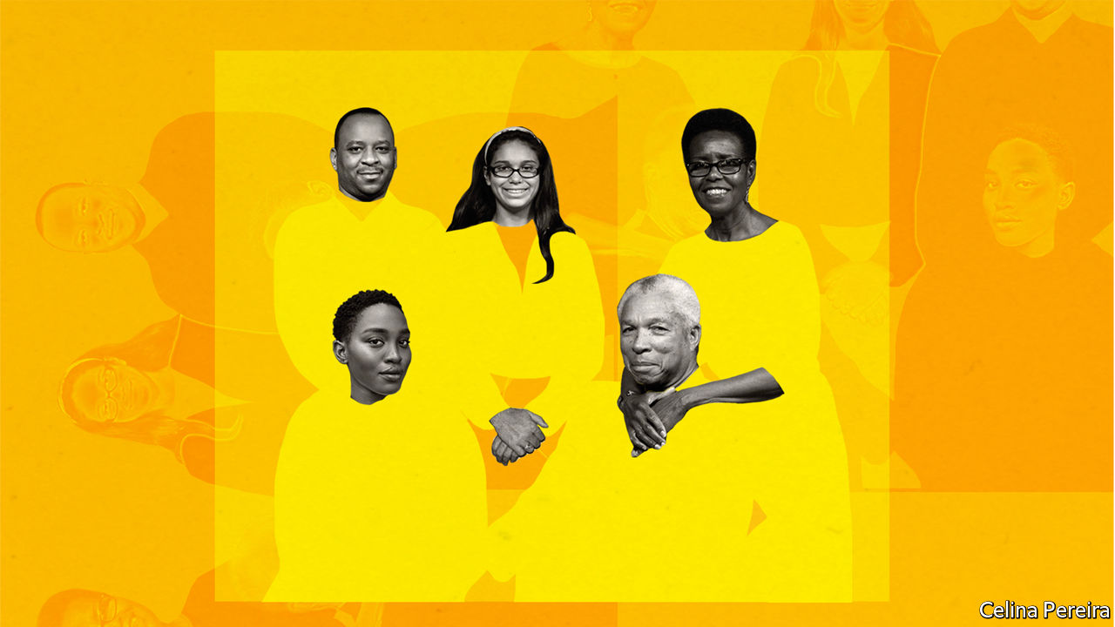

Editor’s note: Some of our covid-19 coverage is free for readers of The Economist Today, our daily [newsletter](https://my.economist.com/user#newsletter). For more stories and our pandemic tracker, see our [coronavirus hub](https://www.economist.com/news/2020/03/11/the-economists-coverage-of-the-coronavirus)

IF ONE HALLMARK of the covid-19 pandemic has been social distancing, another has been enforced intimacy. More than half of humanity has been confined to their homes at one time or another since the start of the outbreak. Many children have seen more of their parents and siblings than ever before; partners have had to negotiate new ways of juggling work and household chores; older, vulnerable relatives have been cut off. An assessment of the virus’s early spread in China, looking at outbreaks involving three or more cases, found that 80% of these clusters occurred in the home.

If covid-19 had struck a century ago, even more people in rich countries (the focus of this article) would have been sharing lockdown. In the early part of the 20th century, quarantines forced many more people together within the walls of the family home. The number of people in an average American household stood at 4.6 in 1900 and 4 in 1930; the figure is around 2.6 now. Many fewer people lived alone, too. In 1940 single-person households accounted for more than 10% of the total in only nine American states; now no state has less than 20% of such households. Only 12.2% of Swedish households had one person in them in 1930; the majority do today.

These changes unfolded over decades. As countries got richer, fertility rates dropped. Welfare states expanded, eroding the importance of the family as a safety-net. The rise of the services sector and the spread of time-saving technologies, among other things, helped more and more women into the labour force. Women began to have children later. Divorce rates rose, as did cohabitation between unmarried couples.

Yet even though families have been moulded by long-run forces, big external shocks have the power to alter their path. Pandemics, wars and particularly deep recessions have all left a lasting mark on the family unit. Might this one do the same?

External shocks can bring about change in several ways. Demography is one. The flu pandemic of 1918 killed at least 50m people, more than were killed in combat in the two world wars combined. A disproportionate number of victims were young adults. The pool of orphans in search of someone to care for them after the pandemic is thought to have led several countries to enact legislation on child adoption, including France in 1923 and England and Wales in 1926.

Consider this entry in the New York Times list of the city’s “100 Neediest Cases” in 1918. As in prior years, a series of pen-portraits catalogued the situations of destitute households in need of help. But this list highlighted the devastation being wrought on families by the flu. Case 69, titled “Widowed and Ill”, begins:

Walter D. was an excellent mechanic, who took good care of his wife and five little boys and girls. His death, of pneumonia following immediately upon influenza, was so sudden that his wife was scarcely able to realise what it was that had happened to them all. The next week she and two of the children were stricken with influenza, and their illness used up all the savings that were left. Terribly weakened, crushed by her grief, the stricken mother is already talking of “three days’ work a week”—all she can think of is the feeding of her hungry little ones.

Decades later another plague struck. The majority of AIDS victims were in sub-Saharan Africa. According to the UN, the number of children to have lost one or both parents to AIDS peaked in 2009 at 15m, most of them in that region. The extended family took on the burden, creating legions of “skipped generation” households. In a paper in 2009 Sheung-Tak Cheng of City University of Hong Kong and Benjamin Siankam of Vanderbilt University found that 13.5% of the over-60s in 23 sub-Saharan countries were living with their grandchildren but not with their adult children.

Big external shocks can cause births to spike as well as deaths. According to “Pale Rider”, Laura Spinney’s book on the flu of 1918, a big rebound in fertility which took place across Europe in 1920 was attributed by many to soldiers returning home from the first world war. But a baby boom in neutral Norway points to a different explanation—that the pandemic both delayed pregnancies and left a healthier child-rearing population in its wake.

The second world war also precipitated a marked, if temporary, rise in fertility. During the baby boom, American women went from having an average of roughly two children in 1940 to an average of almost four in 1957. The reason why points to the enduring impact that external shocks can have on family behaviour. The second world war prompted a large-scale mobilisation of female workers into the labour force, to substitute for men in the armed forces. Only 28% of American women over the age of 15 participated in the workforce in 1940; that figure was 34% by 1945.

## Homeward bound

Many of these women exited the workforce again after the war ended, but plenty stayed. A paper from Matthias Doepke of Northwestern University and his co-authors in 2015, seeking to explain why the baby boom happened, argued that this cohort of experienced workers crowded younger women out of the labour market in the years after the conflict, causing them to have children earlier instead.

The wartime surge in female labour rippled down the generations in other ways. Sexism remained rife, of course. Years after female workers kept America’s munitions factories running, an advertisement for Alcoa Aluminum in 1953 marvelled, above a picture of an astonished woman holding a ketchup bottle: “You mean a woman can open it?”

But within individual families, norms shifted. Using data from that period, Raquel Fernandez of New York University, Alessandra Fogli of University of Minnesota Twin Cities and Claudia Olivetti of Boston College have shown that the wives of men whose mothers worked are themselves much more likely to be in the labour force. Rosie the Riveter did not just change the wartime workforce, but the attitudes of her sons, too.

Economic shocks can also have profound effects on the composition of households. According to the Pew Research Centre, the 2010s were likely to have been the first decade since the 1850s in which the number of people in the average American household went up, albeit marginally. That was owing, at least in part, to the rising share of Americans living with their parents (or “boomeranging”) after the financial crisis of 2007-09.

The proportion of 18- to 32-year-olds living at home went from 36% in 2007 to 41% in 2012, and has remained elevated since, despite the rebound in employment throughout the course of the past decade, in part because of the persistent effects on income of graduating in a recession. However depressing it is for youngsters to move back into their childhood bedrooms, it doesn’t seem to do much for Mum and Dad either. A study into European families by Marco Tosi of the London School of Economics and Emily Grundy of the University of Essex found that, for parents aged 75 and below, their quality of life generally declined when an empty nest started to refill.

The covid-19 pandemic will not chime exactly with these earlier episodes. Unlike AIDS and the flu of 1918, older people are more vulnerable to the virus than younger ones. A post-covid baby boom looks unlikely for that reason alone.

Optimists hope that covid-19 will lead to a more equitable distribution of household chores, as a result of men taking on more of the burden at home during lockdowns (see article). Even limited increases in men’s involvement in child care can affect attitudes. A paper by Lídia Farré of the University of Barcelona and Libertad González of Universitat Pompeo Fabra showed that the introduction of two weeks’ paternity leave in Spain in 2007 lengthened the time it took for couples to have an additional child, partly because men did not want another baby. The risk is that the pandemic does as much to cement conventional roles within families as to dissolve them. As Ms González warns: “If more women are working from home, they are more likely to do both work and chores.”

Historically, technology has helped women into the workforce. Medical advances reduced infant mortality and thus the number of pregnancies that individual women had. The spread of household appliances after the second world war had a salutary effect, as time saved by washing machines and freezers enabled more women to work. The post-pandemic era might lead to faster broadband. A working paper in 2013 by Lisa Dettling, an economist at the Federal Reserve, found that the availability of high-speed residential broadband in America led to a marked increase in the labour-force participation rate of married women.

The numbers of multi-generational households may increase as another burst of boomeranging begins. With universities and workplaces closed, many adult children have already moved back to be with their families. Even if family members don’t actually move in together, they may want to be closer to each other. Diseases do not always unite families. In his introduction to “The Decameron”, a set of stories about the 14th-century Black Death, Giovanni Boccaccio describes how the plague snapped familial bonds:

Such terror was struck into the hearts of men and women by this calamity, that brother abandoned brother, and the uncle his nephew, and the sister her brother, and very often the wife her husband. What is even worse and nearly incredible is that fathers and mothers refused to see and tend their children, as if they had not been theirs.

This pandemic has not been without its own trials on family relations, or even worse—as the reports of increased domestic violence attest to. But it has also raised a kinder set of questions. Arrangements for care of the elderly and the very young are under the microscope. Adult children may take on more caring for their parents in future rather than countenance a care home; they may also be more aware of the value of having grandparents or other relatives nearby for child care. The family unit can be a source of danger for some and of irritation to many. Yet its role as a safety-net has also been thrown into sharper relief by the events of the past five months. ■

This article was downloaded by calibre from <https://www.economist.com/books-and-arts/2020/06/04/the-family-unit-has-shaped-peoples-experience-of-covid-19>

|  |  |  |  |
| --- | --- | --- | --- |
| Previous | Articles | Sections | Next |

|  |  |  |
| --- | --- | --- |
| Books & arts | Sections | Graphic detail |

Economic & financial indicators

Economic data, markets and data

.

|  |  |  |
| --- | --- | --- |
| Books & arts | Sections | Graphic detail |

|  |  |  |  |
| --- | --- | --- | --- |
|  | Articles | Sections | Next |

# Economic data, markets and data

Jun 4th 2020 |

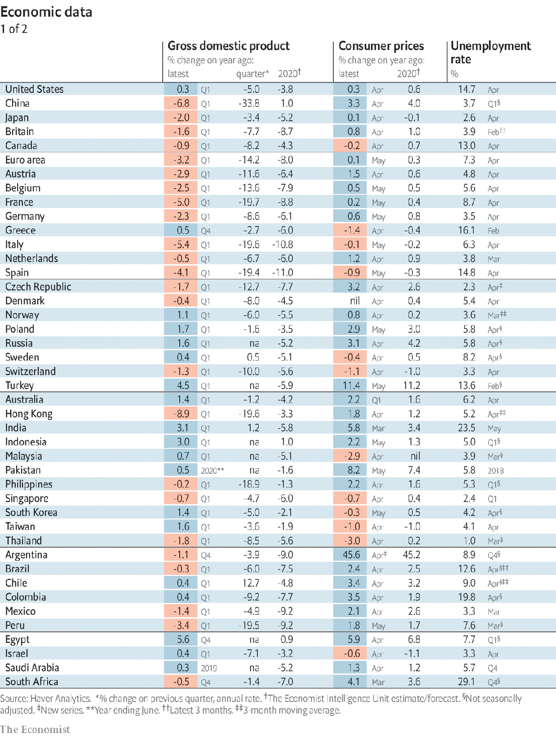

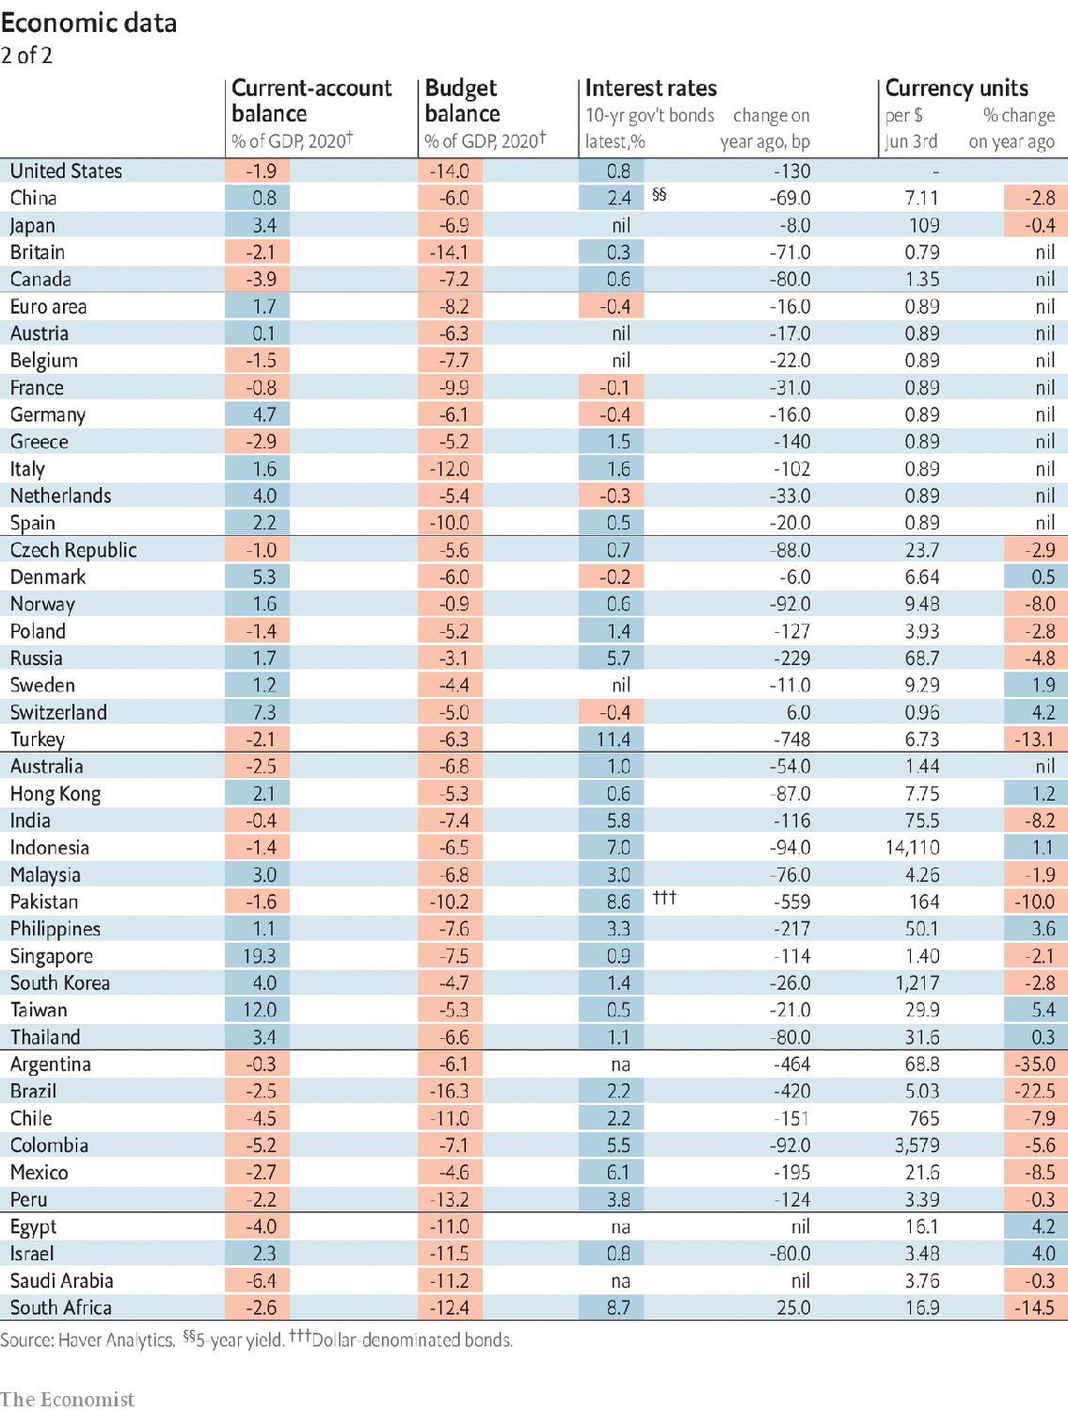

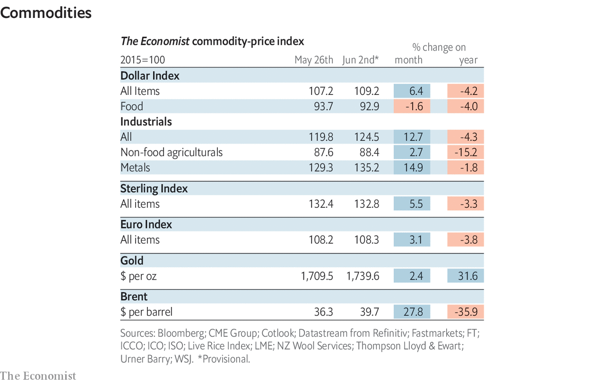

This article was downloaded by calibre from <https://www.economist.com/economic-and-financial-indicators/2020/06/04/economic-data-markets-and-data>

|  |  |  |  |
| --- | --- | --- | --- |
|  | Articles | Sections | Next |

|  |  |  |
| --- | --- | --- |
| Economic & ... | Sections | Obituary |

Graphic detail

Covid-19 and democracy: Out in the open

.

|  |  |  |
| --- | --- | --- |
| Economic & ... | Sections | Obituary |

|  |  |  |  |
| --- | --- | --- | --- |
|  | Articles | Sections | Next |

#### Out in the open

# Democracies contain epidemics most effectively

People living under freely elected governments have been more responsive to lockdown measures

Jun 6th 2020 |

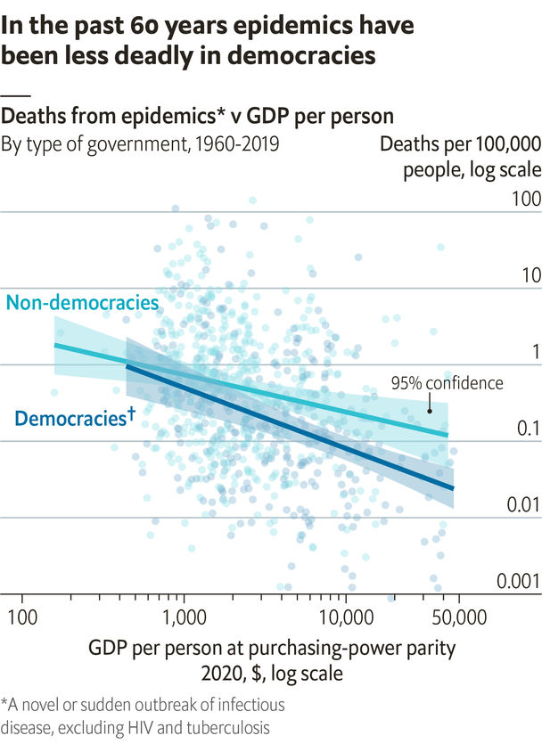

MANY PEOPLE would look at the covid-19 pandemic and conclude that democracies are bad at tackling infectious diseases. America and the EU had months to prepare after China sounded the alarm in January. Both have subsequently suffered more than 300 confirmed deaths per 1m people. China’s Communist Party reports an official death rate that is 99% lower, and has trumpeted its apparent success in containing the outbreak domestically.

Yet most data suggest that political freedom can be a tonic against disease. The Economist has analysed epidemics from 1960 to 2019. Though these outbreaks varied in contagiousness and lethality, a clear correlation emerged. Among countries with similar wealth, the lowest death rates tend to be in places where most people can vote in free and fair elections. Other definitions of democracy give similar results.

We cannot replicate this analysis for covid-19 yet, as it is still spreading at different rates around the world. Western democracies were hit early, in big cities with large flows of people from abroad. Daily deaths are now declining in these places but rising in developing countries, which tend to be less connected and more autocratic.

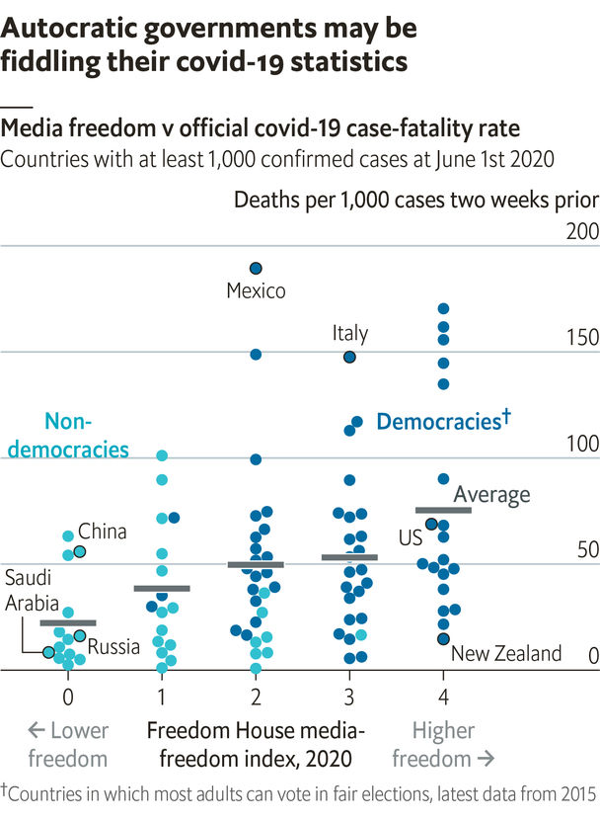

Existing data are also patchy. Countries that do little testing have few official cases. Even among confirmed cases, governments might be tweaking the number of deaths. Countries with a free press, according to Freedom House, a think-tank, have 60 deaths per 1,000 cases on average. Suspiciously, the average in places that lack media freedom is less than half that. A rate of 15 deaths per 1,000 cases is plausible in New Zealand, which has contained the virus, but less so in Russia, which has not.

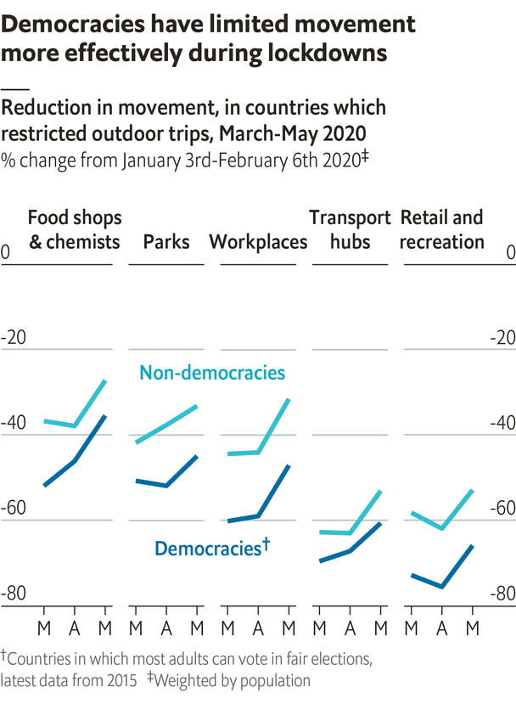

One consistent measure that is available in most countries, but not China, is Google’s index of mobility via smartphone apps. Researchers at Oxford University reckon that, after adjusting for a country’s wealth and other characteristics, democracies saw a 35% larger reduction in movement in response to lockdown policies. The drop in New Zealand, for example, was twice that in autocratic Bahrain.

People who praise China for its handling of covid-19 would do better to look at Taiwan, a neighbouring democracy. China wasted valuable time in December by intimidating doctors who warned of a lethal virus. Taiwan swiftly launched tracing measures in January—and has suffered only seven deaths. ■

Sources: Frey et al. (working paper); Google mobility reports; Boix et al. (2015); Maddison Project; World Bank; Em-Dat; Freedom House; Hale et al. (2020)

This article was downloaded by calibre from <https://www.economist.com/graphic-detail/2020/06/06/democracies-contain-epidemics-most-effectively>

|  |  |  |  |
| --- | --- | --- | --- |
|  | Articles | Sections | Next |

|  |  |  |
| --- | --- | --- |
| Graphic detail | Sections |  |

Obituary

George Floyd: The life pressed out

.

|  |  |  |
| --- | --- | --- |
| Graphic detail | Sections |  |

|  |  |  |  |
| --- | --- | --- | --- |
|  | Articles | Sections | Next |

#### The life pressed out

# George Floyd was killed on May 25th

The unarmed black man whose death has convulsed America was 46

Jun 4th 2020 |



TUESDAYS WERE usually George Floyd’s night on security-guard duty at El Nuevo Rodeo club, the “hottest venue” for Mexican music in Minneapolis. That was urban-music night, when blacks came crowding in to hear R&B, soul, hip-hop and rap. Things could get rowdy sometimes, but he kept order with calm and a big smile and the sheer presence of himself, six-feet-six and with bulging muscles under his coat. That wasn’t the style of another guy there who had done the job for 17 years, an off-duty white police officer with jittery eyes, who would reach for his pepper spray as soon as a fight broke out and fire it over everyone. But few thought their paths had crossed, or that they ever would.

He liked being a bouncer. His regular stint was at the Conga Latin Bistro on East Hennepin, another Mexican-Latino joint with dining and dancing. There he sometimes wore a blue boiler suit with “Security” in large white letters, but also a navy jacket and black polo-neck that made him look a million dollars. At the door he always beamed out his warm welcoming smile, and expected a hug in return from the regulars. He would dance badly, just to make them laugh. (Jovanni Thunstrom, the owner, once tried to teach him Bachata dance, but he was so tall he couldn’t turn him.) Some customers came early to eat the spicy Mexican food with him. In return he did favours for them: drove them home if they were drunk, put their things in his own closet if they didn’t bring spare change for the coat-check. At the end of business, he helped clean down the bar. Mr Thunstrom (“Bossman”, as he kept calling him), was a friend, almost family, and rented him a duplex in St Louis Park, uptown. He liked his neighbours there, and would spend time chatting over the fence to their little boy, teaching him the proper way to shoot hoops. He had been pretty good at basketball, back in Texas.

Since coming to Minneapolis from Houston, several years ago, he had had no problem getting a job. Friends who had gone north before him had persuaded him to come, and they were right. There was no shortage. He worked as a truck driver, revelling in taking big rigs on the Interstate, and found his two security places. He also found a new girlfriend, Courtney Ross. And with that he seemed determined to stay in Minnesota.

That was not the plan at first. H-Town was still home. He grew up there in the Third Ward, the old black section of the city, full of shotgun shacks and run-down public housing as well as more notable buildings, like the Jack Yates High School, which he attended, and Wheeler Avenue Baptist church, where Martin Luther King preached. At Yates, with his height, more than six feet at 12 years old, he shone at sports: he was recruited by South Florida State to play basketball, and was on the Yates football team that made the final of the Texas state championship in 1992 in the Astrodome. The Houston music scene drew him, too; he was “Big Floyd” in a group that backed DJ Screw, a legendary hip-hop DJ, inventor of a new remix technique of slowing tracks down and playing the same track on different turntables (“chopped-and-screwed”, hence the “Screw”). Best of all, he met attractive women, by several of whom he had children. He was a good father while he was around.

Yet Houston was tough, too, especially in the Third Ward. He lived in Cuney Homes, otherwise known as “The Bricks”, a project overrun with drugs, gangs and guns. In 1997 the place was modernised and even won an award, but its reputation did not change much. And as a “brickboy” he did not escape it. In his early 20s he did jail time for theft with a firearm. After that came various arrests for possession of cocaine. He was not made for crime; he admitted in a video later that “bustin’ a gun” was crazy and made his knees shake. But he seemed to drift into these things because there was no line of work or life he was especially good at. His friend Stephen Jackson had become a player for the NBA, in the San Antonio Spurs, and he liked to call Stephen his “twin”, excited by his successes as if they were his own. But he, Big Floyd, was famous mostly for his size—a size that made people think he was not gentle or calm, but a fighting person.

So it could turn out. In 2007 he and five other men forced their way into a woman’s house. He held a gun to her stomach and then searched through the rooms and cabinets, looking for money and drugs. This aggravated robbery earned the “large suspect” five years in prison. When he emerged, he pledged himself to a new life. He became active in his church, Resurrection Houston, organising not only barbecues and basketball games but Bible studies and open-air baptisms, pushing the big tub right into Cuney Homes to evangelise the hardest part of town. It was a Christian work programme that drew him to Minnesota, and he felt ready for that challenge, too. There he could make a completely fresh start, perhaps earn enough money to be a better father. His calls to his friends bubbled with hope for the future.

By the end of May the picture was cloudier. He had been laid off from his security jobs when covid-19 had closed the restaurants. The rent-money for Mr Thunstrom was scraped together somehow, but it was not clear when work would return. He made many calls to friends asking for advice. Meanwhile, the old life brushed him again. On the evening of the 25th he went with two acquaintances to buy cigarettes at Cup Foods on 38th and Chicago, where he was a regular. He tried to pay with a $20 bill which the store clerk thought looked counterfeit, then would not return the cigarettes. The clerk, thoroughly frightened, called 911 and identified the “tall guy” as the man to blame.

When the police arrived he struggled at first, but calmed down once the cuffs were on. Then he refused to get into the squad car. An officer dragged him aside, threw him to the ground helpless and then, for almost nine minutes, knelt on his neck, pressing, pressing, as he cried out for his mother and his breath and his life. He possibly never knew that this was the same white guy with jittery eyes who had worked at El Nuevo Rodeo, the one so ready with the pepper spray to keep the blacks in line. ■

This article was downloaded by calibre from <https://www.economist.com/obituary/2020/06/04/george-floyd-was-killed-on-may-25th>

|  |  |  |  |
| --- | --- | --- | --- |
|  | Articles | Sections | Next |